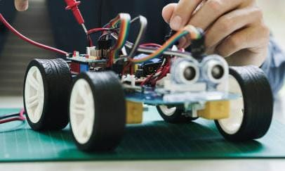

**Let's unlock**

**your**

**full potential**

**together!**

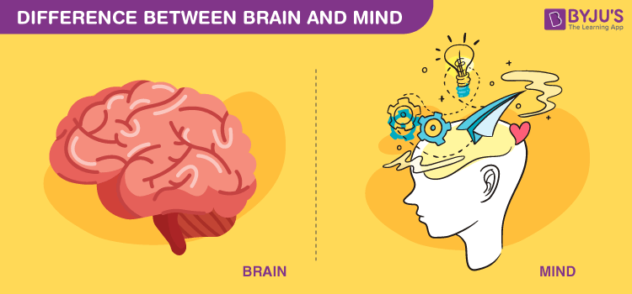

**Join us** today and discover the wonders of STEM! Whether you're a curious beginner or an experienced maker, our STEM laboratory has something for **YOU!**

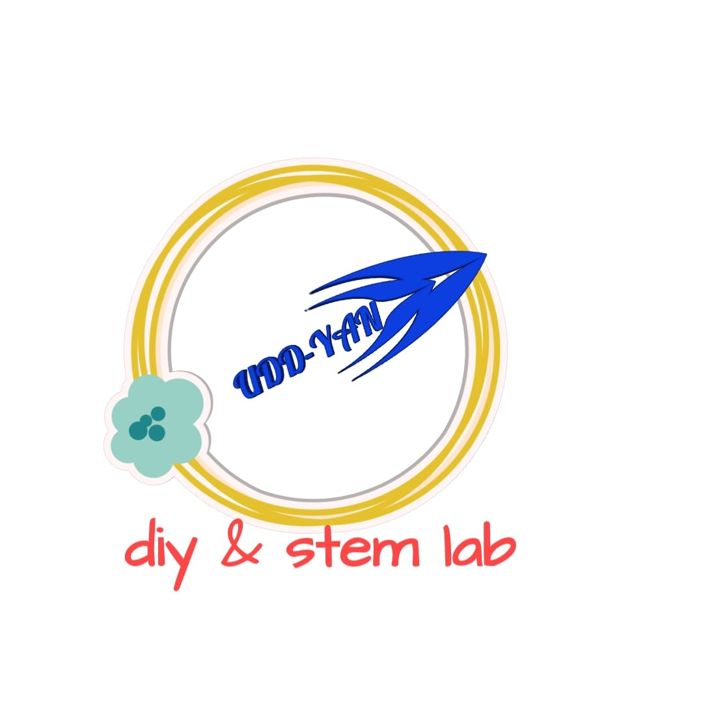

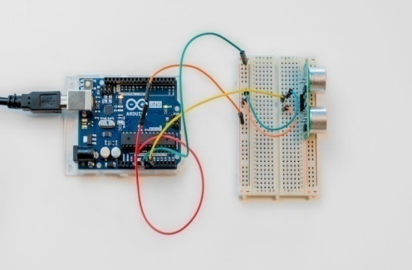Address:

108, Satyamev Royal-3, Nr. Apollo International School, Opp.Dutt Avalon, Tragad, Chandkheda, Ahmedabad

**Contact : 9909008718, 8141528579**

Email: [uddyan.stemlab@gmail.com](mailto:uddyan.stemlab@gmail.com)

**UDDYAN**

DIY & STEM LAB

*“FLY HIGH WITH YOUR*

*IMAGINATION &CREATIVITY”*

Explore various kinds of Do-IT–YOURSELF activities of Science, Technology, Engineering, and Math at UDDYAN DIY & STEM Laboratory!

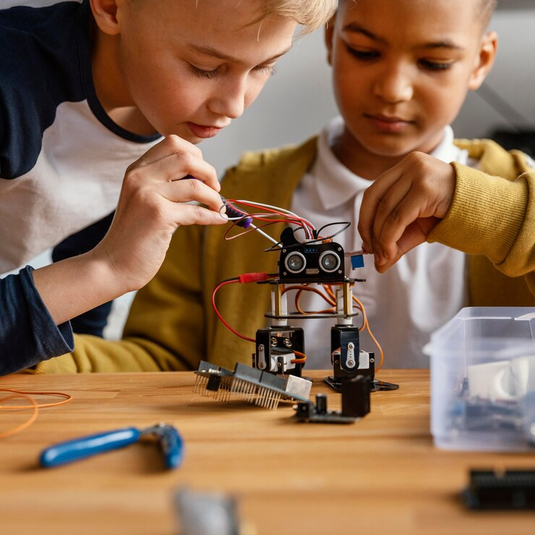

Empowering curious minds to innovate and create through “Hands-on” Experiences.

Our STEM lab also hosts workshops, camps, and special events frequently. These events are led by experts and offer opportunities for students to engage with professionals of various fields.

At our STEM lab, we believe that every student deserves access to high-quality STEM education. That's why we also offer flexible pricing options to ensure deserving students to participate.

We also partner with local schools and different organizations to bring STEM education to underserved communities too. 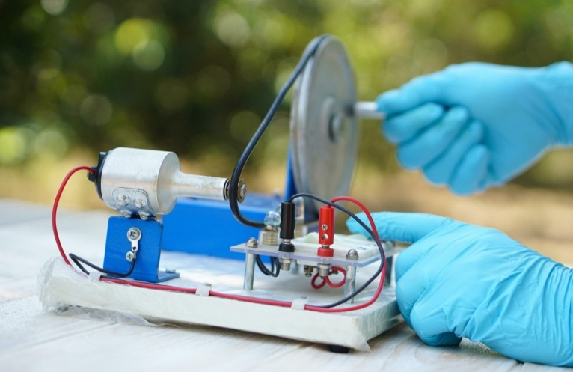

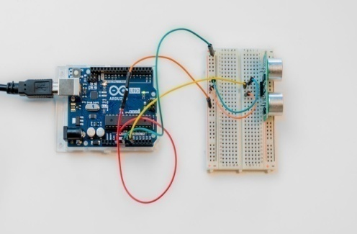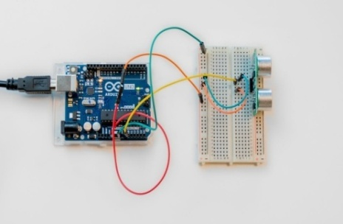We guide students through exciting projects that promote idea generation for problem-solving, design thinking, and collaboration. Our services are:

* STEM courses of one month to year long duration for different age groups.
* Creating electronic/electrical circuits and devices.
* Electrical/Electronics projects guidance for degree/diploma engineering students.
* Conducting experiments using scientific instruments.
* Building STEM projects for school exhibitions.
* Do it yourself Workshops on STEM activities for different age groups.
* Tinkering lab set up at schools.

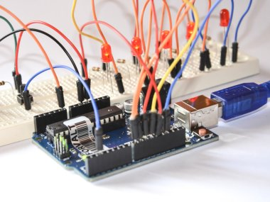

Welcome to our state-of-the-art UDDYAN, DIY & STEM lab. Uddyan is purely working on concept of HANDS ON experiments. Here, students can explore, learn, and create STEM projects and models through DO-it-Yourself activities and projects. DIY activities are designed to inculcate creative design thinking skills, analytical and problem solving skills and to develop critical thinking abilities also.

UDDYAN lab offers a variety of resources and equipment including:

* Robotics kits
* Microcontrollers and sensors
* Circuit building materials
* Scientific instruments and tools
* Computers with required software.
* STEM project kits & STEM Toys
* Physics Lab for 12th science class.

