Pollution gas like co2 , so2 , No2 , Co , O3 gases are measured with help of raspberry pi and sensors. While Measuring the data stored in database.Then web service was created and which will provide the real time pollution data in json format.so that it can be easily consumed by any device.

initially we hava done with delhi pollution data.

* Mobile_App folder contains android app
* Web App folder Contains Web Application

webservice output:

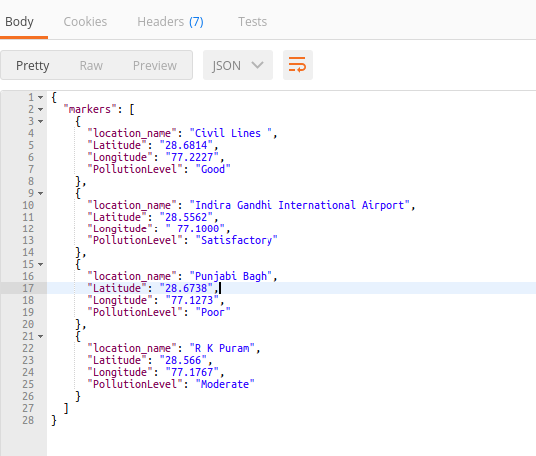

Android App:

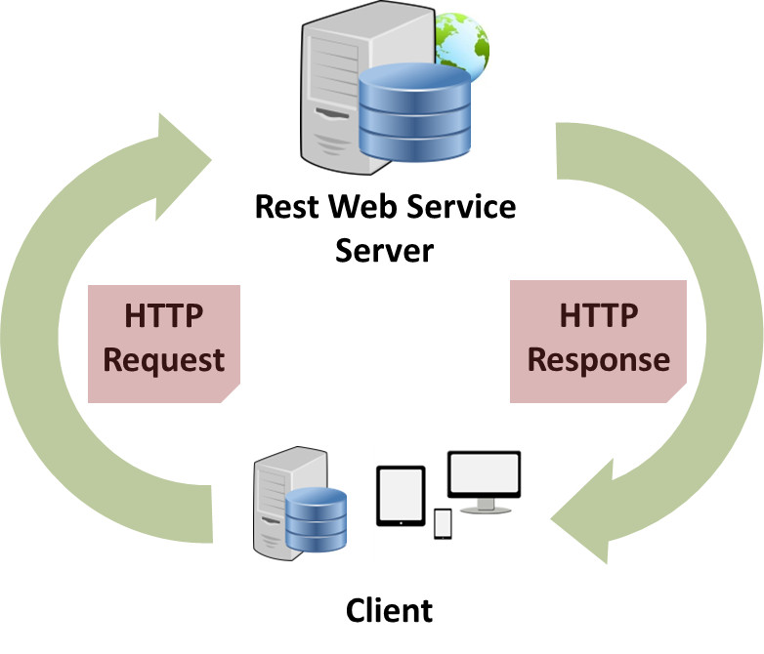

Android app uses the Web Service from LocalHost/Some Other Host.

App consume that web service for getting Details of Real Time Data with location.

It’s integrated with google Map.So that we can get accurate data with better visualization.

Different Markers are used to differentiate the pollution level in Map.

Sample output:

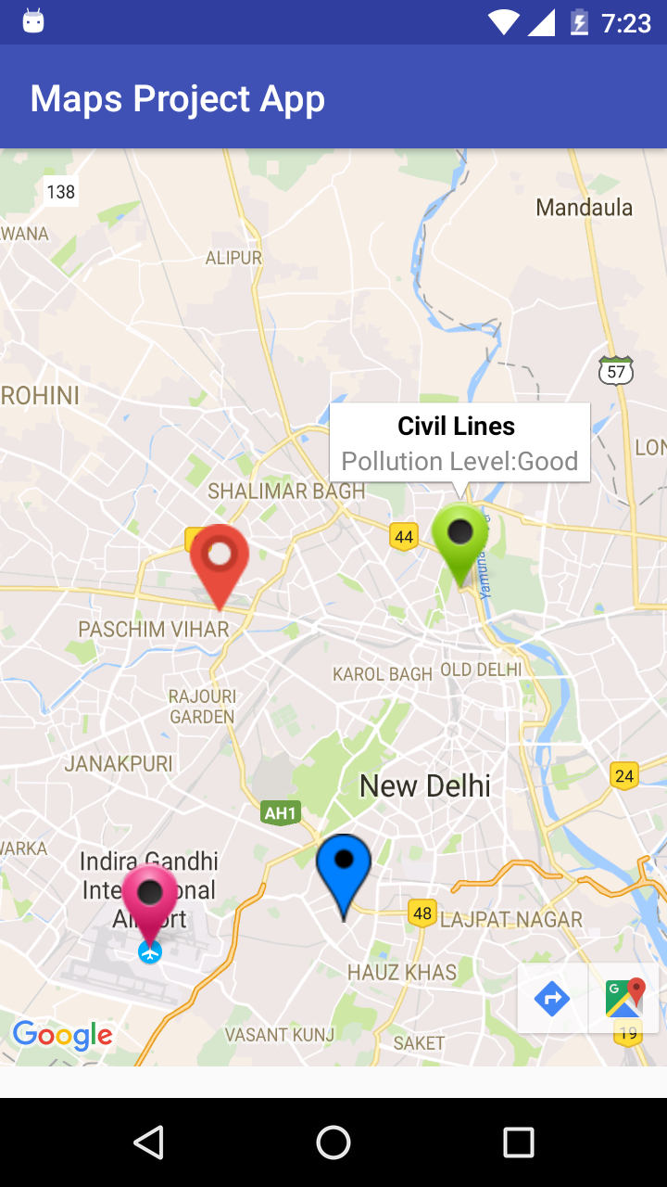

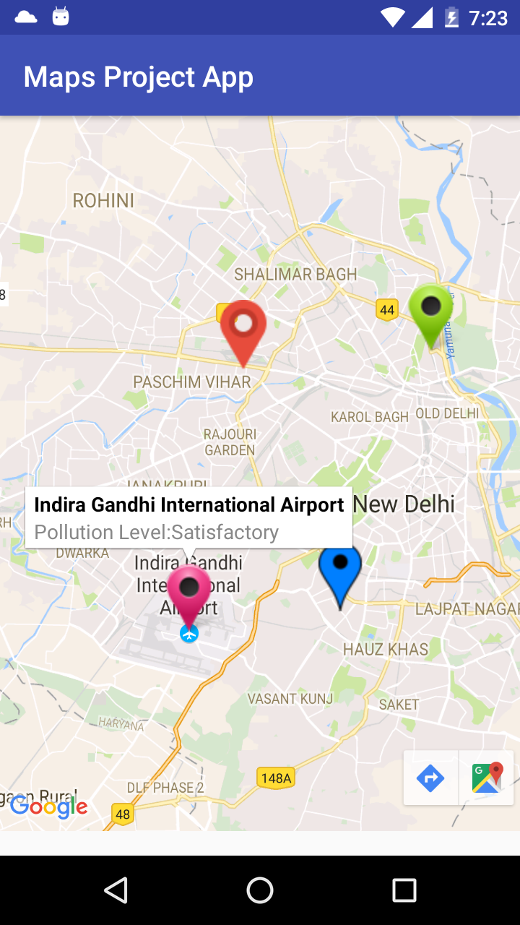

Web Application: [click Here](http://gowthamp.16mb.com/)

Google Map is integrated to show dynamic data with different location.

