Angular:

* Data Binding
* Expressive HTML
* Modular
* Built in Service Integration
* Faster rendering time

An angular application consists of components and services.

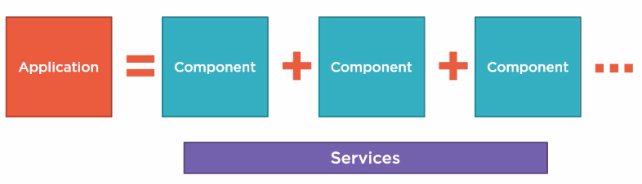

A component has the following parts:

* Template - HTML code or view
* Class – Associated code to support data elements in HTML template also known as properties and methods which respond to button clicks etc.
* Metadata

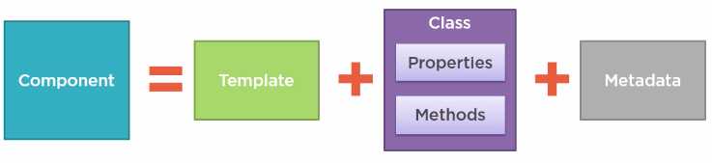

Angular apps are modularized. Each app must have at least one module known as root module.

It can also have feature modules.

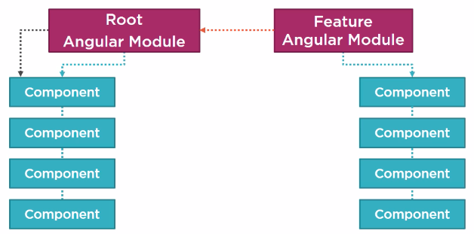

<https://github.com/DeborahK/Angular-GettingStarted>

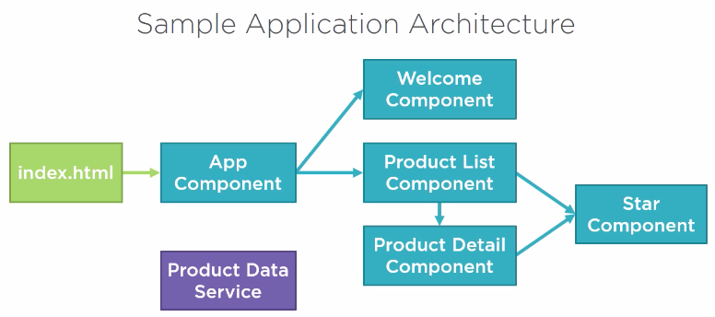

Language: **Typescript**

* Strongly typed (data type present for variables)
* Trans piled to JavaScript.
* Object oriented features

**Set up Angular**

Node Package Manager – Command Line Utility

<https://nodejs.org/en/download/>

This package has installed:

Node.js v10.15.1 to /usr/local/bin/node

npm v6.4.1 to /usr/local/bin/npm

Make sure that /usr/local/bin is in your $PATH.

**Steps to setup an angular application:**

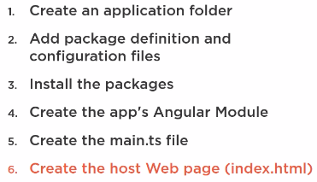

Use angular CLI to generate setup and boiler plate code.

<https://github.com/angular/angular-cli>

**An angular Project Sample:**

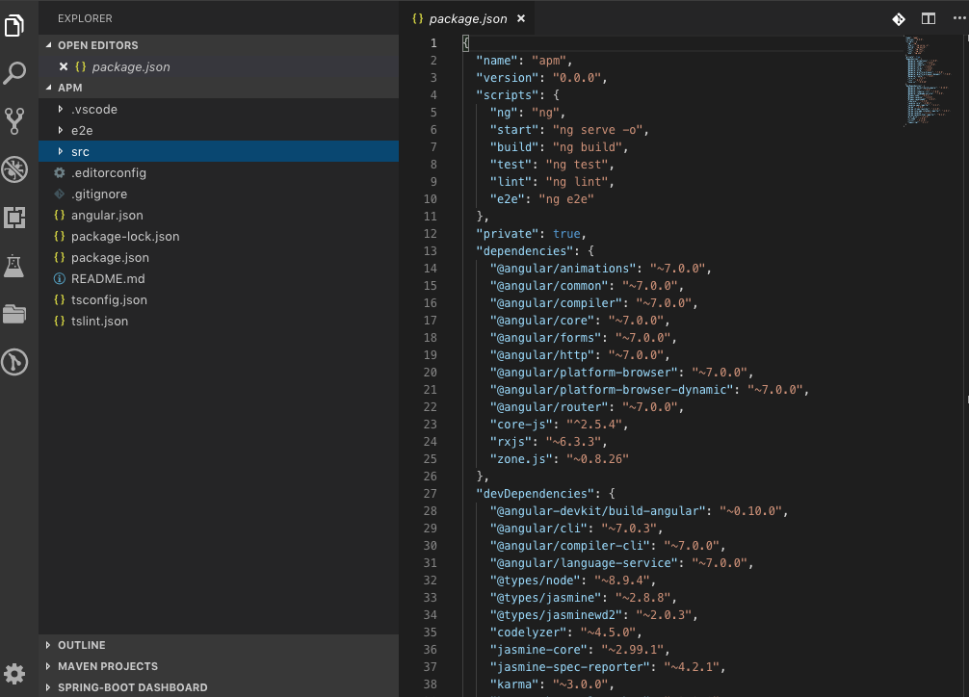

The code is present under src/

All required libraries are defined in package.json

Navigate to the folder which contains package.json in terminal.

* npm -v to check angular version.
* npm install to install dependencies defined in package.json.

A node_modules folder is created where all libraries are stored.

**Start Angular App:**

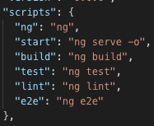

Package.json scripts section has all the start scripts configured.

npm start = ng serve -o (ng = angular, serve = start app, -o = open in default browser)

so npm start can be used to start up our app in default browser.

**Modules**

ES Modules:

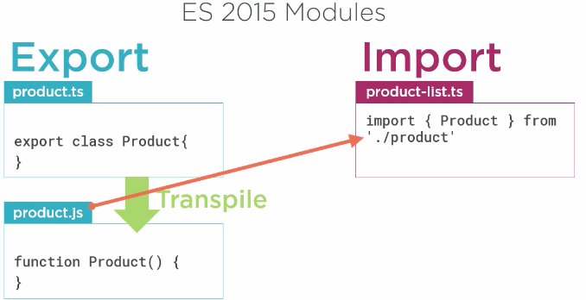

The class Product is exported from product.js (trans piled from .ts) and imported by product-list.ts. Both these files are ES modules.

Angular Modules:

