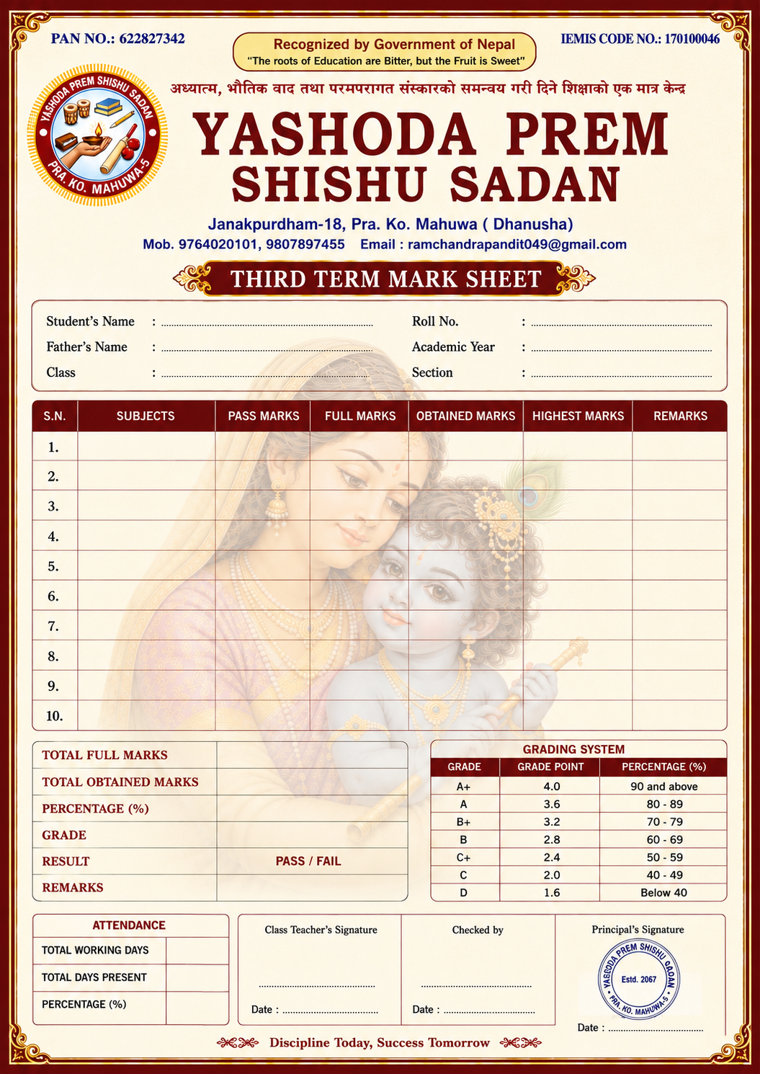
{PER}
{TDP}
{TWD}
{remarks}
{grade}
{percentage}
{totalobtainedmarks}
{totalfullmarks}
{sub10rmk}
{sub9rmk}
{sub7rmk}
{sub8rmk}
{sub6rmk }
{sub5rmk }
{sub4rmk}
{sub3rmk}
{sub2rmk}
{sub1rmk}
{sub10hm}
{sub9hm}
{sub8hm}
{sub7hm}
{sub6hm}
{sub5hm}
{sub4hm}
{sub3hm}
{sub2hm}
{sub1hm}
{sub10om}
{sub9om}
{sub8om}
{sub7om}
{sub6om}
{sub5om}
{sub4om}
{sub3om}
{sub1om}
{sub2om}
{sub10fm}
{sub9fm}
{sub8fm}
{sub7fm}
{sub6fm}
{sub5fm}
{sub4fm}
{sub3fm}
{sub2fm}
{sub1fm}
{sub10pm}
{sub9pm}
{sub8pm}
{sub7pm}
{sub6pm}
{sub5pm}
{sub4pm}
{sub3pm}
{sub2pm}
{sub1pm}
{sub10}
{sub9}
{sub8}
{sub7}
{sub6}
{sub5}
{sub4}
{sub3}
{sub2}
{sub1}
{name}
{father name}
{class name}
{RollNo}
{year}

