DATA ANALYTICS PROJECT REPORT
Loan Approval Analytics & Prediction System

An AI-powered study of what drives loan approval decisions: data cleaning, exploratory analysis, KPIs, business intelligence, a prediction model and an executive dashboard.

Dataset: train.csv (3,192 loan applications, 14 columns)
Tools: Python, pandas, scikit-learn, matplotlib, seaborn, Streamlit
Prepared by: [Add your name]
Date: 19 September 2026

1. Introduction
Lenders make thousands of approve-or-reject decisions. Understanding what really drives those decisions helps a business explain them, spot risks, find missed opportunities and decide where automation can safely help.
This project analyses 3,192 loan applications. It cleans the data, explores it, calculates the key performance indicators (KPIs), turns the findings into business intelligence, trains a simple machine-learning model that predicts the decision, and presents everything in an interactive Streamlit dashboard. The whole solution lives in one Python file (Project.py) so that it is easy to read, run and submit.

2. Problem Statement
The project answers four business questions:
- Which applicant and loan characteristics are associated with approval or rejection?
- How consistent is the decision process, and what risks does it reveal?
- Can the decision be predicted from application data, and how far can that prediction be trusted?
- What concrete actions should management take based on the evidence?

3. Dataset Description
Only the uploaded dataset was used. It contains 3,192 applications and 14 columns. Each row is one application and the target column Loan_Status records the final decision.
Column | Type | Meaning | Blank values
Loan_ID | Text | Unique application identifier | 0
Gender | Text | Applicant gender (Male / Female) | 77
Married | Text | Marital status (Yes / No) | 66
Dependents | Whole number | Number of dependents (0 to 3) | 0
Education | Text | Graduate / Not Graduate | 66
Employment_Status | Text | Salaried / Self-Employed / Unemployed | 56
Applicant_Income | Decimal | Main applicant income (period and currency not stated) | 35
Coapplicant_Income | Decimal | Co-applicant income (0 = none) | 0
Loan_Amount | Decimal | Requested loan amount | 41
Loan_Term | Whole number | Repayment term (60 to 360; months assumed) | 0
Credit_History | Whole number | 1 = good credit history, 0 = no / poor history | 0
Property_Area | Text | Rural / Semiurban / Urban | 0
Age | Decimal | Applicant age in years | 0
Loan_Status | Text | Decision: Approved / Rejected (target) | 0

Important characteristics of the data
- Classes are perfectly balanced: 1,596 approved and 1,596 rejected. The 50% approval rate therefore describes how the sample was built, not a real-world approval rate.
- 341 cells (0.76% of all cells) were blank, spread over six columns. There were no duplicate rows or repeated Loan_IDs.
- The file has no documentation. Currency, whether incomes are monthly or yearly, and the unit of Loan_Term are not stated. Loan_Term is assumed to be in months, and the loan-to-income ratio assumes both amounts use the same period.
- The data records decisions only. It has no repayment or default information, so credit risk itself cannot be measured.
Dataset source: user-provided file (archive.zip containing train.csv). The original publisher was not stated with the file.

4. Methodology
The work follows a standard analytics workflow:
- Load the data and check that all required columns exist.
- Clean the data: standardise text, fix number formats, remove duplicates, correct impossible values, fill blanks and check for outliers.
- Create features: total household income, loan-to-income ratio, co-applicant flag, and age, income and ratio bands.
- Explore the data with summary statistics, distributions, correlations and chi-square tests of association.
- Calculate KPIs and compare approval rates across segments.
- Train and compare two classification models on an 80/20 stratified train/test split; confirm the best with 5-fold cross-validation.
- Measure feature importance with permutation importance (how much the test ROC-AUC falls when one column is shuffled).
- Write the business insights and present everything in a Streamlit dashboard.
Python libraries: pandas and numpy (data handling), scipy (chi-square test), scikit-learn (modelling), matplotlib and seaborn (charts) and Streamlit (user interface).

5. Data Cleaning
The raw file had 3,192 rows and 14 columns. After cleaning and feature creation it has 3,192 rows and 21 columns, with 0 blank cells. The table lists every step and how many cells or rows it touched.
Step | Affected | Action taken
Standardise text | 0 | Trimmed spaces, unified capitalisation and converted placeholders such as '?' or 'NA' to blanks
Fix number formats | 0 | Converted non-numeric entries in numeric columns to blanks
Remove duplicates | 0 | Dropped identical rows and repeated Loan_ID values
Fix impossible values | 0 | Set negative / zero incomes, loan amounts, ages outside 18-100 and invalid credit codes to blank
Check target | 0 | Removed rows whose Loan_Status is missing or not Approved / Rejected
Fill missing numbers | 76 | Replaced blanks in income / amount / age with the column median
Fill missing categories | 265 | Replaced blanks in category / code columns with the most frequent value
Round values | 3,192 | Rounded money columns to 2 decimals and Age to 1 decimal
Outlier check | 38 | Flagged with the 1.5 x IQR rule but kept, because high incomes / loans are realistic
Create features | 6 | Added Total_Income, Loan_to_Income_Ratio, Has_Coapplicant, Age_Group, Income_Band, Loan_to_Income_Band

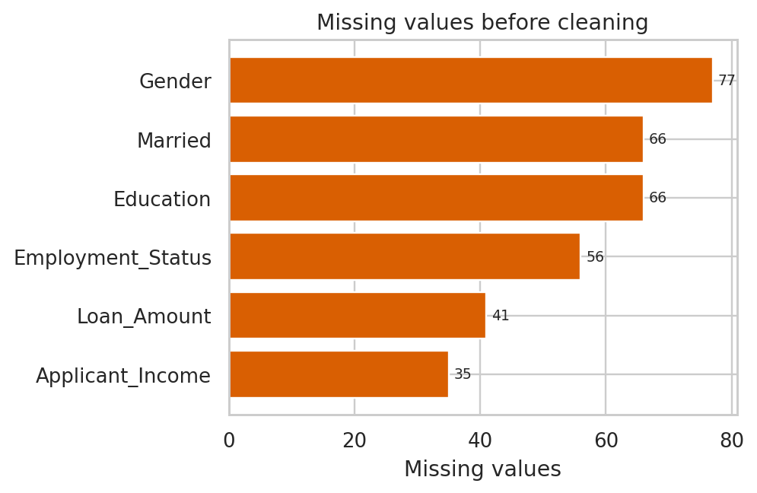
Figure 1: Blank values per column before cleaning
Category columns were filled with the most frequent value and numeric columns with the median. Missing values are only 0.8% of cells, so this has very little effect on the results. The outlier check (1.5 x IQR rule) flagged a small number of values, listed below. They were kept because high incomes and large loans are realistic.
Column | Lower bound | Upper bound | Outliers | Share of rows
Applicant_Income | 7,271.6 | 112,285.2 | 13 | 0.41%
Coapplicant_Income | -12,849.8 | 42,523.3 | 9 | 0.28%
Loan_Amount | 14,907.0 | 288,524.0 | 5 | 0.16%
Age | 14.0 | 56.4 | 11 | 0.34%

6. Exploratory Data Analysis (EDA)

6.1 Summary statistics
Statistic | Applicant Income | Coapplicant Income | Loan Amount | Age | Loan Term
Mean | 59,963 | 15,091 | 151,460 | 35.2 | 212
Std. deviation | 19,933 | 9,542 | 50,314 | 7.7 | 101
Minimum | 15,000 | 0 | 20,000 | 21.0 | 60
Median | 60,290 | 14,609 | 151,968 | 35.1 | 240
Maximum | 138,525 | 47,878 | 373,954 | 61.2 | 360

Incomes, loan amounts and ages are roughly bell-shaped with a mild right tail. About 7% of applicants have no co-applicant income. Loan_Term takes six fixed values from 60 to 360.
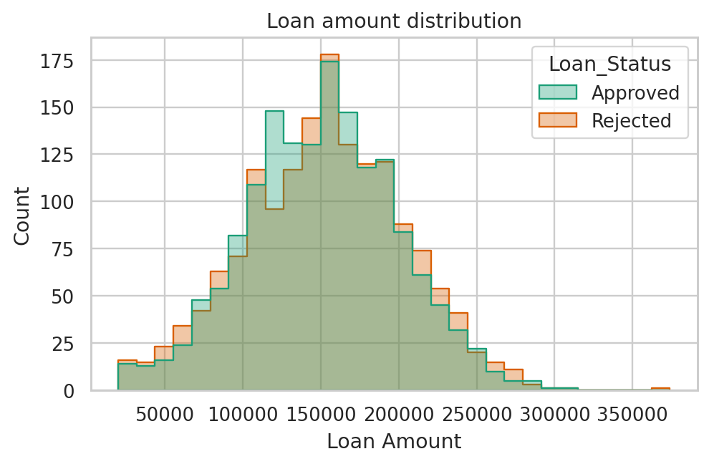  Figure 2: Loan amount by decision | 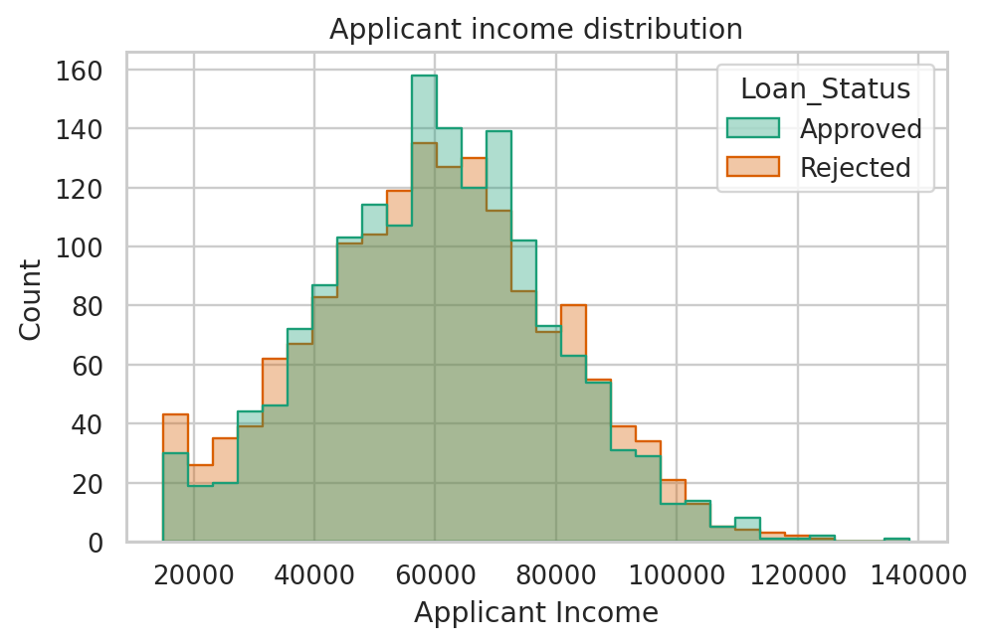  Figure 3: Applicant income by decision

6.2 Correlation
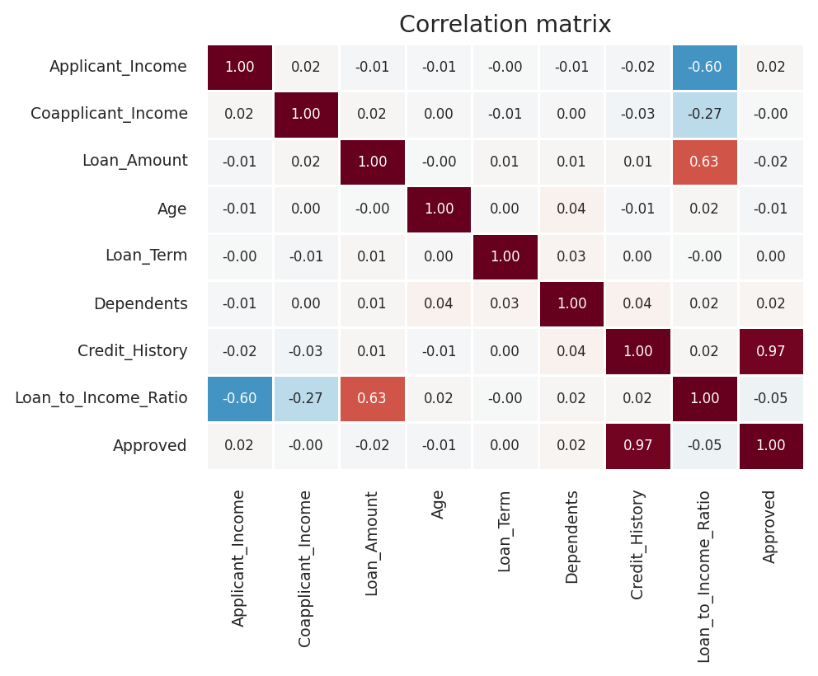
Figure 4: Correlation matrix of numeric columns and approval
Credit_History is almost perfectly correlated with approval (0.97). Income, loan amount, term, dependents and age have correlations close to zero. The strong correlations between income, loan amount and the loan-to-income ratio (-0.60 and 0.63) are expected because the ratio is built from them.

6.3 Approval rate by segment
Factor | Group | Applications | Approved | Approval rate
Credit history | No / poor (0) | 1,542 | 1 | 0.1%
Credit history | Good (1) | 1,650 | 1,595 | 96.7%
Employment | Salaried | 2,234 | 1,159 | 51.9%
Employment | Self-Employed | 809 | 366 | 45.2%
Employment | Unemployed | 149 | 71 | 47.6%
Education | Graduate | 2,389 | 1,217 | 50.9%
Education | Not Graduate | 803 | 379 | 47.2%
Property area | Rural | 626 | 303 | 48.4%
Property area | Semiurban | 987 | 483 | 48.9%
Property area | Urban | 1,579 | 810 | 51.3%
Gender | Female | 1,120 | 564 | 50.4%
Gender | Male | 2,072 | 1,032 | 49.8%
Married | No | 921 | 457 | 49.6%
Married | Yes | 2,271 | 1,139 | 50.1%

6.4 Which differences are real? (chi-square tests)
A chi-square test checks whether the differences in approval between groups are larger than chance would explain. A p-value below 0.05 is treated as statistically significant.
Feature | Chi-square | p-value | Significant | Approval gap (points)
Credit_History | 2,971.47 | <0.0001 | Yes | 96.6
Age_Group | 5.97 | 0.1129 | No | 8.1
Loan_Term | 5.80 | 0.3263 | No | 6.8
Employment_Status | 10.82 | 0.0045 | Yes | 6.6
Income_Band | 5.76 | 0.1237 | No | 4.9
Loan_to_Income_Band | 3.04 | 0.3859 | No | 4.1
Dependents | 1.99 | 0.5739 | No | 3.9
Education | 3.22 | 0.0727 | No | 3.7
Property_Area | 2.15 | 0.3412 | No | 2.9
Gender | 0.07 | 0.7952 | No | 0.6
Married | 0.05 | 0.8147 | No | 0.5

Only Credit_History and Employment_Status show significant differences. Age group, loan term, income band, education, dependents, property area, gender and marital status differ by a few points but these gaps could be chance.

7. Key Performance Indicators (KPIs)
KPI | Value | Why it matters
Total applications | 3,192 | Size of the portfolio analysed
Approval rate | 50.0% | Headline decision outcome (sample is balanced, see Section 3)
Approval rate, good credit history | 96.7% | Shows how strongly good credit is rewarded
Approval rate, poor credit history | 0.1% | Shows how strongly poor credit is penalised
Share with good credit history | 51.7% | Size of the eligible pool
Average loan amount | 151,466 | Typical exposure per application
Average applicant income | 59,966 | Typical borrower capacity
Average household income | 75,058 | Applicant plus co-applicant income
Average loan-to-income ratio | 2.25 | Leverage of an average application
Approved loan volume | 240,319,840 | Total amount of approved loans
Average applicant age | 35.2 | Customer profile

8. Data Visualisations
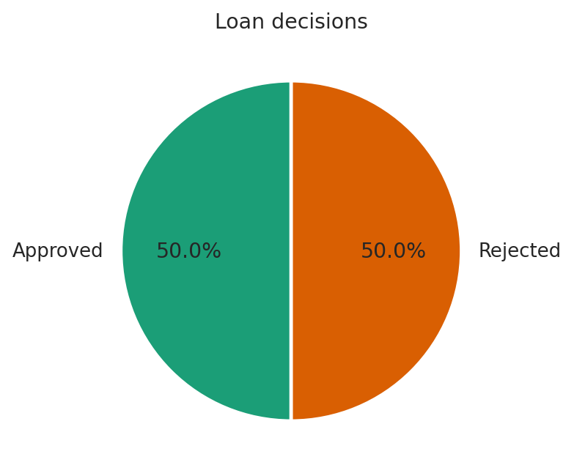  Figure 5: Share of approved and rejected loans (pie chart) | 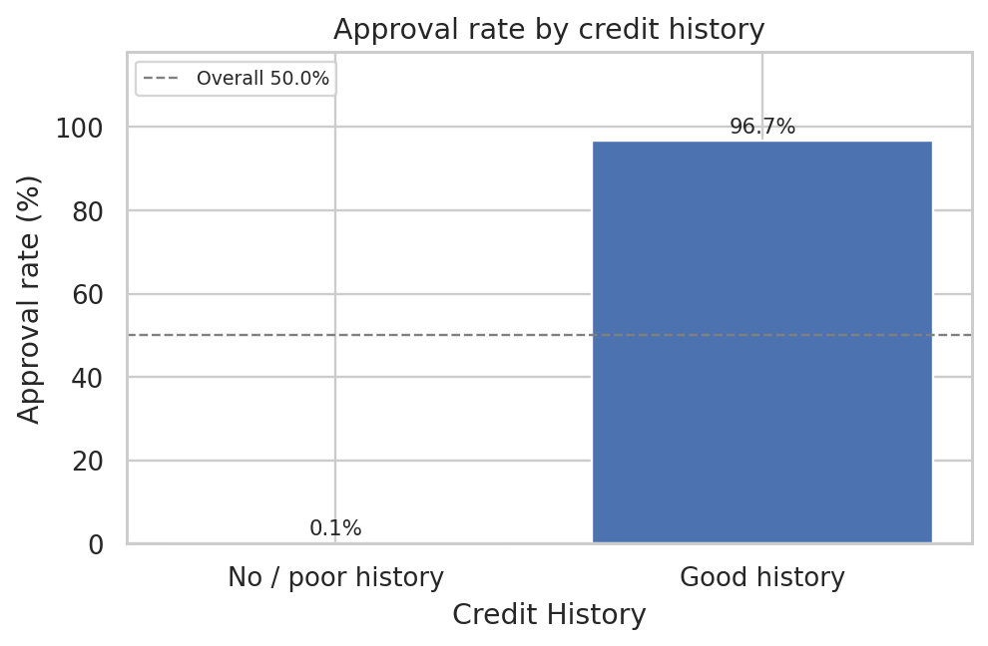  Figure 6: Approval rate by credit history (bar chart)
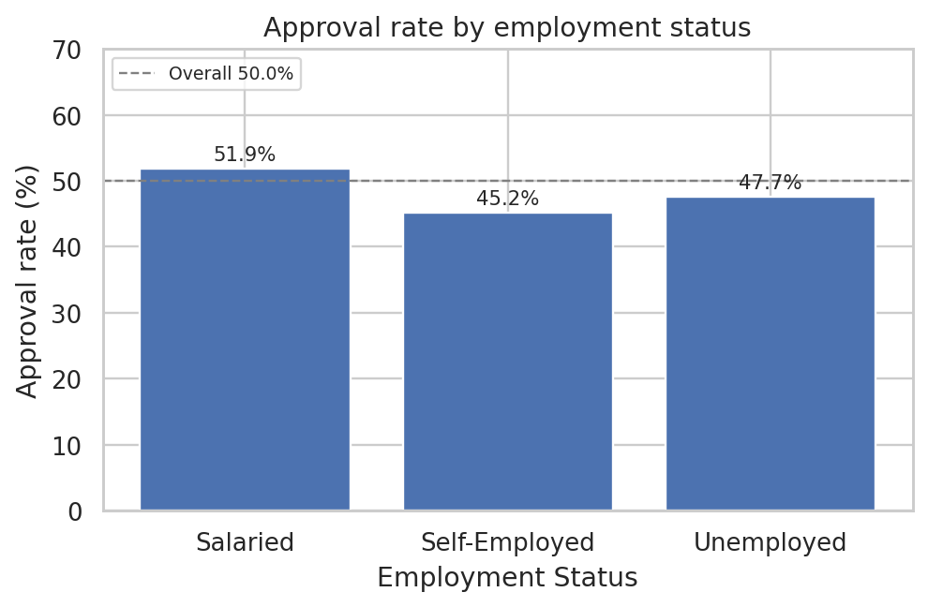  Figure 7: Approval rate by employment status | 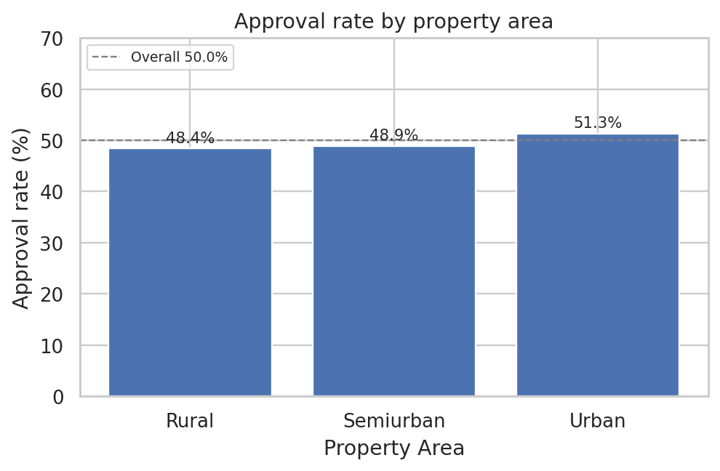  Figure 8: Approval rate by property area
Trend charts. The dataset has no date column, so trends are shown across ordered variables. The value labels matter: the vertical axis is zoomed to 30-70% so small differences can be seen, and the differences are small.
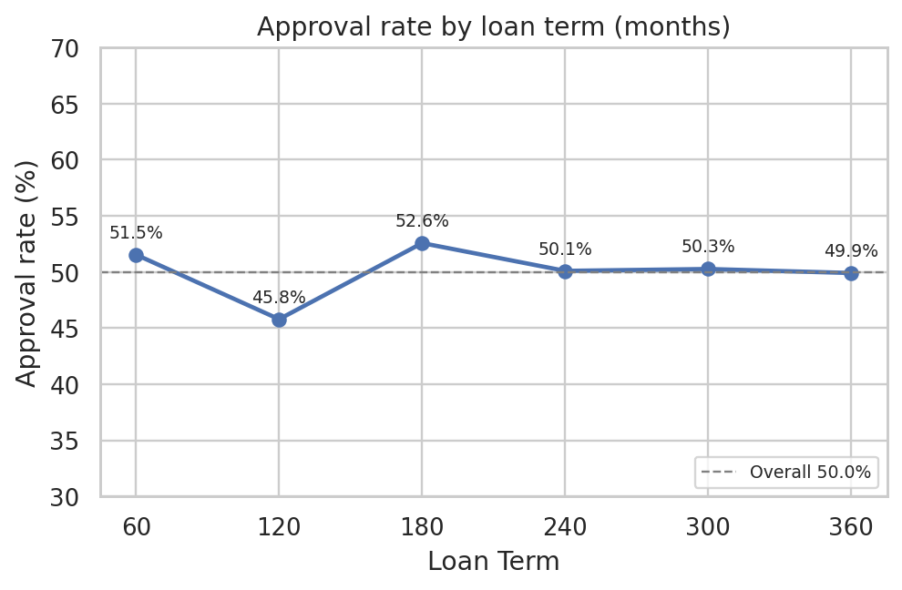  Figure 9: Approval rate by loan term (line chart) | 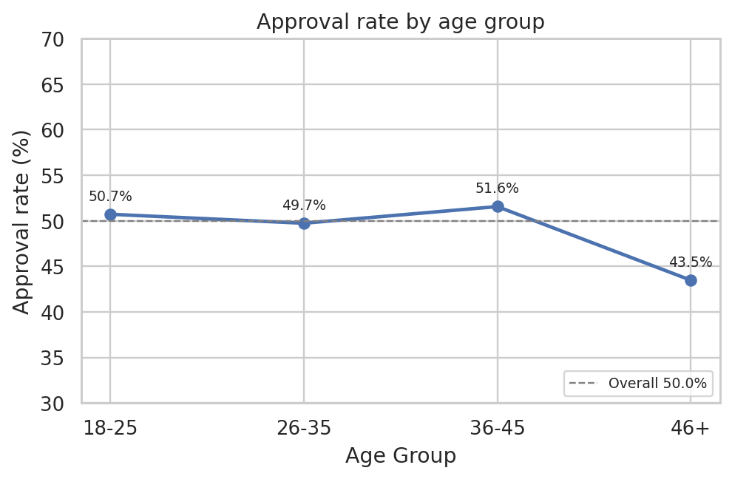  Figure 10: Approval rate by age group
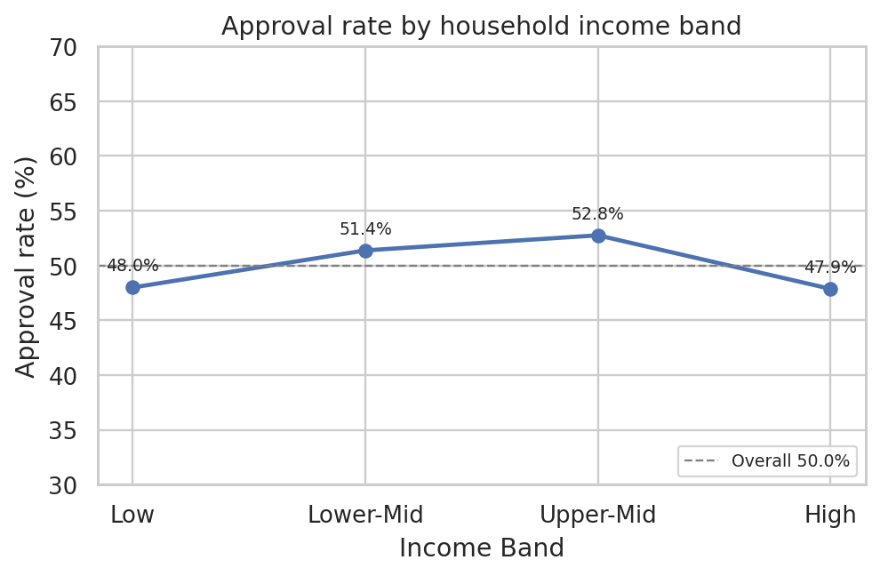  Figure 11: Approval rate by household income band | 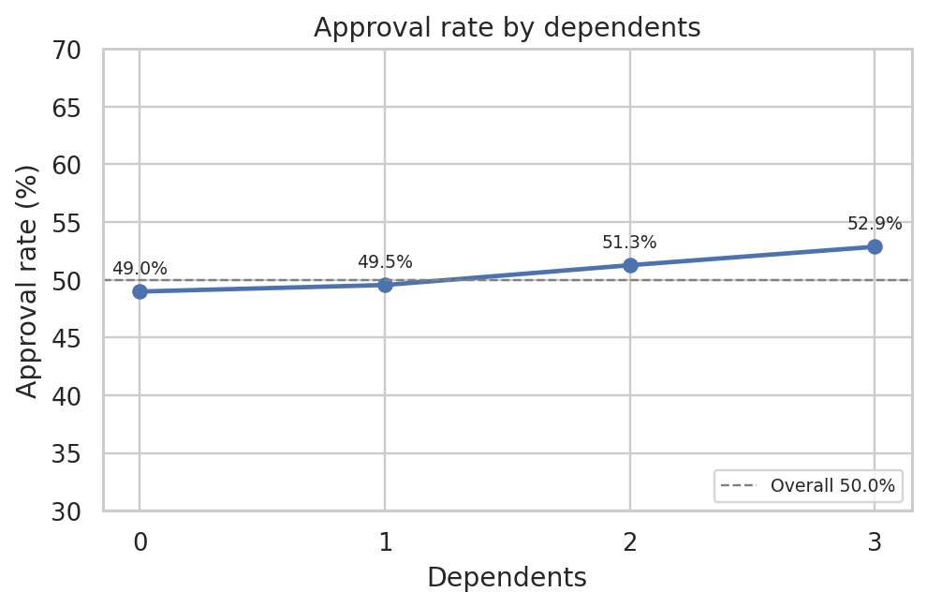  Figure 12: Approval rate by number of dependents
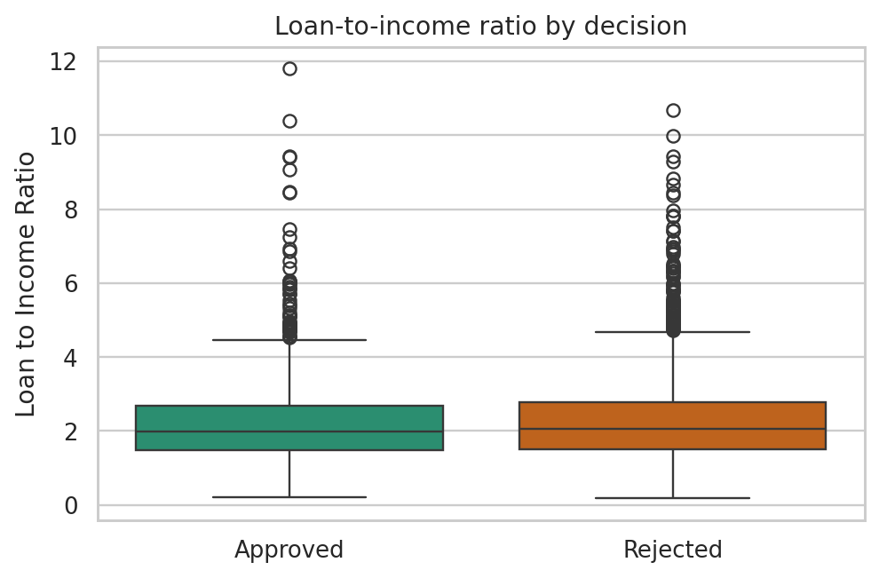  Figure 13: Loan-to-income ratio by decision (box plot) | 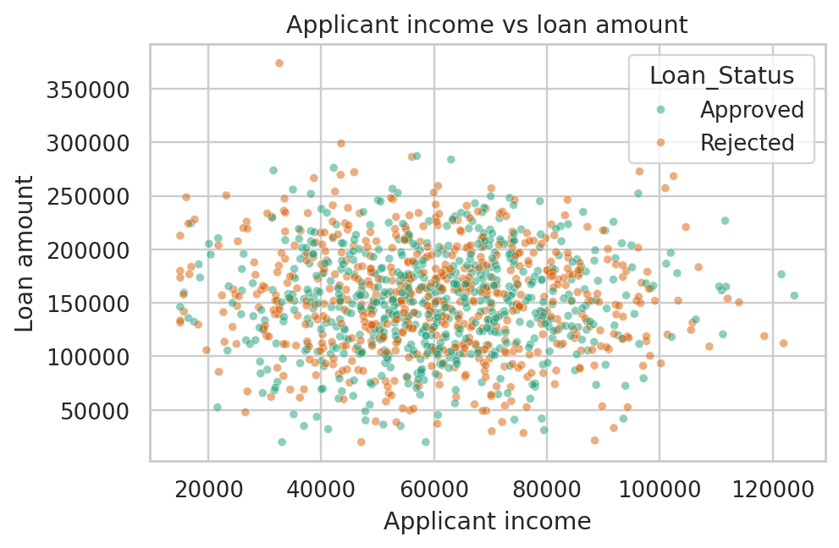  Figure 14: Applicant income vs loan amount (scatter plot)

9. Prediction Model
Two models were trained on 2,553 applications and tested on 639 unseen ones: Logistic Regression (a simple, explainable baseline) and Random Forest (a tree-based ensemble). Numbers were scaled, category columns were one-hot encoded and blanks are filled inside the model pipeline, so new applicants can be scored safely.
Model | Accuracy | Precision | Recall | F1-score | ROC-AUC
Logistic Regression | 97.8% | 96.6% | 99.1% | 97.8% | 0.999
Random Forest | 97.2% | 95.2% | 99.4% | 97.2% | 0.999

Logistic Regression performed best (highest ROC-AUC) and reached 98.6% accuracy in 5-fold cross-validation (standard deviation 0.3%). On the test set it correctly rejected 309 and approved 316 applications, wrongly approved 11 and wrongly rejected 3.
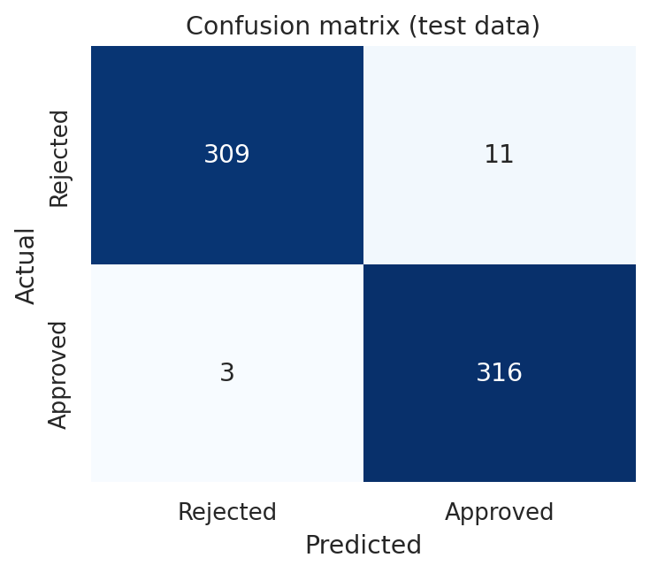  Figure 15: Confusion matrix on the test data | 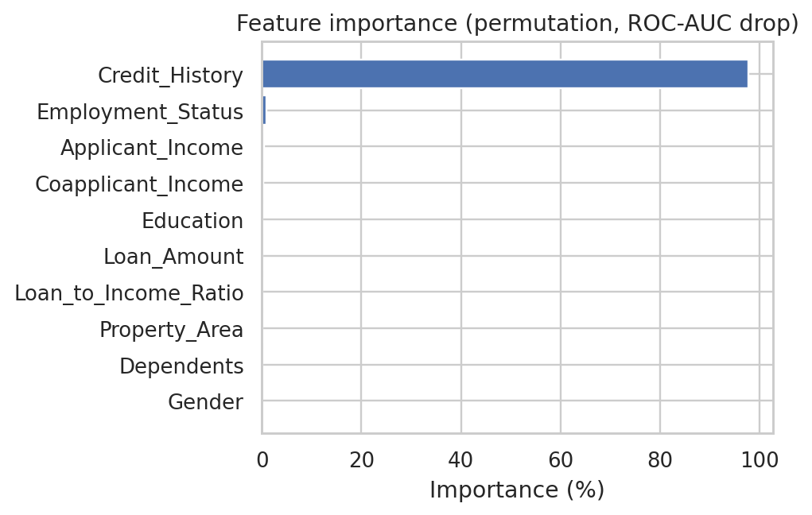  Figure 16: Permutation feature importance

What the model really learned
The high accuracy is misleading. Permutation importance shows that Credit_History accounts for 97.8% of the model's predictive power. Every other column together contributes about 2.2%. To prove this, the models were retrained without Credit_History:
Model (without Credit_History) | Accuracy | F1-score | ROC-AUC
Logistic Regression | 55.2% | 56.1% | 0.554
Random Forest | 51.2% | 49.7% | 0.518

Without credit history the best ROC-AUC is 0.55, barely better than random guessing (0.50). The other information in the file adds almost no predictive value. The model is therefore best used as a decision-support and triage tool that reproduces the current decision pattern, not as evidence that approvals can be predicted from income, age or property details.

10. User Interface (Dashboard)
The dashboard is built with Streamlit and started with the command streamlit run Project.py. A sidebar lets the user upload another CSV and filter by property area, employment status and education. Every KPI, chart and insight on the first seven tabs updates with the filters. The tabs are:
Tab | Purpose
Executive Dashboard | Headline KPI cards, four key charts and the main messages
KPI Summary | All KPIs, approval rate by any segment, chi-square table
Trend Analysis | Line charts of approval rate across term, age, income and dependents
Risk Analysis | Risk findings with leverage charts
Opportunities | Opportunity findings and a downloadable list of applicants for manual review
Recommendations | Prioritised action table with the KPI to track
Data Cleaning | Before / after counts, missing values, outliers, every cleaning step, cleaned-data download
EDA | Data preview, statistics, histograms, correlation matrix, box plots
Prediction Model | Model comparison, confusion matrix, importance, warning about credit history, and a form that predicts one applicant

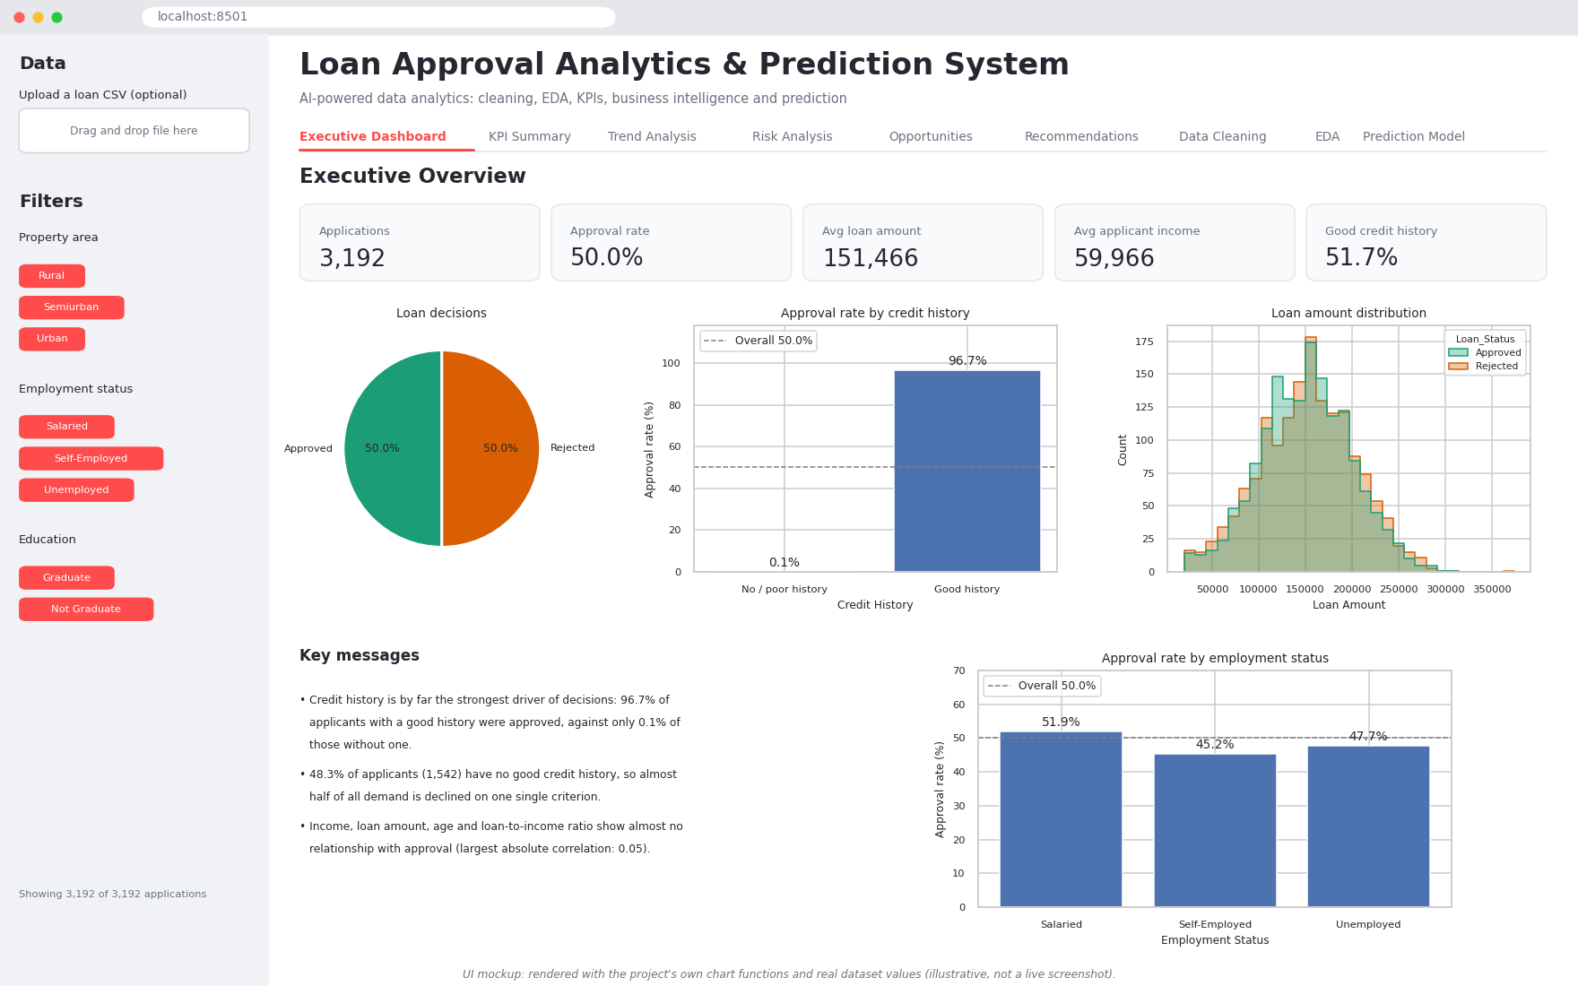
Figure 17: Executive Dashboard tab (UI mockup)
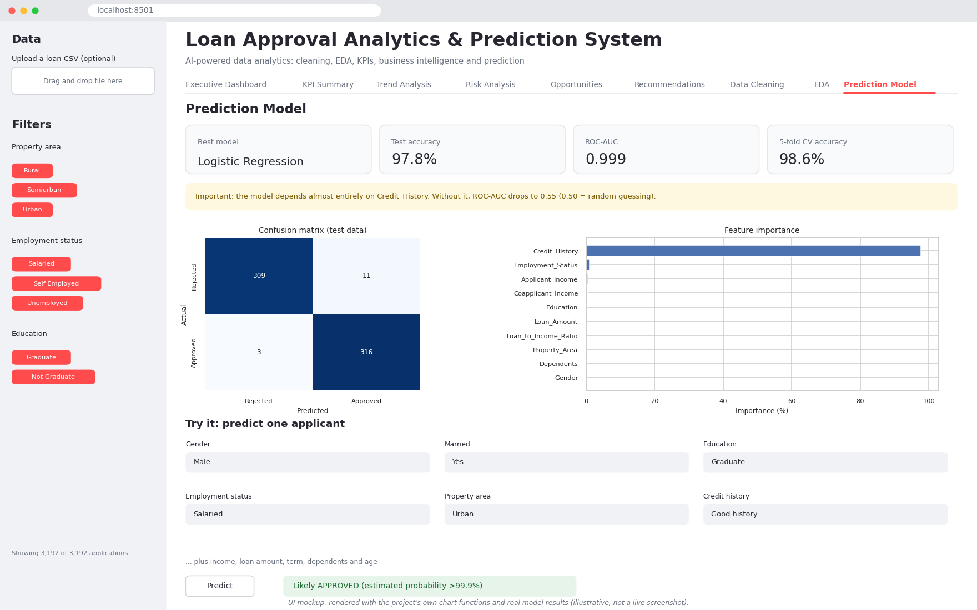
Figure 18: Prediction Model tab with applicant form (UI mockup)
The two images are mockups drawn with the project's own chart functions and the real dataset values to show the layout. They are illustrative and are not screenshots of the running application. Replace them with real screenshots after running the dashboard if your submission requires it.

11. Results
Finding | Evidence
Credit history decides almost everything | 96.7% approved with good history vs 0.1% without (gap of 96.6 points)
Nearly half of applicants are effectively screened out | 48.3% have no good credit history
Self-employed applicants are approved less often | 45.2% vs 51.9% for salaried; significant in the chi-square test and still present among good-credit applicants
Income, loan amount, age and term do not drive approval | All correlations with approval are below 0.06 in absolute value
No significant gender or marital-status gap | Approval gaps of 0.6 and 0.5 points; p-values above 0.79
Model accuracy is high but narrow | 97.8% test accuracy with credit history; ROC-AUC 0.55 without it

12. Business Insights

12.1 Executive overview
- The portfolio holds 3,192 loan applications. 50.0% were approved, with an average requested loan of 151,466 and an average applicant income of 59,966 (currency units as recorded in the dataset).
- Credit history is by far the strongest driver of decisions: 96.7% of applicants with a good history were approved, against only 0.1% of those without one.
- 48.3% of applicants (1,542) have no good credit history, so almost half of all demand is declined on one single criterion.
- Income, loan amount, age and loan-to-income ratio show almost no relationship with approval (largest absolute correlation: 0.05).
- A Logistic Regression model predicts decisions with 97.8% accuracy (ROC-AUC 0.999). Without Credit_History the same approach falls to ROC-AUC 0.55, close to random guessing (0.50).

12.2 KPI summary
The portfolio contains 3,192 applications with an average requested loan of 151,466 and average applicant income of 59,966. Approved loans total 240,319,840. The full KPI table is in Section 7.

12.3 Key drivers
- Model importance ranking (permutation importance): Credit_History (97.8%), Employment_Status (1.0%), Applicant_Income (0.4%).
- Statistically significant differences in approval (chi-square, p<0.05): Credit_History, Employment_Status.

12.4 Trend analysis
- The dataset has no date column, so trends are read across ordered attributes instead of over time.
- Loan term (months): approval ranges from 45.8% (120) to 52.6% (180), a gap of 6.8 points.
- Age group: approval ranges from 43.5% (46+) to 51.6% (36-45), a gap of 8.1 points.
- Household income band: approval ranges from 47.9% (High) to 52.8% (Upper-Mid), a gap of 4.9 points.
- Number of dependents: approval ranges from 49.0% (0) to 52.9% (3), a gap of 3.9 points.
- Loan-to-income band: approval ranges from 48.0% (Very High) to 52.1% (Moderate), a gap of 4.1 points.
- All of these gaps are small next to the 96.6-point gap created by credit history, so none of them is a strong lever on its own. Treat only the factors marked significant in the chi-square table as real patterns; the rest may be noise.

12.5 Risk analysis
- Single-point dependency: 48.3% of applicants are screened out almost entirely by credit history (0.1% approved). Any error in the credit data would flip a large share of decisions.
- Leverage is not controlled: applicants in the highest loan-to-income band are approved 48.0% of the time versus 50.6% in the lowest band, and 17.4% of approved loans exceed 3x household income (assuming incomes are yearly; the dataset does not state the period).
- Segment disadvantage: 'Self-Employed' applicants have the lowest approval rate (45.2%). The gap remains among applicants with a good credit history (Self-Employed: 90.1% vs Salaried: 99.4%), so credit history does not explain it. The data cannot show the cause.
- Fairness monitoring: no statistically significant gender gap was found (p=0.80). Gender and marital status should stay outside decision rules and be re-checked regularly.
- Data quality: 0.8% of cells (341) were blank before cleaning, and the data records decisions, not repayment, so real default risk cannot be measured yet.

12.6 Opportunity analysis
- Untapped segment: 576 applicants with no good credit history still have above-median household income and below-median loan-to-income ratio. They represent 74,231,690 in requested loans that are currently declined and could be reviewed manually.
- Rural reach: rural applicants are only 19.6% of applications and are approved 48.4% of the time, so there is room for targeted outreach.
- Co-applicants: approval is 50.0% with a co-applicant income versus 49.8% without, so encouraging co-applicants is unlikely to raise approvals by itself.
- Policy review: with a good credit history, Self-Employed applicants are approved 90.1% of the time versus 99.4% for Salaried applicants. Matching the higher rate would mean about 38 more approvals from creditworthy applicants.

12.7 Actionable recommendations
Priority | Action | Why (from the data) | KPI to track
High | Pilot manual / alternative-data review for the no-credit-history applicants who have strong income. | 576 such applicants (74,231,690 requested) are declined today. | Approval rate and repayment of the pilot group
High | Use the prediction model only as a triage / pre-screening aid, with human sign-off on decisions. | Accuracy is 97.8%, but it relies almost entirely on Credit_History. | Model vs. human decision agreement
High | Add a loan-to-income guardrail (for example a review flag above 3x household income). | 17.4% of approved loans already exceed 3x income. | Share of approved loans above the threshold
Medium | Show a pre-application eligibility check so applicants learn about credit requirements early. | 48.3% of applications have almost no chance of approval. | Share of applications with poor credit history
Medium | Review the approval rules for non-salaried applicants who have a good credit history, and offer document-preparation support. | With good credit, Self-Employed applicants are approved 90.1% vs 99.4% for Salaried. | Approval gap between employment types (good-credit applicants)
Medium | Track repayment outcomes and review approval rates by gender and marital status every quarter. | The data has decisions only, and fairness needs continuous monitoring. | Default rate; approval gap by protected group
Low | Make key fields mandatory in the application form. | 0.8% of cells were blank before cleaning. | Percentage of blank cells

13. Conclusion
The analysis of 3,192 loan applications shows a decision process that is driven almost entirely by one factor: credit history. Applicants with a good history are almost always approved (96.7%) and those without it almost never are (0.1%). Income, loan size, age, loan term and property area add very little, and there is no evidence of a gender or marital-status gap. The one other significant pattern is that self-employed applicants are approved less often, even when their credit history is good.
A simple model reaches 97.8% accuracy, but only because it reads the credit-history field. The most valuable next steps are to review applicants who lack credit history but have strong income (576 in this data), to examine the approval rules for self-employed applicants, to add a leverage guardrail, and to start collecting repayment outcomes so that real credit risk can be studied.

Limitations
- The dataset has no dates, currency or unit documentation, and no repayment outcomes.
- The 50% approval rate and the strength of the credit-history effect suggest a sampled or curated dataset, so results should not be generalised to a real lender without validation.
- Missing values were filled with medians and most frequent values; the effect is small (0.8% of cells) but not zero.
- The analysis, model and charts were run and checked on the full dataset. The Streamlit interface code was exercised with a scripted run of every tab, but it was not viewed in a live browser session, so the images in Section 10 are mockups, not screenshots.

Future work
- Add repayment / default data and build a true credit-risk model.
- Add fairness dashboards that track approval gaps over time.
- Deploy the dashboard and connect it to a live data source.

