11/21/2022

Dhruba Saha

B.Sc Sem-v

B.Sc-(sem-v)-Comp-o4

VB-2480 of 2017-18

Digital Image Processing:

Assignment 2:

1. Flip any image without using any built-in function.

Code:

%Flip any image without using any built-in function

clear

img1 = imread("pout.tif");

img2 = img1(:,end:-1:1,:);

figure('name','Flip any image without using any built-in function','NumberTitle','off');

subplot(1,2,1)

imshow(img1);

title('Original')

subplot(1,2,2)

imshow(img2);

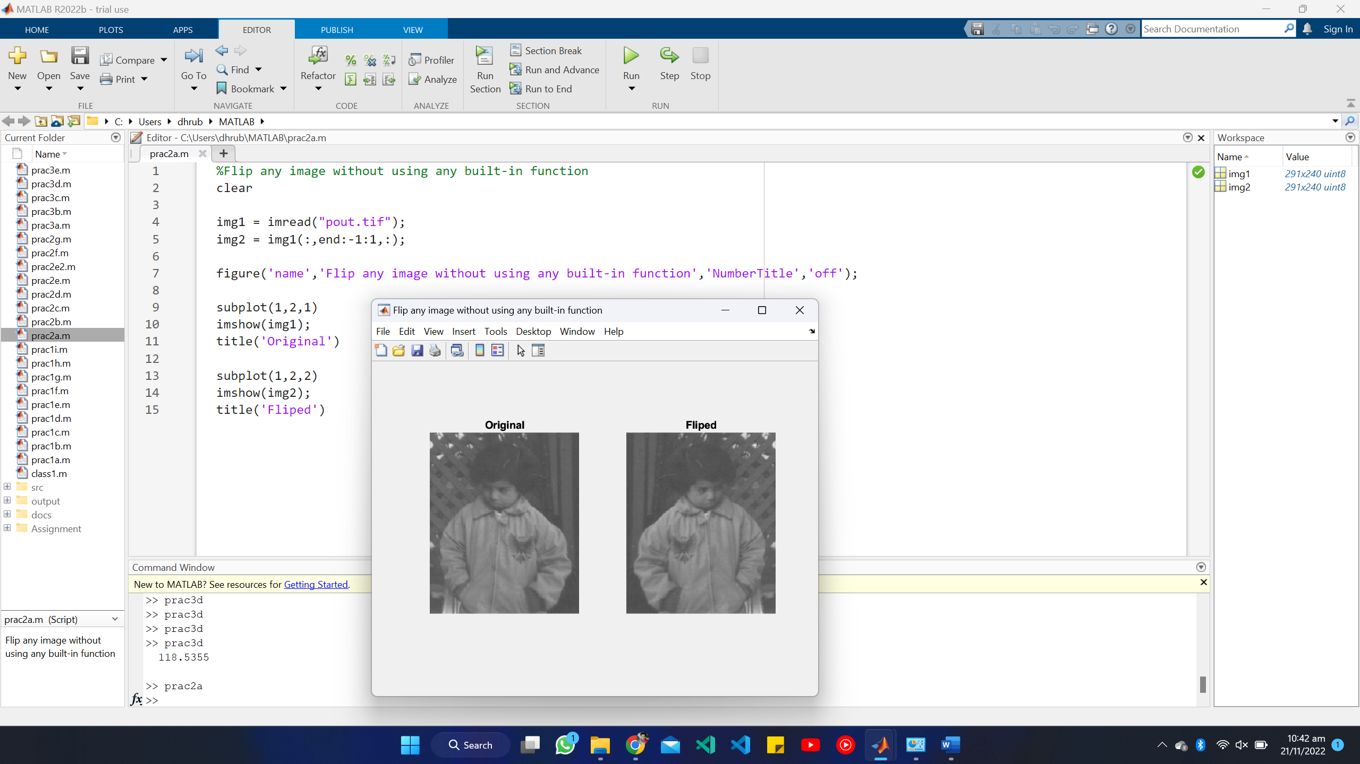title('Fliped')

1. Flip any image upside down without the use of any built-in function

%Flip any image upside down without the use of any built-in function

clear

img1 = imread("src\images.jpg");

img2 = img1(end:-1:1,:,:);

figure('name','Flip any image upside down without the use of any built-in function','NumberTitle','off');

subplot(1,2,1)

imshow(img1);

title('Original')

subplot(1,2,2)

imshow(img2);

title('Fliped')

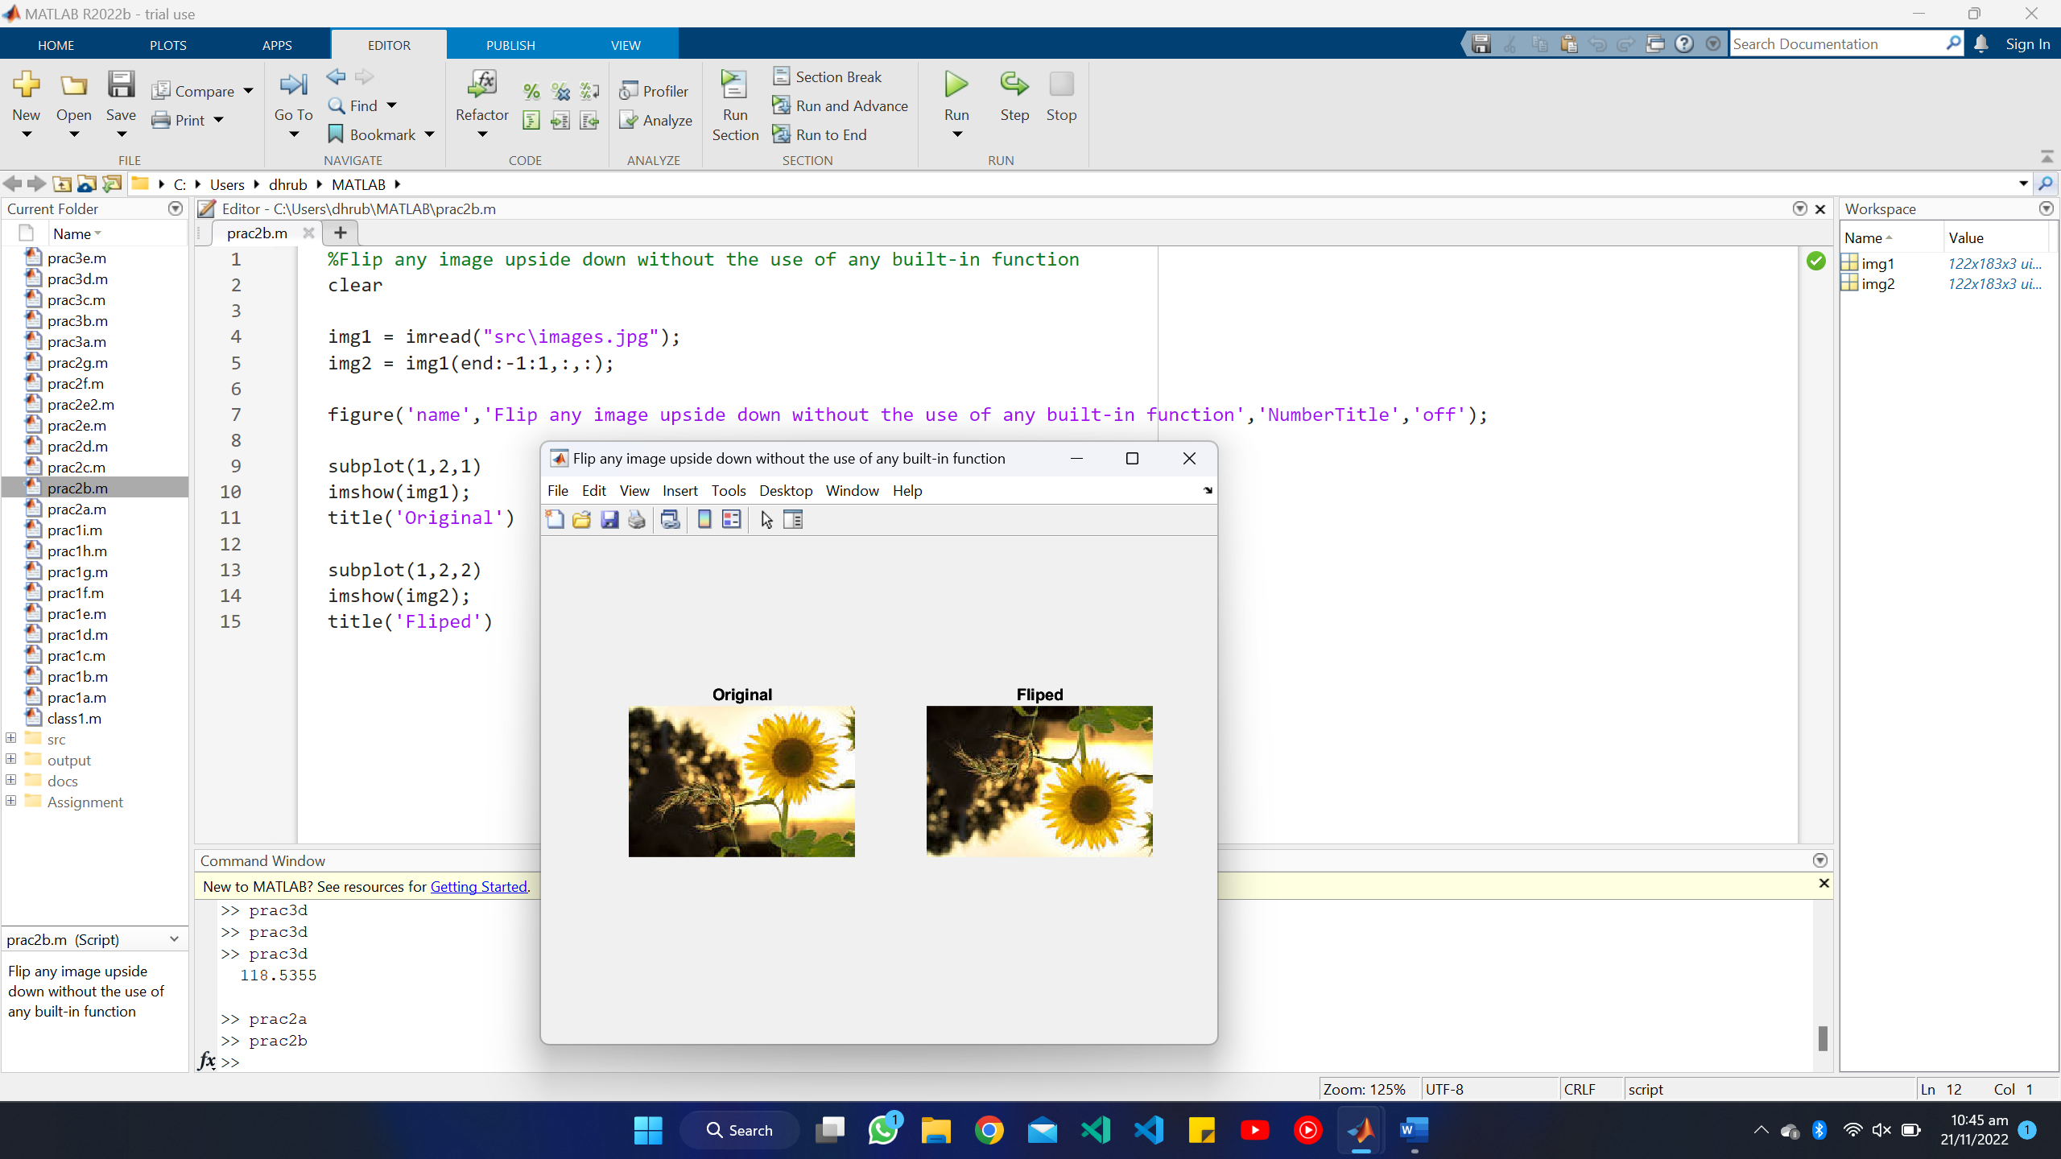

1. Make Negative image (Without the use of built-in function)

%Make Negative image (Without the use of built-in function)

clear

img1 = imread("src/8-bit-256-x-256-Grayscale-Lena-Image.png");

img2 = mod(255-img1,256);

figure('name','Make Negative image (Without the use of built-in function)','NumberTitle','off');

subplot(1,2,1)

imshow(img1);

title('Original')

subplot(1,2,2)

imshow(img2);

title('Negative')

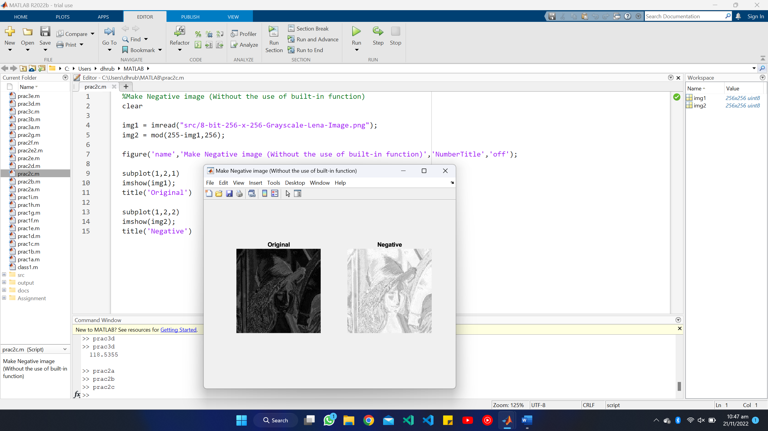

1. Plot Histogram of a grayscale image

%Plot Histogram of a grayscale image

clear

img1 = imread("src/8-bit-256-x-256-Grayscale-Lena-Image.png");

figure('name','Plot Histogram of a grayscale image','NumberTitle','off');

subplot(1,2,1)

imshow(img1);

title('Photo')

subplot(1,2,2)

imhist(img1)

title('Histogram')

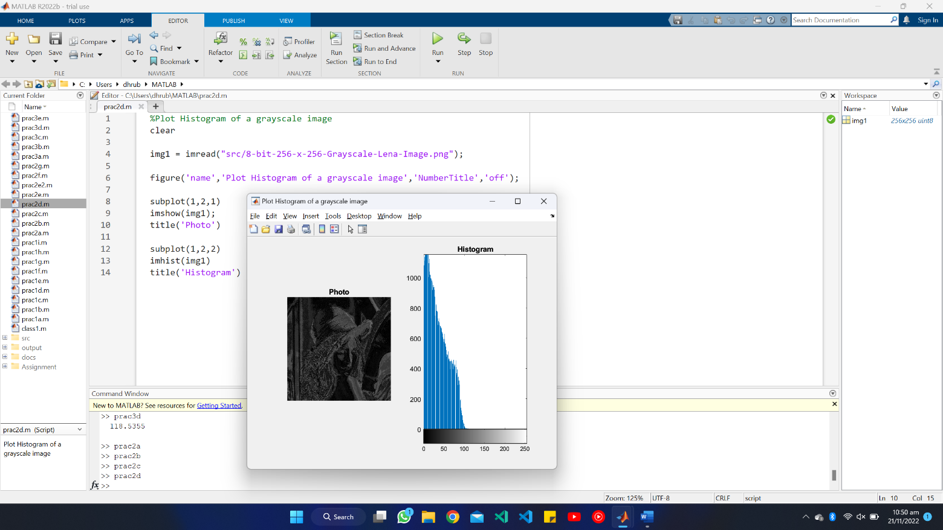

1. Plot Histogram of a color image

%Plot Histogram of a color image

clear

img = imread("src/rgb.jpg");

[red, green, blue]=imsplit(img);

allblack = zeros(size(img, 1, 2), class(img));

redimg = cat(3,red,allblack,allblack);

greenimg = cat(3,allblack,green,allblack);

blueimg = cat(3,allblack,allblack,blue);

figure('name','Plot Histogram of a color image','NumberTitle','off');

subplot(1,4,1)

imshow(img);

title('Original')

subplot(1,4,2)

imhist(redimg);

title('Red Histogram')

subplot(1,4,3)

imhist(greenimg);

title('Green Histogram')

subplot(1,4,4)

imhist(blueimg);

title('Blue Histogram')

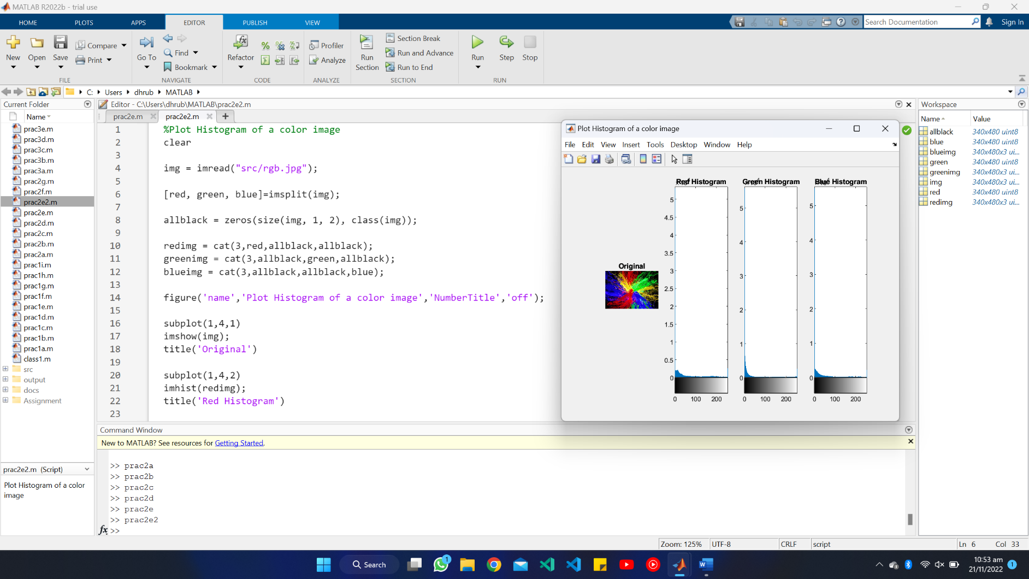

1. Obtain two images with low contrast (light and dark) and high contrast and plot respective histograms. Observe the difference.given color/gray-scale image into black & white image

%Obtain two images with low contrast (light and dark) and high contrast and plot respective histograms. Observe the difference.

clear

img1 = imread("src/moonhighcon.png");

img2 = imread("src\moonlowcon.png");

figure('name','Obtain two images with low contrast (light and dark) and high contrast and plot respective histograms. Observe the difference.','NumberTitle','off');

subplot(2,2,1)

imshow(img1);

title('High Contrast')

subplot(2,2,2)

imhist(img1)

title('High Contrast: Histogram')

subplot(2,2,3)

imshow(img2);

title('Low Contrast')

subplot(2,2,4)

imhist(img2)

title('Low Contrast: Histogram ')

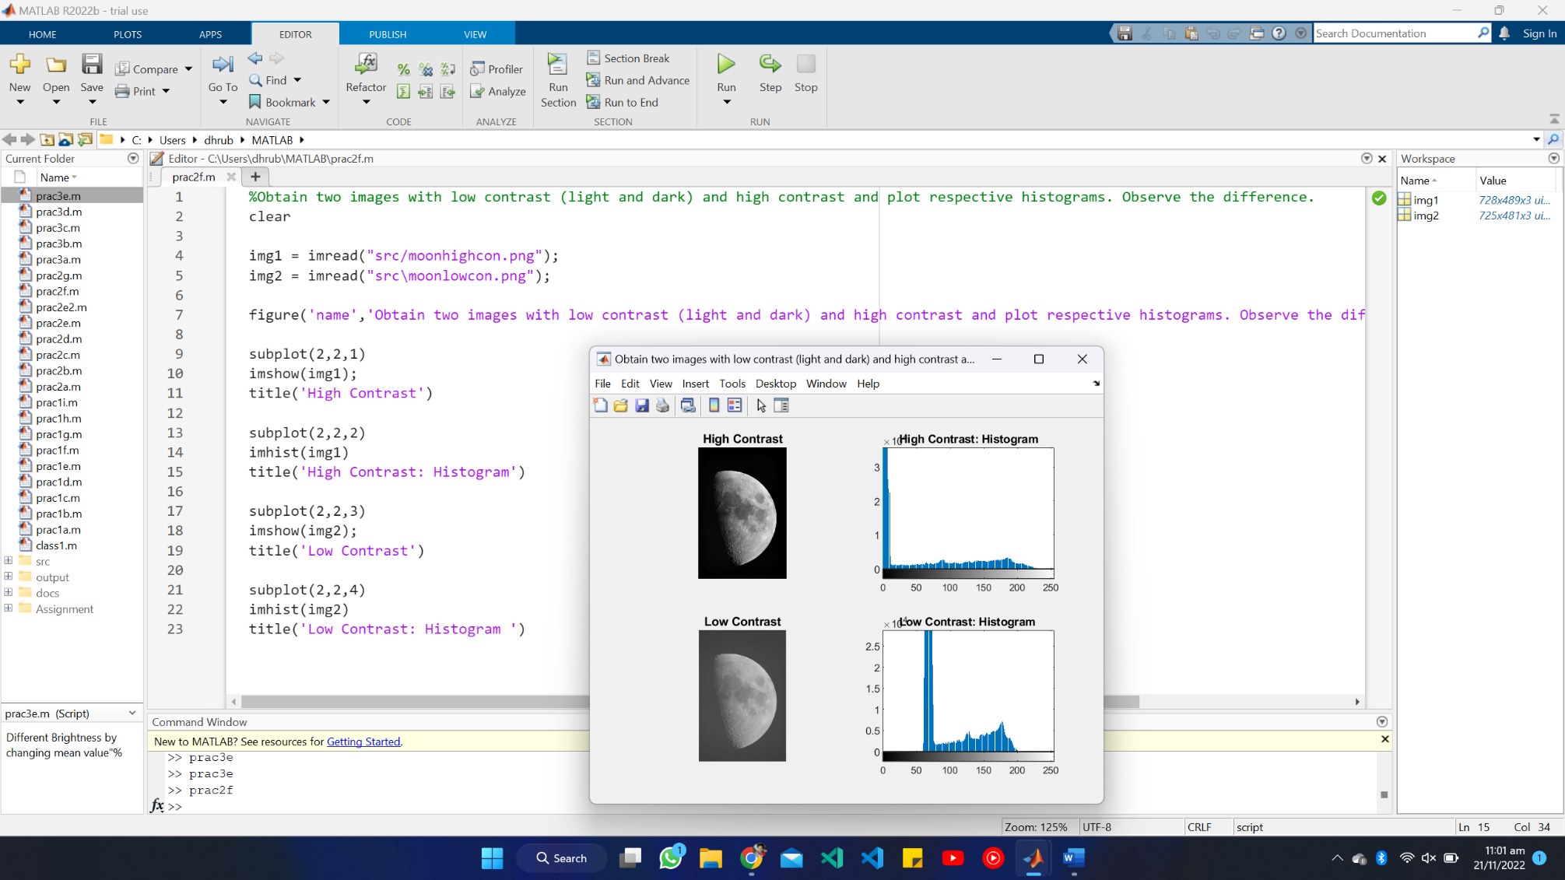

1. Contrast stretching

%contrast stretching

clear

img1 = imread("src/grey.jpeg");

rmax = max(img1(:));

rmin = min(img1(:));

E = 20;

m = 170;

img2 = 1./(1+((m./double(img1)).^E));

figure('name','Contrast stretching','NumberTitle','off');

subplot(2,2,1)

imshow(img1);

title('Normal')

subplot(2,2,2)

imshow(img2)

title('After operation')

subplot(2,2,3)

imhist(img1);

title('Histogram: Normal')

subplot(2,2,4)

imhist(img2)

title('Histogram: After operation')

