1. IP address

2. static/dynamic differences

3. ip v4 vs v6

4. subnet musk

5. dns

1.IP Address: An IP address is a unique address that identifies a device on the internet or a local network.

IP stands for "Internet Protocol," which is the set of rules governing the format of data sent via the internet or local network.

An IP address is a string of numbers separated by periods. IP addresses are expressed as a set of

four numbers — an example address might be 192.158.1.38. Each number in the set can range from 0 to 255.

So, the full IP addressing range goes from 0.0.0.0 to 255.255.255.255.

IP addresses are not random. They are mathematically produced and allocated by the Internet Assigned Numbers Authority (IANA),

a division of the Internet Corporation for Assigned Names and Numbers (ICANN). ICANN is a non-profit organization that was

established in the United States in 1998 to help maintain the security of the internet and allow it to be usable by all.

Each time anyone registers a domain on the internet, they go through a domain name registrar, who pays a small fee to ICANN

to register the domain.

Types of ip

1. consumer

2. private

3. public-> a.dynamic b.static

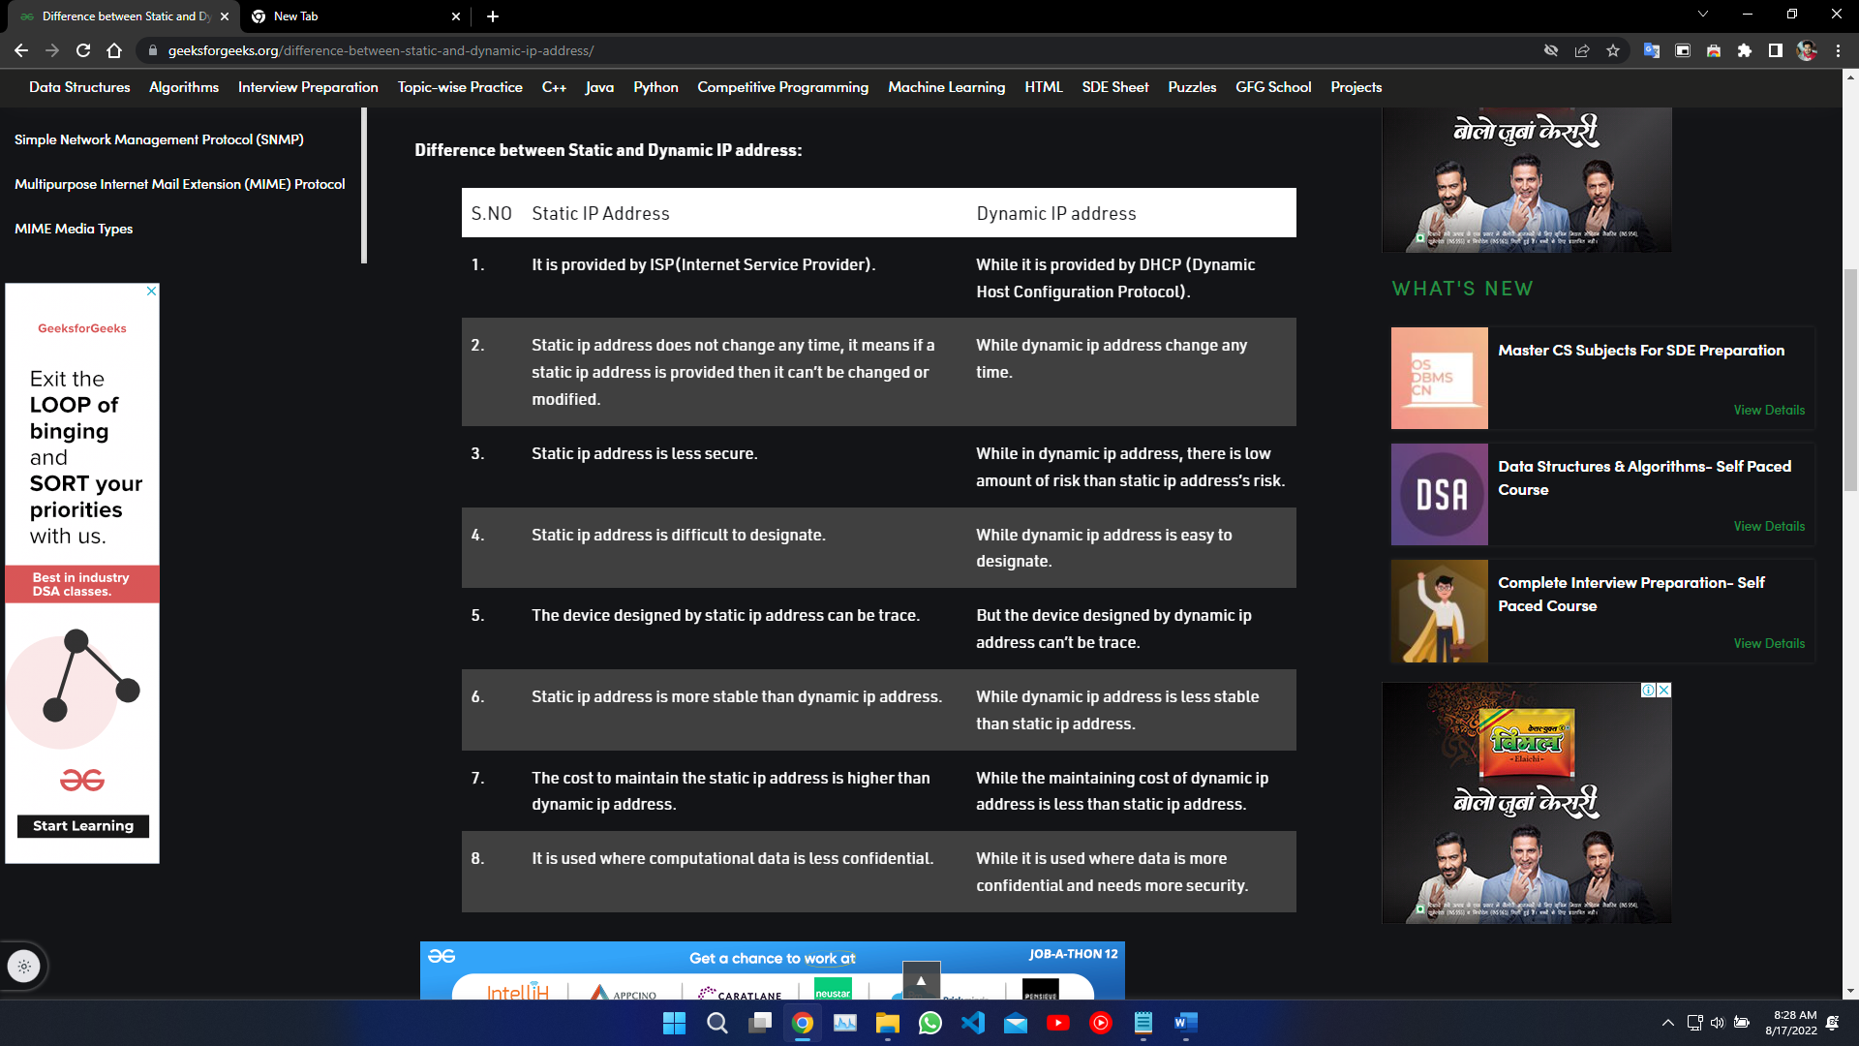

2. static vs dynamic

Dynamic IP addresses: Dynamic IP addresses change automatically and regularly. ISPs buy a large pool of IP addresses and

assign them automatically to their customers. Periodically, they re-assign them and put the older IP addresses back into the

pool to be used for other customers. The rationale for this approach is to generate cost savings for the ISP. Automating the

regular movement of IP addresses means they don’t have to carry out specific actions to re-establish a customer's IP address

if they move home, for example. There are security benefits, too, because a changing IP address makes it harder for criminals

to hack into your network interface.

Static IP addresses: In contrast to dynamic IP addresses, static addresses remain consistent. Once the network assigns an

IP address, it remains the same. Most individuals and businesses do not need a static IP address, but for businesses that plan

to host their own server, it is crucial to have one. This is because a static IP address ensures that websites and email addresses

tied to it will have a consistent IP address — vital if you want other devices to be able to find them consistently on the web.

3.ip v4 vs v6

IPv4: a brief history

IPv4,was developed in the early 1980s. In those days, you had to know a website’s numeric IP address in order to access it over the internet. Then, the Domain Name Service (DNS) came along, which translates numbers into the names we currently see in the URLs we use as we navigate the web.

So when you enter "avast.com" into your browser's URL field, the DNS translates that name back into a number (e.g., 104.103.88.45). That enables us to navigate the web much more conveniently, because it’s much easier to recall a website’s name than a bunch of numbers that make up its IP address.

Have we run out of IPv4 addresses?

IPv4 has a theoretical limit of 4.3 billion addresses, which was more than enough in 1980. But as the internet grew and went global, we quickly ran out of addresses, especially in today’s era of smartphones and IoT devices.

The internet has been running out of IPv4 addresses since the 1990s. While clever engineers have found ways around the problem, it wasn’t long before a more permanent fix was needed. Developed to solve these capacity issues for good, IPv6 was needed when IPv4 could no longer support the load.

At present, IPv4 coexists on the internet with its newer version, though eventually, everything will use IPv6. Replacing old IPv4 equipment would be prohibitively expensive and disruptive, and so IPv6 is being slowly rolled out as older IPv4 hardware is retired.

What is IPv6?

Internet Protocol version 6, or IPv6, was first introduced in the late 1990s as a replacement for IPv4. It uses 128-bit addresses formatted as eight groups of four hexadecimal numbers separated by colons. IPv6 is the solution that addresses the relatively limited number of IP addresses possible under IPv4. Under IPv6, there will no longer be a shortage of the total number of possible addresses.

IPv6 allows for a theoretical 340,282,366,920,938,463,463,374,607,431,768,211,456, or 340 undecillion addresses. This means that every device on the internet can have a unique IPv6 address. An example IPv6 address looks like this — 2002:0de6:0001:0042:0100:8c2e:0370:7234 — but there are ways to abbreviate this rather clunky notation.

In addition to increasing the supply of IP addresses, IPv6 also addressed IPv4’s many shortcomings — chief among them being security, which we’ll delve into more later.

The advent of IPv6 brought more functionality, in addition to more IP addresses. For example, IPv6 supports multicast addressing, which allows bandwidth-intensive packet flows (such as multimedia streams) to be sent to multiple destinations simultaneously, reducing network bandwidth. But is IPv6 better than IPv4? Let’s find out.

IPv6 has a new feature called autoconfiguration, which allows a device to generate an IPv6 address as soon as it powers up and puts itself on the network. The device begins by looking for an IPv6 router. If one is present, the device can generate a local address and a globally routable address, allowing access to the wider internet. In IPv4-based networks, the process of adding devices often has to be done manually.

IPv6 allows devices to stay connected to several networks simultaneously. This is due to interoperability and configuration capabilities that enable the hardware to automatically assign multiple IP addresses to the same device.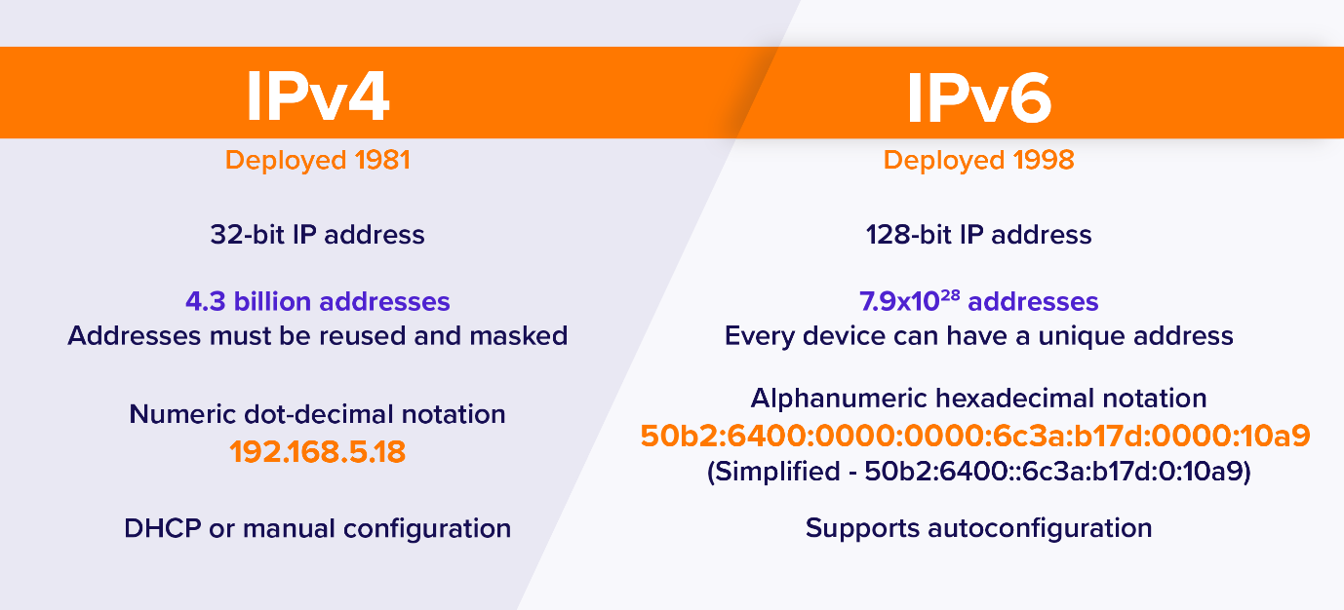

4. subnet musk

What is Subnet Mask?

A subnet mask is a 32-bit number created by setting host bits to all 0s and setting network bits to all 1s. In this way, the subnet mask separates the IP address into the network and host addresses.

The “255” address is always assigned to a broadcast address, and the “0” address is always assigned to a network address. Neither can be assigned to hosts, as they are reserved for these special purposes.

The IP address, subnet mask and gateway or router comprise an underlying structure—the Internet Protocol—that most networks use to facilitate inter-device communication.

When organizations need additional subnetworking, subnetting divides the host element of the IP address further into a subnet. The goal of subnet masks are simply to enable the subnetting process. The phrase “mask” is applied because the subnet mask essentially uses its own 32-bit number to mask the IP address.

5.DNS

What is DNS?

The Domain Name System (DNS) is the phonebook of the Internet. Humans access information online through domain names, like nytimes.com or espn.com. Web browsers interact through Internet Protocol (IP) addresses. DNS translates domain names to IP addresses so browsers can load Internet resources.

Each device connected to the Internet has a unique IP address which other machines use to find the device. DNS servers eliminate the need for humans to memorize IP addresses such as 192.168.1.1 (in IPv4), or more complex newer alphanumeric IP addresses such as 2400:cb00:2048:1::c629:d7a2 (in IPv6).