AAI500 - Applied Artificial Intelligence
San Diego University
Customer Credit Default Prediction
Submitted to: Instructor Azka Azka
Submitted by:
Anugrah Rastogi
Mallesham D
Dhrub Satyam

Table of Content

Table of Content
Abstract
1. Introduction
2. Data Handling and Preparation Techniques
3. Data Exploration and Insights
Feature Selection
4. Model Selection
5. Model Analysis
6. Conclusion and Recommendations
Appendix (Code and Output)
References

Abstract
This document presents a data-driven approach to identifying customers who may fail to repay their credit obligations. The study uses structured financial records that include behavioral and personal characteristics to build and evaluate prediction models.
After preparing the data-cleaning missing values, converting categories, and scaling numeric fields, we explored it for patterns and distributions. Subsequently, we implemented and assessed four classification algorithms - Logistic Regression, Decision Tree, Random Forest, and XGBoost - using training and validation data.
To evaluate how well each model identified defaults, we assessed them using several performance metrics such as ROC AUC, F1 Score, Precision, and Recall. Out of all the models tested, the Random Forest algorithm demonstrated the most dependable outcomes, striking an effective balance between prediction accuracy and model interpretability.
Based on the findings, we suggest that Random Forest be considered for real-world deployment, along with ongoing evaluation to ensure fair and ethical decision-making.

Introduction
Figuring out if a customer might miss a credit payment is a real-world challenge that banks and financial companies face every day. It helps them reduce risk and make smarter lending decisions. The ability to identify risky borrowers before issuing credit can significantly reduce financial losses, streamline approval workflows, and enhance regulatory compliance.
This project, undertaken as part of the AAI500 course at the University of San Diego, leverages machine learning techniques on a real dataset containing both behavioral and demographic factors. This analysis is based on a public dataset available from an online platform (Kaggle, 2023).
This project primarily aimed to create dependable models for predicting potential credit defaulters, assess the effectiveness of different machine learning techniques in terms of accuracy and practicality, and generate meaningful insights to improve credit evaluation processes.

Data Handling and Preparation Techniques
To ensure consistency in the dataset (Kaggle, 2023), missing entries in numeric fields were filled using the median of each column. We chose the median instead of the mean because it is less sensitive to unusual or extreme values. This method helped maintain the integrity of the data set and reduced the risk of bias introduced by outliers.
Dataset Overview:
- Training Set: 70,000 records with 82 features
- Test Set: 33,000 records with 80 features
- Target Column: The target column indicates whether a customer has defaulted (1) or not (0).
Cleaning and Preprocessing Steps:
- Managing Missing Data: For numerical columns with missing entries, our approach employed the median value to fill the gaps. The median is preferred over the mean because it is robust to outliers, ensuring that extreme values do not skew the data.
  - Example: If the income column had missing entries, they were filled with the median income value of the entire column.
- Categorical Encoding: To handle categorical data, one hot encoding was applied, transforming string or Boolean values into numeric form. This encoding process was carried out uniformly on both the training and test datasets. To ensure consistency and avoid unseen categories, encoders were trained using the combined set of unique values from both datasets.
  - Example: Gender: {'Male' → 0, 'Female' → 1}
- Feature Scaling: We used RobustScaler to scale numerical features. Unlike standard scaling methods, RobustScaler uses the interquartile range (IQR), which makes it highly effective in the presence of outliers and models are not overly influenced by extreme values.
- Feature Alignment: To prevent inconsistencies during prediction, we made sure the training and test datasets had the same columns. This included, Dropping extra columns if present in either set and Ensuring consistent column order.
- Target Isolation: The target column was designated as the output label, where a value of 0 represents non-defaulting customers and 1 indicates default cases.

3. Data Exploration and Insights
Exploratory Data Analysis (EDA) helps us get a clearer picture of the data we are working with. It involves spotting irregularities, exploring feature behavior, and forming early hypotheses. In this project, EDA allowed us to examine how different variables interact with the outcome (credit default), which was essential in selecting meaningful features for modeling.
Univariate Analysis
We began by examining distributions of key features to understand their spread, outliers, and potential impact.
- Numerical Features: age, monthly_income, debt_ratio, number_of_open_credit_lines, etc. Some variables showed right-skewed distributions, especially financial ones like debt_ratio and monthly_income.
- Categorical Features: To prepare categorical variables of boolean and object types for modeling, one-hot encoding was applied to convert them into numerical representations. Certain categorical features had imbalanced value counts, which might influence the model bias if not handled properly.
- Example Chart: It revealed a long tail indicating a small number of customers with very high debt ratios.
Bivariate Analysis
We analyzed features related to the target variable.
- Boxplots: Here, debt_ratio and number_of_dependents were higher on average among defaulters.
- Correlation Matrix: Heatmaps helped spot weak to moderate correlations. Most features showed low linear correlation, suggesting nonlinear models (e.g., trees) might perform better.
- Default Distribution: Only ~20.6% of records were labeled as defaulters. This class imbalance required attention during model training (e.g., via class_weight='balanced' or resampling techniques).
Key Visual Insights
- Target Imbalance: Defaulted (1): ~20% and Non-defaulted (0): ~80%. This significant imbalance influenced our choice of metrics (F1-score, ROC AUC instead of accuracy).
- Outliers: Features like monthly_income had extreme values. Instead of dropping, we used RobustScaler to mitigate their influence.
- Missing Data: We found missing data in income and dependent count fields. Imputed using median values, preserving the distribution shape.

Feature Selection
Feature Selection
The initial dataset contained 189 features. To enhance model performance, generalization, and prevent overfitting, we implemented a two-step feature selection strategy using statistical techniques.
Information Value (IV)
Information Value (IV) quantifies how effectively a feature can distinguish between the binary target classes. It is commonly used in credit scoring applications to assess the predictive strength of each variable. Features with very low IVs offer limited value, while excessively high IVs may signal data leakage.
IV Score Range | Interpretation
< 0.02 | Not predictive
0.02 – 0.1 | Weak predictive power
0.1 – 0.3 | Moderate predictive power
0.3 – 0.5 | Strong predictive power
> 0.5 | Potential leakage
By applying IV filtering, we removed 85 features that were either insignificant or flagged as suspicious due to unusually high IV scores.
Pearson Correlation
To further eliminate redundancy, we calculated the Pearson correlation coefficient between all numerical features. Features with high pairwise correlation (≥ 75%) can cause multicollinearity, leading to model instability and inflated variance.
This step led to the removal of 16 additional features that showed high correlation with other predictors.
Final Feature Set
After completing both IV and correlation-based filtering, we reduced the dataset from 189 to 72 features. This streamlined feature space improved both the efficiency and reliability of our machine learning models.

Summary of EDA Outcomes

Insight | Action Taken
Class imbalance in target | Used class_weight='balanced' and chose suitable metrics
Skewed financial data | Applied RobustScaler
Categorical encoding needed | Used One Hot Encoder
Correlations were weak | Preferred ensemble models like Random Forest/XGBoost
Missing values in key columns | Used median imputation

4. Model Selection
Choosing the right model is essential when dealing with real-world data—especially one that involves imbalanced classes like credit default prediction. The models were trained using the final set of 72 features after IV and correlation-based filtering. Our selection process involved testing multiple algorithms with varying complexity and interpretability.
Candidate Models
We explored 4 supervised classification algorithms, each has its unique advantages.
Model | Rationale
Logistic Regression | Simple, interpretable, works well as a baseline.
Decision Tree | It is easy to visualize and explain decisions.
Random Forest | It handles non-linearities, robust to noise, good for tabular data.
XGBoost | State-of-the-art gradient boosting algorithm with excellent accuracy and performance.

Hyperparameter Tuning
All models were optimized for ROC AUC through GridSearchCV, applying a 5-fold cross-validation strategy.
Logistic Regression:
- Logistic regression is a foundational classification method, particularly effective when the relationship between features and outcome is approximately linear (Hosmer, Lemeshow, & Sturdivant, 2013).
- Grid: C values and solvers
- class_weight='balanced' was used to address the target imbalance
Decision Tree:
- Decision trees provide an intuitive structure for modeling decisions and are widely used due to their interpretability and low computational cost (Quinlan, 1986).
- Grid: max_depth, min_samples_split, min_samples_leaf
Random Forest:
- Random Forest enhances decision tree performance by using ensemble learning to reduce overfitting and improve accuracy (Breiman, 2001).
- Grid: n_estimators, max_depth, min_samples_split
XGBoost:
- XGBoost is a high-performance gradient boosting library recognized for its ability to manage sparse datasets effectively and includes regularization to improve model generalization (Chen and Guestrin, 2016).
- The tuning parameters used include: n_estimators, max_depth, and learning_rate.
- Used eval_metric='logloss'
Tools Used:
- GridSearchCV for tuning (Pedregosa et al., 2011a).
- RobustScaler to scale numerical features (Pedregosa et al., 2011b).
- LabelEncoder for categorical encoding (Pedregosa et al., 2011c).
Evaluation Strategy
To evaluate models fairly, we split the training data:
- 80% for training, 20% for validation
- Performance was measured using:
  - ROC AUC Score (discrimination ability)
  - F1-Score (balance between precision and recall)
  - Precision & Recall (for defaulters)
Validation Results:
Model | ROC AUC | F1 Score | Precision | Recall
Decision Tree | 0.8808 | 0.6855 | 0.75 | 0.63
Logistic Regression | 0.9057 | 0.7134 | 0.63 | 0.82
XGBoost | 0.9576 | 0.7906 | 0.82 | 0.76
Random Forest | 0.9633 | 0.8049 | 0.85 | 0.76

Best Model Selected
After comparing all the results, Random Forest model is selected as the final model due to highest ROC AUC, strong F1-score, and balanced precision-recall trade-off.

5. Model Analysis
After training and tuning, we analyzed each model’s performance on the validation set to assess its real-world applicability. The focus was on evaluating how well each model could identify defaulters (class 1) without generating too many false positives.
Classification Reports
To understand how well each algorithm identified defaulters, we assessed their precision, recall, and F1-score for placing particular emphasis on how accurately they handled class 1, which represents default instances.

Model | Precision  (class 1) | Recall  (class 1) | F1 Score  (class 1) | ROC AUC
Logistic Regression | 0.63 | 0.82 | 0.7134 | 0.9057
Decision Tree | 0.75 | 0.63 | 0.6855 | 0.8808
Random Forest | 0.85 | 0.76 | 0.8049 | 0.9633
XGBoost | 0.82 | 0.76 | 0.7906 | 0.9576

Understanding the Evaluation Metrics:
- Precision tells us how accurate the model’s default predictions were — in other words, Out of the predicted defaulters, how many were actually correct?.
- Recall measures how effectively the model detects customers who actually defaulted.
- F1 Score is a balanced score that considers both precision and recall, helping us understand overall model effectiveness for the default class.
- ROC AUC measures the model’s ability to correctly separate defaulters from non-defaulters across all thresholds — the higher, the better.
Random Forest led with the highest F1 and ROC AUC, making it best suited for production.
Visual Insights:
We plotted key evaluation curves to support our findings:
1. ROC Curve: The ROC curve shows that the Random Forest model achieves the highest Area Under the Curve (AUC), indicating its superior classification performance.
2. Precision-Recall Curve: Confirms the effectiveness in handling class imbalance.
3. Model Comparison Bar Chart
Model | ROC AUC | F1 Score
Random Forest | 0.9633 | 0.8049
XGBoost | 0.9576 | 0.7906
Logistic Regression | 0.9057 | 0.7134
Decision Tree | 0.8808 | 0.6855

Summary of Observations
- Random Forest performed best overall, especially in identifying defaults accurately.
- XGBoost was a close second and could be explored further for optimization.
- Logistic Regression, while simple, showed surprisingly good recall but low precision—making it risky for production.
- The Decision Tree was interpretable but too simplistic for this complex dataset.
Why Choose Random Forest?
- We have achieved the highest ROC AUC and F1-score among all tested models.
- It demonstrates consistent performance across both defaulter and non-defaulter classes.
- It effectively handles noisy data and is resilient to outliers.
- It is well-suited for datasets containing a combination of numerical and categorical features, making it ideal for financial applications.

6. Conclusion and Recommendations
Project Recap:
This project focused on developing a machine learning approach to identify the likelihood of customer credit default using structured, real-world data. Dimensionality reduction via IV and correlation analysis helped in improving model efficiency and reducing noise, ultimately boosting performance. Through systematic preprocessing, model building, and evaluation, we were able to explore multiple classification models and identify the most effective solution.
Key Findings:
The Random Forest algorithm stood out as the most dependable model, demonstrating strong predictive accuracy and a good balance between correctly identifying defaults and avoiding false alarms, outperforming others with the following.
- Highest ROC AUC (0.9633)
- Strong F1 Score (0.8049)
- Balanced precision (0.85) & recall (0.76)
XGBoost showed competitive results, slightly behind Random Forest, and can be considered for further tuning or ensemble techniques. Logistic Regression, though basic, demonstrated strong recall (0.82), meaning it rarely missed defaulters, but suffered from low precision (0.63), potentially flagging too many false positives. Decision Tree underperformed, indicating a need for deeper tree-based models or ensemble methods for such complex data.
Business Implications:
A robust credit default prediction model offers several advantages to banks and financial institutions. It helps minimize financial losses by identifying high-risk customers early. It improves customer experience by speeding up approvals for low-risk applicants. Such models also support regulatory compliance by being explainable and auditable. Additionally, they help reduce operational costs by automating parts of the decision-making process.
Recommendations
To further improve model performance and business adoption:
- Feature Engineering: Create features like trend indicators, rolling averages, or recent transaction history. Explore time-window aggregation for behavior-based features.
- Model Optimization: Perform more extensive hyperparameter tuning (e.g., using randomized search). Consider implementing ensemble techniques such as stacking or majority voting by combining the strengths of high-performing models like Random Forest and XGBoost. This hybrid approach may enhance prediction stability and improve overall model performance.
- Bias & Fairness Audits: It is essential to examine whether the model's decisions are consistent across various demographic groups, such as different age brackets, genders, or income levels. This includes checking if certain groups are unfairly favored or penalized. Conducting fairness assessments can help confirm that the model behaves responsibly and does not introduce unintentional bias in credit evaluations.
- Model Monitoring: Set up a feedback loop to monitor predictions and update the model regularly. Use A/B testing to evaluate model performance against existing systems.
- Interpretability: We may utilize techniques such as SHAP (SHapley Additive exPlanations) or LIME to enhance the explainability of the model's predictions. These tools help in understanding how individual features contribute to the prediction outcomes. This level of transparency is especially important when the results are used in customer-facing applications, as it provides clear justifications for each decision.
Final Recommendation
Based on current evaluation metrics, Random Forest is recommended for deployment as the primary model. However, continual monitoring, feedback integration, and further experimentation with advanced techniques will help refine predictions in real-world environments.

Appendix (Code and Output)

Appendix A (Data Preparation and Analysis)
Appendix A.1 Import Libraries and Data
Code:
import pandas as pd
import gc
import numpy as np
import matplotlib.pyplot as plt
import seaborn as sns

Appendix A.2 Load Data and Merge
Code:
train_iter_obj = pd.read_csv('/Users/anugrahrastogi21gmail.com/Downloads/amex-default-prediction/train_data.csv', chunksize=7_000_0) # 0.5 million rows per chunk

for train_chunk in train_iter_obj:
print(train_chunk.shape)
# process or save each chunk
train_chunk.to_csv("/Users/anugrahrastogi21gmail.com/Documents/USD_project/customer-credit-default-prediction/01_data/train_data.csv", index=False)
break
Output:
(70000, 190)

Code:
train_df = pd.read_csv("/Users/anugrahrastogi21gmail.com/Documents/USD_project/customer-credit-default-prediction/01_data/train_data.csv")
memory_bytes = train_df.memory_usage(deep=True).sum()
memory_mb = memory_bytes / (1024 * 1024)
print(memory_mb)
train_labels_df = pd.read_csv("/Users/anugrahrastogi21gmail.com/Downloads/amex-default-prediction/train_labels.csv")

train_df_complete = pd.merge(train_df, train_labels_df, how="inner", on="customer_ID")

train_df_complete.shape, train_df.shape
Output:
117.51184463500977
((70000, 191), (70000, 190))

Appendix B EDA (Exploratory data analysis)
Appendix B.1 Description of the train dataset
Code:
train_df_complete.describe().T

Output:
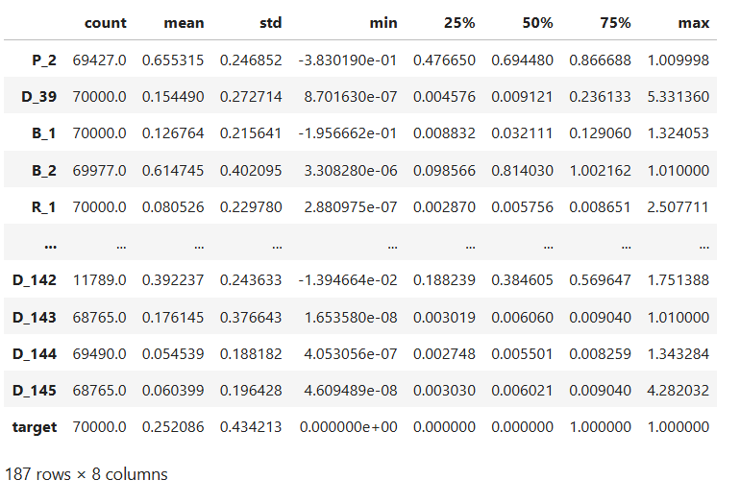
Appendix B.2 Count of numerical and categorical columns
Code:
train_df_complete['S_2'] = pd.to_datetime(train_df_complete['S_2'])
numerical_columns = train_df_complete.select_dtypes(include=['number']).columns.tolist()
categorical_columns = train_df_complete.select_dtypes(include=['object', 'category']).columns.tolist()

print("number of numerical columns: ", len(numerical_columns),'\n',
"number of categorical columns: ", len(categorical_columns))

Output:
number of numerical columns: 187
number of categorical columns: 3

Appendix B.3 Checking Null Values
Code:
null_value_df = pd.DataFrame({'column_name':train_df_complete.isnull().sum().index,
'null_count':train_df_complete.isnull().sum().values})

null_value_df["percent_missing"] = null_value_df["null_count"]*100 / len(train_df_complete)
null_value_df.sort_values('percent_missing', ascending=False).to_csv("null_percentage_df.csv", index=False)

Appendix B.4 Removing Null Values
Code:
null_columns = null_value_df[null_value_df["percent_missing"] > 90]["column_name"].to_list()
print("count of null value columns to be dropeed: ", len(null_columns))
train_df_complete = train_df_complete.drop(null_columns, axis=1)
print("shape of train dataset after droppping null valued columns: ", train_df_complete.shape)

Output:
count of null value columns to be dropeed: 15
shape of train dataset after droppping null valued columns: (70000, 176)

Appendix B.5 Removing Columns with >90% Null Values
Code:
null_columns = null_value_df[null_value_df["percent_missing"] > 90]["column_name"].to_list()
print("count of null value columns to be dropeed: ", len(null_columns))
train_df_complete = train_df_complete.drop(null_columns, axis=1)
print("shape of train dataset after droppping null valued columns: ", train_df_complete.shape)

Output:
count of null value columns to be dropeed: 15
shape of train dataset after droppping null valued columns: (70000, 176)
Appendix B.6 Checking Zero Values
Code:
zero_value_df = pd.DataFrame({
'column_name': train_df_complete.columns,
'zero_count': (train_df_complete == 0).sum().values
})

# Add percentage of zero values
zero_value_df['percent_zeros'] = (zero_value_df['zero_count'] * 100) / len(train_df_complete)

# Sort by highest percentage of zeros
zero_value_df = zero_value_df.sort_values('percent_zeros', ascending=False)
zero_value_df.to_csv("zero_percentage_df.csv", index=False)
zero_value_df
Output:
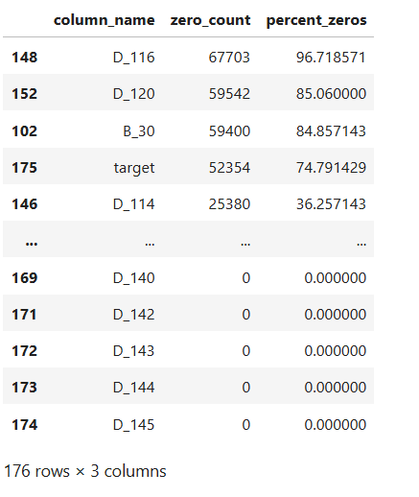
Appendix B.7 Removing Columns with >90% Null Values
Code:
zero_columns = zero_value_df[zero_value_df["percent_zeros"] > 90]["column_name"].to_list()
print("count of zero value columns to be dropped: ", len(zero_columns))
train_df_complete = train_df_complete.drop(zero_columns, axis=1)
print("shape of train dataset after droping zero valued columns: ", train_df_complete.shape)

Output:
count of zero value columns to be dropped: 1
shape of train dataset after droping zero valued columns: (70000, 175)

Appendix B.8 Distribution of target variable
Code:
import matplotlib.pyplot as plt
import seaborn as sns

# Set seaborn style
sns.set(style="whitegrid")

# Calculate percentages
target_counts = train_df_complete['target'].value_counts(normalize=True) * 100

# Plot
plt.figure(figsize=(6, 4))
target_counts.plot(kind='bar', color=['skyblue', 'salmon'])

# Add labels and title
plt.xlabel('Target Class')
plt.ylabel('Percentage (%)')
plt.title('Percentage Distribution of Target Variable')
plt.xticks(rotation=0)

# Add percentage labels on bars
for i, value in enumerate(target_counts):
plt.text(i, value + 1, f'{value:.2f}%', ha='center', fontsize=10)

plt.tight_layout()
plt.show()

Output:
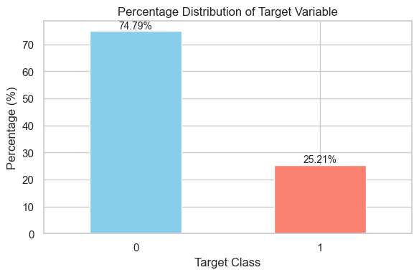

Appendix C Data pre-processing
Appendix C.1 Box plot to observe the skewness and outliers
Code:
import pandas as pd
import matplotlib.pyplot as plt
from matplotlib.backends.backend_pdf import PdfPages

# Filter numerical columns
numerical_cols = train_df_complete.select_dtypes(include='number').columns

# Create PDF to save plots
with PdfPages('box_plots_numerical_features.pdf') as pdf:
for col in numerical_cols:
if col != 'target':

plt.figure(figsize=(8, 4))
plt.boxplot(train_df_complete[col].dropna(), vert=False)
plt.title(f'Box Plot of {col}')
plt.xlabel(col)
plt.tight_layout()
# Save each plot to the PDF
pdf.savefig()
plt.close()

print("Box plots saved to 'box_plots_numerical_features.pdf'")

Appendix C.2 Remove Outliers
Code:
percentile25 = train_df_complete['P_2'].quantile(0.25)
percentile75 = train_df_complete['P_2'].quantile(0.75)
iqr = percentile75-percentile25
upper_limit = percentile75 + 1.5 * iqr
lower_limit = percentile25 - 1.5 * iqr

train_df_complete['P_2'] = np.where(train_df_complete['P_2'] >= upper_limit,
upper_limit,
np.where(train_df_complete['P_2'] <= lower_limit,
lower_limit,
train_df_complete['P_2']))
sns.boxplot(train_df_complete['P_2'])

Output:
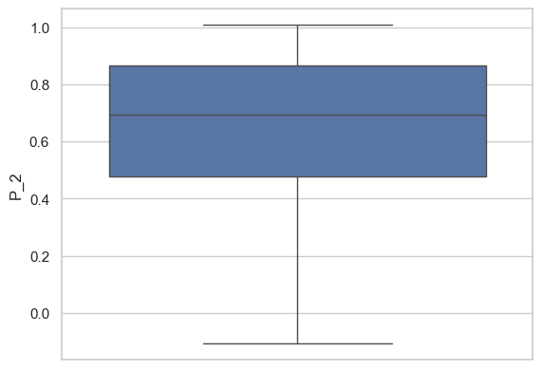
Appendix C.3 Categorical variables distribution vs target
Code:
for col in categorical_columns:
if col != "customer_ID":

plt.figure(figsize=(6, 4))
sns.barplot(data=train_df_complete, x=col, y='target', estimator='mean', order=train_df_complete[col].value_counts().index)
plt.title(f'Mean Target by {col}')
plt.xticks(rotation=45)
plt.tight_layout()
plt.show()

Output:
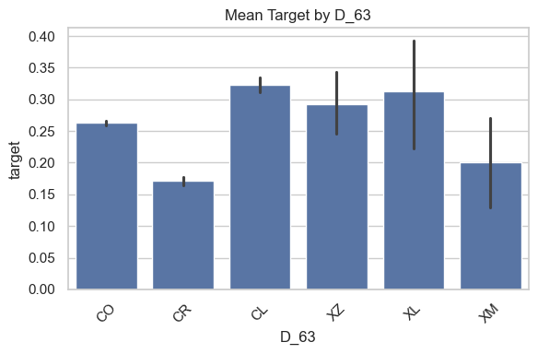
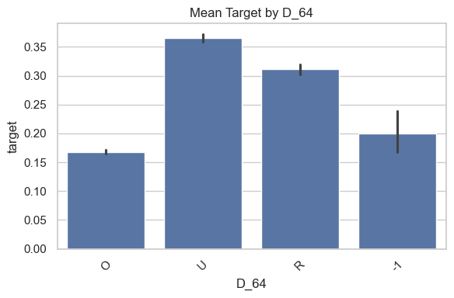

Appendix D Feature selection technique (Information Value)
Appendix E.1 IV Calculation
Code:
def calculate_iv(df, feature, target, bins=10):
"""
Calculate Information Value (IV) for a single feature.

Parameters:
- df: pandas DataFrame
- feature: the column name of the feature
- target: the binary target variable (0 = good, 1 = bad)
- bins: number of bins for numerical variables

Returns:
- iv (float): Information Value of the feature
"""
temp_df = df[[feature, target]].copy()

# Bin if numerical
if pd.api.types.is_numeric_dtype(temp_df[feature]):
try:
temp_df['bin'] = pd.qcut(temp_df[feature], q=bins, duplicates='drop')
except ValueError: # Handle features with fewer unique values than bins
temp_df['bin'] = temp_df[feature]
else:
temp_df['bin'] = temp_df[feature]

# Grouping and WOE/IV calculation
grouped = temp_df.groupby('bin')[target].agg(['count', 'sum'])
grouped.columns = ['total', 'bads']
grouped['goods'] = grouped['total'] - grouped['bads']

# Percentages
grouped['% of Bads'] = grouped['bads'] / grouped['bads'].sum()
grouped['% of Goods'] = grouped['goods'] / grouped['goods'].sum()

# Add small value to avoid division by zero
grouped['WOE'] = np.log((grouped['% of Goods'] + 1e-6) / (grouped['% of Bads'] + 1e-6))
grouped['IV'] = (grouped['% of Goods'] - grouped['% of Bads']) * grouped['WOE']

iv = grouped['IV'].sum()

return iv

def calculate_iv_all_features(df, target_col):
"""
Calculate IV for all features in a DataFrame (excluding the target).

Parameters:
- df: pandas DataFrame
- target_col: the name of the target column (binary: 0 = good, 1 = bad)
- bins: number of bins for numeric features

Returns:
- DataFrame: sorted IV values for each feature
"""
iv_dict = {}
feature_cols = df.columns.drop([target_col, 'customer_ID'])

for col in feature_cols:
try:
iv = calculate_iv(df, col, target_col)
iv_dict[col] = iv
except Exception as e:
print(f"Skipped {col} due to error: {e}")
continue

iv_df = pd.DataFrame.from_dict(iv_dict, orient='index', columns=['IV'])
iv_df = iv_df.sort_values(by='IV', ascending=False)
return iv_df

# Example: Assuming your target column is named 'target'
iv_result = calculate_iv_all_features(train_df_complete, target_col='target').reset_index()
iv_result.to_csv("IV_result.csv", index=False)

Appendix D.2 Removing features with IV < 0.02
Code:
columns_to_remove_weak_iv = iv_result[iv_result["IV"] < 0.02]["index"].to_list()
len(columns_to_remove_weak_iv)
Output:
38

Appendix D.3 Removing features with IV < 0.5
Code:
columns_to_remove_hyper_iv = iv_result[iv_result["IV"] > 0.5]["index"].to_list()
len(columns_to_remove_hyper_iv)

Output:
47

Appendix D.4 Removing features from the train dataset
Code:
columns_to_remove_weak_iv.extend(columns_to_remove_hyper_iv)
len(columns_to_remove_weak_iv)

Output:
85
Appendix D.5 Drop 85 features from IV method
Code:
train_df_complete.drop(columns_to_remove_weak_iv, axis=1, inplace=True)
train_df_complete.shape
Output:
(70000, 90)
Appendix D.6 Remove highly correlated variables using Pearson correlation
Code:
def correlation(dataset, threshold, verbose=False):
"""
Identify highly correlated features to drop based on a threshold.

Parameters:
- dataset (pd.DataFrame): The input DataFrame with numeric columns.
- threshold (float): Correlation threshold above which to drop one of the variables.
- verbose (bool): If True, prints each pair of correlated features.

Returns:
- col_corr (set): Set of column names to consider for dropping.
"""
col_corr = set()
corr_matrix = dataset.corr(numeric_only=True)

for i in range(len(corr_matrix.columns)):
for j in range(i):
corr_value = abs(corr_matrix.iloc[i, j])
if corr_value > threshold:
colname = corr_matrix.columns[i]
if verbose:
print(f"High correlation ({corr_value:.2f}) between: {colname} and {corr_matrix.columns[j]}")
col_corr.add(colname)
return col_corr

Appendix D.7 Removing correlated features (threshold >= 75%)
Code:
high_corr_cols = correlation(train_df_complete, threshold=0.75, verbose=True)
train_df_complete_corr = train_df_complete.drop(columns=high_corr_cols)
print("Final train dataset shape: ", train_df_complete_corr.shape)
Output:
High correlation (0.78) between: R_4 and R_2
High correlation (0.92) between: B_13 and B_12
High correlation (0.80) between: S_15 and S_8
High correlation (0.79) between: R_8 and R_5
High correlation (0.78) between: S_16 and B_21
High correlation (0.77) between: D_84 and D_53
High correlation (1.00) between: D_104 and D_103
High correlation (0.85) between: D_107 and D_103
High correlation (0.84) between: D_107 and D_104
High correlation (0.82) between: D_118 and D_115
High correlation (0.82) between: D_119 and D_115
High correlation (1.00) between: D_119 and D_118
High correlation (0.75) between: D_129 and D_128
High correlation (0.90) between: D_131 and D_79
High correlation (0.92) between: D_132 and D_131
High correlation (1.00) between: D_141 and D_139
High correlation (0.80) between: D_142 and D_141
High correlation (1.00) between: D_143 and D_139
High correlation (1.00) between: D_143 and D_141

Final train dataset shape: (70000, 74)
Appendix D.8 Perform one-hot encoding for 2 categorical features
Code:
cat_cols = ["D_64", "D_63"]
train_df_complete_corr_encd = pd.get_dummies(train_df_complete_corr, columns=cat_cols)

Appendix D.9 Saving Processed and Final Train and Test Data Sets
Code:
train_df_complete_corr_encd.to_csv("/Users/anugrahrastogi21gmail.com/Documents/USD_project/customer-credit-default-prediction/01_data/processed_train_data.csv",
index=False)

Note: Since the test data is of 33Gb, we need to reduce the size of our test data to 33k records and to be able to push the data files into Github repository
Appendix E Model Selection and Evaluation
Appendix E.1 Load Data
Code:
# Step 1: Import Libraries and Load Data

import os
import warnings
import numpy as np
import pandas as pd
import matplotlib.pyplot as plt

from sklearn.preprocessing import LabelEncoder, RobustScaler
from sklearn.model_selection import GridSearchCV, train_test_split
from sklearn.tree import DecisionTreeClassifier

from sklearn.ensemble import RandomForestClassifier
from sklearn.linear_model import LogisticRegression
from sklearn.tree import DecisionTreeClassifier
from sklearn.metrics import classification_report, roc_auc_score, f1_score

from xgboost import XGBClassifier

# Setup
warnings.filterwarnings('ignore')
%matplotlib inline

# File paths
train_file = "processed_train_data.csv"
test_file = "processed_test_data.csv"

# Validate file presence
if not os.path.exists(train_file) or not os.path.exists(test_file):
raise FileNotFoundError(f"Missing file(s): {train_file if not os.path.exists(train_file) else ''} {test_file if not os.path.exists(test_file) else ''}")

# Load CSVs
train_df = pd.read_csv(train_file)
test_df = pd.read_csv(test_file)

# Shape report
print(f"Train Dataset: {train_df.shape}")
print(f"Test Dataset: {test_df.shape}")

Output:
Train Dataset: (7000, 78)
Test Dataset: (7000, 76)

Appendix E.2 Preprocess Data (Data Cleaning)

Code:
# Step 2: Clean and preprocess the data

# Define target column
target_feature = 'target'
if target_feature not in train_df.columns:
raise ValueError(f"Target column '{target_feature}' not found in training data")

# Separate features and target
input_train_data = train_df.drop(columns=[target_feature])
output_train_data = train_df[target_feature]
input_test_data = test_df.drop(columns=[target_feature], errors='ignore')

# Align train and test columns
shared_features = input_train_data.columns.intersection(input_test_data.columns)
input_train_data = input_train_data[shared_features]
input_test_data = input_test_data[shared_features]
print(f"Aligned columns: {len(shared_features)}")

# Handle missing values
num_features = input_train_data.select_dtypes(include=[np.number]).columns
for col in num_features:
fill_value = input_train_data[col].median()
input_train_data[col].fillna(fill_value, inplace=True)
input_test_data[col].fillna(fill_value, inplace=True)

# Encode categorical columns
encoder_dict = {}
cat_features = input_train_data.select_dtypes(include=['object', 'bool']).columns
for col in cat_features:
encoder = LabelEncoder()
combined_values = pd.concat([input_train_data[col], input_test_data[col]], axis=0).astype(str).unique()
encoder.fit(combined_values)
input_train_data[col] = encoder.transform(input_train_data[col].astype(str))
input_test_data[col] = encoder.transform(input_test_data[col].astype(str))
encoder_dict[col] = encoder

# Split training data into train and validation sets
X_train_set, X_val_set, y_train_set, y_val_set = train_test_split(
input_train_data, output_train_data, test_size=0.2, random_state=42, stratify=output_train_data
)

# Scale features
robust_scaler = RobustScaler()
X_train_scaled = robust_scaler.fit_transform(X_train_set)
X_val_scaled = robust_scaler.transform(X_val_set)
X_test_input = robust_scaler.transform(input_test_data)

print(f"Training set: {X_train_set.shape}, Validation set: {X_val_set.shape}, Test set: {input_test_data.shape}")

Output:
Aligned columns: 76
Training set: (5600, 76), Validation set: (1400, 76), Test set: (7000, 76)

Appendix E.3 Train Models with Hyperparameter Tuning

Code:
# Initialize models and parameter grids
model_dict = {
'RandomForest': {
'model': RandomForestClassifier(random_state=42, n_jobs=-1),
'param_grid': {
'n_estimators': [50, 100],
'max_depth': [10, 20, None],
'min_samples_split': [2, 5]
}
},
'DecisionTree': {
'model': DecisionTreeClassifier(random_state=42),
'param_grid': {
'max_depth': [5, 10, 15],
'min_samples_split': [2, 5],
'min_samples_leaf': [1, 2]
}
},
'XGBoost': {
'model': XGBClassifier(random_state=42, n_jobs=-1, eval_metric='logloss'),
'param_grid': {
'n_estimators': [50, 100],
'max_depth': [3, 6],
'learning_rate': [0.1, 0.01]
}
},
'LogisticRegression': {
'model': LogisticRegression(random_state=42, max_iter=10000, class_weight='balanced'),
'param_grid': {
'C': [0.1, 1.0, 10.0],
'solver': ['lbfgs', 'liblinear']
}
}
}

# Train and tune models
best_model_dict = {}
for model_name, model_conf in model_dict.items():
print(f"\nTuning {model_name}...")
grid_search = GridSearchCV(
model_conf['model'], model_conf['param_grid'], cv=5, scoring='roc_auc', n_jobs=-1
)
grid_search.fit(X_train_scaled, y_train_set)
best_model_dict[model_name] = grid_search.best_estimator_
print(f"Best parameters: {grid_search.best_params_}")
print(f"Best ROC-AUC score from cross-validation: {grid_search.best_score_:.4f}")

This code block carries out the following steps:
- It divides the dataset into training and validation subsets.
- It performs hyperparameter tuning using grid search over parameters like n_estimators, max_depth, and min_samples_split.
- It selects the best-performing model based on ROC AUC and F1 score metrics.
- It displays a detailed classification report for performance evaluation.

Output:
Tuning RandomForest
- Best parameters: {'max_depth': None, 'min_samples_split': 2, 'n_estimators': 100}
- Best ROC-AUC score from cross-validation: 0.9559
Tuning DecisionTree
- Best parameters: {'max_depth': 10, 'min_samples_leaf': 2, 'min_samples_split': 5}
- Best ROC-AUC score from cross-validation: 0.8708
Tuning XGBoost
- Best parameters: {'learning_rate': 0.1, 'max_depth': 6, 'n_estimators': 100}
- Best ROC-AUC score from cross-validation: 0.9536
Tuning LogisticRegression
- Best parameters: {'C': 0.1, 'solver': 'liblinear'}
- Best ROC-AUC score from cross-validation: 0.9074

Appendix E.4: Model Evaluation

Each model was assessed on the validation set using metrics such as ROC-AUC, F1-score, and a detailed classification report, as demonstrated in the code below.
Code:
# Evaluate each model
validation_results = {}
for model_label, tuned_model in best_model_dict.items():
print(f"\n{model_label} Validation Results:")
y_valid_pred = tuned_model.predict(X_val_scaled)
y_valid_proba = tuned_model.predict_proba(X_val_scaled)[:, 1]

validation_results[model_label] = {
'roc_auc': roc_auc_score(y_val_set, y_valid_proba),
'f1_score': f1_score(y_val_set, y_valid_pred),
'y_val_pred': y_valid_pred,
'y_val_proba': y_valid_proba
}

print(classification_report(y_val_set, y_valid_pred))
print(f"ROC AUC: {validation_results[model_label]['roc_auc']:.4f}")
print(f"F1 Score: {validation_results[model_label]['f1_score']:.4f}")

Output:
Below is the detailed classification report which includes precision, recall, F1-score, and support.
RandomForest Validation Results:
precision recall f1-score support
0 0.92 0.96 0.94 10471
1 0.85 0.76 0.80 3529

accuracy 0.91 14000
macro avg 0.89 0.86 0.87 14000
weighted avg 0.91 0.91 0.91 14000

ROC AUC: 0.9633
F1 Score: 0.8049
DecisionTree Validation Results:
precision recall f1-score support
0 0.88 0.93 0.91 10471
1 0.75 0.63 0.69 3529

accuracy 0.85 14000
macro avg 0.82 0.78 0.80 14000
weighted avg 0.85 0.85 0.85 14000

ROC AUC: 0.8808
F1 Score: 0.6855
XGBoost Validation Results:
precision recall f1-score support
0 0.92 0.94 0.93 10471
1 0.82 0.76 0.79 3529

accuracy 0.90 14000
macro avg 0.87 0.85 0.86 14000
weighted avg 0.90 0.90 0.90 14000

ROC AUC: 0.9576
F1 Score: 0.7906
LogisticRegression Validation Results:
precision recall f1-score support
0 0.93 0.84 0.88 10471
1 0.63 0.82 0.71 3529

accuracy 0.83 14000
macro avg 0.78 0.83 0.80 14000
weighted avg 0.86 0.83 0.84 14000

ROC AUC: 0.9057
F1 Score: 0.7134
Model Comparison Table
Model | Accuracy | ROC AUC | F1 Score  (Class 1) | Precision  (Class 1) | Recall  (Class 1)
Random  Forest | 0.91 | 0.9633 | 0.8049 | 0.85 | 0.76
XGBoost | 0.90 | 0.9576 | 0.7906 | 0.82 | 0.76
Decision  Tree | 0.85 | 0.8808 | 0.6855 | 0.75 | 0.63
Logistic  Regression | 0.83 | 0.9057 | 0.7134 | 0.63 | 0.82

Appendix E.5: Model Performance Comparison

To compare the effectiveness of all trained models, we evaluated them using the validation dataset based on key performance metrics: Accuracy, ROC AUC, F1-Score, Precision, and Recall.
A grouped bar chart was generated to visually compare the ROC AUC and F1 scores across all models, using the code provided below.

Code:
# Collect metrics
model_names = list(validation_results.keys())
roc_auc_scores = [validation_results[name]['roc_auc'] for name in model_names]
f1_scores = [validation_results[name]['f1_score'] for name in model_names]

# Plot comparison
fig, ax = plt.subplots(figsize=(10, 6))
x = np.arange(len(model_names))
width = 0.35
ax.bar(x - width/2, roc_auc_scores, width, label='ROC AUC', color='skyblue')
ax.bar(x + width/2, f1_scores, width, label='F1 Score', color='lightcoral')
ax.set_title('Model Performance Comparison')
ax.set_ylabel('Scores')
ax.set_xlabel('Models')
ax.set_xticks(x)
ax.set_xticklabels(model_names, rotation=45)

ax.legend()
for i, (roc, f1) in enumerate(zip(roc_auc_scores, f1_scores)):
ax.text(i - width/2, roc + 0.01, f'{roc:.3f}', ha='center')
ax.text(i + width/2, f1 + 0.01, f'{f1:.3f}', ha='center')
plt.tight_layout()
plt.show()

Output:

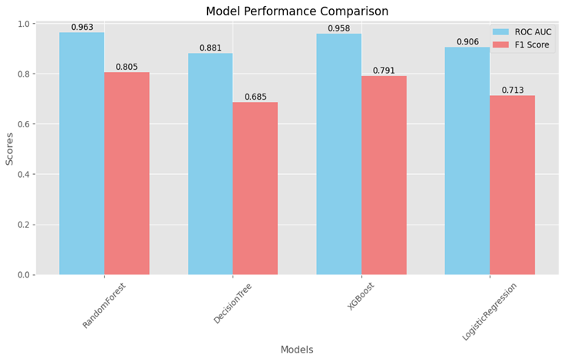

Appendix E.6: Make Final Predictions

Using the ROC-AUC evaluation, choose the best model and run predictions on the unseen test set with the following snippet.
Code:
# Select best model based on ROC-AUC
best_model_name = max(validation_results, key=lambda x: validation_results[x]['roc_auc'])
best_model = best_model_dict[best_model_name]
print(f"Best model: {best_model_name} (ROC AUC: {validation_results[best_model_name]['roc_auc']:.4f})")

# Make predictions
predictions = best_model.predict(X_test_input)
probabilities = best_model.predict_proba(X_test_input)[:, 1]
print(f"Generated {len(predictions)} predictions")
print(f"Default rate: {(predictions == 1).mean():.4f}")

# Save predictions
output = pd.DataFrame({'Prediction': predictions, 'Probability': probabilities})
output.to_csv('test_predictions.csv', index=False)
print("Predictions saved to 'test_predictions.csv'")

Output:
Best model: RandomForest (ROC AUC: 0.9633)
Generated 33000 predictions
Default rate: 0.2061
Predictions saved to 'test_predictions.csv'

Appendix E.7: Visualizations

To support the model evaluation and comparison, we generated the following visualizations.
1. ROC Curve – Receiver Operating Characteristic: The curve displays how the True Positive Rate and False Positive Rate vary as the classification threshold changes, highlighting the model's performance trade-offs.
2. Precision-Recall Curve: This curve is especially useful for imbalanced datasets, as it focuses on the minority class (defaults in our case).
The following code is used to generate ROC Curve and Precision-Recall Curve.
Code:
import matplotlib.pyplot as plt
import seaborn as sns
from sklearn.metrics import roc_curve, precision_recall_curve, auc
import numpy as np
import pandas as pd

# Set plotting style
plt.style.use('ggplot')

# Recalculate ROC and PR curves using consistent y_val length
fig = plt.figure(figsize=(15, 12))

# 1. ROC Curve
plt.subplot(2, 2, 1)
for model_name, model in best_model_dict.items():
y_val_proba = model.predict_proba(X_val_scaled)[:, 1]

# Slice y_val_set to match length if needed
if len(y_val_set) != len(y_val_proba):
min_len = min(len(y_val_set), len(y_val_proba))
y_val_plot = y_val_set[:min_len]
y_val_proba = y_val_proba[:min_len]
else:
y_val_plot = y_val_set

fpr, tpr, _ = roc_curve(y_val_plot, y_val_proba)
roc_auc = auc(fpr, tpr)
plt.plot(fpr, tpr, label=f'{model_name} (AUC = {roc_auc:.3f})')

plt.plot([0, 1], [0, 1], 'k--', label='Random')
plt.xlabel('False Positive Rate')
plt.ylabel('True Positive Rate')
plt.title('ROC Curves')
plt.legend(loc='lower right')
plt.grid(True)

# 2. Precision-Recall Curve
plt.subplot(2, 2, 2)
for model_name, model in best_model_dict.items():
y_val_proba = model.predict_proba(X_val_scaled)[:, 1]

if len(y_val_set) != len(y_val_proba):
min_len = min(len(y_val_set), len(y_val_proba))
y_val_plot = y_val_set[:min_len]
y_val_proba = y_val_proba[:min_len]
else:
y_val_plot = y_val_set

precision, recall, _ = precision_recall_curve(y_val_plot, y_val_proba)
pr_auc = auc(recall, precision)
plt.plot(recall, precision, label=f'{model_name} (AUC = {pr_auc:.3f})')

plt.xlabel('Recall')
plt.ylabel('Precision')
plt.title('Precision-Recall Curves')
plt.legend(loc='lower left')
plt.grid(True)

plt.tight_layout()
plt.show()

Output:

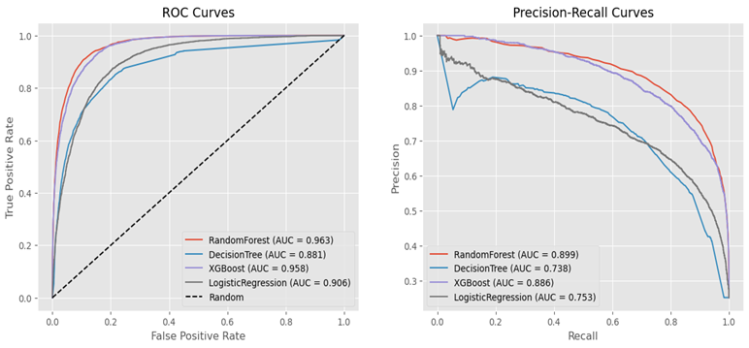
These visual insights help in making data-backed decisions and further validate the choice of Random Forest as the final model due to its stable and well-balanced performance across key evaluation metrics.

References

- Kaggle. (2023). Customer Credit Default Prediction Dataset. Retrieved from https://www.kaggle.com/datasets
- Pedregosa, F., et al. (2011). GridSearchCV – Scikit-learn 1.4.2 documentation. Scikit-learn. https://scikit-learn.org/stable/modules/generated/sklearn.model_selection.GridSearchCV.html
- Pedregosa, F., et al. (2011). RobustScaler – Scikit-learn 1.4.2 documentation. Scikit-learn. https://scikit-learn.org/stable/modules/generated/sklearn.preprocessing.RobustScaler.html
- Pedregosa, F., et al. (2011). LabelEncoder – Scikit-learn 1.4.2 documentation. Scikit-learn. https://scikit-learn.org/stable/modules/generated/sklearn.preprocessing.LabelEncoder.html
- Hosmer, D. W., Lemeshow, S., & Sturdivant, R. X. (2013). Applied Logistic Regression (3rd ed.). Wiley.
- Quinlan, J. R. (1986). Induction of decision trees. Machine Learning, 1(1), 81–106. https://doi.org/10.1007/BF00116251
- Breiman, L. (2001). Random forests. Machine Learning, 45(1), 5–32. https://doi.org/10.1023/A:1010933404324
- Chen, T., & Guestrin, C. (2016, August). XGBoost: A scalable tree boosting system. In Proceedings of the 22nd ACM SIGKDD International Conference on Knowledge Discovery and Data Mining (pp. 785–794). ACM. https://doi.org/10.1145/2939672.2939785

