**How to Install SonarQube:**

1. Download sonarqube from https://www.sonarqube.org/downloads/ (Community)

2. Unzip file

3. Update conf\wrapper.com set java

wrapper.java.command=D:\elk\elasticsearch-7.15.2\jdk\bin\java

4. Run bin\windows-x86-64\StartSonar.bat

5. Once started open http://localhost:9000 in browser

6. Credentials: admin/admin

7. Click on My Account

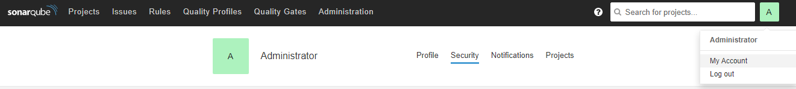

8. Click on Security

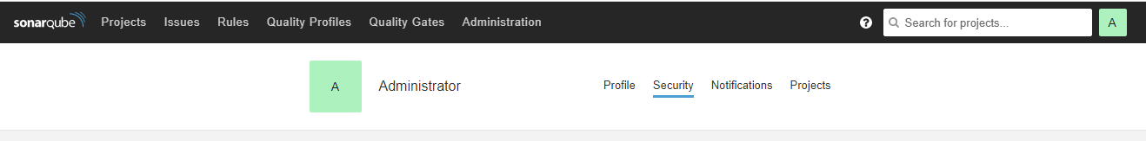

9. Enter token name and click on generate button

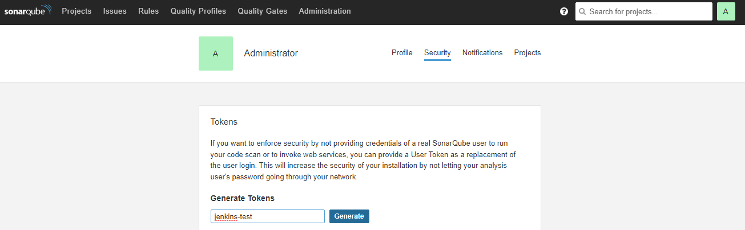

10. Click on Administration 🡪 Configuration 🡪 General Settings 🡪 Security

**Enable local webhooks validation set off (**This is required to use local Jenkins for webhooks**)**

11. Click on Webhooks (Administration 🡪 Configuration 🡪 Webhooks)

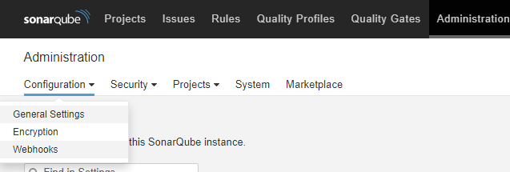

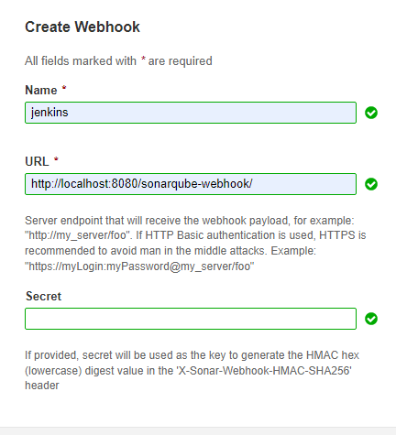

**Go to Jenkins and Integrate SonarQube:**

Go to Jenkins Dashboard

1. Manage Jenkins 🡪 Manage Plugins 🡪 Install [SonarQube Scanner for Jenkins](https://plugins.jenkins.io/sonar) plugin
2. Go to Manage Jenkins 🡪 Configure System 🡪 SonarQube servers

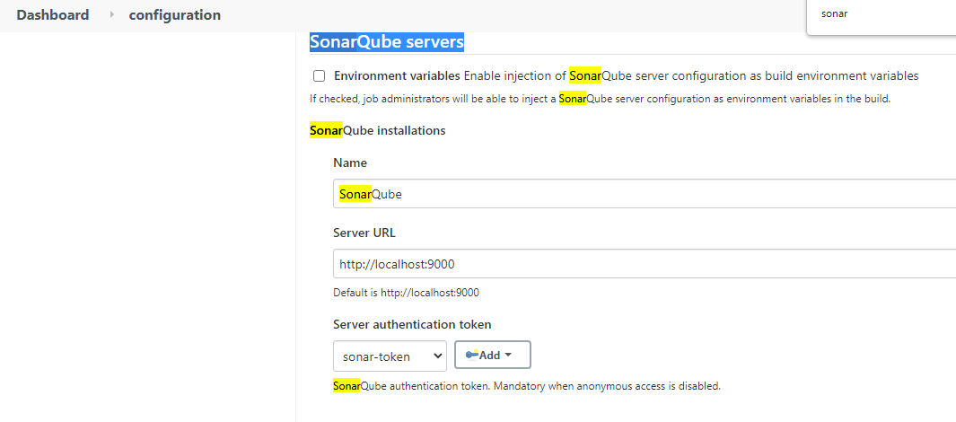

Click on Add button to create token or click on <http://localhost:8080/credentials/store/system/domain/_/> click on Add Credentials

Select Kind : Secret text and use the token generated in Sonar step 9.

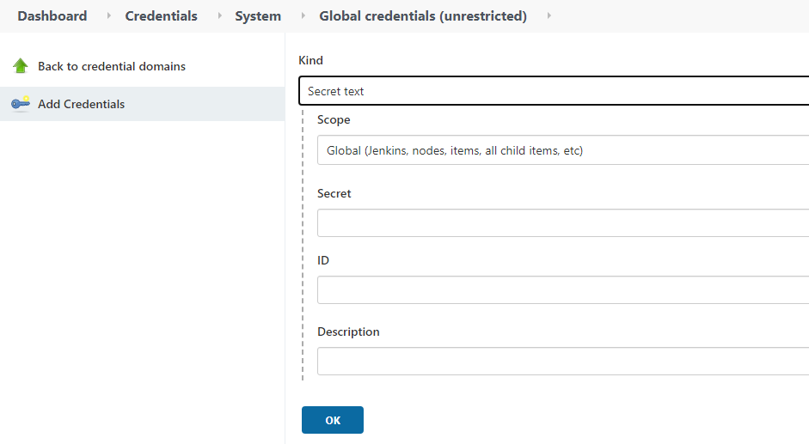

Use below stage to trigger sonar scan and quality check

stage('SonarQube Analysis') {

steps{

withSonarQubeEnv('SonarQube') {

bat 'mvnw sonar:sonar'

}

}

}

stage("Quality Gate Statuc Check"){

steps{

timeout(time: 5, unit: 'MINUTES') {

waitForQualityGate abortPipeline: true

}

}

}