Swarm Information Foraging to Develop Forest Inventories

|  |  |  |
| --- | --- | --- |
| Dhruva Arun  Naval Research Laboratory Laboratory of Autonomous Systems ResearchWashington DC, United States | Loy McGuire  Naval Research Laboratory Laboratory of Autonomous Systems ResearchWashington DC, United States | Donald Sofge  Naval Research Laboratory Laboratory of Autonomous Systems ResearchWashington DC, United States |

*Abstract*—This electronic document is a “live” template and already defines the components of your paper [title, text, heads, etc.] in its style sheet. *\*CRITICAL: Do Not Use Symbols, Special Characters, Footnotes, or Math in Paper Title or Abstract*. (*Abstract*)

Keywords—component, formatting, style, styling, insert (key words)

# Introduction

Wildfires are fast, destructive, and erratic, rendering them a threat to both civilians and infrastructure. The trajectory of a wildfire depends on several factors, including tree species, tree heights, and tree trunk diameters. Accurately predicting wildfires requires a database of all of these tree attributes for forests across the globe. Many organizations are working towards developing such an inventory with various strategies and resources.

Diameter at Breast Height (DBH) is a crucial metric for assessing tree growth, health, and overall ecosystem dynamics. It is challenging to sample DBH values at a large scale. However, research suggests that DBH values can be predicted with the tree's height and the density of trees in the area. By carefully selecting a set of trees to sample within a forest stand, the rest of the tree diameters can be accurately predicted [1].

The objective of this paper was to design a swarm methodology that selects and collects DBH values which most effectively identifies a trend capable of predicting the Diameter at Breast Height of the rest of the trees in the forest stand.

# Setup

## Simulation Environment

The simulation environment is based on a dataset collected by USDA at the Manitou Experimental Forest, containing tree coordinates, heights, and diameters. After parsing the database and constructing a numpy spacial grid of cells, with some cells being trees and some being open area, each tree is assigned a density value based on the number of and distance to nearby trees using computations from a density kernel.

A 3x3 “home” area is designated at the center of the forest, where all UAVs are deployed from and return to. Each UAV gets deployed to a random cell on the grid, assuring special coverage across the forest. The computations of each UAV runs as a separate task on a separate thread, thus establishing a distributed swarm network. Each UAV has access to limited fuel and must return to the home area before the fuel runs out. The fuel depletes proportionally to the distance the drone travels, and the drone must also spend fuel to measure the DBH value of a tree. After returning home, a UAV may be redeployed and its fuel will be refilled.

Throughout the simulation, each UAV only has access to nearby forest information within a specified radius. This allows for the forest environment to be scaled up while maintaining efficient UAV decision making.

The swarm is limited to 3 UAVs, each of which are deployed once, resulting in a small amount of collected data points. The limited number of collected data points increases relative the information value each tree holds, thus increasing the importance of careful tree selection.

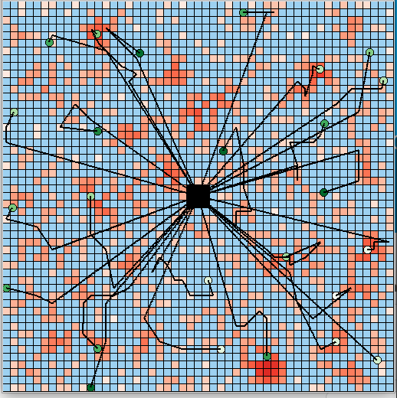

Figure - This image shows a simulation using more drones different shaped forest than the environment used in this paper. The shade of red represents the tree density.

## Potential Field Overlay

The UAV tree selection process makes use of potential field maximums. The information field holds the information value of each nearby cell, which is computed using the algorithms described in the next section. The proximity field is pre-defined, favoring closer cells over further cells. The two potential fields are combined with a weighted sum, and the UAV chooses the cell with the greatest value, represented as the darkest cell in Figure 2.

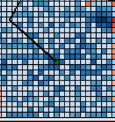Overlaying potential fields allows for changes in UAV decision making to be easily implemented if additional constraints are placed or different forms of information are introduced.

## Performance Metric

The performance of the simulation is evaluated based on the data points (trees) collected. Gaussian Regression is used to compute a trend function relating density and height to tree diameter by fitting the sampled data points. The difference between the predicted trend function and the actual DBH values is then evaluated using mean squared error. The MSE difference is the sole metric of the simulation.

# Information Value Algorithms

This section describes different methods used to compute the information value of a given cell, which is the main influence of UAV tree selection.

## Random Information Value

This algorithm is a control for a baseline comparison. The information value of each nearby cell is completely randomized.

## Information Value from Threshold

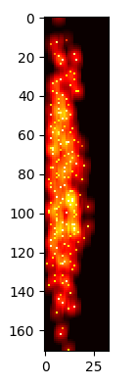 This algorithm does not consider the DBH value of the sampled tree, and only aims to sample trees across the range of tree heights and densities. A 2D grid with an X axis of density and Y axis of height keeps track of the information value of every (height, density) coordinate. The information of a coordinate is solely dependent on the previously collected coordinates.

Each sampled tree is plotted on the threshold as a (height, density) coordinate, signifying the coordinate now contains very little additional information, along with a small surrounding radius to show that the information value of nearby coordinates has also reduced. This is because to build an accurate trend function, a wide spread of tree heights and densities must be sampled. Gathering many data points with similar heights and densities does not provide any additional insight about the overall trend of the forest stand.

|  |
| --- |
| Figure 3 - Threshold |

## Information Value from Gaussian Regression

Gaussian Regressions are unique in that they not only determine the curve of best fit for a set of points, but also the information entropy (uncertainty) of the prediction of each data point. Building a good trend function requires minimizing the amount of information entropy for the curve prediction. Thus, utilizing Gaussian Regression to choose data points with minimal information entropy directly works towards building a good trend function. The information value of a tree can be quantified simply as the amount of uncertainty of the Gaussian Regression at the respective (height, density, DBH) coordinate in 3D space.

An initial attempt at Gaussian Regression of randomly selected points showed that there was very little correlation between density and DBH, high correlation between height and DBH. It also yielded a result with a constant and low uncertainty throughout the graph (Fig. 4), suggesting the model required tuning to yield accurate information entropy data.

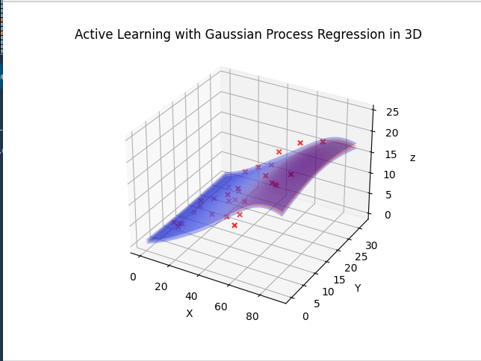

Figure , X Height, Y Density, Z DBH (Note the lack of correlation between Y and Z)

Since density did not have much of an impact on DBH values, it could be ignored during the tuning process and tuning could be done in 2D (height and DBH).

Different hyper parameters for the smoothness, length scale, noise level, and kernel width were tested with various number of training dataset sizes to yield smooth results with larger uncertainties occurring in areas that have fewer data points or in areas with data points that significantly diverge from the general trend of the previously collected data points. Figure 5 shows the Gaussian Regression output with the final hyper parameters for various training dataset sizes.

|  |
| --- |
| 7 Data Points |
| 20 Data Points |
| 40 Data Points |

Figure

# Results

After the text edit has been completed, the paper is ready for the template. Duplicate the template file by using the Save As command, and use the naming convention prescribed by your conference for the name of your paper. In this newly created file, highlight all of the contents and import your prepared text file. You are now ready to style your paper; use the scroll down window on the left of the MS Word Formatting toolbar.

## Data

**The template is designed for, but not limited to, six authors.** A minimum of one author is required for all conference articles. Author names should be listed starting from left to right and then moving down to the next line. This is the author sequence that will be used in future citations and by indexing services. Names should not be listed in columns nor group by affiliation. Please keep your affiliations as succinct as possible (for example, do not differentiate among departments of the same organization).

### For papers with more than six authors: Add author names horizontally, moving to a third row if needed for more than 8 authors.

### For papers with less than six authors: To change the default, adjust the template as follows.

#### Selection: Highlight all author and affiliation lines.

#### Change number of columns: Select the Columns icon from the MS Word Standard toolbar and then select the correct number of columns from the selection palette.

#### Deletion: Delete the author and affiliation lines for the extra authors.

## Discussion

This study has shown that Gaussian Process Regression is very effective as a decision making algorithm for UAVs to minimize information entropy in a trend function. GPRs can be applied to other information foraging problems that attempt to determine trend functions between various variables.

Currently, GPRs in swarms may not be scalable as the GPR repeatedly fits the whole set of selected points for each new point selection. Developing a strategy to optimize this process, such as only performing regression on segments of the selected dataset based on the new trees available, will allow for the scaling of this foraging algorithm to large forest areas with large amounts of UAVs.

Density has no correlation with DBH values, despite our intuition. It is possible that the density-DBH correlation is too complex to be discovered by GPRs, so further research exploring this topic may yield interesting results.

Introducing more variables, such as species and location, may yield trend functions with smaller mean squared errors and will allow swarms to travel across various stands, instead of being limited to a single stand per GPR.

Headings, or heads, are organizational devices that guide the reader through your paper. There are two types: component heads and text heads.

Component heads identify the different components of your paper and are not topically subordinate to each other. Examples include Acknowledgments and References and, for these, the correct style to use is “Heading 5”. Use “figure caption” for your Figure captions, and “table head” for your table title. Run-in heads, such as “Abstract”, will require you to apply a style (in this case, italic) in addition to the style provided by the drop down menu to differentiate the head from the text.

Text heads organize the topics on a relational, hierarchical basis. For example, the paper title is the primary text head because all subsequent material relates and elaborates on this one topic. If there are two or more sub-topics, the next level head (uppercase Roman numerals) should be used and, conversely, if there are not at least two sub-topics, then no subheads should be introduced. Styles named “Heading 1”, “Heading 2”, “Heading 3”, and “Heading 4” are prescribed.

## Figures and Tables

#### Positioning Figures and Tables: Place figures and tables at the top and bottom of columns. Avoid placing them in the middle of columns. Large figures and tables may span across both columns. Figure captions should be below the figures; table heads should appear above the tables. Insert figures and tables after they are cited in the text. Use the abbreviation “Fig. 1”, even at the beginning of a sentence.

1. Table Type Styles

| Table Head | Table Column Head | | |
| --- | --- | --- | --- |
| Table column subhead | Subhead | Subhead |
| copy | More table copya |  |  |

1. Sample of a Table footnote. (*Table footnote*)
2. Example of a figure caption. (*figure caption*)

Figure Labels: Use 8 point Times New Roman for Figure labels. Use words rather than symbols or abbreviations when writing Figure axis labels to avoid confusing the reader. As an example, write the quantity “Magnetization”, or “Magnetization, M”, not just “M”. If including units in the label, present them within parentheses. Do not label axes only with units. In the example, write “Magnetization (A/m)” or “Magnetization {A[m(1)]}”, not just “A/m”. Do not label axes with a ratio of quantities and units. For example, write “Temperature (K)”, not “Temperature/K”.

##### Acknowledgment *(Heading 5)*

The preferred spelling of the word “acknowledgment” in America is without an “e” after the “g”. Avoid the stilted expression “one of us (R. B. G.) thanks ...”. Instead, try “R. B. G. thanks...”. Put sponsor acknowledgments in the unnumbered footnote on the first page.

##### References

The template will number citations consecutively within brackets [1]. The sentence punctuation follows the bracket [2]. Refer simply to the reference number, as in [3]—do not use “Ref. [3]” or “reference [3]” except at the beginning of a sentence: “Reference [3] was the first ...”

Number footnotes separately in superscripts. Place the actual footnote at the bottom of the column in which it was cited. Do not put footnotes in the abstract or reference list. Use letters for table footnotes.

Unless there are six authors or more give all authors’ names; do not use “et al.”. Papers that have not been published, even if they have been submitted for publication, should be cited as “unpublished” [4]. Papers that have been accepted for publication should be cited as “in press” [5]. Capitalize only the first word in a paper title, except for proper nouns and element symbols.

For papers published in translation journals, please give the English citation first, followed by the original foreign-language citation [6].

1. G. Eason, B. Noble, and I. N. Sneddon, “On certain integrals of Lipschitz-Hankel type involving products of Bessel functions,” Phil. Trans. Roy. Soc. London, vol. A247, pp. 529–551, April 1955. *(references)*
2. J. Clerk Maxwell, A Treatise on Electricity and Magnetism, 3rd ed., vol. 2. Oxford: Clarendon, 1892, pp.68–73.
3. I. S. Jacobs and C. P. Bean, “Fine particles, thin films and exchange anisotropy,” in Magnetism, vol. III, G. T. Rado and H. Suhl, Eds. New York: Academic, 1963, pp. 271–350.
4. K. Elissa, “Title of paper if known,” unpublished.
5. R. Nicole, “Title of paper with only first word capitalized,” J. Name Stand. Abbrev., in press.
6. Y. Yorozu, M. Hirano, K. Oka, and Y. Tagawa, “Electron spectroscopy studies on magneto-optical media and plastic substrate interface,” IEEE Transl. J. Magn. Japan, vol. 2, pp. 740–741, August 1987 [Digests 9th Annual Conf. Magnetics Japan, p. 301, 1982].
7. M. Young, The Technical Writer’s Handbook. Mill Valley, CA: University Science, 1989.

**IEEE conference templates contain guidance text for composing and formatting conference papers. Please ensure that all template text is removed from your conference paper prior to submission to the conference. Failure to remove template text from your paper may result in your paper not being published.**