Forest Data Collection for Wildfire Path Mapping

Drone surveillance of large areas – exploration, no longer surveillance meaning cells DO NOT age
https://www.degruyter.com/document/doi/10.1515/geo-2020-0290/html
An important preliminary step with regard to forest inventory and management is individual tree detection (ITD), which is required to calculate forest attributes such as stem volume, forest uniformity, and biomass estimation
Monitoring and quantifying the canopy growth, chances of plant diseases, and changes happening within forest structures – especially at tree levels – on a timely basis are crucial for optimizing yields and for determining the response of forests to climate anomalies. Although traditional field-based methodologies provide us with detailed data, these tasks can be expensive, time-consuming, and labor-intensive, specifically for monitoring and measuring large areas of forested landscapes [1,2,3,4,5,6]. As a consequence, there exists a need to tap into state-of-the-art remote sensing methodologies, in particular unmanned aerial vehicles (UAVs)

DATA ACQUISITION
- UAV-SfM data: point clouds were built from a UAV carrying a RGB sensor through the stereo matching of multiple overlapping aerial images.
  - resources for purchasing sensors or extensive field data collection are not feasible, although limitations related to accuracy should be considered
- UAV-lidar data
  - UAV-lidar system and had trees precisely mapped in the field, representing a best-case scenario regarding point cloud generation and field validation.

I might have to to a study comparing the spacial efficiency of a single drone with large span and range of lidar sensitivity versus many drones with weak lidars covering less area

https://www.elsight.com/blog/drone-connectivity-for-unmanned-aerial-vehicles-explained/

UAV swarm communication and control architectures: a review
“One specific example of a commercial application that would benefit from UAV swarm is the observation of normalized difference vegetation index (NDVI). NDVI is an important observation for precision agriculture. NDVI observation requires flying sUAS over farmland. Cameras equipped with remote sensing equipment record high-resolution geo-tagged imagery of crops. NDVI imagery and sensing equipment show what parts of fields of crops are in the proper or improper stages of development. Surveying a farm with hundreds or thousands of acres is time-consuming and lacks efficiency using current methods. The use of a coordinated number of sUAS surveyilidarng an entire farmstead with little to no operator intervention would greatly increase efficiency and could revolutionize precision agriculture.”

vvvv Explains why Infastructure based swarm architecture not good for UAVsy
Infrastructure-based swarm architectures are dependent upon the GCS for coordination of all drones. This dependency causes a lack of system redundancy. In the event of an attack or failure to any operation of the GCS, the operability of the entire swarm is compromised. Infrastructure-based methods require all UAVs to be within propagation range of the GCS. A drawback to unlicensed radio frequency communications is that communication may be susceptible to interference.
Because of the light payload capacities of sUAS, the hardware necessary to establish reliable communication with an infrastructure may limit the utility of infrastructure-based swarms. Another drawback is a lack of distributed decision making. In an infrastructure-based architecture, the GCS coordinates the decision-making of all UAVs based on computations and algorithms developed in the GCS. Figure 3 demonstrates the infrastructure-based swarm architecture.

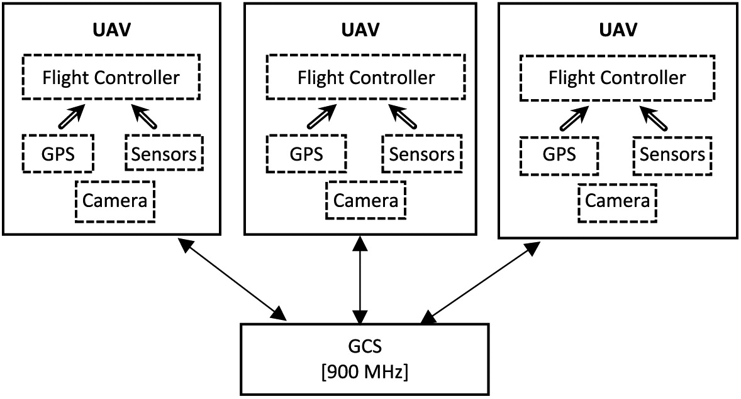

Flying ad-hoc network (FANET) architecture
FANETs is a group of UAVs communicating with each other with no need for an access point, but at least one of them must be connected to a ground base or satellite.
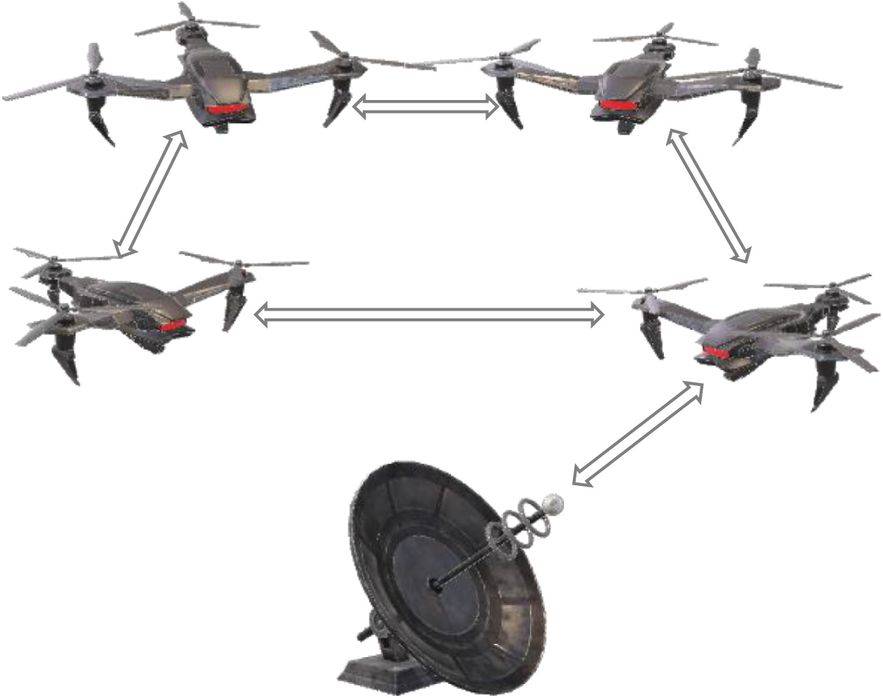

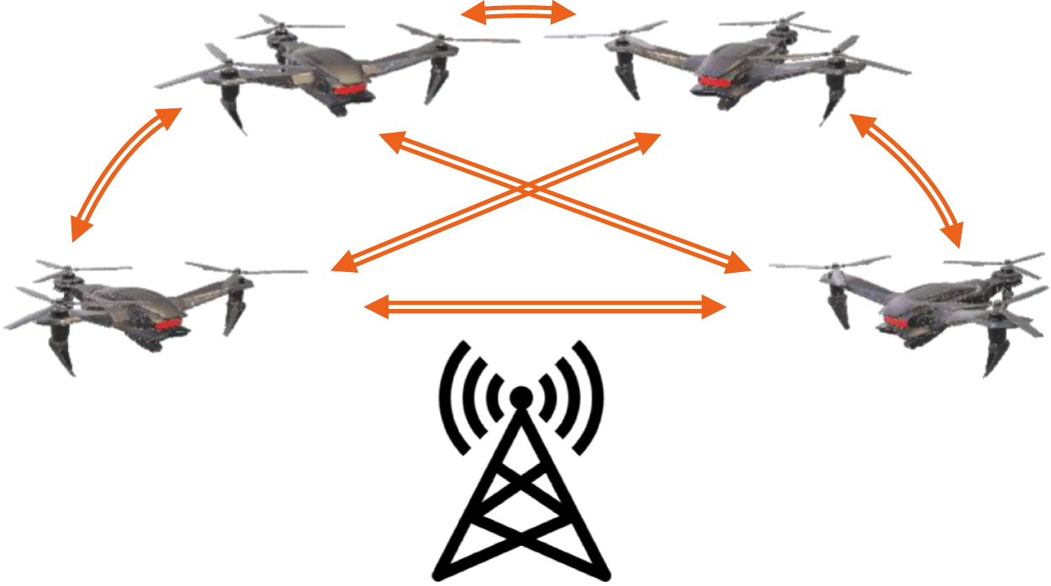
The proposed architecture is an adaptation of an ad-hoc network realized through infrastructure support. Specifically, the infrastructure features complete UAV-to-UAV communication, where the telemetry of each UAV is communicated to every other UAV via cellular mobile infrastructure, as shown in Fig. 5. In this architecture, decisions are distributed among the UAVs, and the infrastructure is purely used to transmit data.

Strengths of proposed architecture
The advantages of this architecture are many. First, the range for which the UAVs can communicate is practically unlimited. Nearly the entirety of the United States has 3G or better cellular data coverage with speed ever increasing. The reliability and redundancy of mobile networks for UAV swarm are less of a concern than for traditional infrastructure-reliant UAV swarm architecture because of the inherent reliability of cellular base stations. While high levels of autonomy can be achieved through traditional architectures, the redundancy provided by the proposed infrastructure is advantageous in comparison.

While 4G speeds are sufficient for these packets, 5G will allow for additional data streaming including data types, such as video from payload cameras or data from payload light detection and ranging (LiDAR) systems. The ability to achieve low latency is important for UAV swarm communication.

CONCLUSION
Specific development of autonomous swarms with UAV-to-UAV communication and coordination ability is central to advancing the utility of UAV swarms. Though swarm technology has yet to be practically utilized in commercial applications, there exists great potential. The use of cellular mobile framework alleviates limiting factors for traditional UAV swarm communication approaches. The use of cellular networks for UAV swarm would greatly increase swarm efficiency and commercial utility especially in the presence of upcoming 5G networks with M2M communication capabilities.

LIGHTWEIGHT LIDAR CARRYIGN SMALL DRONE CAPABLE OF VERY FAST SPEEDS? DISTRIBUTED AD HOC NETWORK, IDK ABOTU CELLULAR STUFF?

https://www.mdpi.com/1999-4907/13/1/3
https://www.forsite.ca/pdf/Forsite_Flatsheet_Innovative%20Inventories.pdf
https://www.forsite.ca/services/forest-inventory
Combinatino of TLS and ALS
Drones deploying SMRs for TLS

https://sci-hub.st/10.1016/j.rse.2021.112540
FLIGHT PATTERN AND CAMERA ANGLE DO MATTER

“Since preliminary testing of crosshatch and off-nadir UAS data
acquisition methods indicate improved point density in the lower can-
opy and stem region (Díaz et al., 2020), it is logical to more thoroughly
investigate the impact of these variables on extracted tree parameters
like DBH. “

“To better understand the reliability of
UAS-derived tree heights, future work should explore the stability of
independent UAS acquisitions of the same stand as this would reveal any
errors propagating from the SfM algorithm and inform the potential for
repeat acquisitions for tree growth monitoring”

1. SfM serpentine with nadir angled camera over entire area
2. SfM generates point cloud
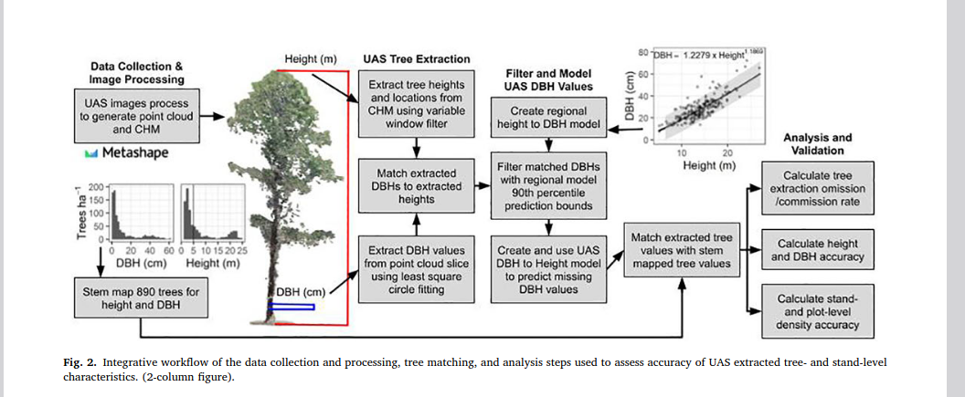
PRIMARY DATA
- UAS Images
- Stem Map
- Regional height to DBH relationship

Extract CHMs and point clouds from UAS Images
“The FIA annual inventory provides objective and scientifically credible data on the extent, condition, volume, growth, depletion and health of our forest”

https://www.mdpi.com/2072-4292/12/24/4144
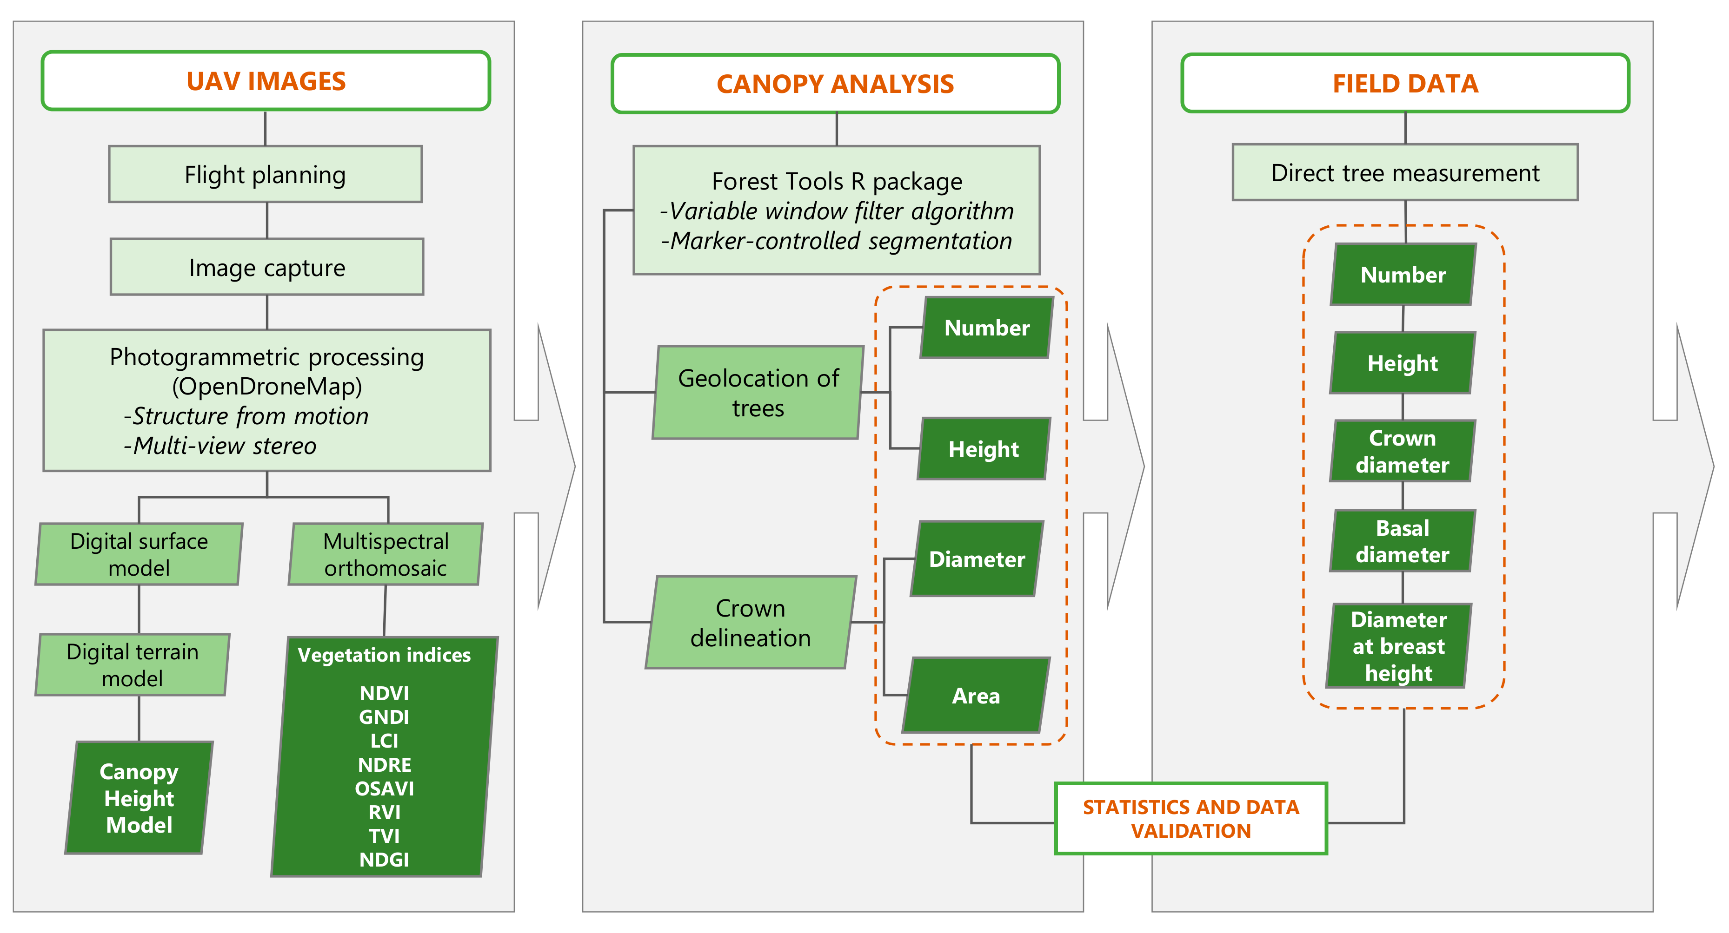
Grid of Cells
Function inputting direction of robot, off nadir angle, and height of robot returns a point cloud, DBH extracted and stuff

How to decide what patches to fly over with crosshatch
1. FIELD DATA – stand density generalization (compare all segments of forest to general density, check for differences)
2. spatial overlay of DBH and satellite data??
- DBSCAN of missing DBH data, form high density clusters, assign drones to largest close clusters
3. Possibility of no swarm dynamics, single robot algorithm to reroute swarm during serpentine to areas with large amounts of missing DBH values

