- Introduction
  - Goal: predict dbh values
  - Objective of paper (swarm to efficiently get dbh values with limited fuel)
  - Transition to methods
- Methods
  - Simulation Setup
    - Forest Database
  - Threshold Based
  - Gaussian Regression
    - Gaussian Kernel Tuning?
      - Many different hyperparameters tried before final set was decided on
  - Random Walk
- Results & Discussion
  - Compare metrics
    - 3d graphs from each type along with mean metrics over hundreds of runs
    - Include number of selected points
  - Show 3D graphs from different methdos
    - Std large in threshold and randomwalk
  - Explain other patterns/trends
    - Lots of noise, can cause false trends
    - Density did not have much effect on DBH, mainly height
    - Limiting access to collectable points improves performance of gaussian
- Conclusion
  - Gaussian > threshold > randomwalk
  - Gaussian is effective in reducing information entropy, which minimizes MSE
  - 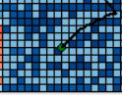
  - 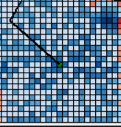

Presentation Outline

- Swarm Objective
  - collect dbh values to predict the rest
  - selectivity
- Simulation
  - Forest Database with trees of different heights in areas of different densities
  - UAVs get deployed to random points and start collecting info
  - UAVs use potential field overlay (proximity and information value)
  - Performance metric of simulation
- Different Algorithms
  - Random Information
  - Threshold Info Value
  - Gaussian Regression
- Results
  - Gaussian Regression performed the best, show some cool graphs

