QUESTIONS
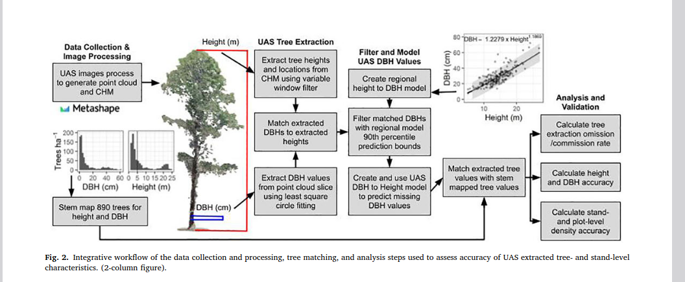

- Why did you choose the crosshatch and serpentine patterns?
- Why are the extracted heights and DBH values spatially paired? Can’t they be paired during the data collection process?
- After collecting DBH values, the next step is to identify areas that require more DBH data. Would a spatial overlay of DBH values and satellite data yield areas that have the most missing DBH values?
- What is the estimated cost per drone?
- What is the purpose of stem maps?
- Why is the relationship between height and DBH linear?

My Idea Pitch:
Robot swarm to cover large area with serpentine pattern, calculate clusters with a lot of missing DBH values, assign individual robots in swarm to clusters to fly over with crosshatch (goal will be to fly over all of the clusters as fast as possible)
Follow Up:
Is this practical/useful?

