Dhruva Arun
06/26/2023 - 08/25/2023

UAS-Based Forest Inventory Development with Swarming Algorithms

Problem Description
After talking to Peter Root, a professional at Wildfire Robotics, I have found that wildfire suppression with water and other methods should only be performed when absolutely necessary to protect a community. Otherwise, it is beneficial to nature to allow the wildfires to naturally burn through the forest, producing the ideal environment for new forests to grow. Mr. Root explained that the best action that can be taken right now is working to generate an inventory of trees in forests across the globe (species, height, age, etc.), thus allowing experts to track the path a given wildfire will take and create controlled burns to protect communities. Multiple companies are working towards this goal right now with innovative solutions (Foresite).

Recent work done in this research paper made use of UAVs with SfM processing to develop point clouds of trees, allowing for a cheaper and functional alternative to ALS and TLS (Aerial and Terrestrial Lidar Sensing). The study asserted that flight patterns and camera angles significantly affect the precision and error of the measurements taken by the UAVs. The research paper tested the below flight patterns and camera angles:
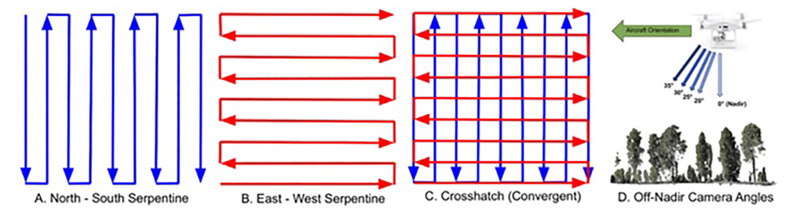
It finally concluded that the measurements “might see efficiency gains by flying entire stands with serpentine patterns and then sample portions of a stand with a crosshatch pattern … Work is needed to understand what proportion of a stand (uniform forest community) needs to be sampled with the crosshatch pattern to ensure enough DBH values are extracted to impute the missing DBH values.” Thus, a solution is necessary to identify these sample portions of the strands and fly over them as quickly and thoroughly as possible.

Objectives
My project will aim to solve two problems:
- Develop a strategy to identify what parts of a stand require additional measurements (Areas of Focus Identification)
- Develop a swarming algorithm to extract additional measurements from a set of specified areas using a distributed swarm.

Swarm Architecture
The UAV architecture will be based on the proposed architecture from this research paper. The paper proposes “an adaptation of an ad-hoc network realized through infrastructure support. Specifically, the infrastructure features complete UAV-to-UAV communication, where the telemetry of each UAV is communicated to every other UAV via cellular mobile infrastructure, as shown in Fig. 5. In this architecture, decisions are distributed among the UAVs, and the infrastructure is purely used to transmit data.”
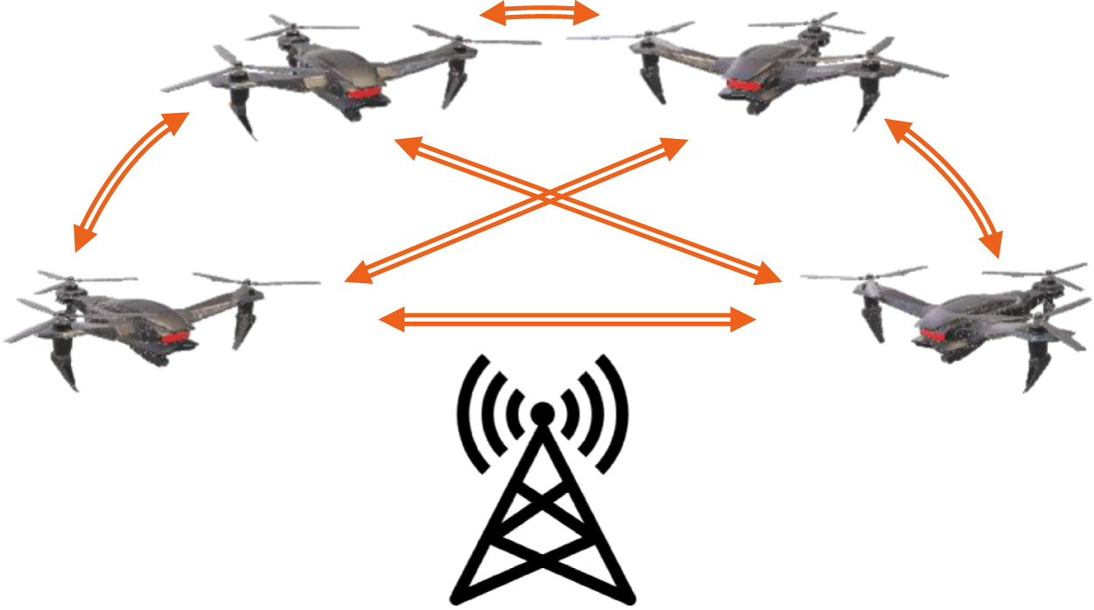

Proposed Areas of Focus Identification Algorithm
- Pass through the entire area with serpentine paths for each UAV
- Methods of AOF Identification TO BE RESEARCHED
  - Will likely involve a clustering algorithm of cells on a grid, with each cell being a portion of the forest with not enough extracted DBH values)

Proposed Swarming Algorithm
- A Greedy algorithm will assign drones to area of focuses based on the sum of importance scores of each point in the focus cluster and the distance from the drone to the centroid of the area of focus
  - assignments will continue until all area of focuses have been re-measured with the crosshatch pattern

Resources Needed
- Just a Tkinter Python environment, maybe a coppeliasim environment if time permits

Task Plan / Schedule
- Week 3: Research what parameters should influence whether or not an individual tree should be flown over again
- Week 3 and 4: Develop a base simulation that can set up an environment of “trees” (represented as cells in a grid) each with these different parameters
- Week 4 and 5: Implement the UAVs in the simulation that can interact with the cells
END OF WEEK 5 (MIDTERM GOAL): Steps 1 through 3 must be completed.
- Week 6 and 7: Implement the swarming algorithms
  - Possibly try different swarming algorithms and compare their effectiveness (also compare to base case of passing over the entire area with crosshatch, have a metric to measure the efficiency of the swarming algorithm with amount of additional points generated and time taken)
- Week 7: If time permits, implement a graphic visualization of the generated environment and the drones with copellia sim
END OF WEEK 7 (FINAL GOAL): Step 4 must be completed.
- Week 8: Final Technical Report and Presentation

