**SYNOPSIS**

**On**

**“FEE MANAGEMENT SYSTEM”**

**Submitted in the partial fulfillment of the requirements**

**for the award of**

Bachelor of Computer Application



Affiliated to C.C.S. University

2018-2021

Under The Guidance To: Submitted To:

Mr. MUNISH SHARMA Dr. RAJEEV KUMAR

H.O.D.

Submitted By:

BADAL SANGWAN - 1080986106039

NAVNEET TYAGI - 1080986106074

AAKASH - 1080986106005

BCA- V SEM



### [DEWAN INSTITUTE OF MANAGEMENT STUDIES](https://www.collegesearch.in/colleges/dewan-institute-of-management-studies-meerut)

### NH-58, PARTAPUR, MEERUT

**STUDENT DECLARATION/CERTIFICATE**

I hereby declare that the work, which is being presented in the Project entitled **“FEE MANAGEMENT SYSTEM”** in partial fulfillment of the requirement for the award of **BACHELOR OF COMPUTER APPLICATION (BCA)** degree, is an authentic record of my own work Carried out under the supervision of **Mr. MUNISH SHARMA**  **Associate Professor of DIMS , Meerut .**

The matter embodied in this project has not been submitted by me for the

Award of any other degree.

Date:------------------------------

(Full Signature of the student)

This is to certify that the above statements made by the candidate are correct

to the best of my knowledge.

BADAL SANGWAN - 1080986106039

NAVNEET TYAGI - 1080986106074

AAKASH - 1080986106005

(-------------------------)

(Project Supervisor)

**CERTIFICATE**

I hereby certify that the work which is being presented in the BCA final year Project Report entitled “**FEE MANAGEMENT SYSTEM”** by By GROUP inpartial fulfillment of the requirements for the award of the degree of **Bachelor of Computer Application** submitted to DIMS, Meerut is an authentic record of their work carried out under my guidance.

This is to certify that the above statement made by the candidates is correct to the best of my knowledge.

BADAL SANGWAN - 1080986106039

Signature

NAVNEET TYAGI - 1080986106074

Signature

AAKASH - 1080986106005

Signature

**CONTENTS**

* **INTRODUCTION**
* **OBJECTIVE**
* **OPERATION DEFINITION**
* **SOLUTION DOMAIN**
* **SYSTEM DOMAIN**
* **APPLICATION DOMAIN**
* **FUTURE SCOPE OF THE PROJECT**
* **CONCLUSION**

# *BCA Project Report*

# *(CS-76)*

**INDEX**

* Introduction
* Objective
* Tools/Environment Used
* Analysis Document]
* Design Document
* Testing
* Input and output screen
* Implementation of security for software developed
* Limitation of project
* Future application of project
* Bibliography

INTRODUCTION

Fees Management Software is a complete and customized solution for a Fees handling regular management work. By going through the flow of pplication one can easily maintain its student detail, fees detail, Employee detail, Certificate details, Time Table and Exam scheduling, Exams and Question Paper detail and Transportation Detail. This software includes the management of students, Employee, Accounts, Transportation, library, Fees, Exam, Time Table, Inventory and its respective reports with ministrative module to provide better security. User-friendly menus can easily generate all the reports.

Tools/Platform

Hardware and Software Requirement

HARDWARE : Pentium I -5 or above, 8 RAM.

SOFTWARE : Core Java

RDBMS : Sql Server 2005

OPERATING SYSTEM : Windows 10 Later

**Analysis Document**

**SOFTWARE REQUIREMENTS SPECIFICATION (SRS)**

**Specific requirements**

## Functional requirements

### User class – Student

**This section is for UOP Fees of Computing Student**

1. Student registration form. Student can be register on the system and fill in all detail and forward to choose project/supervisor.
2. Change Detail. Student can change detail if information is incorrect such as telephone number.
3. Change Password. Student can change his login password at any time for security reason.
4. Forget password. Student can request his password if he/she forgotten the password.

### User class – Academic Staff

All staff can view the details of any student.

**3.1.4 User class – Unit Cohort co-ordinator**

Certain staff may be designated as Unit or Cohort Co-ordinators and can change the details of any student doing their unit or project cohort.

Change Student Detail

Unit Cohort co-ordinator can change student detail for incorrect information.

View Student Detail

Unit Cohort co-ordinator can view student information and monitor their progress.

List Student

Unit Cohort co-ordinator can list all students in different period of different group.

Change Password

Unit Cohort co-ordinator can reset the student’s password if required.

**3.1.5 User class – System Administrator**

List Student

System Administrator can list all students in different period of different group to check any error.

Change Password

System Administrator can reset the student’s password if required.

**3.1.6 User class – Administration Staff**

List Student

Administration Staff can list all students in different period of different group.

**3.2 Design constraints**

The system need to design base on the existed code and database using J2SE 5.0, J2EE 1.4 and Struts 1.2.x.

**3.3 Software system attributes**

**3.3.1 Security**

The system needs to log client’s information of registration such as IP address and time for security purpose.

Password should encrypted and store in the database.

**3.3.2 Maintainability**

The system developing using Struts, all action is detailed in struts-config.xml and web.xml that easy to modify and make update.

**3.3.3 Portability**

The web application is coding in J2EE and Struts, therefore, it should be transferable between different OS and Java container.

**3.4 Other requirements**

For further extending, is able to send notification by SMS.



This phase of system development life cycle is related to the testing of the software after it has been developed .In this phase the testing engineer carries out various testing strategies and tools to check whether the software developed by the programmer is according to the predefined standards and the quality of the software is matching the requirements. The various techniques used for testing by a testing engineer are whitebox testing, blackbox testing, unit testing and so on. These all techniques are useful in getting rid if the shortcomings or the failures which are there on the part of programmer. If certain failures are encountered the programmer is informed and he is supposed to eliminate those failures from the software, which is error free from bugs, and ready for implementation on the client side is developed.

### Implementation :

This phase relates to installing the software on the client-side. The various procedures that are involved for implementing a software includes giving documentation of the

details regarding the basic and the technical part of the software. It also includes checking of various hardware resources available with the client and making sure that the software is running properly on their machine.

### Maintenance / post-implementation:

In this phase review is conducted by the technical support engineers on the client side to check whether the software is running properly according to the changing needs of the client from time to time .If there is any failure in the software or the client is not able to access the database then the same is intimated (informed) to the programmers or the developers and in the certain cases it can be taken care by technical support engineer who is there with the client to check all these errors.

**E-R Diagram:**



Design Document

Data Flow Diagram

**DFD Symbol:**

|  |  |
| --- | --- |
| ***Stands For*** | ***Symbols*** |
| Source or Destination of Data | Square  Rectangle |
| Flow of Data |  |
| Process which transforms | Rounded Rectangle  Oval  Circle |
| Store of Data |  |

We consider three levels of DFDs

Level 0 DFD

Level 1 DFD

Level 2 DFD

**DFD Level 0**

CFD (Context Flow Diagram)

or

CAD (Context Analysis Diagram)

Student or Applicant

ADMINISTRATOR

**DFD Level 1**



**DFD LEVEL 2**

**Fees Management Process**

**DFD LEVEL 2**

**Fees Management Process**



**TESTING**

Testing is the process of detecting errors. Testing performs a very critical role for quality assurance and for ensuring the reliability of software. The results of testing are used later on during maintenance also

**Psychology of Testing**

**The aim of testing is often to demonstrate that a program works by showing that it has no errors. The basic purpose of testing phase is to detect the errors that may be present in the program. Hence one should not start testing with the intent of showing that a program works, but the intent** **should be to show that a program doesn’t work.**

**Testing is the process of executing a program with the intent of finding** **errors.**

Testing Objectives:

The main objective of testing is to uncover a host of errors, systematically and with minimum effort and time. Stating formally, we can say,

* Testing is a process of executing a program with the intent of finding an error.
* A successful test is one that uncovers an as yet undiscovered error.
* A good test case is one that has a high probability of finding error, if it exists.
* The tests are inadequate to detect possibly present errors.
* The software more or less confirms to the quality and reliable standards.

## LEVELS OF TESTING

**In order to uncover the errors present in different phases we have the concept of levels of testing. The basic levels of testing are**

Client Needs Acceptance Testing

**Requirements System Testing**

**Design Integration Testing**

**Code Unit Testing**

UNIT TESTING

Unit testing focuses verification effort on the smallest unit of software i.e. the module. Using the detailed design and the process specifications testing is done to uncover errors within the boundary of the module. All modules must be successful in the unit test before the start of the integration testing begins.

In this project each service can be thought of a module. There are so many modules like Login, HW Admin, Master Admin, Normal User, and Employee. Each module has been tested by giving different sets of inputs. When developing the module as well as finishing the development so that each module works without any error. The inputs are validated when accepting from the user.

**INTEGRATION TESTING**

After the unit testing we have to perform integration testing. The goal here is to see if modules can be integrated properly, the emphasis being on testing interfaces between modules. This testing activity can be considered as testing the design and hence the emphasis on testing module interactions.

In this project the main system is formed by integrating all the modules. When integrating all the modules I have checked whether the integration effects working of any of the services by giving different combinations of inputs with which the two services run perfectly before Integration.

**SYSTEM TESTING**

Here the entire software system is tested. The reference document for this process is the requirements document, and the goal so to see if software meets its requirements.

Here entire **Library Mgt System** has been tested against requirements of project and it is checked whether all requirements of project have been satisfied or not.

**ACCEPTANCE TESTING**

Acceptance Test is performed with realistic data of the client to demonstrate that the software is working satisfactorily. Testing here is focused on external behavior of the system; the internal logic of program is not emphasized.

In this project ‘Network Management of Database System’ I have collected some data and tested whether project is working correctly or not.

Test cases should be selected so that the largest number of attributes of an equivalence class is exercised at once. The testing phase is an important part of software development. It is the process of finding errors and missing operations and also a complete verification to determine whether the objectives are met and the user requirements are satisfied

Test Case

A Test Case is a set of condition or variables under which a tester will determine if a requirement or use case an application is partially or fully satisfied. It may take many test cases to determine that a requirement is fully satisfied.

**Test Case Design**

.Test case design focuses on a set technique for the cases that meet overall testing objectives.

Any software product can be tested in one of two ways:

**WHITE BOX TESTING**

This is a unit testing method where a unit will be taken at a time and tested thoroughly at a statement level to find the maximum possible errors.

I tested step wise every piece of code, taking care that every statement in the code is executed at least once. The white box testing is also called Glass Box Testing.

I have generated a list of test cases, sample data, which is used to check all possible combinations of execution paths through the code at every module level?

**BLACK BOX TESTING**

This testing method considers a module as a single unit and checks the unit at interface and communication with other modules rather getting into details at statement level. Here the module will be treated as a block box that will take some input and generate output. Output for a given set of input combinations are forwarded to other modules.

**Some test Case Designed for Fees Management System**

**Test Case for Sign In function**

|  |  |  |  |  |  |  |  |
| --- | --- | --- | --- | --- | --- | --- | --- |
| Test case id | Objective | Test steps | Test Data | Expected result | Actual result | State | status |
| 1 | To check the functionality of sign in function | 1. Start the Application 2. Click on sign in 3. Enter User name 4. Enter Password | library  72 | Desired menu should appear on the mail screen. | Desired menu is visible. | Executed. | pass |

**Test Case for function**

|  |  |  |  |  |  |  |  |
| --- | --- | --- | --- | --- | --- | --- | --- |
| Test case id | Objective | Test steps | Test Data | Expected result | Actual result | State | status |
| 1 | To check the functionality of sign in function | 1. Start the Application 2. Click on sign in 3. Select Add member option 4. Enter name 5. Enter age. 6. Enter address 7. Enter gender 8. Enter phone no | vipin  23  Delhi  Female  9136365324 | New member record should be added and desired page should open | New member record should be added and desired page should open | Executed. | pass |

**Input and output screen**

**1. Login form**

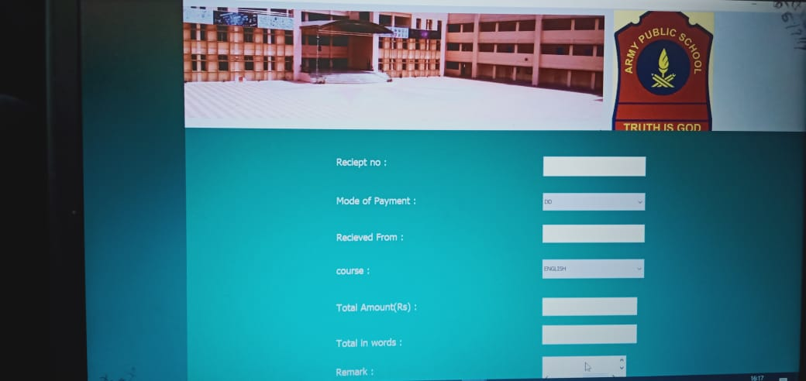

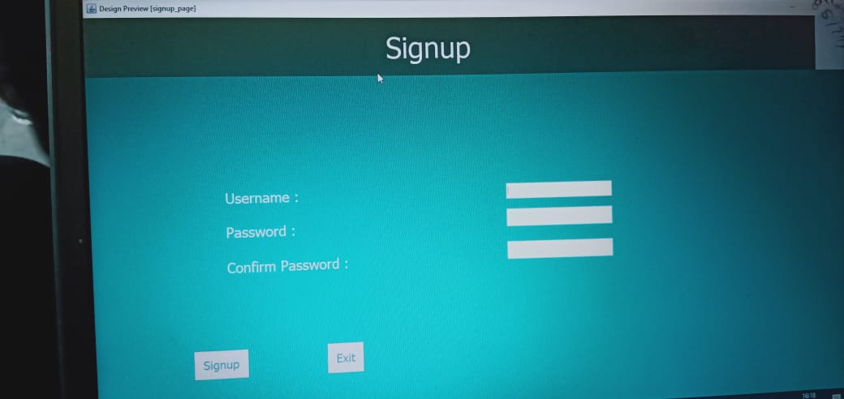

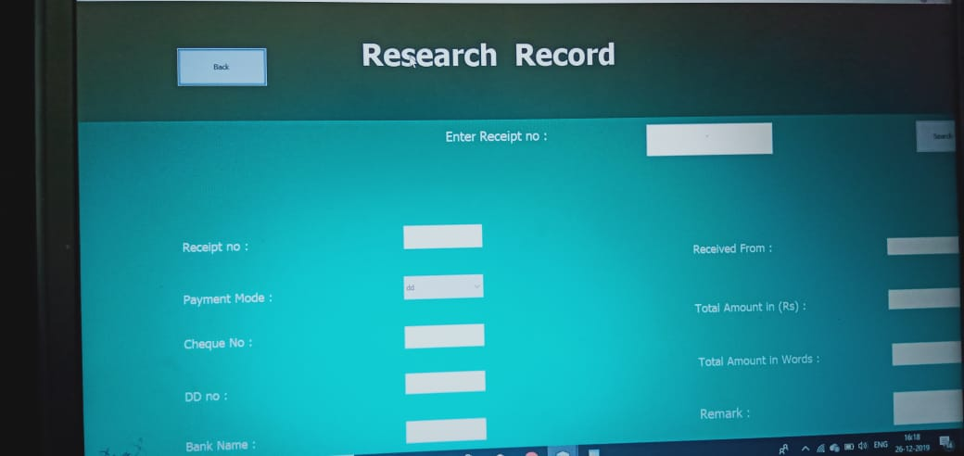

**System Security**

* Only authorized employee can access that software.
* Project is protected with login page which make sure employee or admin is authenticated before accessing secured files.
* Role based security model make sure, only administrative user’s can access Admin Control Panel.

**Limitation Of Project**

This project will be useful for any Feess and colleges with slightly modification. It may be used for English Medium Fees as well as Hindi Medium Feess. Project is flexible i.e. any change / modification in data base may be perform easily. Also this project could be made web enabled.

This project may be upgraded with some more modules such as sports module, prize module, student attendance module, employee salary module, annually receipt and expenditure reports generation etc. This project can also be made for multi-user environment.

**Future Scope and further enhancement**

The scope of the Fees management system facilitate us in the following jobs :-

* Maintaining Student Records
* Automatic Preparation of Marksheet
* Automatic updation in student TC
* Library Managenent

**BIBLIOGRAPHY**

1. An Introduction to Databse Management System by “Bipin C Desai”.
2. Software Engineering by “Roger S. Pressman”..
3. Software Engineering by “Jalote”.
4. PL/SQL by “Evan Barros”.
5. An Introduction to Databse Management System by “C. J. Date”.
6. Databse Concepts by “Korth, Silbertz”
7. Guide to Visual Basic 6.0 by “Nortan & Groh”