Q1.Draw a labeled diagram of a typical home Wi-Fi setup showing a modem, router, switch, access point, and at least two devices (like a laptop and smartphone) connected to the network.
Typical Home Wi-Fi Setup:
“Internet connection first comes to the modem. The modem connects to the router, which manages network traffic and provides Wi-Fi. The switch provides extra wired network ports. The access point provides Wi-Fi coverage to devices like a laptop and smartphone.”
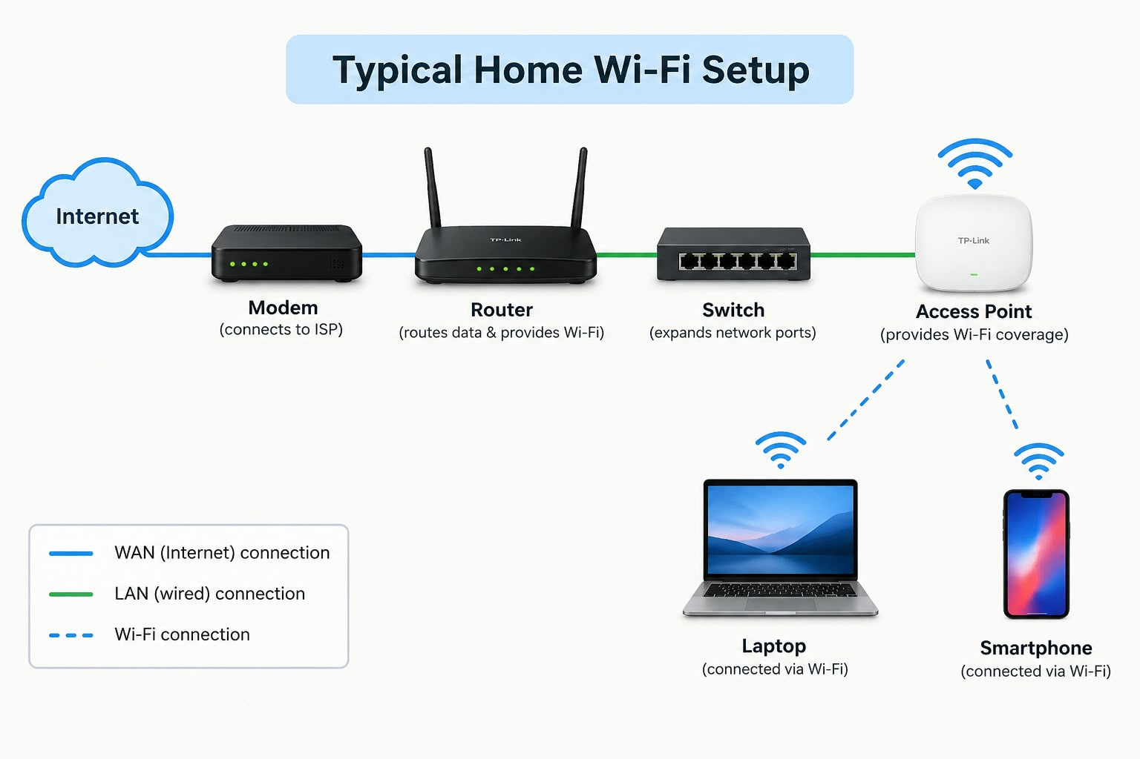
2. List the main function of each networking hardware device: modem, router, switch, access point, and network cable. For each, give a real-life example of where you might see or use it (for example, 'router: at home to share internet').
1. Modem
Function: It connects your home to the Internet.
Example: At home, the modem receives Internet from your ISP.
2. Router
Function: It shares the Internet with many devices.
Example: At home, a router gives Internet to your phone and laptop.
3. Switch
Function: It connects many devices using network cables.
Example: In an office, a switch connects many computers.
4. Access Point
Function: It provides or extends Wi-Fi coverage.
Example: In a school or office, an access point provides Wi-Fi in different rooms.
5. Network Cable
Function: It connects devices for a wired network.
Example: An Ethernet cable connects a computer to a router.
Real-Life Examples

1. Modem:
At home, a modem receives the Internet connection from an ISP such as Jio, Airtel or BSNL.

2. Router:
At home, a Wi-Fi router shares the Internet with smartphones, laptops, smart TVs and other devices.

3. Switch:
In an office, a switch connects many computers, printers and other devices using Ethernet cables.

4. Access Point:
In a school, office or large house, an access point provides Wi-Fi in areas where the main router's Wi-Fi signal is weak.

5. Network Cable:
At home or in an office, an Ethernet cable connects a computer to a router or switch for a wired Internet connection.
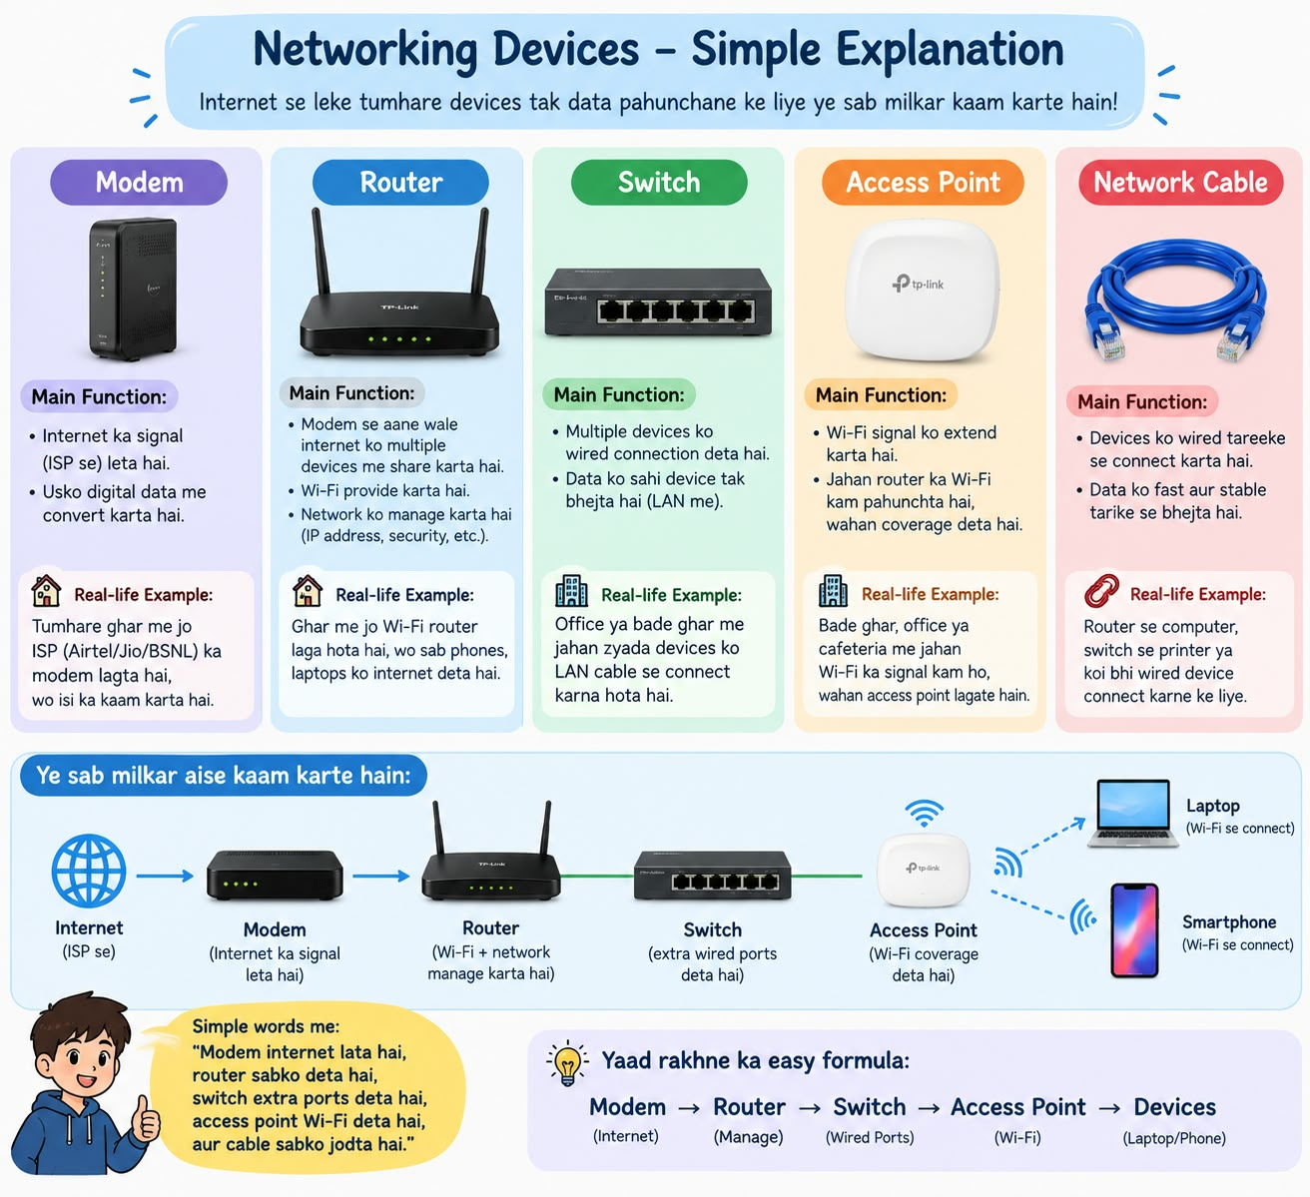
3.
Take photos or find images online (with source links) of at least three types of network cables (such as Ethernet, coaxial, fiber optic) and write one line describing where each is commonly used.

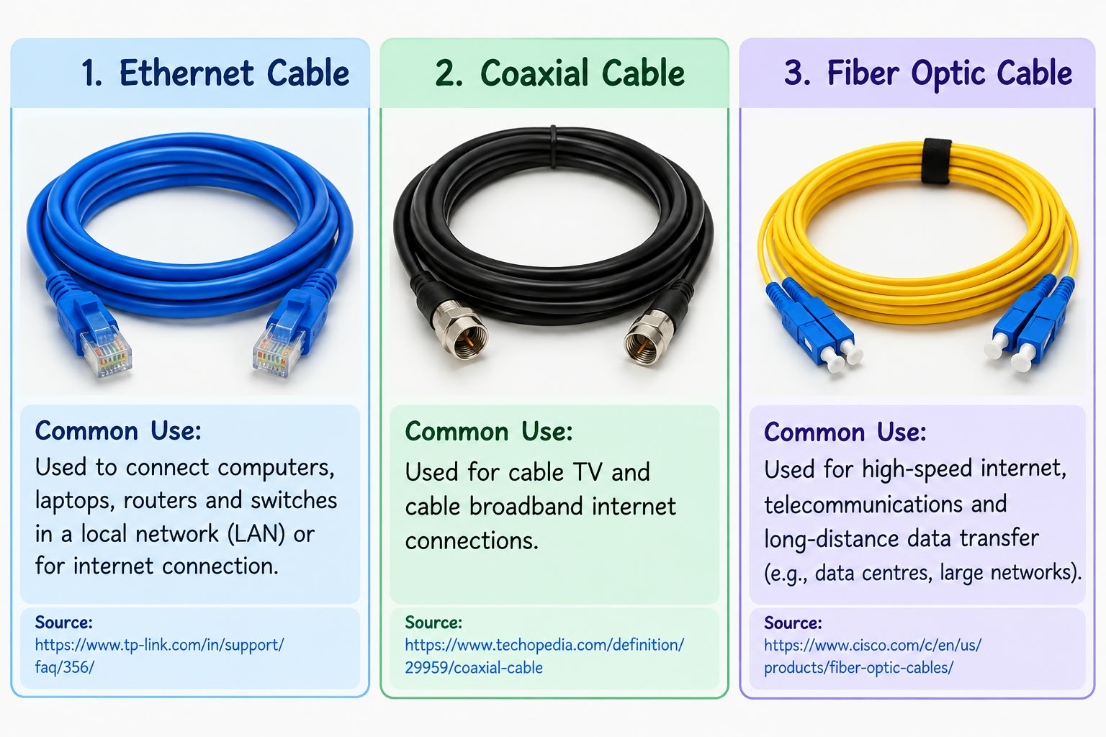

4.Create a comparison table listing at least four differences between a router and a switch, including their main use, typical location, and how they handle data.
Feature | Router | Switch
Main use | Connects different networks and directs traffic between them | Connects devices within the same network
Typical location | Between a local network and the internet/WAN | Inside a local area network (LAN)
How it handles data | Routes packets between different networks using IP addresses | Forwards frames between devices using MAC addresses
Primary layer | Mainly operates at Layer 3 (Network) | Mainly operates at Layer 2 (Data Link)
Example connection | Connects a home/office LAN to the internet | Connects PCs, printers, and servers within an office LAN

