Software Testing Assignment - Module­­_3

1. What is RDBMS?

The software used to store, manage, query, and retrieve data stored in a relational database is called a relational database management system (RDBMS).

The RDBMS provides an interface between users and applications and the database, as well as administrative functions for managing data storage, access, and performance.

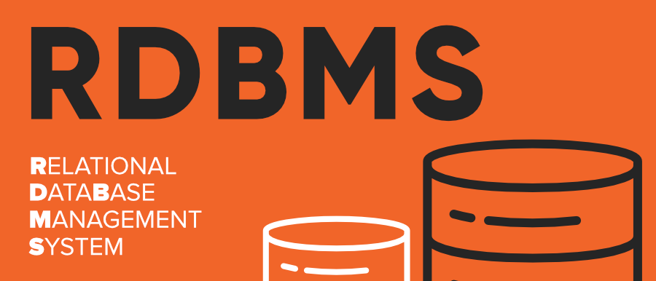

Advantages of RDBMS:

* Flexibility: Tables and relationships can be easily modified.
* Scalability: RDBMSs are capable of handling large amounts of data efficiently.
* Data Integrity: Constraints and rules ensure that the data remains accurate and consistent.
* Security: RDBMSs offer robust mechanisms for data security, such as access control and user permissions.

2. What is SQL.

SQL stands for Structured Query Language.

SQL is a standard language for storing, manipulating and retrieving data in databases.

SQL allows you to access and manipulate the databases. To use SQL in: MySQL, SQL Server, MS Access, Oracle, Sybase, Informix, Postgres, and other database systems.

Database

Table

Columns(Field)

Records(rows)

e.g

Database : Employee_db

Table : Employee

Emp_id Emp_Name Salary Dept

---------------------------------------------------

101 dhrumil 30000 Sales

3. Write SQL Commands.

These SQL command is cauterized into five types are:

1. DDL (Data Definition Language)

2. DQL (Data Query Language)

3. DML (Data Manipulation Language)

4. DCL (Data Control Language)

5. TCL (Transaction Control Language)

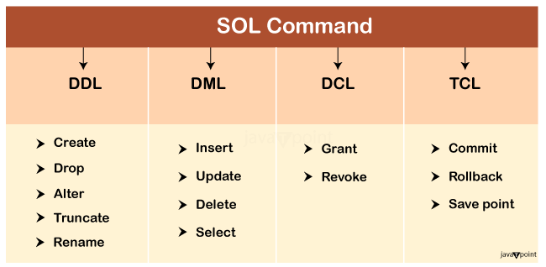

4. What is join?

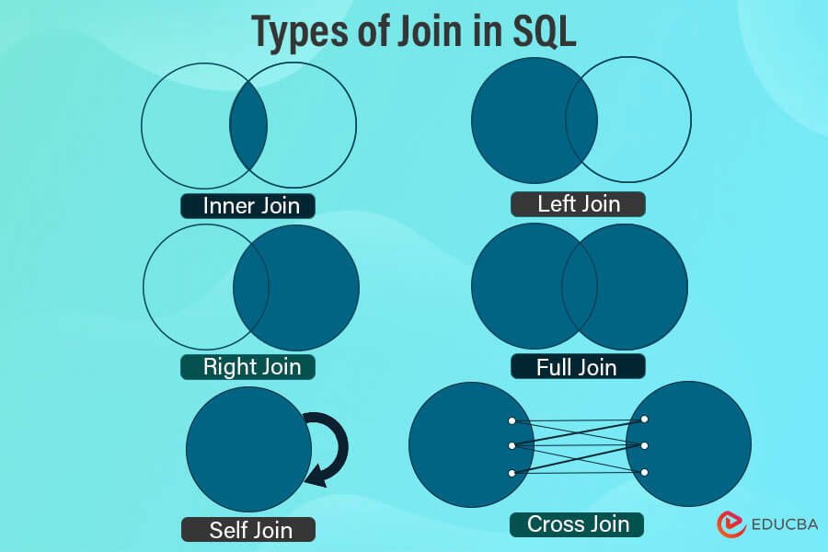

A JOIN clause is used to combine rows from two or more tables, based on a related column between them.

The join keyword merges two or more tables and creates a temporary image of the merged table. Then according to the conditions provided, it extracts the required data from the image table, and once data is fetched, the temporary image of the merged tables is dumped.

5. Write type of joins.

Different types of SQL joins are there:

1. INNER JOIN: The INNER JOIN keyword selects all rows from both the tables as long as the condition is satisfied. This keyword will create the result-set by combining all rows from both the tables where the condition satisfies i.e value of the common field will be the same.

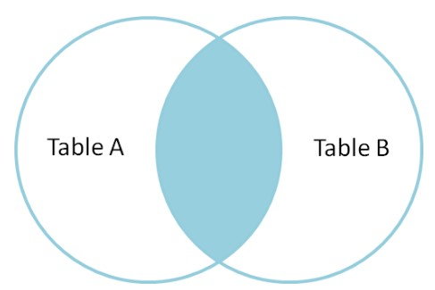

select product.pro_id, product.Pro_name, category.Cat_Name from product INNER JOIN category on product.Cat_ID=category.Cat_ID;

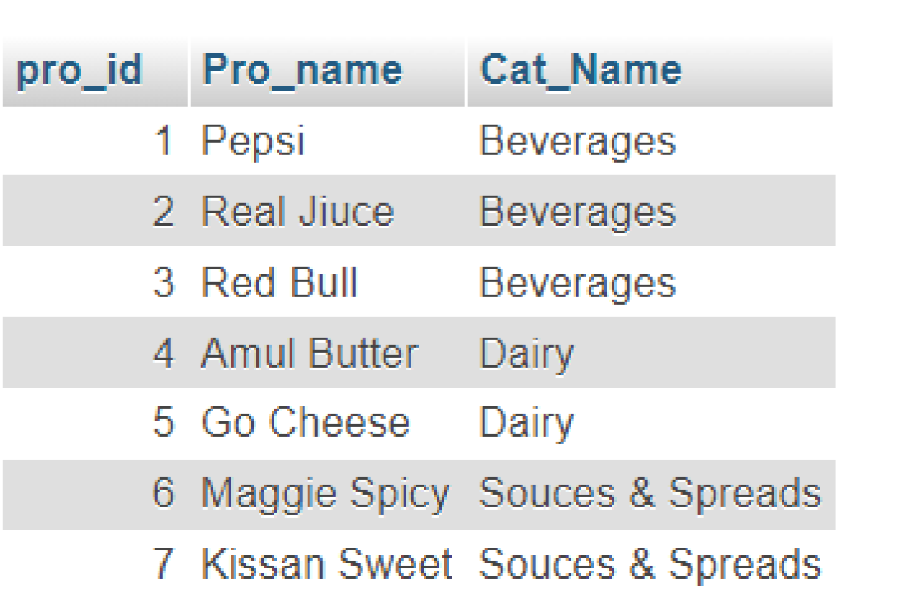

# LEFT JOIN :

This join returns all the rows of the table on the left side of the join and matches rows for the table on the right side of the join. For the rows for which there is no matching row on the right side, the result-set will contain null. LEFT JOIN is also known as LEFT OUTER JOIN.

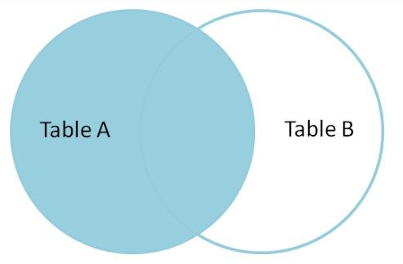

select category.Cat_Name, product.Pro_name from category LEFT OUTER JOIN product on product.Cat_ID = category.Cat_ID;

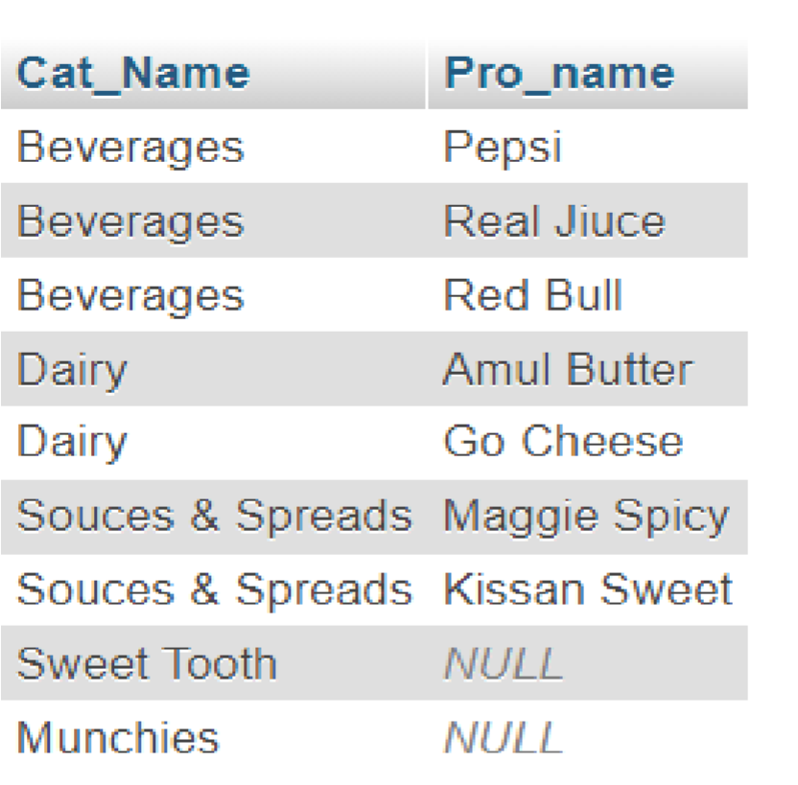

# 3. RIGHT JOIN :

RIGHT JOIN is similar to LEFT JOIN. This join returns all the rows of the table on the right side of the join and matching rows for the table on the left side of the join. For the rows for which there is no matching row on the left side, the result-set will contain null. RIGHT JOIN is also known as RIGHT OUTER JOIN.

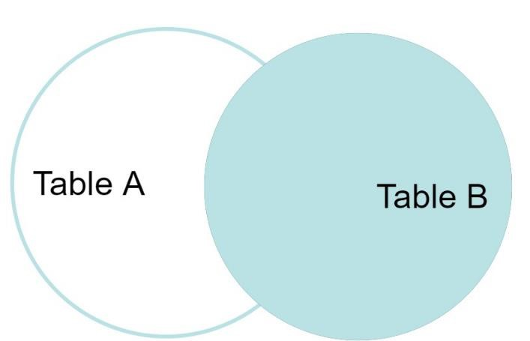

select category.Cat_Name, product.Pro_name from category RIGHT

OUTER JOIN product on product.Cat_ID = category.Cat_ID;

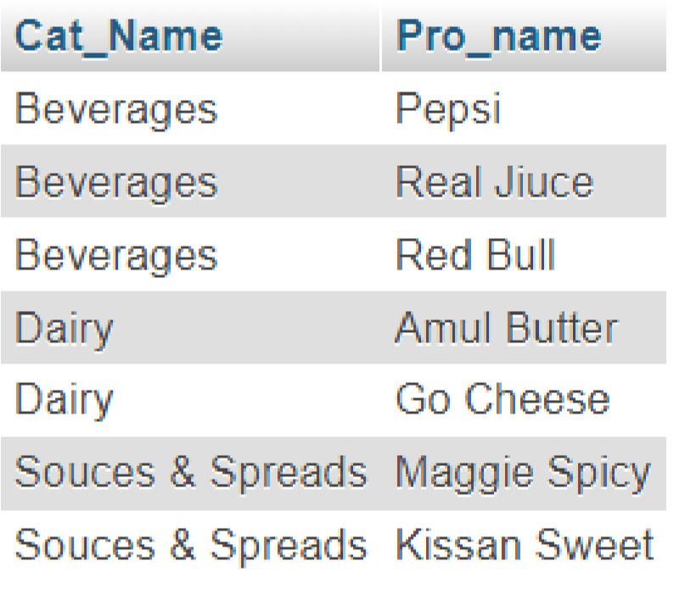

# 4. FULL JOIN :

FULL JOIN creates the result-set by combining results of both LEFT JOIN and RIGHT JOIN. The result-set will contain all the rows from both tables. For the rows for which there is no matching, the result-set will contain NULL values.

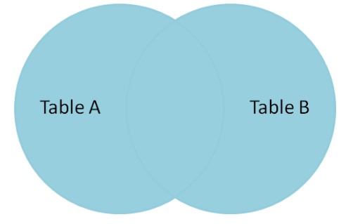

select category.Cat_Name, product.Pro_id from category FULL JOIN product on product.Cat_ID=category.Cat_ID;



6. How Many constraint and describes itself.

* SQL constraints are used to specify rules for the data in a table.
* Constraints are used to limit the type of data that can go into a table. This ensures the accuracy and reliability of the data in the table. If there is any violation between the constraint and the data action, the action is aborted. Returns records that have matching values in both tables.

The following constraints are commonly used in SQL:

* NOT NULL - Ensures that a column cannot have a NULL value
* UNIQUE - Ensures that all values in a column are different
* PRIMARY KEY - A combination of a NOT NULL and UNIQUE. Uniquely identifies each row in a table
* FOREIGN KEY - Prevents actions that would destroy links between tables
* CHECK - Ensures that the values in a column satisfies a specific condition
* DEFAULT - Sets a default value for a column if no value is specified
* CREATE INDEX - Used to create and retrieve data from the database very quickly.

# 1. SQL NOT NULL Constraint :

* By default, a column can hold NULL values.
* The NOT NULL constraint enforces a column to NOT accept NULL values.
* This enforces a field to always contain a value, which means that you cannot insert a new record, or update a record without adding a value to this field.

|  |
| --- |
| CREATE TABLE Persons  (  ID int NOT NULL,  LastName varchar(255) NOT NULL,  FirstName varchar(255) NOT NULL,  Age int  ); |

# 2. SQL UNIQUE Constraint:

* The UNIQUE constraint ensures that all values in a column are different.
* Both the UNIQUE and PRIMARY KEY constraints provide a guarantee for uniqueness for a column or set of columns.

CREATE TABLE Persons

(

ID int NOT NULL UNIQUE,

LastName varchar(255) NOT NULL,

FirstName varchar(255),

3. SQL PRIMARY KEY Constraint :

* The PRIMARY KEY constraint uniquely identifies each record in a table.
* Primary keys must contain UNIQUE values, and cannot contain NULL values.
* A table can have only ONE primary key; and in the table, this primary key can consist of single or multiple columns (fields).

CREATE TABLE Persons

(

ID int NOT NULL PRIMARY KEY,

LastName varchar(255) NOT NULL,

FirstName varchar(255),

Age int

);

4. SQL FOREIGN KEY Constraint :

* The FOREIGN KEY constraint is used to prevent actions that would destroy links between tables.
* A FOREIGN KEY is a field (or collection of fields) in one table, that refers to the [PRIMARY KEY](https://www.w3schools.com/sql/sql_primarykey.asp) in another table.
* The table with the foreign key is called the child table, and the table with the primary key is called the referenced or parent table.

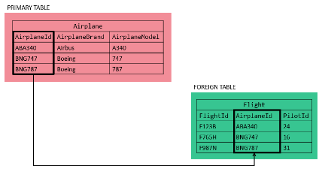

CREATE TABLE Orders (

OrderID int NOT NULL,

OrderNumber int NOT NULL,

PersonID int,

PRIMARY KEY (OrderID),

FOREIGN KEY (PersonID) REFERENCES Persons(PersonID)

);

CREATE TABLE Orders (

OrderID int NOT NULL PRIMARY KEY,

OrderNumber int NOT NULL, PersonID int FOREIGN KEY REFERENCES Persons(PersonID) );

5. SQL CHECK Constraint :

* The CHECK constraint is used to limit the value range that can be placed in a column.
* If you define a CHECK constraint on a column it will allow only certain values for this column.
* If you define a CHECK constraint on a table it can limit the values in certain columns based on values in other columns in the row.

CREATE TABLE Persons (

ID int NOT NULL,

LastName varchar(255) NOT NULL,

FirstName varchar(255),

Age int CHECK (Age>=18)

);

6.  SQL DEFAULT Constraint :

* The DEFAULT constraint is used to set a default value for a column.
* The default value will be added to all new records, if no other value is specified.

CREATE TABLE Persons (

ID int NOT NULL,

LastName varchar(255) NOT NULL,

FirstName varchar(255),

Age int,

City varchar(255) DEFAULT 'Sandnes'

);

CREATE TABLE Orders (

ID int NOT NULL, OrderNumber int NOT NULL,

OrderDate date DEFAULT GETDATE()

);

7. Difference between RDBMS vs DBMS.

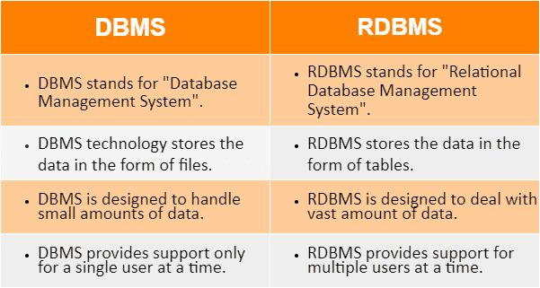

8. What is API Testing.



Application Programming Interface testing, is a software testing process that verifies the functionality, security, performance, and reliability of an API:

* What it does

API testing involves sending requests to an API and checking the responses to ensure they match the expected results.

* Why it's important

API testing is critical for automating testing because APIs are the primary interface to application logic. It can also help improve the efficiency of your testing strategy and deliver software faster.

* How it works

API testing can be performed directly on the API or as part of integration testing.

* Types of API testing

There are many types of API testing, including validation testing and UI testing.

9. Types of API Testing:

Mainly 3 types of API testing:-

Open APIs: These types of APIs are publicly available to use like OAuth APIs from Google. It has also not given any restriction to use them. So, they are also known as Public APIs.

Partner APIs: Specific rights or licenses to access this type of API because they are not available to the public.

Internal APIs: Internal or private. These APIs are developed by companies to use in their internal systems. It helps you to enhance the productivity of your teams.

10. What is Responsive Testing?



Responsive testing involves how a website or web application looks and behaves on different devices, screen sizes, and resolutions. The goal of responsive testing is to ensure that the website or web application can be used effectively on various devices, including desktops, laptops, tablets, and smartphones.

11. Which types of tools are available for Responsive Testing.

Responsive Testing Tools

* LT Browser
* Lembda Testing
* Google Resizer
* am I responsive
* Pixel tuner

For Ex :<https://ui.dev/amiresponsive>

12. What is the full form of .IPA , .APK ?

IPA :- iOS package App, international phonetic alphabet

APK :- Android Application Package kit

13. How to create step for to open the developer option mode ON?

Step 1: Go to Settings >my Phone.

Step 2: Tap Software Info > Build Number.

Step 3: Tap Build Number seven times. After the first few taps, you should see the steps counting down until you unlock the developer options. You may also have to tap in your PIN for verification.

Step 4: Once developer options are activated, you will see a message that reads, You are now a developer.

Step 5: Go back to the Settings pane, where you will now find Developer options as an entry.

Step 6: Tap it and toggle (USB debugging) the switch on if it is not already, and from there, you can proceed to make adjustments to your phone.

