Software Testing Assignment - Module­­_4

# **1.Which components have you used in Load Runner?**

LoadRunner is a performance testing tool that uses several components to simulate user activity, measure system performance, and analyze results. Some of the key components used in LoadRunner include:

1. Virtual User (V-user) scripts
2. Controller
3. Load Generators
4. Analysis

These components work together to simulate user activity, measure performance, and analyze results.

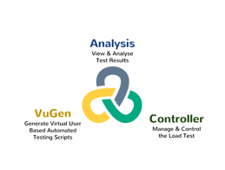

# **2.How can you set the number of Vusers in Load Runner?**

In LoadRunner, we can set the number of Vusers in the following ways:

* **Controller:** In the Controller, go to "Scenario" > "Vusers" and set the "Number of Vusers" field.
* **Runtime Settings:** In the Vuser script, go to "Runtime Settings" > "General" and set the "Number of Vusers" field.
* **Command Line:** Use the command line option "-n" followed by the number of Vusers, for example: "lr -n 10".

Note: The number of Vusers can also be controlled through the LoadRunner API and through external automation tools.

# **3.What is Correlation?**

correlation is the process of capturing and replacing dynamic values in a script with unique values for each virtual user (Vuser). This ensures that each Vuser interacts with the application independently, simulating real-user behavior.

* Handle session IDs, tokens, and other unique identifiers
* Simulate unique user inputs, like usernames and passwords
* Capture and reuse dynamic data, such as timestamps or order numbers

By correlating dynamic values, you ensure that your load test accurately reflects real-world usage and avoids errors caused by duplicate or hardcoded values.

# **4.What is the process for developing a Vuser Script?**

The process for developing a Vuser script in LoadRunner is:

* **Record:** Capture user interactions with the application using LoadRunner's recording tool.
* **Analyze:** Review the recorded script, identify dynamic values, and determine what needs to be correlated.
* **Parameterize:** Replace dynamic values with parameters to enable unique data for each Vuser.
* **Correlate:** Capture and replace dynamic values with correlated data.
* **Script Enhancement:** Add think time, loops, conditional statements, and other logic to simulate realistic user behavior.
* **Verification:** Validate the script's functionality and accuracy.
* **Debug:** Test and debug the script to ensure it runs smoothly.
* **Finalize:** Prepare the script for load testing by setting runtime settings and configuring logging.

This process helps create a robust Vuser script that accurately simulates real-user interactions with the application.

# **5.When to used Usablity Testing?**

Usability testing helps ensure a positive user experience, identify areas for improvement, and inform design decisions throughout the product development lifecycle.

# **6.How Load Runner interacts with the application?**

LoadRunner uses software agents called "protocols" to communicate with the application. These protocols mimic real-user interactions by sending requests to the application's servers and receiving responses. The protocols used depend on the application's architecture and technology stack.

Here's how it works:

1. **application Selection:** LoadRunner selects the appropriate protocol (e.g., HTTP, Web Services, Citrix) based on the application's technology.
2. **Script Recording:** LoadRunner records user interactions with the application using the selected protocol, capturing requests and responses.
3. **Script Replay:** During load testing, LoadRunner replays the recorded script, sending requests to the application's servers using the same protocol.
4. **Request/Response:** The application processes the requests and sends responses back to LoadRunner, which analyzes the responses to verify functionality and performance.
5. **Data Correlation:** LoadRunner correlates dynamic data, such as session IDs or tokens, to ensure each virtual user interacts with the application independently.
6. **Generate Load:** LoadRunner generates a large volume of virtual users, each executing the script and interacting with the application, simulating real-world usage.

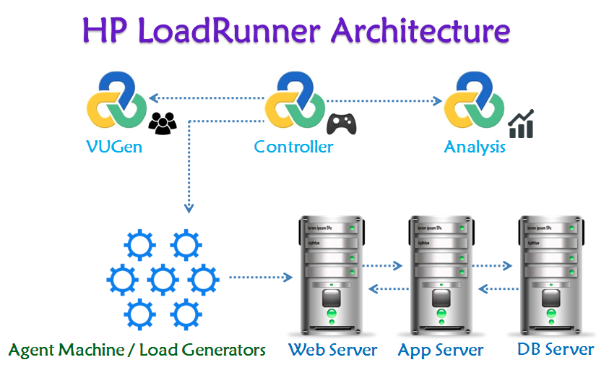

# **7.How many V-Users are required for load testing?**

The number of VUsers (Virtual Users) required for load testing depends on several factors, including:

**1. Expected user load:** Estimate the number of real users who will be using the application simultaneously.

**2. Application complexity:** More complex applications may require more VUsers to simulate realistic usage.

**3. Test goals:** Identify what you want to achieve with load testing (e.g., peak performance, stress testing).

**4. Hardware resources:** Ensure the load testing environment can handle the desired number of VUsers.

Here are some general guidelines:

* **Low-load testing:** 10-50 VUsers (e.g., small applications, development testing)
* **Medium-load testing (Stress):** 50-200 VUsers (e.g., medium-sized applications, performance testing)
* **High-load testing (Scalability):** 200-1,000 VUsers (e.g., large applications, stress testing)
* **Extreme-load testing (flood):** 1,000+ VUsers (e.g., very large applications, extreme stress testing)

Remember, the key is to simulate realistic user behavior and gradually increase the load to measure the application's performance and identify bottlenecks.

# **8.What is the relationship between Response Time and Throughput?**

Response Time and Throughput are two related but distinct performance metrics:

* **Response Time:** The time it takes for an application to respond to a user request or action. It measures how long a user must wait for a response.
* **Throughput:** The number of user requests or actions an application can handle within a given time period (e.g., transactions per second).

The relationship between Response Time and Throughput is:

* Inverse correlation: As Throughput increases (more requests handled), Response Time typically decreases (faster responses).
* Trade-off: Improving one metric can impact the other. For example, optimizing for faster Response Times might reduce Throughput, and vice versa.
* Balance: Aim for a balance between Response Time and Throughput to ensure a good user experience and efficient system performance.
* In load testing, analyzing both Response Time and Throughput helps identify performance bottlenecks and optimize application performance.

# **9.What determines the level of risk?**

The level of risk is determined by several factors, which can vary depending on the context and type of risk.

* How likely something is to happen **(probability)**
* How bad the outcome could be **(impact)**
* How vulnerable you are to harm **(vulnerability)**
* Whether there are safeguards in place **(mitigating factors)**

# **10.Mention what are the categories of defects?**

Defects can be categorized into several types, including:

* **Critical:** The defects will cause downstream damage.
* **Major:** The defects could cause a downstream damage.
* **Minor:** The defects are highly unlikely to cause the downstream damage

# **11.Difference between Priority and Severity**

|  |  |
| --- | --- |
| **Priority** | **Severity** |
| Refers to the impact or potential impact of a defect on the system, user, or business. | Refers to the order in which defects should be addressed or fixed |
| Measures the potential damage or risk caused by the defect. | Determines the urgency and importance of resolving the defect. |
| Typically categorized as:  - Critical (High)  - Major (Medium)  - Minor (Low) | Typically categorized as:  - High (Must-fix, critical)  - Medium (Should-fix, important)  - Low (Nice-to-fix, minor) |
| Typically set by project managers, business stakeholders, or customer support based on business needs. | Usually determined by the technical team (developers, QA testers) based on system behavior and code impact. |

# **12.What is Bug Life Cycle?**

The Bug Life Cycle, also known as the Defect Life Cycle, is the process that a bug or defect goes through from the time it is detected to the time it is resolved. The typical stages of the Bug Life Cycle are:

* **New:** The bug is detected and reported.
* **Assigned:** The bug is assigned to a team or individual for further investigation.
* **Open:** The bug is confirmed and accepted for fixing.
* **In Progress:** Work on resolving the bug has started.
* **Resolved:** The bug is fixed and verified.
* **Verified:** The fix is tested and confirmed to be correct.
* **Closed:** The bug is closed, and the issue is considered resolved.
* **Reopened:** If the bug reappears or the fix is incomplete, it is reopened.

This life cycle ensures that bugs are properly tracked, managed, and resolved in a systematic and efficient manner.

# **13.What is priority?**

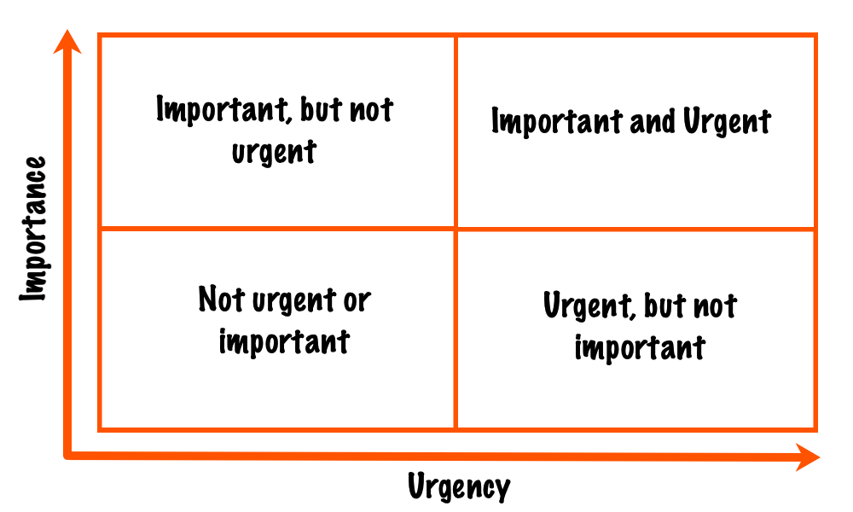If you are raising any bug for any application, how soon you want the developer to fix that the system, it’s called priority.

Priority refers to the level of importance assigned to a task, bug, or issue, determining the order in which it should be addressed or resolved.

High (Critical), Medium (Major), Low (Minor)

# **14.What is severity?**

The impact of defect on the customer business workflow is known as severity.

Severity refers to the potential impact or damage that a bug, defect, or issue can cause to a system, application, user, or business.

Critical (High), Major (Medium), Minor (Low), Trivial (Very Low)

# **15.Advantage of Bugzila.**

Bugzilla's advantages make it a popular choice for bug tracking and management in software development teams.

* **Open-source:** Free to use and modify.
* **Customizable:** Tailor it to your team's needs.
* **Scalable:** Handles large numbers of bugs and users.
* **User-friendly:** Intuitive interface for easy bug tracking.
* **Searchable:** Powerful search functionality for quick bug lookup.
* **Reporting:** Generate detailed reports on bug trends and metrics.
* **Collaboration:** Assign, track, and discuss bugs with team members.
* **Version control:** Track bugs across different product versions.
* **Security:** Granular access control and security features.
* **Community support:** Active community and extensive documentation.
* **Integration:** Integrates with various tools and platforms.
* **Stability:** Reliable and stable bug tracking system.