**File Name: Automated Drone News LinkedIn Publisher**

* **Full Name:** Dhrumil Pawar
* **Phone Number:** (+91) 9904191054
* **Date of Birth:** 29/10/2003
* **Educational Details:**
* Degree: Bachelor Of Technology
* Branch: Computer Science
* College/University: ITM(SLS) Baroda University
* Year: 2025
* **GitHub Repository Link :**  
  link : [https://github.com/dhrumil1128/Automated-Drone-News-LinkedIn-Publisher](https://github.com/dhrumil1128/Automated-Drone-News-LinkedIn-Publisher?utm_source=chatgpt.com)
* **Screenshots :**  
  (All available under the /screenshots folder inside the repo.)

1. **n8n Workflow :**

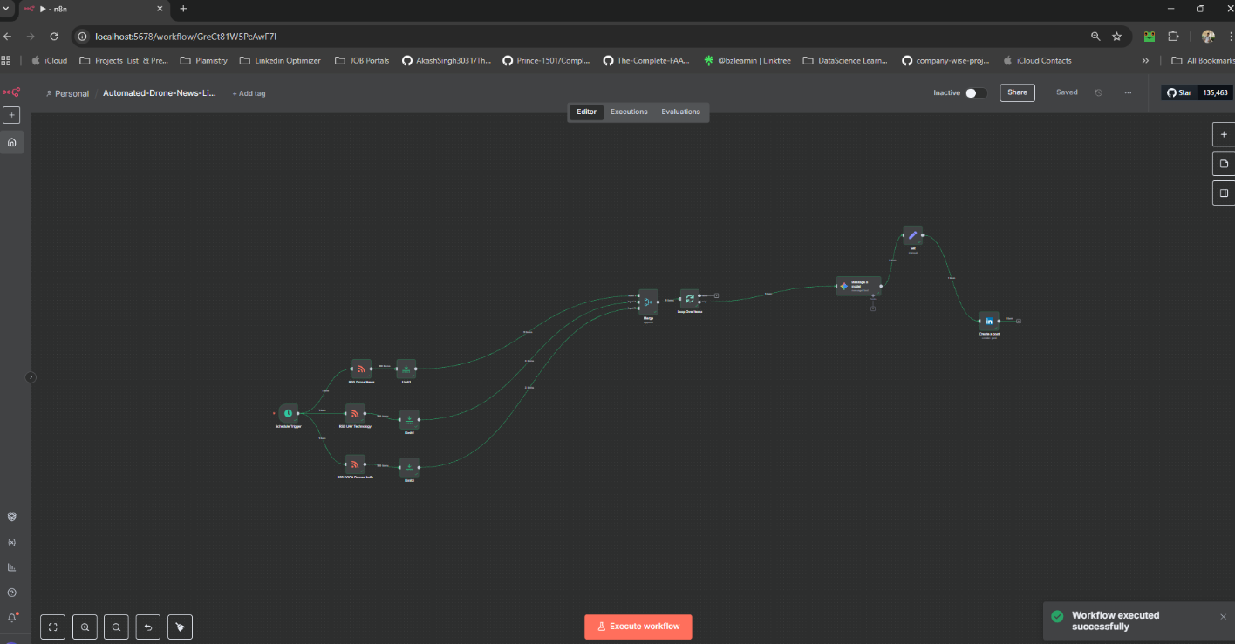

1. **Gemini Output(JSON) :**

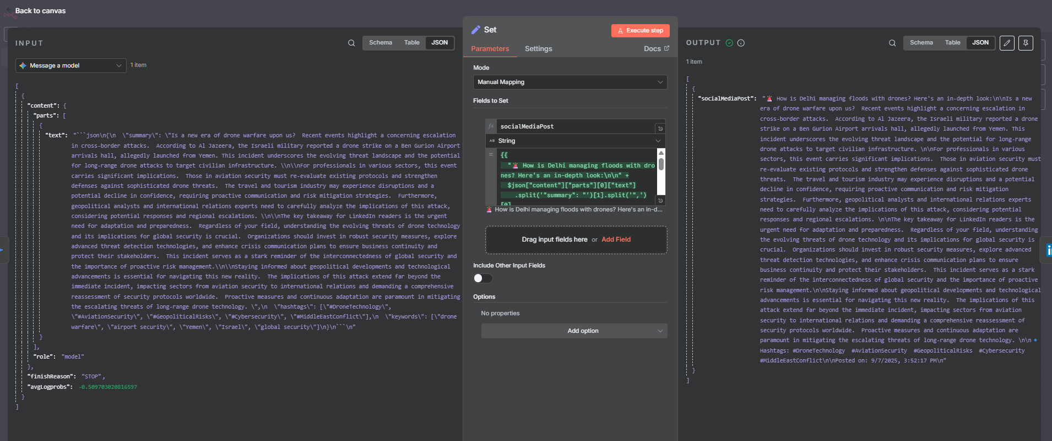

1. **LinkedIn Post :**

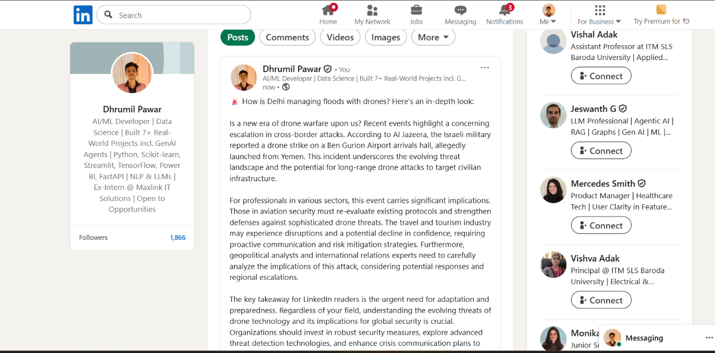

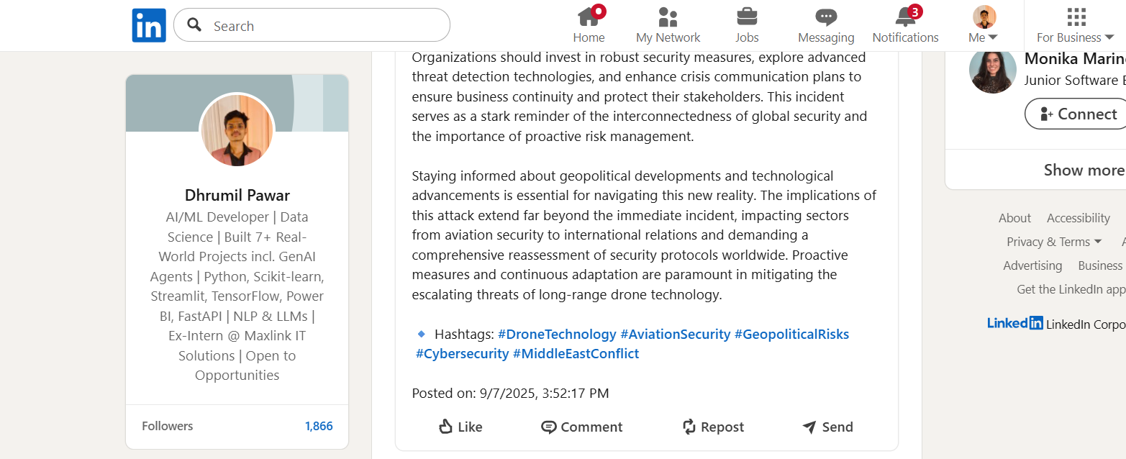

* **Availability:**
* Working Days: Monday – Saturday
* Working Hours: 10:00 AM – 6:00 PM IST
* **Preferred Interview Slots:**
* Morning Slot: 10:30 AM – 3:30 AM IST
* Evening Slot: 5:30 PM – 6:00 PM IST