Name: ______________________________________ Date: ________________________

**Student Exploration:** **Cell Structure**

**Vocabulary:** cell membrane, cell wall, centriole, chloroplast, cytoplasm, endoplasmic reticulum, Golgi apparatus, lysosome, mitochondria, nuclear membrane, nucleolus, nucleus, organelle, plastid, ribosome, vacuole, vesicle

**Prior Knowledge Questions** (Do these BEFORE using the Gizmo.)

1. What are some of the structures inside a cell that help it to live and perform its role in an organism? Nucleus, mitochondria, ribosomes
2. How do you think plant cells differ from animal cells? (Hint: What can plants do that animals cannot?) Plants do photosynthesis so they have chloroplasts, cell wall

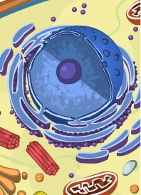

**Gizmo Warm-up**

The *Cell Structure* Gizmo allows you to look at typical animal and plant cells under a microscope. On the ANIMAL CELL tab, click **Sample** to take a sample of an animal cell. Use the **Zoom** slider to see the cell at a magnification of 2000x (2000 times larger than normal). On the dropdown menu, select **Centrioles**.

1. Use the up/down and left/right sliders to manipulate the cell. Find the red arrow pointing to the **centrioles**. Make a sketch of the centrioles in the space below.

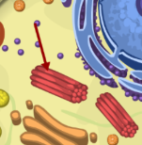

1. Read the description of the centrioles. What is their function?

These bundles of microtubules play a role in organizing the movement of chromosomes during cell division.

|  |  |  |
| --- | --- | --- |
| **Activity A:**  **Animal cells** | Get the Gizmo ready:   * Check that an **Animal cell** is mounted on the microscope. * Check that the **Zoom** is set to 2000x. | Untitled-5 |

**Question: Organelles are specialized structures that perform various functions in the cell. What are the functions of the organelles in an animal cell?**

1. Label: Locate each organelle in the animal cell. Label the organelles in the diagram below.

Nuclear membrane

Nucleolus

vacuole

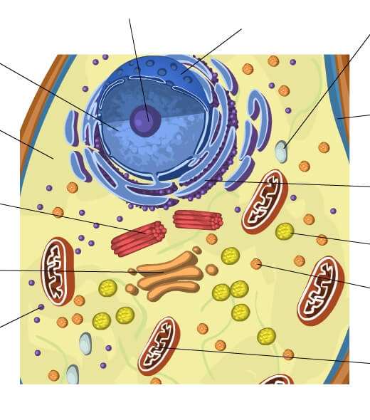

Golgi apparatus

mitochondria

Cell membrane

ER

lysosome

vesicles

ribosomes

centriole

cytoplasm

nucleus

1. Match: Read about each organelle. Then match each organelle to its function/description.

_H__ **Cytoplasm**

__E_ **Lysosome**

_F__ **Mitochondria**

__A__ **Centriole**

__B__ **Endoplasmic reticulum**

_M__ **Vacuole**

_D__ **Cell membrane**

_J__ **Nucleus**

_L__ **Ribosome**

_C__ **Nuclear membrane**

_G__ **Golgi apparatus**

____ **Vesicle**

_I__ **Nucleolus**

1. Structure that organizes motion of chromosomes.
2. Stack of membranes that packages chemicals.
3. Membrane that protects the nucleus.
4. Membrane that surrounds and protects the cell.
5. Sac filled with digestive chemicals.
6. Structures that converts nutrients to energy.
7. Passageways where chemicals are made.
8. Jelly-like substance within the cell membrane.
9. Structure that manufactures ribosomes.
10. Structure that contains DNA and regulates genes.
11. Package created by the Golgi apparatus.
12. Small structure that synthesizes proteins.
13. Sac that stores water, nutrients, or waste products.

|  |  |  |
| --- | --- | --- |
| **Activity B:**  **Plant cells** | Get the Gizmo ready:   * Select the PLANT CELL tab, and click **Sample**. * Set the **Zoom** to 2000x. | Untitled-5 |

**Question: What functions do the organelles in a plant cell perform?**

1. Label: Locate each organelle in the plant cell. Label the organelles in the diagram below.

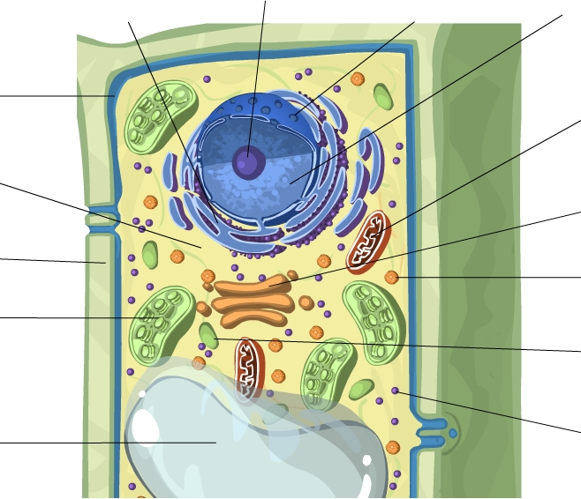

1. Compare: What structures are present in an animal cell, but not in a plant cell? __________

_________________________________________________________________________

What structures are present in a plant cell, but not in an animal cell? __________________

­­­­_________________________________________________________________________

1. Fill in: Name the organelle or organelles that perform each of the following functions.
   1. _____________________ convert sunlight to chemical energy.
   2. The _____________________ and the _____________________ help to support the plant cell and help it to maintain its shape.
   3. _____________________ store food or pigments.
   4. The ­_____________________ converts food into energy. It is found in both plant cells and animal cells.