# BAT4M1 Summative Part A

## The Royal Canadian Mint—Janet Chen

**Products/Services provided**

The Royal Canadian Mint produces all of Canada’s circulation coins: the nickel, dime, quarter, loonie, and toonie. The Royal Canadian Mint also creates circulation coins on behalf of 89 other nations. Alongside producing all of Canada’s circulation coins, the Royal Canadian Mint also produces rare collector coins made from gold, silver, and platinum; bullion coins; and medals, medallions, and tokens. The Mint also offers gold and silver refining and assaying services alongside the production of coins.

**Financial highlights**

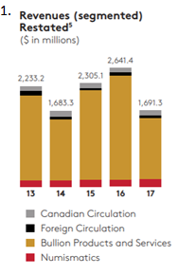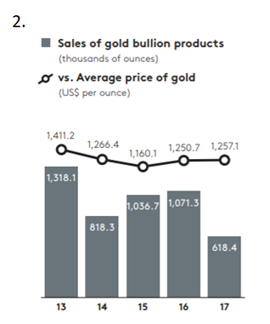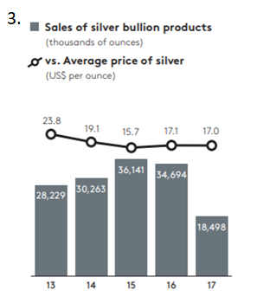

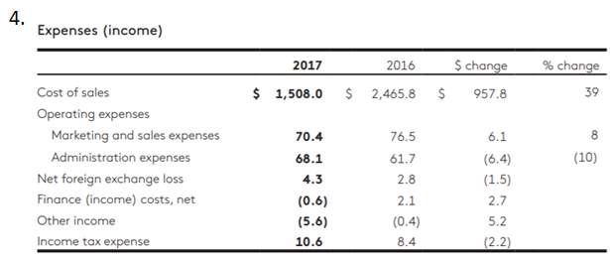

Figures 1, 2, and 3 all refer to the revenue that the Royal Canadian Mint is earning. As seen in Figure 1, the amount of revenue earned in 2017 was drastically lower than in 2016. When examining the different segments of each bar, the Canadian Circulation, International Circulation, and Numismatics sections remained steady; it was the Bullion section that made up the majority of revenue earned by the RCM. This is proven by graphs 2 and 3, which show that total sales of bullion products dropped by almost 50% from 2016 to 2017.

Figure 4 refers to the expenses incurred by the Royal Canadian Mint. What is interesting is that the Royal Canadian Mint paid more income tax this year than it did last year, indicating that it had a higher net income this year despite its revenues dropping significantly.

**Future directions**

According to their 2017 financial statements, the Royal Canadian Mint has 3 corporate objectives for 2018: to strengthen the position of their core mandate; to create a foundation for strong, sustainable performance; and to support their employees and enable them to be successful. Their first objective describes their core mandate, which is to achieve their profit targets while reducing their costs to Canada; this is obviously exemplified by the fact that their cost of sales has dropped significantly since 2016, but they still need to do some work to prevent their revenue from dropping significantly once more.

**SWOT**

|  |  |  |  |
| --- | --- | --- | --- |
| **Strengths** | **Weaknesses** | **Opportunities** | **Threats** |
| **Product differentiation:**  Rare collectible coins made of high-quality pure gold, silver, and platinum. The only authorized maker of Canadian currency coins.  **International recognition:**  Produces circulation coins for lots of countries, owns a patented coin-plating technology which creates superior quality + durability  **Resources:**  Plants in Ottawa, Winnipeg  **Employees:**  From 2007 to 2010, Mediacorp Canada Inc. named the Mint one of “Canada’s Top 100 Employers” | * Main source of revenue is collectible bullion coins—only a few people buy collectible coins vs. how many people use circulation coins * Unsustainable revenue; people are not always going to be interested in collectables * Significant recent changes to business strategies can affect employee morale and business success while changes are made | * Recently, the Federal Finance Department began allowing the RCM to collect revenue from circulation coins again after it stopped in 2015 * This will allow the RCM to gain more revenue from one of its primary focuses * Change of focus to new customer-driven strategy has begun to produce positive results in profitability and company achievements | * Declining public interest in bullion collectible coins resulted in lower revenue * Declining revenue has resulted in less funds and job cuts, thus preventing the RCM from working to gain more revenue * RCM is investing millions in new offices, but will not be reimbursed for those expenses * Market price of precious metals is significantly less than that of RCM’s coins, resulting in weak sales |

**MD&A**

Although revenues decreased from $2641.4 to $1,691.3 between 2016 and 2017, net profit before income tax increased 43% from $30.7 million to $43.9 million, specifically due to improvements in Numismatics and Foreign Circulation areas. The MD&A mentions that revenues from the Canadian Circulation business increased by $2.9 million in 2017 after the amendment which allowed the RCM to collect revenue from Canadian circulation coins, effective December 21, 2016.

Notably, in 2017, revenue earned from the Bullion Products and Services sector of the RCM decreased 42%, from $2.3 billion to $1.4 billion; this was due to decreased demand overall while the average prices of gold and silver remained consistent. Meanwhile, Numismatics and Foreign Circulation revenues both increased by 18% and 1% respectively.

The cost of sales incurred by the RCM decreased 39% from 2016 to 2017, mainly due to the decrease in Bullion revenues in 2017, but also because a different product mix was used for Foreign Circulation coins in 2017 compared to 2016. Otherwise, operating expenses remained consistent, with few anomalies.

The Royal Canadian Mint has many risk management requirements, which are embedded in staff responsibilities. Main risks which could impact the achievement of the RCM’s objectives include changes in shareholder relations, regulations, and requirements; the volatility of the Bullion market, which was felt significantly this year; and the changes of foreign market dynamics.

Overall, the RCM expects demand for Canadian circulation coins and gold and silver bullion to decline in 2018 after Canada’s 150th celebration. The RCM states that it has strong contracted business for its Foreign Circulation areas in 2018 and plans to carefully manage operating costs to mitigate market uncertainty, while focusing on customer strategies and differentiating their­ products in order to maintain their strong market presence.