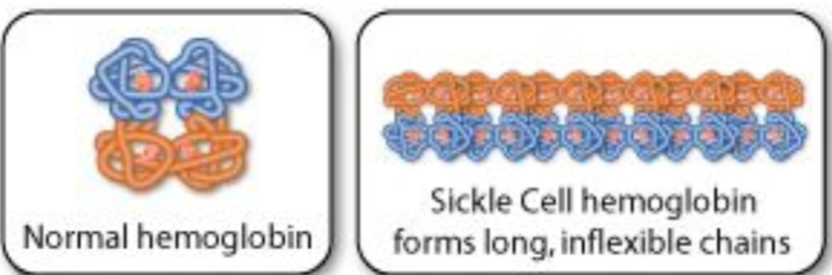
CHAPTER 8 THE ORIGIN OF SPECIES
8.1 NATURAL SELECTION p. 326
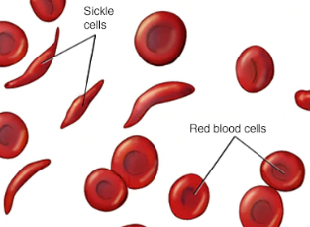
Explain how natural selection favours the sickle-cell trait in some African countries.

In humans, the sickle-cell allele resulted from a single base mutation in the DNA coding for hemoglobin. Individuals who are heterozygous for the allele are resistant to malaria and thus have a better chance of surviving than those who lack the allele.

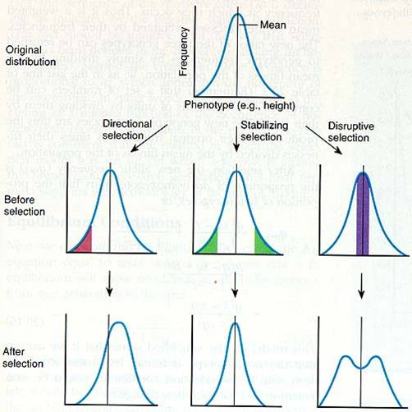
Three Types of Selection Explain each of the following:
Stabilizing Selection selection against individuals exhibiting traits that deviate from the
current population average
Directional Selection selection that favours an increase or decrease in the value of a trait
from the current population average
Disruptive Selection selection that favours two or more variations of a trait that differ
from the current population average
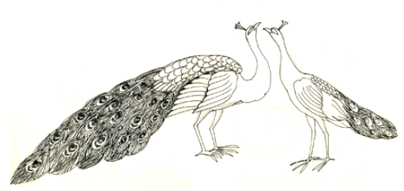
Additionally, there is Sexual Selection differential reproductive success caused by variation in the ability to obtain mates; results in sexual dimorphism, and mating and courtship behaviours
Explain why sexual selection is in check by predation.

Traits such as bright coloration and large antlers can be favoured by sexual selection, they are often a disadvantage when it comes to longevity

Which type of selection led to the following characteristics?
a) hollow and very lightweight bones in birds – directional selection
b) hundreds of different but genetically very similar species of fruit flies living in the Hawaiian Islands
- distributive
c) turtles species that have changed little over millions of years – stabilizing selection
d) males of many frog species that calle very spring, while females are silent – sexual selection
Genetic Drift
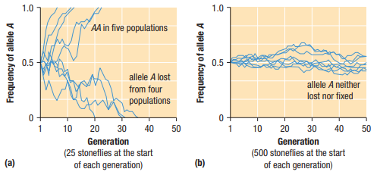
Changes to allele frequency as a result of chance; such changes are much more pronounced in small populations.
Allele fixation = lost alleles.
Any lost alleles result in a net reduction in the genetic diversity of the population.

Differentiate between two types of genetic drift: Bottleneck and Founder Effect.
Bottleneck: A dramatic, often temporary, reduction in population size, usually resulting in significant genetic drift.
Founder’s Effect: genetic drift that results when a small number of individuals separate from their original population and establish a new population
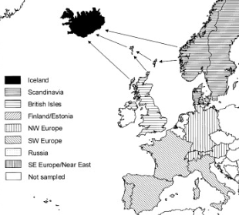
The human population of Iceland was founded by a relatively small initial population more than 1000 years ago. Would you expect the genetic diversity of Icelanders to be more or less than the genetic diversity of Canadians? Explain.
Less – genetic drifts regress towards the same direction
p. 335 #1, 2, 4, 6, 7, 8
1. Frequency of allele combination are a result of natural selection
2. Selection resulted in an increase of population of people that are adapted to high altitudes.
3. A mutation can result in selection of the trait developed from the mutation.
4. Through male comptetition selection, males with greater domincance traits are selected out
6. No need for a directional selection.
7. No - stabalizing selection is still occuring
8. No, females do not attract to that trait as it is common to females as well. It is a stabilizing selection.
8.2 SPECIATION p. 336
Speciation always involves isolation. Explain.
A group is put into a new environment and fixed there so they must adapt to continue.
Explain the following mechanisms which keep separate species distinct:
Reproductive isolating mechanism - any behavioural, structural, or biochemical trait that prevents individuals of different species from reproducing successfully together

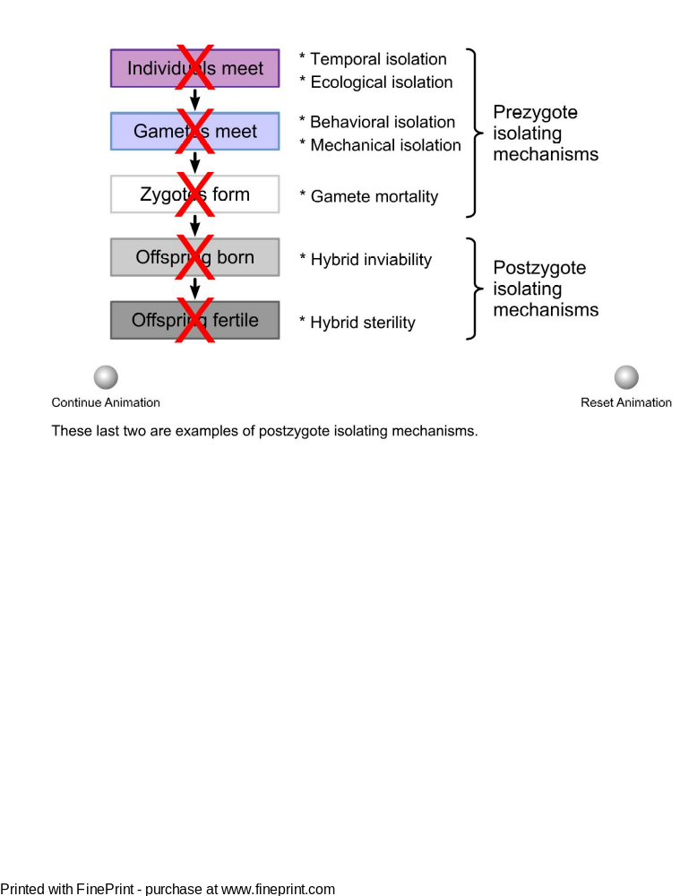
Prezygotic mechanism - a reproductive isolating mechanism that prevents interspecies mating and fertilization (for example, ecological isolation, temporal isolation, and behavioural isolation)

Post zygotic mechanism - a reproductive isolating mechanism that prevents maturation and reproduction in offspring from interspecies reproduction

Define allopatric speciation. - the formation of a new species as a result of evolutionary changes following a period of geographic isolation

Define sympatric speciation.
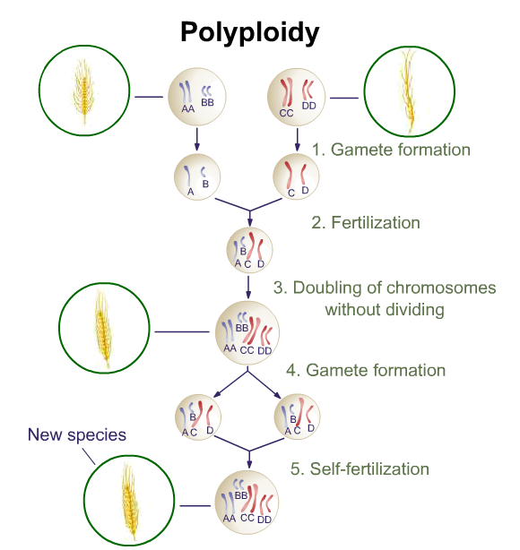
- The evolution of populations within the same geographic area into separate species

Explain polyploidy and hybrid species.
- Polyploidy can result in sympatric speciation. Mutations causing polyploidy double the number of chromosomes in an individual. Polyploids produce fertile offspring when mated with each other but produce sterile offspring when mated with the original species.
Page 340 #1 – 6
1. Morphology, Carbon dating,
2. A) Post zygotic mechanizm
B) Prezygotic mechanism
C) Prezygotic mechanism
D) Reproductive isolating mechanism
E) Reproductive isolating mechanism
3. The practice of isolating groups is the same as allopatric speciation.
4. The larger island – it’s isolation allows for the speciation of more unique species
5. A) With the occurence of allopatric speciation
B) Their speciation will reduce their diversty and then reduce their environmental adaptation
6. A) 2n, increase of chromosome result in sterile
B) Yes, their reduction in genetic diversity is a key piece of evidence
C) They are not able to produce fertile offspring

