8.3 PATTERNS OF EVOLUTION p. 341
Explain adaptive radiation. the relatively rapid evolution of a single species into many new species, filling a variety of formerly empty ecological niches
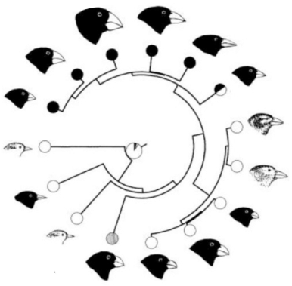
What causes adaptive radiation happen. The process usually occurs when a variety of new resources become available—resources that are not being used by other species.
The colonizing finch of an island faced stabilizing selection on the mainland. Explain.
They evolved into 13 seperate species that compete within each other for a specific seed that outside species do not compete for.

Once the finch arrived at the mainland, over two million years it evolved into at least 15 different species of finch. Explain how adaptive radiation would have happened.
It would have occured if resourses were much more available in variety.
How is the adaptive radiation of cichlid fishes similar to the Galapagos finches? The species are found nowhere else on earth,
Divergent evolution leads to two predictable outcomes…
1. competition between species is minimized as new species diverge to fi ll specialized ecological niches
2. new species continue to evolve until most available resources are used
Convergent evolution is observed amongst different lineages. It is the evolution observed of distantly related species.
Page 345 #1-6
- Resources are unused and species can grow to use facing no competition in the process.
- Variety of resources were not being used and species grew to be able to use them by divergence.
- Based on resources available from environment. Divergent occurs from one species branching out and Convergent occurs from more than one species growing similar.
- A) Divergent B) Allow for greater visibility of each other
- Have lost instinctual predetorial fear as a result of no competition in its environment.
- Dolphins evolved from a mammal parent species and their anatomy work similar to current land mammals. Other fish have evolved from reptile species.
8.5 mACROEVOLTUON p. 348
Macroevolution is large-scale evolutionary changes including the formation of new species and new taxa.
What is thought to be the cause of the mass extinction that caused the extinction of most dinosaurs 65 million years ago? The landing of an asteroid crater.
Briefly discuss the differences between the theory of gradualism and the theory of punctuated equilibrium.
The theory of gradualism states that as new species evolve, they appear very similar to the original species and only gradually become more distinctive. Over long periods of time small changes accumulate, resulting in dramatically different organisms. In situations where the environment changes slowly, evolutionary changes would likely be gradual.

8.7 HUMAN EVOLUTION p. 359
Primates - a group of relatively large-brained, mostly arboreal mammals that includes prosimians, monkeys, apes, and humans
The common ancestor of primates dates back to – 60 million years ago
Based on figure 2, humans are most closely related to which other primate? Chimpanzees
Modern humans evolved around - 6 million years ago
Discuss how cultural practices influenced evolution of humans. Domestication practices resulted in tolerances to many resources.

