Software Requirement Specification Document for

Player & Agent Basketball Web Portal

Submitted To

John Rigatti

Version: 1.0

Date: February 24, 2021

**Prepared By:**

**SPEC USA**

Contents

1. Introduction 4

1.1. Project Objective 4

1.2. Users 4

2. Player 4

2.1. Sign Up 4

2.2. Log In 4

2.3. Dashboard 4

2.4. Player Profile 6

2.5. Edit Profile 7

2.6. Change Password 8

2.7. Search 8

2.8. Saved Profile 10

2.9. Community 12

2.10. Resources Library 13

2.11. Notifications 14

2.12. Messages 14

2.13. Team Open Positions 15

2.14. Top Matches 16

3. Agent 16

3.1. Sign Up 16

3.2. Log In 16

3.3. Dashboard 16

3.4. Agent Profile 17

3.5. Edit Profile 18

3.6. Change Password 18

3.7. Search Profile 19

3.8. Saved Profile 19

3.9. Community 19

3.10. Resource Library 19

3.11. Messages 19

3.12. Notifications 19

4. Coach Module 19

4.1. Sign Up 19

4.2. Log In 19

4.3. Dashboard 19

4.4. Coach Profile 19

4.5. Edit Profile 21

4.6. Change Password 21

4.7. Search Profile 21

4.8. Saved Profile 21

4.9. Manage and Create Team 21

4.10. Manage and Create Open Positions 21

4.11. View Received Players Profile 22

4.12. Reviews 22

5. Content Management Pages 22

5.1. Home 22

5.2. About 22

5.3. FAQ 22

5.4. Join 22

5.5. Contact us 22

5.6. Privacy Policy 22

5.7. Terms condition 22

5.8. Site map 22

6. Queries 22

# Introduction

## Project Objective

This is a requirement specification document for Basketball Web Portal for Agents, Players, and Teams. The proposed web portal is for the basketball agent industry with the target audience being college basketball players, basketball agents, and basketball coach / team / club. The website would need to have search and filter functionality as well as messaging, Community Discussion, Resource Library, and potentially payment processing.

## Users

* Players
* Agents
* Coach / Team / Club: From here onwards we will use the term “Coach”.
* Admin

# Player

## Sign Up

Here on this page agent / player / coach can register themselves on the portal. At the time of registration, we will ask for the basic details Name, Email ID, Contact No, Password, and Re-confirm Password only.

|  |  |  |
| --- | --- | --- |
| Field | Field Type | Field Details |
| Name | Text Box | User needs to enter his name. |
| Email ID | Text Box | User needs to enter his Email ID. |
| Contact No | Text Box | User needs to enter his Contact No. It will be optional field. |
| Password | Text Box | User needs to enter password |
| Re-confirm Password | Text Box | User needs to enter password to re-confirm |
| Submit | Button | User needs to click on this button to register his account. |

#### Business Rules

* Contact no will be optional field and won’t be displayed publicly, only visible when user has logged into portal.

## Log In

#### Field Details

|  |  |  |
| --- | --- | --- |
| Field | Field Type | Field Details |
| Email ID | Text Box | User needs to enter his registered Email ID |
| Password | Text Box | User needs to enter password |
| Submit | Button | User needs to click on this button to login to his account. |

## Dashboard

Here on this screen player can see his dashboard. On the dashboard he will be able to see his recent activities like number of profile views – who has viewed his profile, profile viewed by him, when he appeared in someone’s search, someone responded to them in discussion forum (community), when someone they are following updates their profile, pending follow requests, received new message, when someone opened the message send by this user, when someone refers this user.

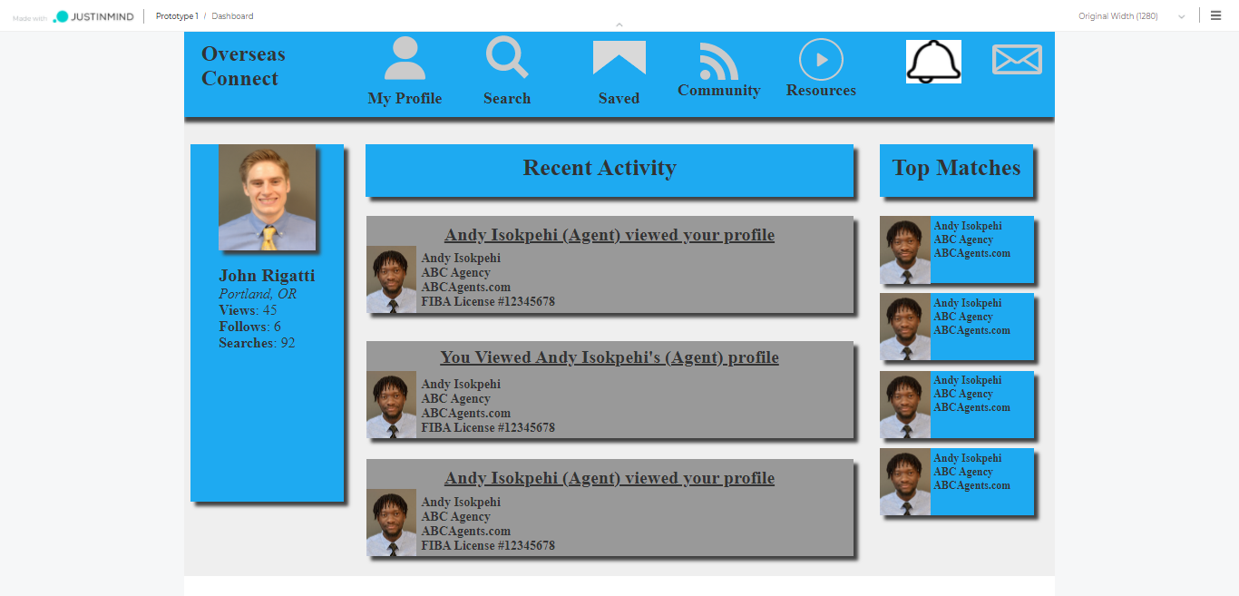

#### Field Details

|  |  |  |
| --- | --- | --- |
| Field | Field Type | Field Details |
| Agent Link | Tile | By clicking on this logo from anywhere, one can go to the dashboard of player log in. |
| My Profile | Tile | On click of this button, user will be redirected to his profile. |
| Search | Tile | To search any of the users on this portal user needs to click on this button. |
| Saved | Tile | By clicking on this button user can view the saved profile of agents, players and coaches by him on this portal. |
| Discussion Forum | Tile | By clicking on this button user can view all posted discussion forum on this portal. |
| Resources Library | Tile | By clicking on this button user can view all posted resource library on this portal. |
| Notifications | Tile | Users can view all the notifications like a new message, new follow requests, new profile views, search appearance, following request acceptance, when someone made changes in the profile that the user is following. |
| Messages / Chat | Tile | All past and new messages along with draft and deleted messages will be shown on this screen. |
| Profile Stats | Tile | Here on this tile, user can see profile’s statistics; Name, Location, No of Views of his profile, No of followers, No of Following, How many times his profile appears in search |
| Recent Activity | Tile | Here user can see who has visited his profile and user has viewed whose profile with basic profile details:  Players: photo, name, height, weight, position, school  Agents: photo, name, agency name, website  Coach: photo, name, location |
| ~~Top Matches~~ | ~~Tile~~ | ~~More Details required on this part.~~ |

#### Business Rules

## Player Profile

Here on this screen player can view his own profile and if required player can edit the same. On the top after all menus, we will show how many percentage of profile is completed.

* Step 1: Photo, Name, Email ID, Contact No, Location
* Step 2: Height, Weight, Position, School
* Step 3: Stats (PPG, RPG, APG, BPG, SPG, FG%, FT%, 3PT%, T/O, GS/GP), Awards, Film, Preferences, Top Skills

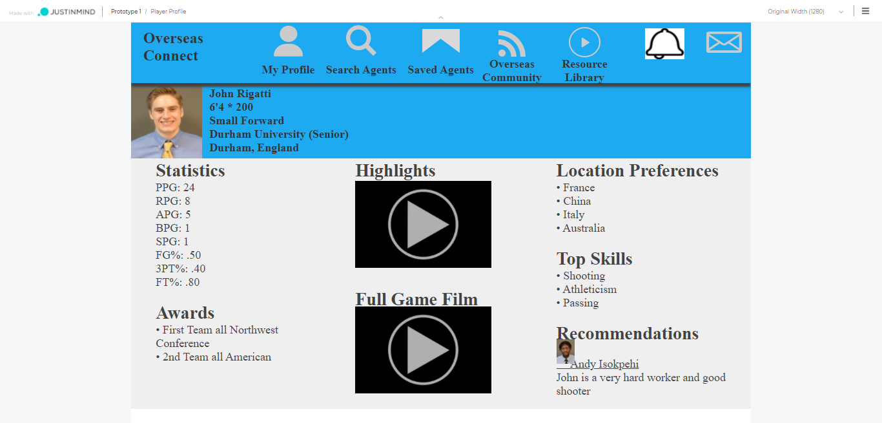

#### Field Details

|  |  |  |
| --- | --- | --- |
| Field | Field Type | Field Details |
| Photo | Label | Player can upload his photo and the same will be displayed |
| Name | Label | Name of the player, one cannot change the name without admin approval; When any user requests for name changes, his request will go to admin for approval. |
| Status | Label | Here player’s current status will be displayed, which he has selected from his profile. |
| Height and Weight | Label | Height and Weight of the player |
| Position | Label | Position of the user in the basketball team |
| School | Label | School of the Player |
| Email ID | Label | Email ID of the player |
| Contact No | Label | Contact No of the player, Optional field |
| Location | Label | Here city and country to be displayed; user can select Country / States of UK and cities of the Country / States. |
| Nationality | Label | Player needs to add his nationality as per his passport. Multiple, maximum 2 |
| Statistics | Label | All the stats related to player; PPG, RPG, APG, BPG, SPG, FG%, FT%, 3PT%, T/O, GS/GP |
| Awards | Label | Award won by user |
| Highlights | Video | User can upload his highlight video |
| Full Game Film | Video | User can upload video of their full game. |
| Location Preferences | Label | User can set their location preferences. |
| Top Skills | Label | User can mention his skills and the same will be displayed over here. |
| References | Label | Other users of this platform can refer / recommend this user and same will be displayed here. Here on this screen, latest 3 references will be displayed; and next to that “View All” link will be given, to see view all references given till date. |

#### Business Rules

* User can update his name but it will go to admin for his approval; once request is approved by admin then only name will be changed.
* User cannot change his Email ID.
* ~~User can only give reference to other player, if the user is following that player.~~

## Edit Profile

From this page, player can edit his profile.

#### Field Details

|  |  |  |
| --- | --- | --- |
| Field | Field Type | Field Details |
| Photo | Image | Player can remove / change his profile photo |
| Name | Text Box | Name of the player, one cannot change the name without admin approval; When any user requests for name changes, his request will go to admin for approval. |
| Height and Weight | Text Box | Player can change Height and Weight |
| Position | Drop Down | Position of the user in the basketball team; player can select from the drop down list. |
| School | Text Box | Player can enter his school |
| Email ID | Label | Email ID of the player; player cannot update it. |
| Contact No | Text Box | Contact No of the player. This will be optional field. |
| Location | Drop-down | Here city and country to be selected from drop down; user can select Country of world; can select state of that country; and select city of the state |
| Nationality | Drop-down | Player needs to add his nationality as per his passport. Player can select maximum 2 nationalities. |
| Statistics | Text Box | All the stats related to player; PPG, RPG, APG, BPG, SPG, FG%, FT%, 3PT%, T/O, GS/GP |
| Awards | Text Area | Award won by user |
| Highlights | Video | User can upload his highlight video |
| Full Game Film | Video | User can upload video of their full game. |
| Location Preferences | Drop-down | User can set their location preferences, can be multiple selection |
| Top Skills | Label | User can mention his skills and the same will be displayed over here. |

#### Business Rules

* Once statistics will be uploaded by player, it will go to admin for approval. Once verified by admin, player’s profile will be marked as verified

## Change Password

From this screen user can change his password.

#### Field Details

|  |  |  |
| --- | --- | --- |
| Field | Field Type | Field Details |
| Current Password | Text Box | User needs to enter his current password |
| New Password | Text Box | User needs to enter new password, which he wants to change |
| Reconfirm New Password | Text Box | User needs to reconfirm new password |
| Submit | Button | User needs to click on this button to submit the change password form. |

#### Business Rules

* Current password should be matched with

## Search

User can search any of the agent, player and coach profile who is registered on this portal. Here on this page, we will give an option to user, whether he wants to search for agent / player / coach. On the right side, we will display last 5 viewed profiles.

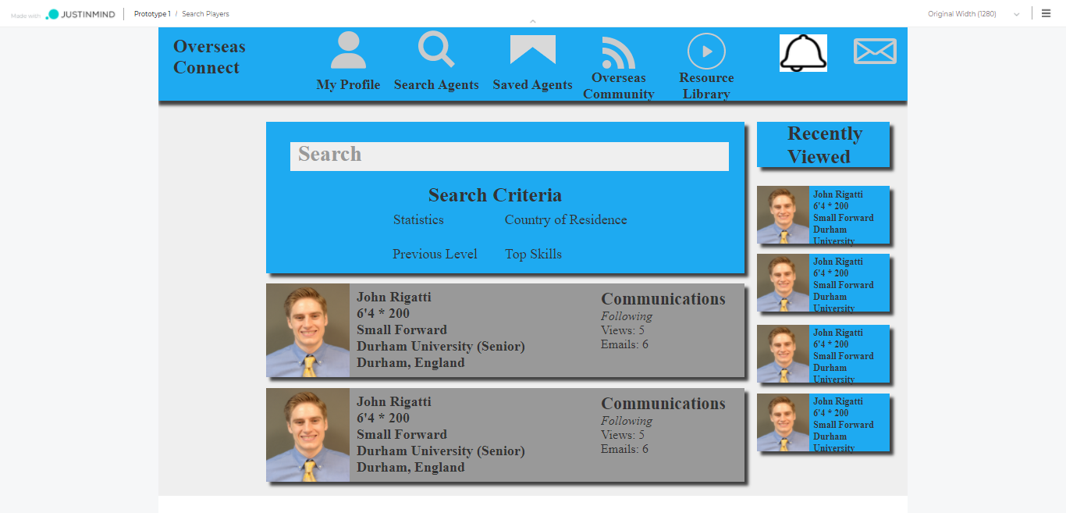

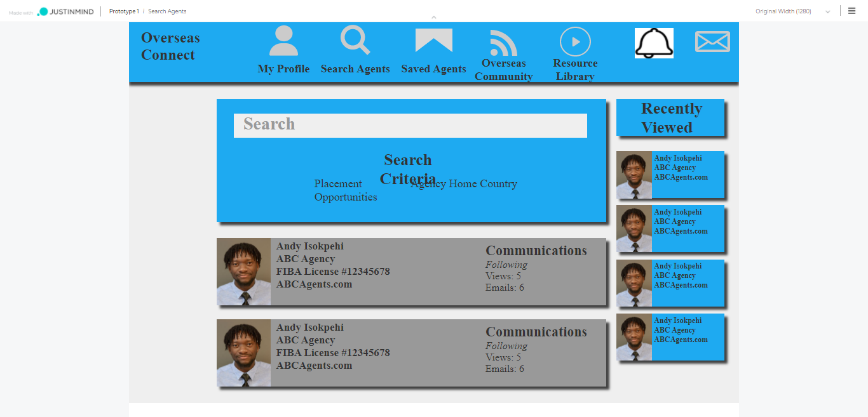

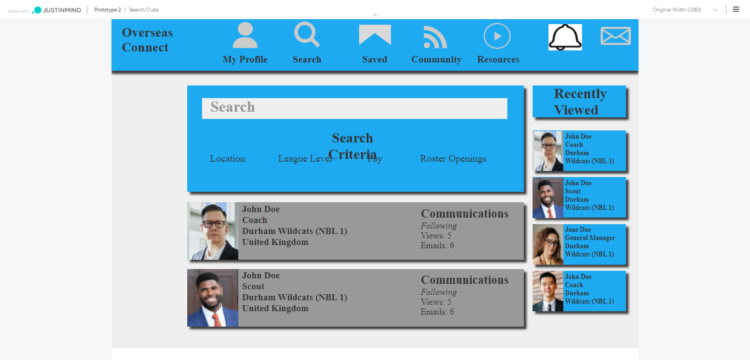

#### Field Details

|  |  |  |
| --- | --- | --- |
| Field | Field Type | Field Details |
| Search with Name | Text box | Here from this text box, user can search any of the registered user on this portal with his name. |
| Search for | Radio Button | This field is to define user wants to search for agent / player / coach. 3 radio buttons will be given and user has to select one. Default selected will be Agent. |
| Filtration Criteria |  |  |
| Player – Statistics | Dropdown | All the stats in the dropdown will be given, and for each stat range will be given for filtration. |
| Player – Country of Residence | Dropdown | In dropdown, user can select country of the player and as per selection of the country – player filtration will be done. Multiple selections to be given. |
| Player – Previous Level |  | No field as such previous level in profile. |
| Player – Top Skills | Drop Down (Multiple selection) | User can select multiple skills for filtration of players. |
| Agent – Placement Opportunity |  | No field as such in profile. |
| Agent – Agency Home Country | Dropdown | User can select country, and based on that agent filtration will be done and displayed. Multiple selections to be given. |
| Coach – Country | Dropdown | User can select country, and based on that coach filtration will be done and displayed. |
| Coach – League Level |  | No field as such in profile. |
| Coach – Pay |  | No field as such in profile. |
| Coach – Roster Opening | Drop Down (Multiple selection) | User can select multiple openings for filtration of coach. |
| View Result | Tile | As per filtration criteria system will search and list down users. In search result basic details of user will be shown;  Players: photo, name, height, weight, position, school, city, state / country, profile views, followers, following  Agent: photo, name, agency name, FIBA License no, website, followers, following  Coach: photo, name, location, followers, following |
| Save Profile | Button | By clicking here, user can save profile of a user and same will be displayed when one clicks on Saved Profile tile from upper menu. |
| Follow / Unfollow | Button | User can follow or unfollow user. |
| Recently Viewed | Tile | On the right side, display last 5 recently viewed profiles with basic info;  Players: photo, name, height, weight, position, school  Agents: photo, name, agency name, website  Coach: photo, name, location |

#### Business Rules

Filtration criteria will be different for agent, player and coach.

* Player criteria: Stats (click on stats and see larger pop up where they can set specific requirements), country of residence, previous level, top skills, age
* Agent criteria: placement opportunities, agency home country
* Club criteria: Location, league level, pay, roster opening

## Saved Profile

On this screen user can see saved profile of other users. User can search in the saved profile through name only and filtration criteria will be same as Search profile.

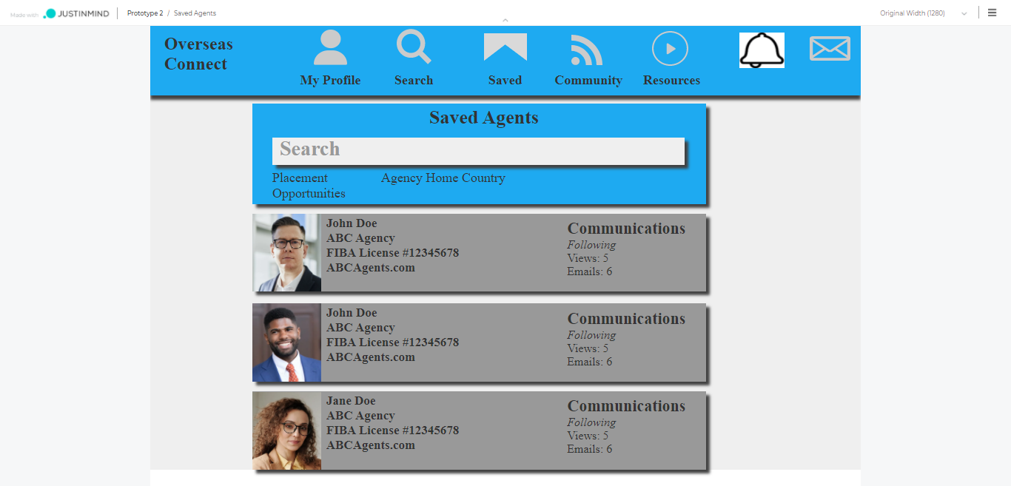

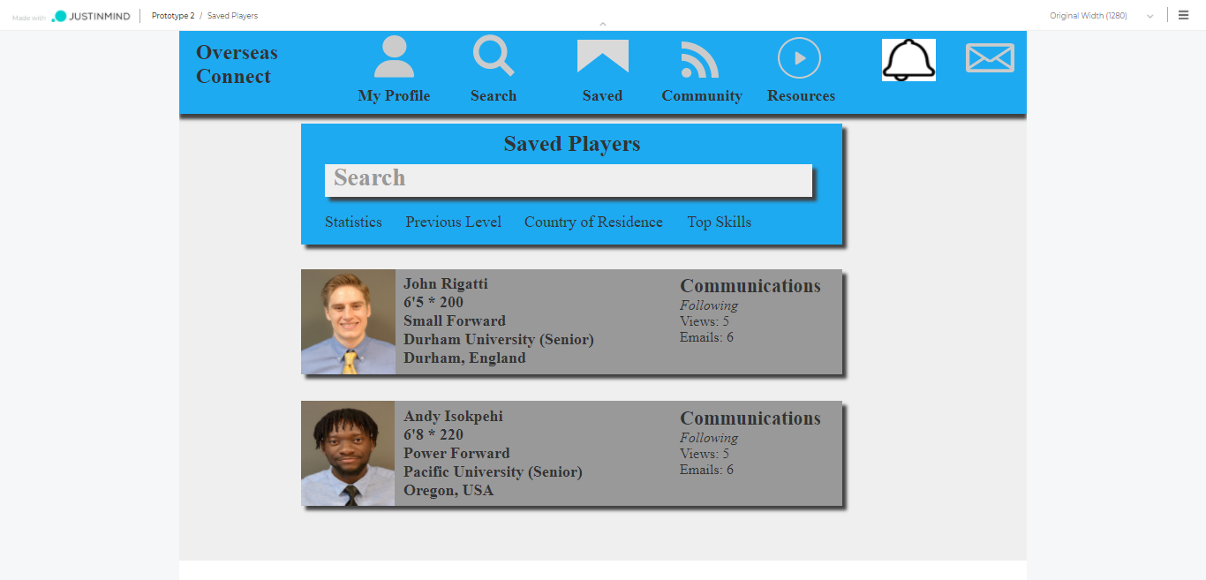

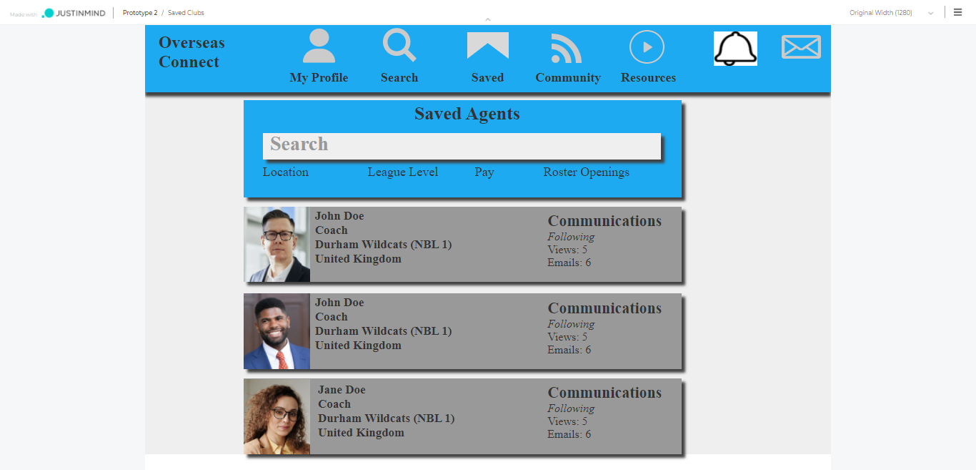

|  |  |  |
| --- | --- | --- |
| Field | Field Type | Field Details |
| Search | Text Box | Through this search text box, user can search saved user profile with user’s name. |
| Filtration Criteria |  | Same as search profile |
| View Result | Tile | As per filtration criteria system will search and list down users. In search result basic details of user will be shown;  Players: photo, name, height, weight, position, school, city, state / country, profile views, followers, following  Agent: photo, name, agency name, FIBA License no, website, followers, following  Coach: photo, name, location, followers, following |
| Save / Unsave Profile | Button | By clicking here, user can save profile of a user and same will be displayed when one click on Saved Profile tile from upper menu. If the profile is already saved, then provision to unsave profile will be given. |
| Follow / Unfollow | Button | User can follow or unfollow user. Give provision to send a message along with follow request. |
| Recently Viewed | Tile | On the right side, display last 5 recently viewed profiles with basic info;  Players: photo, name, height, weight, position, school  Agents: photo, name, agency name, website  Coach: photo, name, location |

## Community

Here on this page user can see all discussion forums added by other users and admin. Also user can create new discussion forum from this screen.

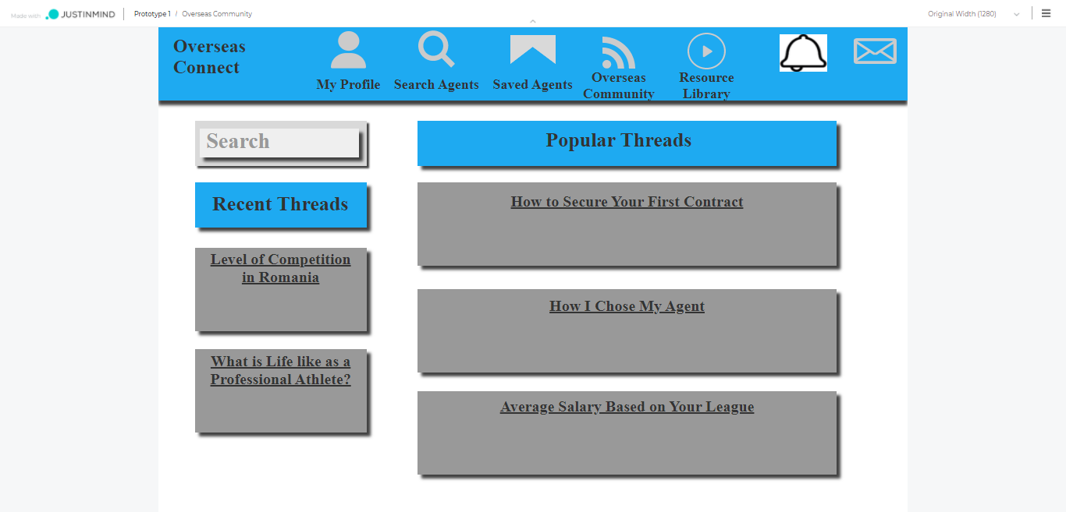

|  |  |  |
| --- | --- | --- |
| Field | Field Type | Field Details |
| Search | Text Box | Through this search text box, user can search threads with thread topic and description. |
| Add New | Button | User can add new thread, by entering title of the thread and description, along with image and video. |
| Save Thread | Button | By clicking here, user can save thread. Saved threads will be displayed on right side of the screen. |
| Popular Threads | Tile | In the center of the screen, we will display popular threads. On click of title of a thread, in a new window thread will open with all details. Popularity will be decided based on the maximum time viewed threads and based on posted in recent time. |
| Recently Viewed | Tile | On the left side, display last 5 recently viewed threads. On click of title of a thread, in a new window thread will open with all details. |
| Detailed Thread | Page | When any user clicks on title of a thread, new page will open with all the thread details. Below thread details, like, comment, save, report button will be given. Along with that name of the user who has posted the thread also will be displayed. |
| Saved Threads | Tile | On the right side of the screen, saved threads will be displayed. |

## Resources Library

Here from this screen, users can view all the content uploaded by admin in the system. Admin can upload content in 3 formats: Simple Text, Images and Videos

When user clicks on the title, content will be open in new window.

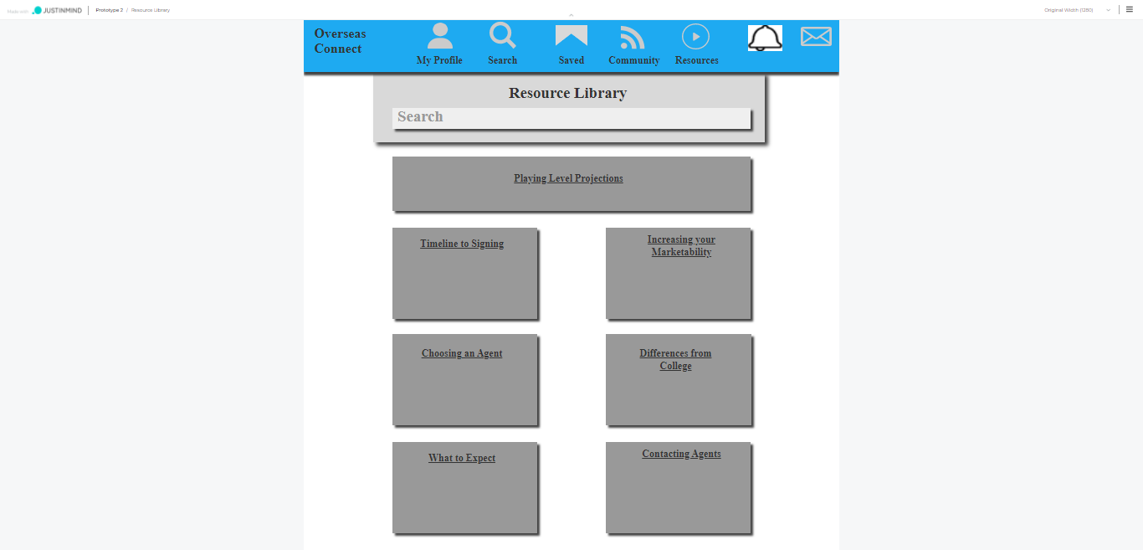

## Notifications

All the recent updates will be displayed on click of this tile. We have considered below type of activities to be considered in notifications.

* New Profile View
* Someone searches you
* Accept Follow Request
* New Follow Request
  + When click on this user, provide an option to follow back that user.
* New Message
* When someone opens the message send by this user
* Whenever changes made in profile of user whom he is following
* When someone refers to this user
  + From here user can approve or reject given reference

## Messages

Here on this page, user can see all new messages and communication history. On left side there will be type of folders, and next to that all user name will be displayed with new and past messages.

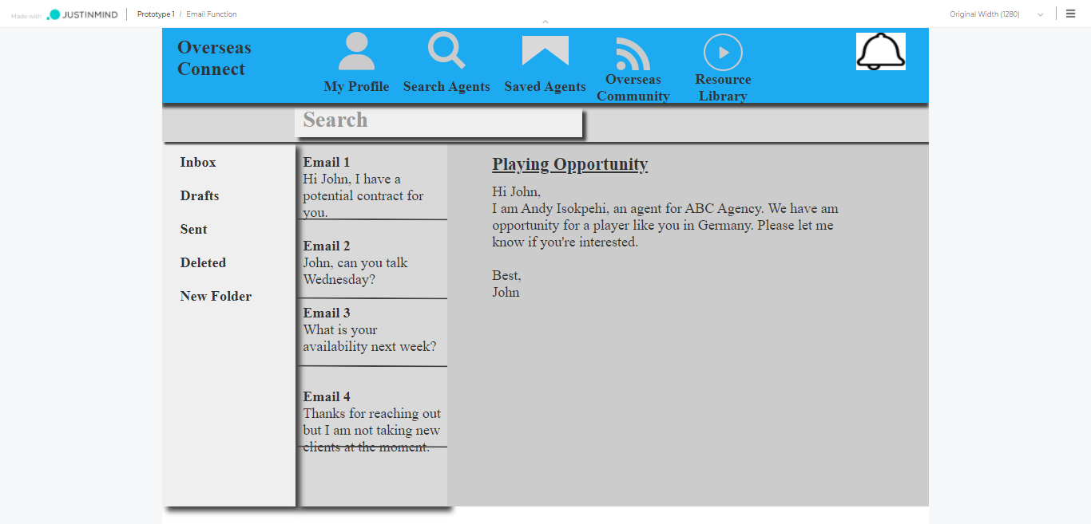

|  |  |  |
| --- | --- | --- |
| Field | Field Type | Field Details |
| Search | Text Box | Through this search text box, user can search user for user name. |
| Folder Type | Tile | On the left side of the screen, folder types will be displayed.  All Messages: All the messages from all the users will be displayed including Drafts, Read, Unread and deleted.  New Message: To send new message user can click on New Message and search for user’s name and send.  Drafts: The messages typed and not sent will be saved in draft messaged.  Unread: The messages which user has not read will be saved under this type.  Deleted: User can delete the messages (whole chat deleted of that user) and saved under this type. |
| User Name | Tile | All the users’ names will be displayed, with whom communication has happened previously. |
| Send Messages | Text Box | User can type a message and send message. |
| Send | Button | By clicking here, user can send message. |
| Attachment | Button | User can attach images or file and send message. |
| Automated Message | Tile | Default automated message will be given to user, user can click and reply will be send automatically. Messages will be: Yes, No, Sure, Thank you, Okay, Bye, Have a Nice Day, Hi, Hello, |

#### Business Rules

* Users can only send message to those users, that they are following and who are also following them back
* This page’s layout will have a text message type feel, not an email feel.

## Team Open Positions

From this screen, player can see open positions in teams, posted by Coach of respective teams. Player can apply on the open positions.

Screen is missing.

## ~~Top Matches~~

~~Screen is missing.~~

# Agent

## Sign Up

Same as player profile

## Log In

#### Field Details

|  |  |  |
| --- | --- | --- |
| Field | Field Type | Field Details |
| Email ID | Text Box | User needs to enter his registered Email ID |
| Password | Text Box | User needs to enter password |
| Submit | Button | User needs to click on this button to login to his account. |

## Dashboard

Here on this screen agent can see his dashboard. On the dashboard he will be able to see his recent activities like number of profile views – who has viewed his profile, profile viewed by him, when he appeared in someone’s search, someone responded to them in discussion forum (community), when someone they are following updates their profile, pending follow requests, received new message, when someone opened the message send by this user, when someone refers this user, etc.



#### Field Details

|  |  |  |
| --- | --- | --- |
| Field | Field Type | Field Details |
| Agent Link | Tile | By clicking on this logo from anywhere, one can go to the dashboard of player log in. |
| My Profile | Tile | On click of this button, user will be redirected to his profile. |
| Search | Tile | To search any of the users on this portal user needs to click on this button. |
| Saved | Tile | By clicking on this button user can view the saved profile of agents, players and coaches by him on this portal. |
| Discussion Forum | Tile | By clicking on this button user can view all posted discussion forum on this portal. |
| Resources Library | Tile | By clicking on this button user can view all posted resource library on this portal. |
| Notifications | Tile | Users can view all the notifications like a new message, new follow requests, new profile views, search appearance, following request acceptance, when someone made changes in the profile that the user is following. |
| Messages / Chat | Tile | All past and new messages along with draft and deleted messages will be shown on this screen. |
| Profile Stats | Tile | Here on this tile, user can see profile’s statistics; Name, Location, No of Views of his profile, No of followers, No of Following, How many times his profile appears in search |
| Recent Activity | Tile | Here user can see who has visited his profile and user has viewed whose profile with basic profile details:  Players: photo, name, height, weight, position, school  Agents: photo, name, agency name, website  Coach: photo, name, location |
| ~~Top Matches~~ | ~~Tile~~ | ~~More Details required on this part.~~ |

#### Business Rules

## Agent Profile

Here on this page agent can view his own profile and make changes if required. On the top after all menus, we will show how many percentage of profile is completed.

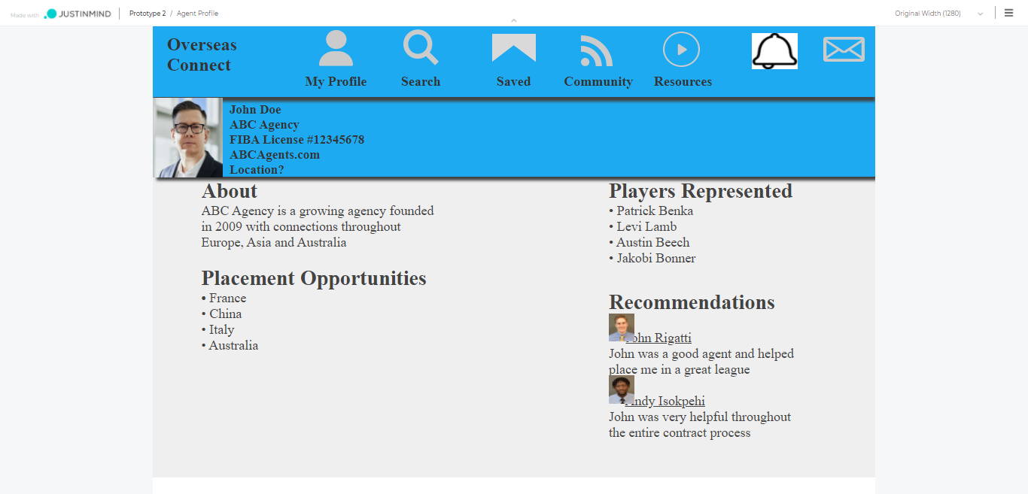

* Step 1: Photo, Name, Agency Name, FIBA License, Email ID, Contact No, Address, Website
* Step 2: About, Placement Opportunities, Players Represented

#### Field Details

|  |  |  |
| --- | --- | --- |
| Field | Field Type | Field Details |
| Photo | Label | User can upload his photo and same will be displayed in his profile. |
| Name | Label | Name of the agent, one cannot change the name without admin approval; When any user requests for name changes, his request will go to admin for approval. |
| Agency Name | Label | Agency Name of an agent |
| FIBA License | Label | FIBA License No of Agent / Agency |
| Email ID | Label | Email ID of the player |
| Contact No | Label | Contact No of the player, optional field |
| Location | Label | Here city and country to be displayed; user can select Country / States of UK and cities of the Country / States. |
| Website | Link / URL | Website URL will be entered by Agent and displayed |
| About Agency | Label | About agency |
| Placement Opportunities |  | Need more details |
| Players Represented |  | Need more details |
| References | Label | Other users of this platform can refer / recommend this user and same will be displayed here. Here on this screen, latest 3 references will be displayed; and next to that “View All” link will be given, to see view all references given till date. |

#### Business Rules

* User can update his name but is will go to admin for his approval; once request is approved by admin then only name will be changed.
* User cannot change his Email ID.
* User can give refer agent, only if the user is following that agent.

## Edit Profile

## Change Password

From this screen user can change his password.

#### Field Details

|  |  |  |
| --- | --- | --- |
| Field | Field Type | Field Details |
| Current Password | Text Box | User needs to enter his current password |
| New Password | Text Box | User needs to enter new password, which he wants to change |
| Reconfirm New Password | Text Box | User needs to reconfirm new password |
| Submit | Button | User needs to click on this button to submit the change password form. |

#### Business Rules

* Current password should be matched with

## Search Profile

Similar to Player

## Saved Profile

Similar to Player

## Community

Similar to player module

## Resource Library

## Messages

Similar to player module

## Notifications

Similar to player module

# Coach Module

This module is specially designed for Coach or Team, who can manage his team from this portal. He can view all registered members’ profile, search and save profiles, manage own profile, post and manage job positions / openings.

## Sign Up

## Log In

## Dashboard

## Coach Profile

Here on this screen Coach can see his own profile and modify it.

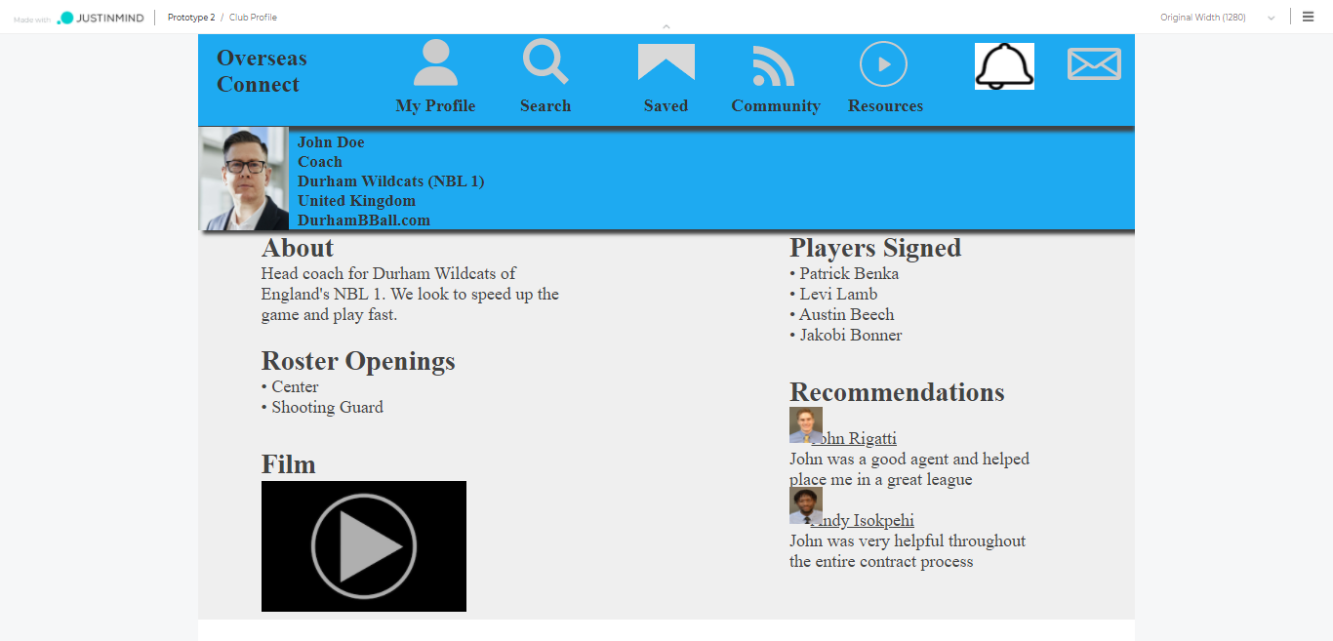

#### Field Details

|  |  |  |
| --- | --- | --- |
| Field | Field Type | Field Details |
| Photo | Label | User can upload his photo and same will be displayed in his profile. |
| Name | Label | Name of the Coach, one cannot change the name without admin approval; When any user requests for name changes, his request will go to admin for approval. |
| Club Name | Label | Club name of the coach where he is working / has worked. |
| Country | Label | Country of the Coach |
| Website | Link / URL | Website URL will be entered by Agent and displayed |
| About Club | Label | About club |
| Roster Opening | Label | Coach can mention open positions in a team; can be multiple. |
| Full Game Film | Video | User can upload video of his full game. |
| Team (Players Signed) | Label / Link | Coach can mention team members, members can be from portal as well outside portal. Players who are on this portal are displayed with URL and on click of that link player profile will be opened in new tab. |
| References | Label | Other users of this platform can refer / recommend this user and same will be displayed here. Here on this screen, latest 3 references will be displayed; and next to that “View All” link will be given, to see view all references given till date. |

#### Business Rules

* User can update his name but is will go to admin for his approval; once request is approved by admin then only name will be changed.
* No limitations for team members

## Edit Profile

## Change Password

From this screen user can change his password.

#### Field Details

|  |  |  |
| --- | --- | --- |
| Field | Field Type | Field Details |
| Current Password | Text Box | User needs to enter his current password |
| New Password | Text Box | User needs to enter new password, which he wants to change |
| Reconfirm New Password | Text Box | User needs to reconfirm new password |
| Submit | Button | User needs to click on this button to submit the change password form. |

#### Business Rules

* Current password should be matched with

## Search Profile

Similar to player module

## Saved Profile

Similar to player module

## Manage and Create Team

Here from this screen, coach can manage team members for the team. He can select either from portal or if member is not registered on portal coach simply can add his basic details and add member. For any team member, coach can select his position in basketball team from the dropdown menu; and team members who are not registered on portal, coach can add name and position. For players already registered on portal, URL will be given; on click of that URL, in new tab player profile will open.

## Manage and Create Open Positions

Here from this screen coach can create open positions in the team and players can see the same.

#### Field Details

|  |  |  |
| --- | --- | --- |
| Field | Field Type | Field Details |
| Playing Position | Drop Down | Coach can select playing position from the dropdown. Single Selection |
| Location | Label | Name of the Coach, one cannot change the name without admin approval; When any user requests for name changes, his request will go to admin for approval. |
| Duration of Contract | Label | Club name of the coach where he is working / has worked. |
| Start Month of Contract | Label | Country of the Coach |
| Pay | Link / URL | Coach can define pay, if user plays for that specific position. This will be an optional field. |
| Additional Benefits | Text Area | Coach can mention additional benefits if player plays for this position. This will be an optional field. |
| Player Requirements | Text Area | Coach can mention open positions in a team; can be multiple. |

## View Received Players Profile

Here on this screen, coach can see all the applications / profiles received for specific open positions listed by him. Coach can approve / reject the application for specific position; once for specific position, a profile has been accepted other profile for that positions will be disqualified automatically.

## Reviews

# Content Management Pages

For all below mentioned pages content will be provided by client.

## Home

## About

## FAQ

## Join

## Contact us

## Privacy Policy

## Terms condition

## Site map

# Queries

* Ranking Algorithm (from Stats) at the of development require.
* Open Position Application Flow will cover at design phase
* Top Matches Algorithm at the time of development will taken care.
* Missing Screens will taken care at the time design phase:
  + Agent and Coach Dashboard, Position Opening, Apply on Vacant Position, Create-Manage & View Teams, Reviews, View Received Player Profiles for Team Positioning
* Stat of player will be single or multiple? As you mentioned, once it will be uploaded by player – system needs to notify admin. What if he made changes in stats? Verified will be removed till admin approves it.