200 Water Rooftop Virtual Showroom
Technical overview of the interactive 3D rooftop experience.

Purpose & Experience
- Creates a scroll-driven 3D building tour that transitions into a roof-only inspection mode for rooftop systems.
- Users open the detail view, rotate the roof, and inspect callouts, leader lines, legend, and flow overlays.

Technology Stack
Runtime | Static HTML/CSS/JavaScript; Tailwind CDN; Lucide; Roboto.
3D + motion | Three.js 0.170, GLTFLoader, MeshoptDecoder, WebGLRenderer, PerspectiveCamera, GSAP ScrollTrigger.
Models | Optimized full-building model and a dedicated high-detail rooftop model.

Engineering Workflow
- model-preload.js centralizes GLB loading: building first, roof deferred and prefetched later.
- The building GLB is cloned, material-prepared, centered, uniformly scaled, rotated, and framed with a custom camera/light rig.
- Rooftop framing samples upper-roof vertices and adjusts projection until the inspection view fits cleanly.
- Roof-only alignment replays the building transform, then screen-aligns the separate roof model.

Code evidence: deferred model loading
export const buildingGltfPromise = preloadGltf(paths.building);
if (!roofGltfPromise) roofGltfPromise = preloadGltf(paths.roof);

Interaction Engineering
Scroll choreography | A smoothed playhead synchronizes camera, FOV, lights, CTA state, render timing, and roof prefetch.
DOM + WebGL sync | rooftop-labels.js projects 3D anchors so DOM labels, leader lines, legend, and SVG flow paths stay aligned with the model.

Performance Engineering
- Primary GLB is preloaded and cached; roof loading is deferred until needed.
- MeshoptDecoder handles compressed GLBs; optimized metadata includes EXT_meshopt_compression/KHR_mesh_quantization.
- Renderer DPR is capped, mobile antialiasing is disabled, and rendering pauses outside the active 3D section.

Architecture
User scroll / CTA -> GSAP ScrollTrigger + smoothing -> Three.js scene/camera/lights -> full-building GLB and roof-only alignment -> DOM/SVG labels and flow overlays

Rooftop Detail View
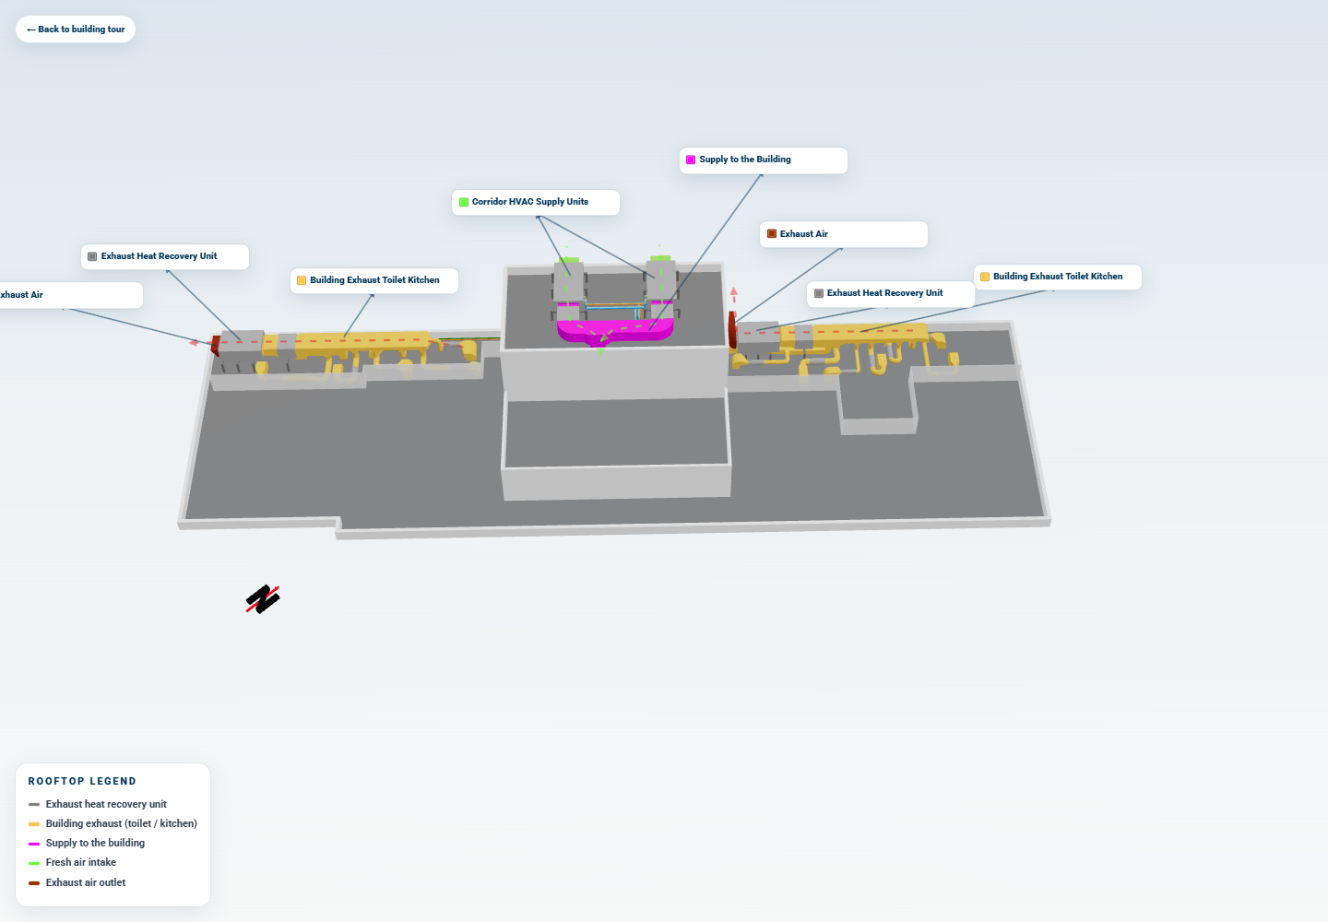 | Rooftop interaction shown  - Roof-only inspection state loaded from the project rooftop GLB.  - Equipment labels, leader lines, legend, and flow overlays presented in one coordinated view.  - Screen-space DOM/SVG annotations aligned to the underlying WebGL model.
Figure: Active rooftop detail view

Implementation Areas
Cross-model alignment | Transform replay plus projected-bounds matching bridges full-building and roof-only GLBs with different coordinate assumptions.
Rooftop camera math | Roof vertex sampling, projection checks, and iterative distance fitting create the inspection composition.
Overlay precision | DOM labels and SVG flows remain attached to live 3D anchors through resize, drag, and model swapping.
Code evidence: scroll smoothing
const delta = targetProgress - playhead.progress;
playhead.progress += delta * smoothing;
timeline.progress(playhead.progress);

Evidence & Limits
Evidence reviewed: runtime HTML/CSS/JS modules, README, building-scroll-recipe.md, wrangler.jsonc, audit scripts/screenshots, and GLB metadata from logos/*.glb.
- Blender is verified only as source/export evidence; active optimized GLBs report glTF-Transform v4.4.2.
- Not verified: source .blend file, backend code, package/build pipeline, or live import/use of rooftop-retrofit.js.

