ADVANCE NETWORK SECURITY

LAB-1: Learn to use commands like tcpdump, netstat, ifconfig, nslookup and traceroute.

- TCPDUMP: tcpdump is a command-line packet analyzer tool used for capturing and analyzing network traffic in real-time.

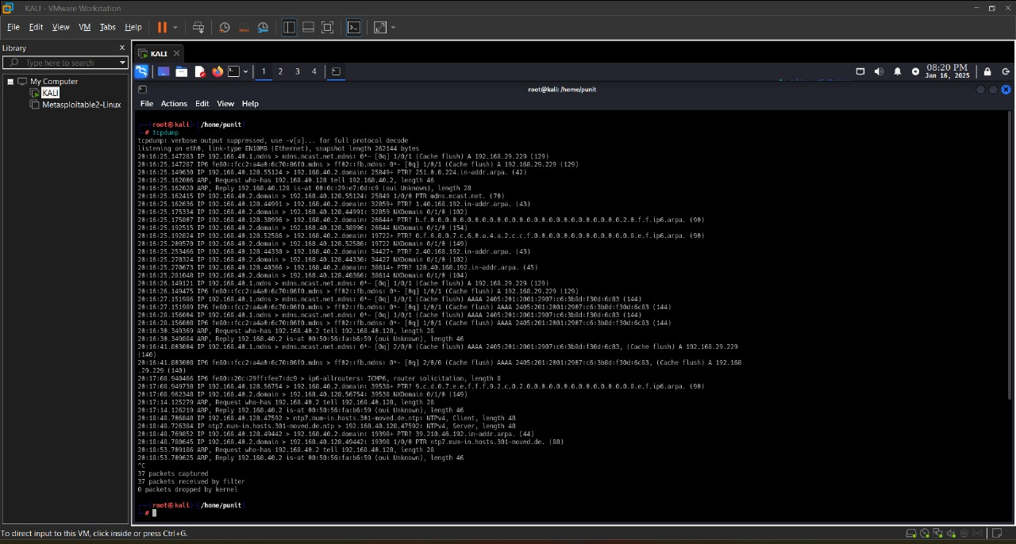
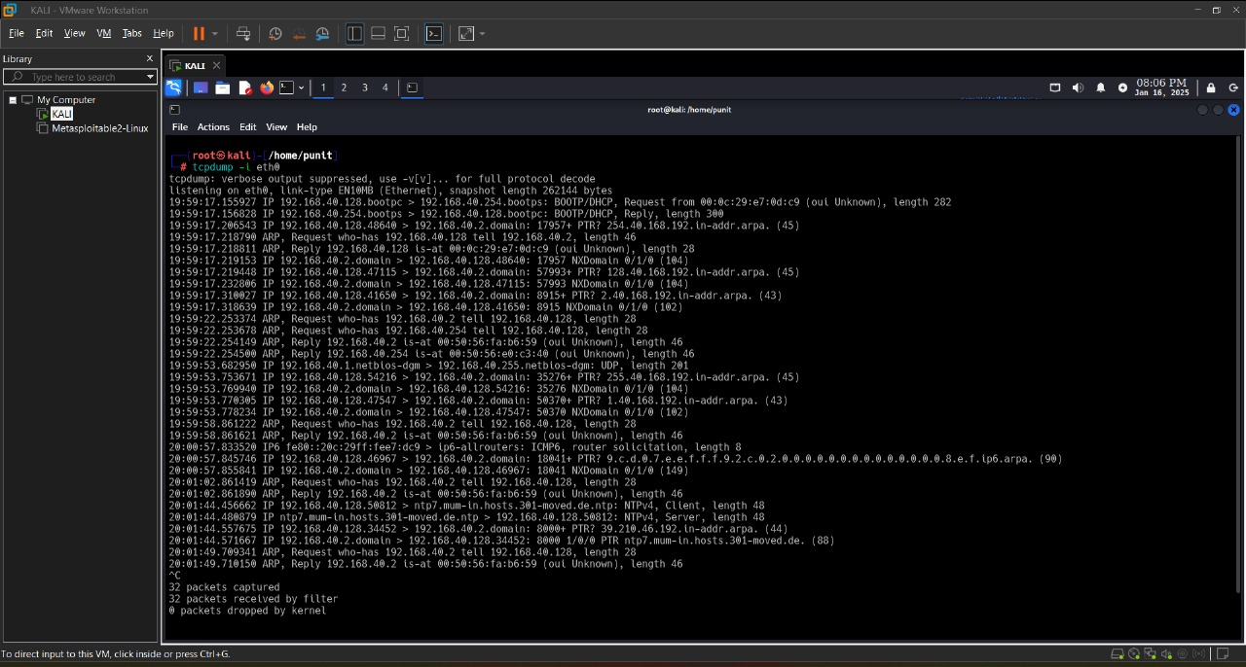
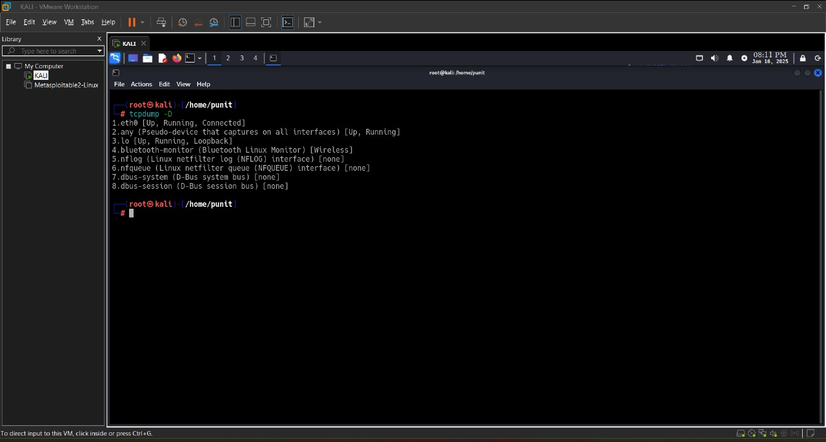

- NETSTAT: netstat (short for "network statistics") is a command-line tool used for displaying network-related information on a computer or network device.
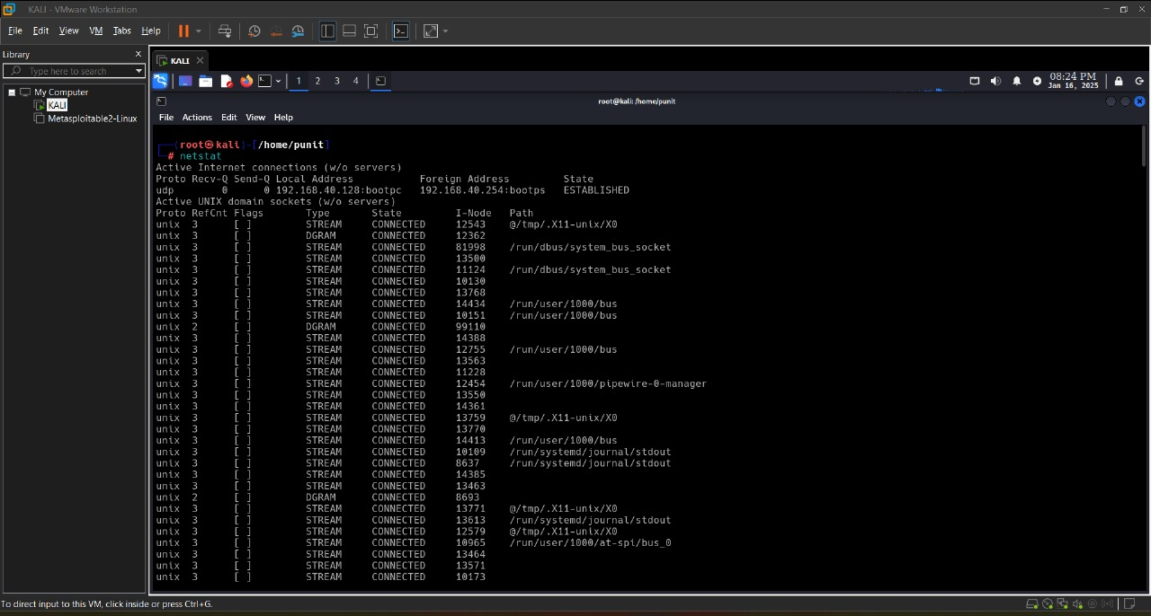
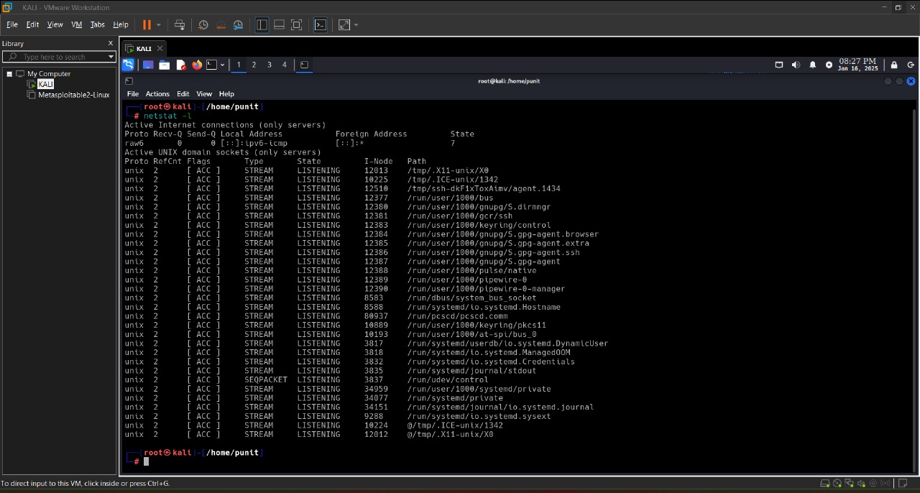
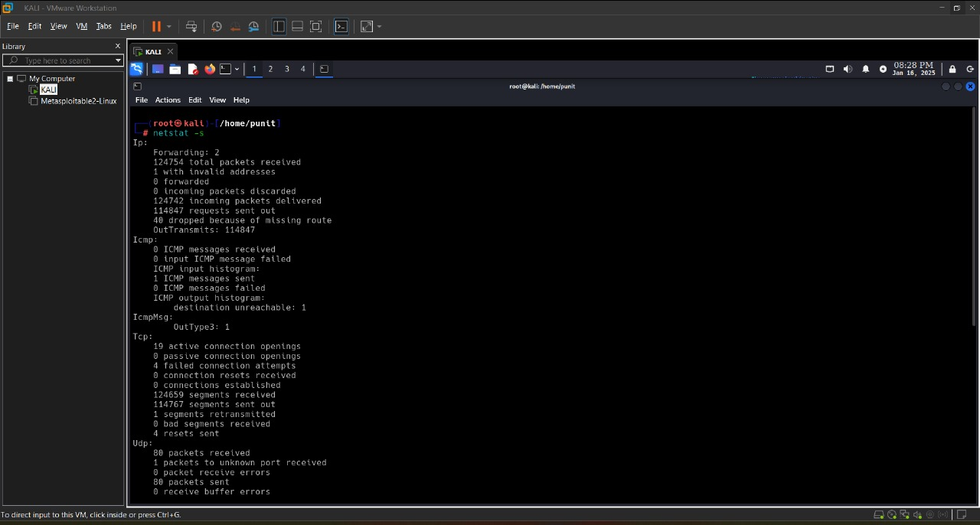

- IFCONFIG: ifconfig (short for "interface configuration") is a command-line tool used to configure, manage, and display information about network interfaces on Unix-like operating systems.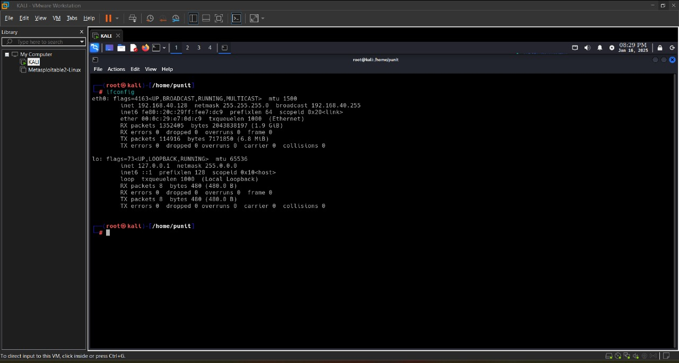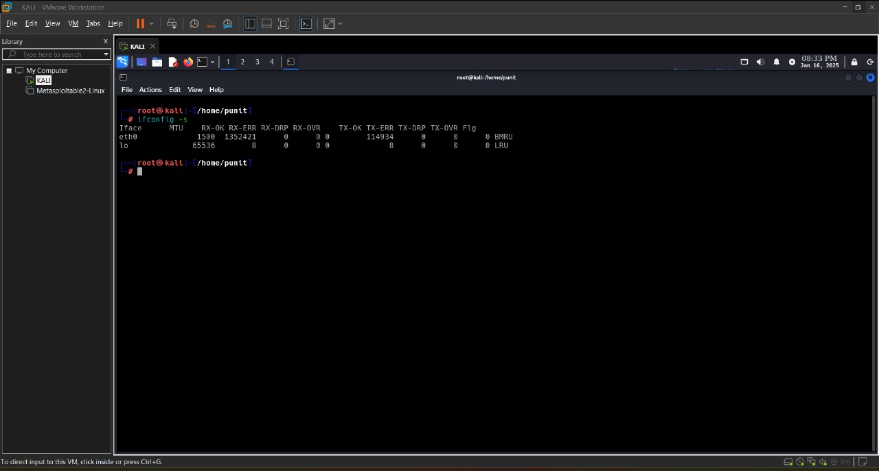

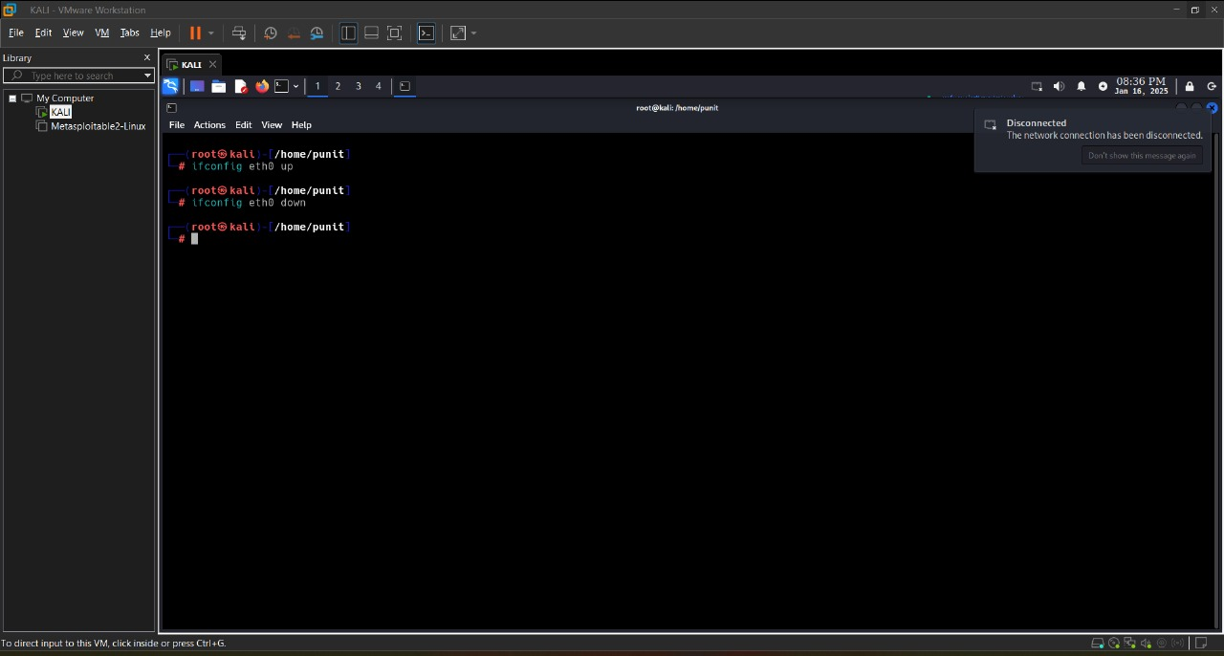

- NSLOOKUP: nslookup (short for "name server lookup") is a command-line tool used to query Domain Name System (DNS) servers to retrieve domain name information, such as IP addresses associated with a domain, or to perform reverse lookups (getting domain names from IP addresses).
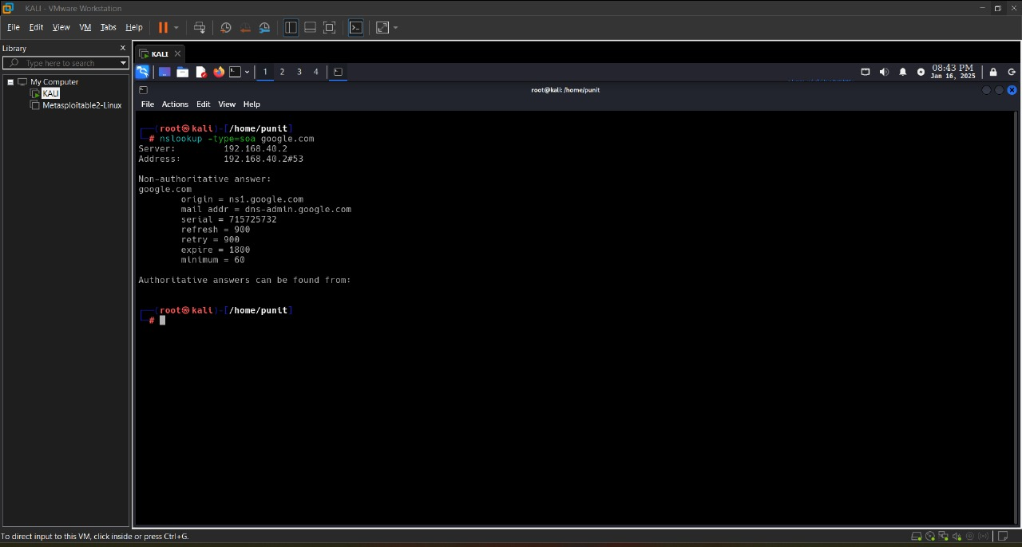
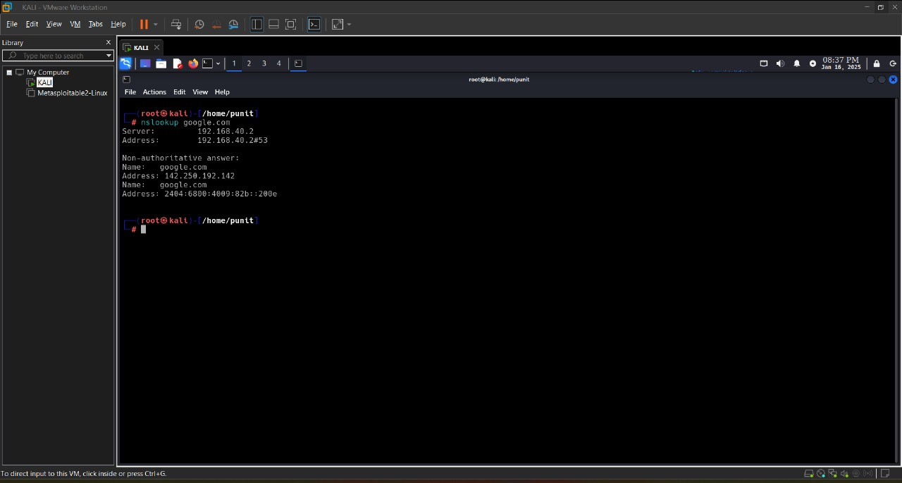

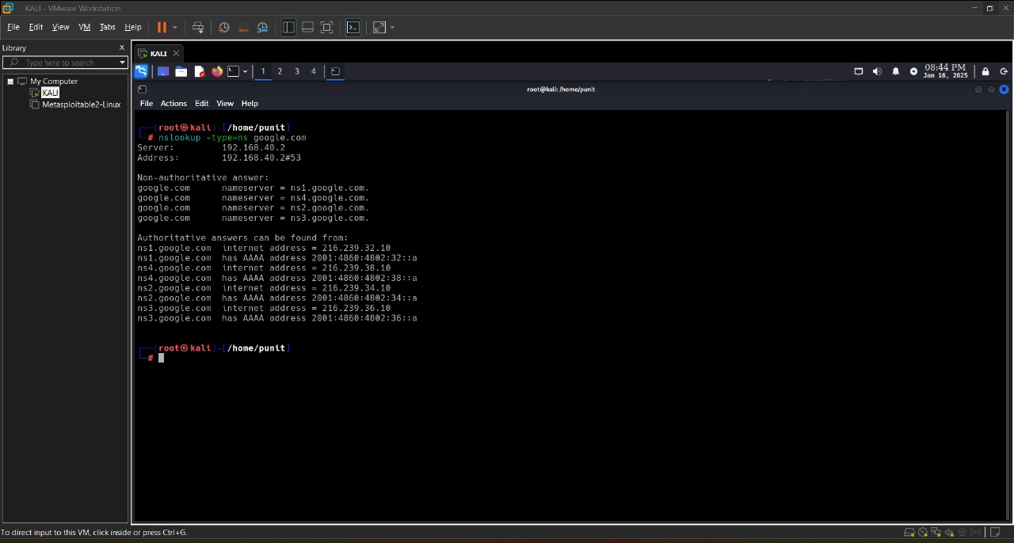

- TRACEROUTE: traceroute is a command-line tool used to trace the path that data packets take from one computer to another across an IP network.
