Advanced Network Security MSCY0204

Lab 2
Aim: Capture ping and traceroute PDUs using Network Protocol Analyzer and examine.
Step: 1
Ping and trace:
Use Ping Command with an extension to Display packet Information such as Response Time, Packet Size and Sequence Number.
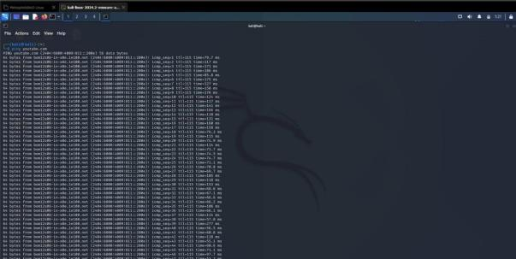
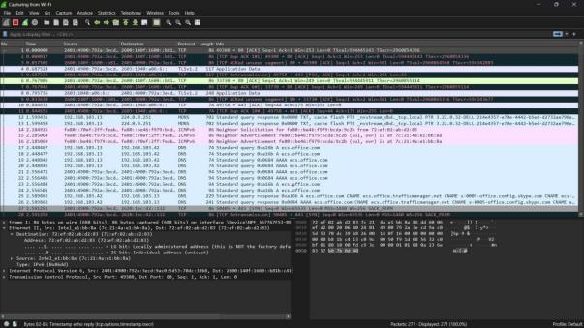
Punit Soni IU2454520053

Advanced Network Security MSCY0204

Step 2: Stop Wireshark then search Website in browser and then restart Wireshark Display packet.
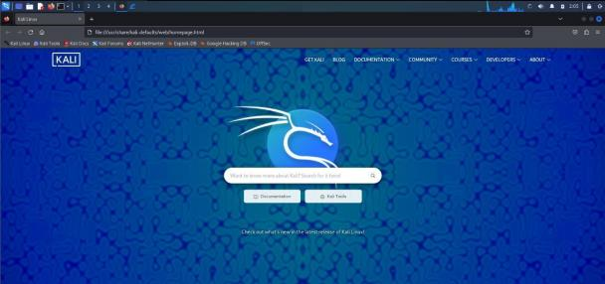
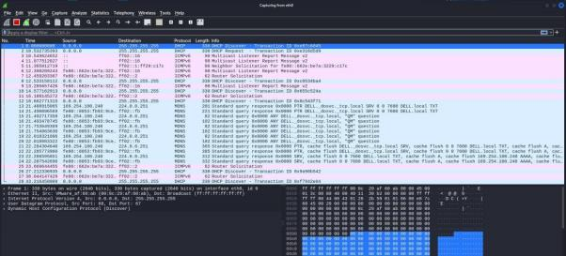
Conclusion:
Capturing Ping and Traceroute PDUs with a Network Protocol Analyser helps confirm connectivity, measure latency, and identify network paths. Ping verifies end-to-end reachability and Round Trip Time (RTT), while Traceroute reveals intermediary hops and potential bottlenecks. Both are essential for diagnosing network performance and troubleshooting issues.

Punit Soni IU2454520053

