LAB 3

AIM: Clone the Particular Webpage’s by Using Import requests Module and also save that webpage Using Python Language.

Code:

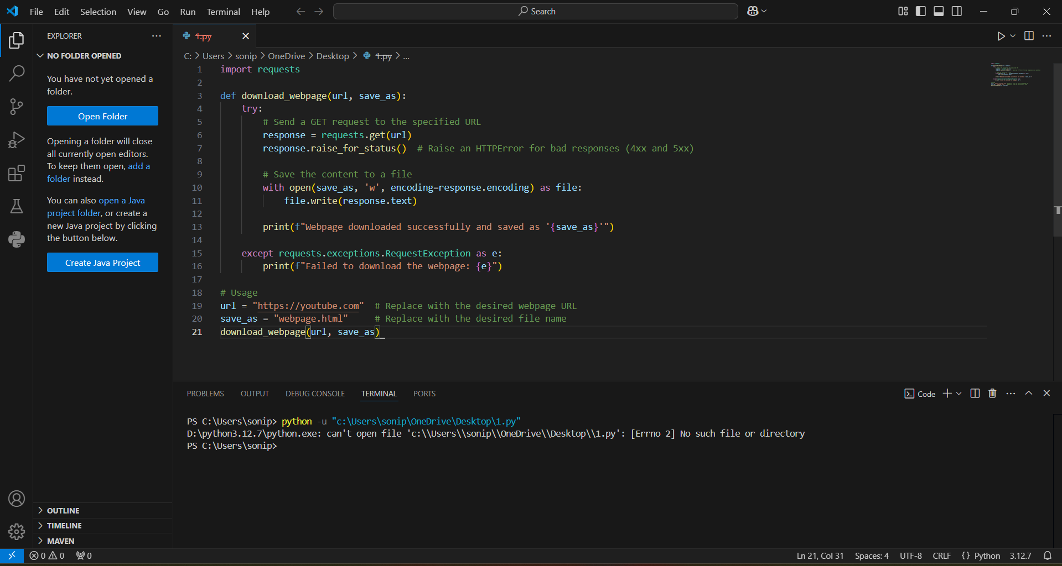

Clone Webpage of Google and Youtube:

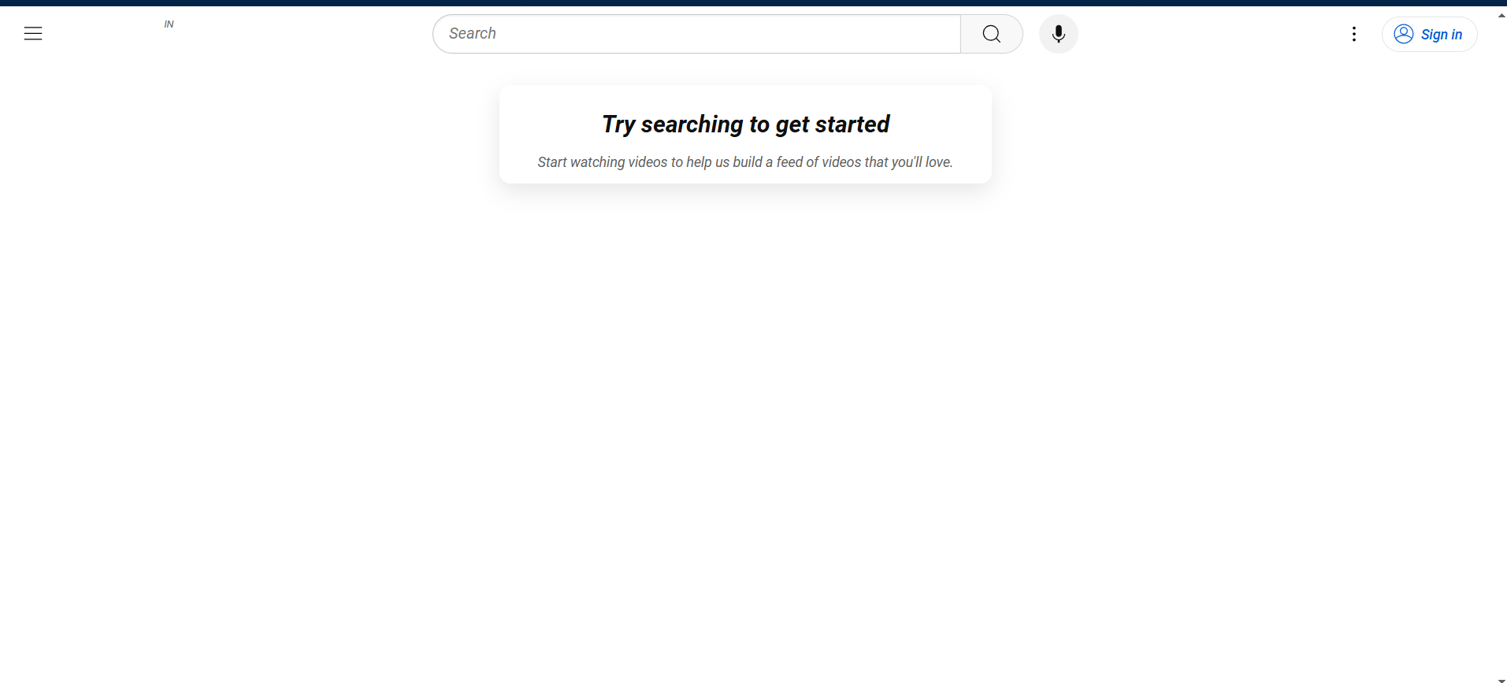

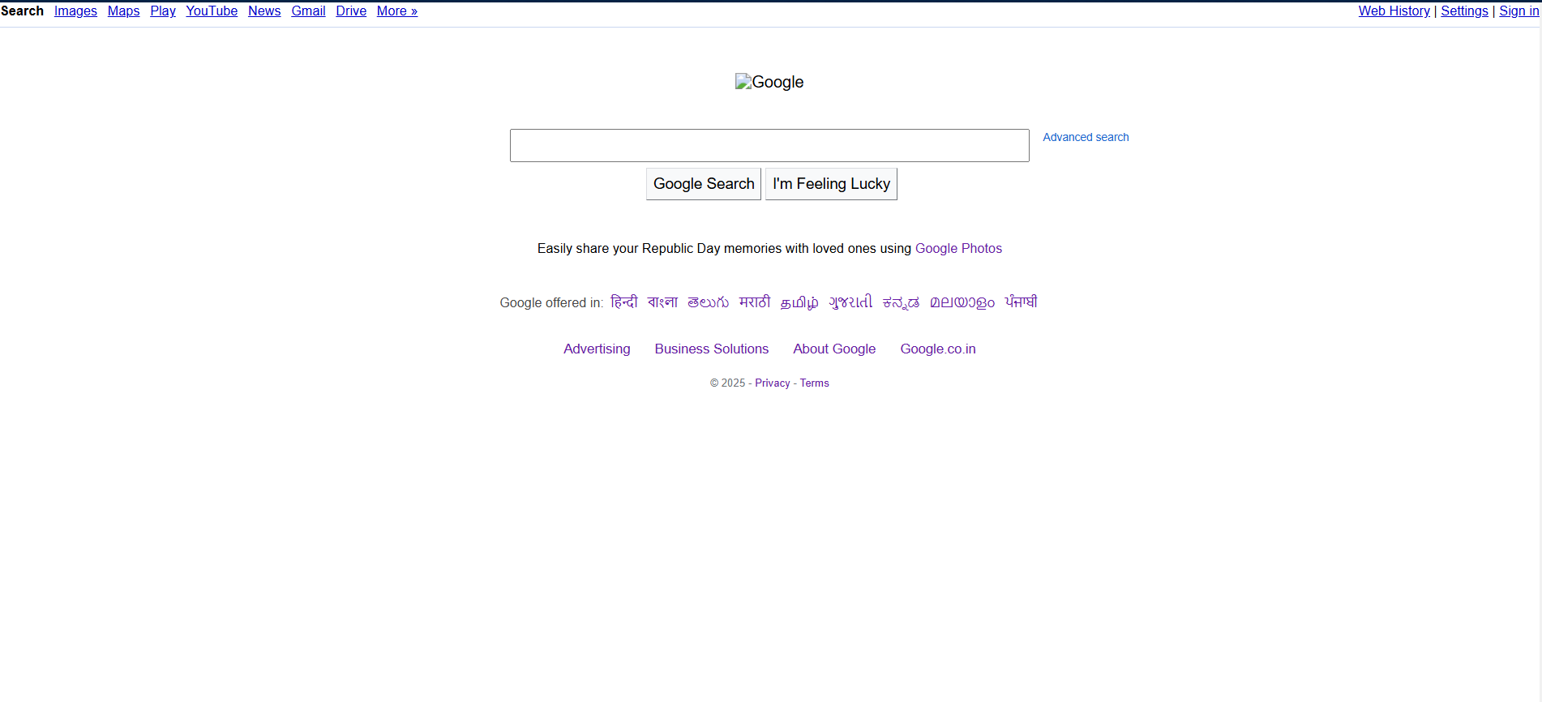

Conclusion:

- Website cloning is a powerful tool in both malicious and legitimate contexts. In the world of network security, it’s most commonly associated with phishing and fraud, which can have severe consequences for both individuals and organizations. However, when used ethically, it can also help in identifying vulnerabilities and securing digital platforms. As a result, continuous vigilance, awareness, and the implementation of best security practices are essential in defending against such attacks.

