PRACTICAL 7

Aim: Simulation of DNS using UDP sockets.

DNS Server: A server that listens for queries and responds with the appropriate IP address.

The server will listen for DNS queries, process them, and send back an appropriate response. This example will simulate a very basic DNS server that responds with a predefined IP address.

Code:

Dns_server.py

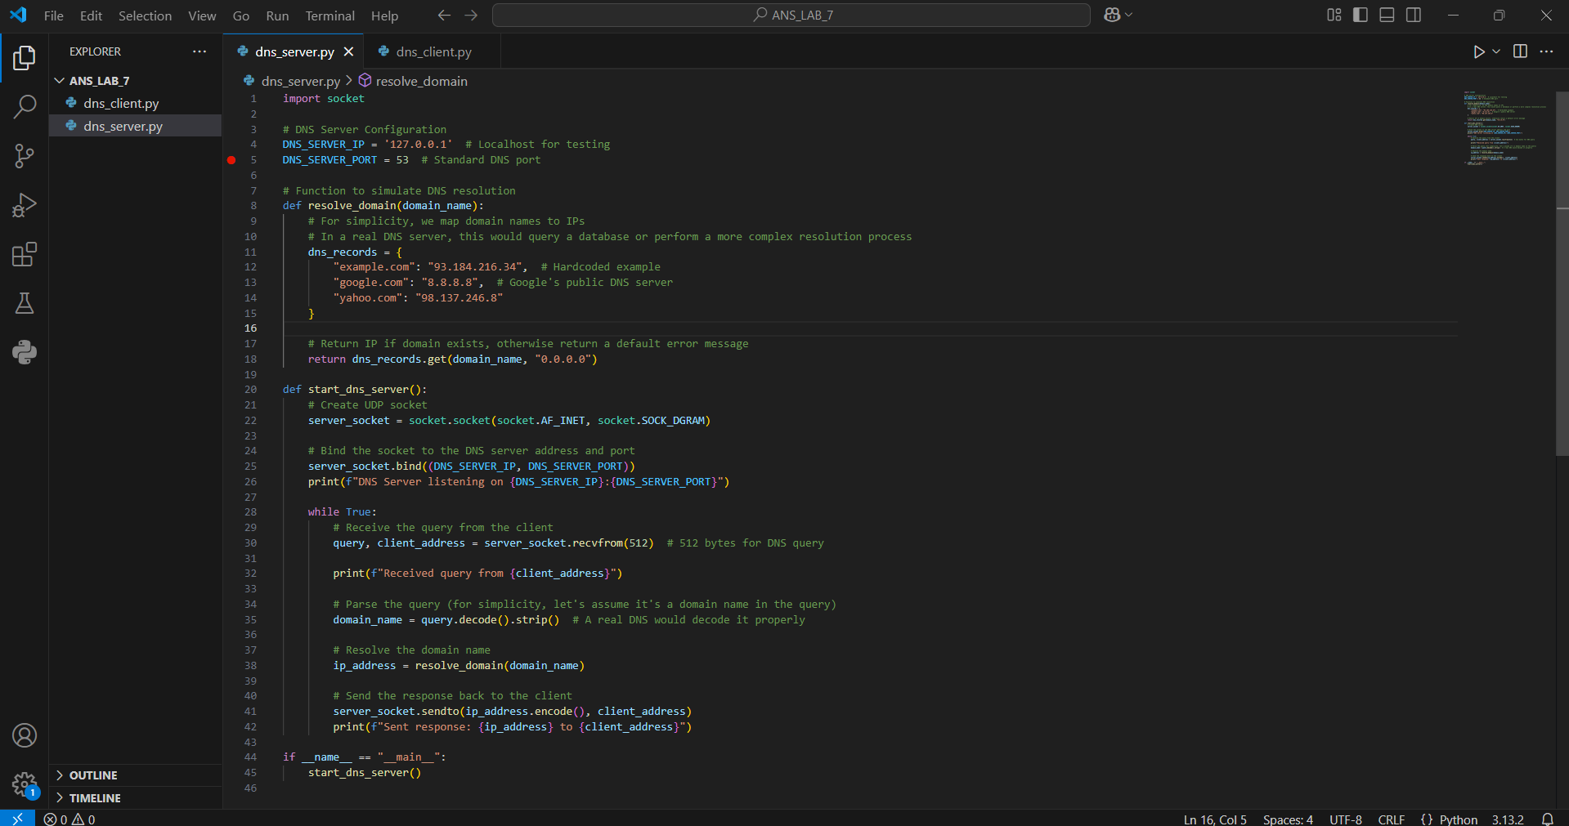

DNS Client: A client that queries a DNS server for a domain's IP address.

This client will create a UDP socket, send a DNS query to a DNS server, and wait for the response.

Dns_client.py

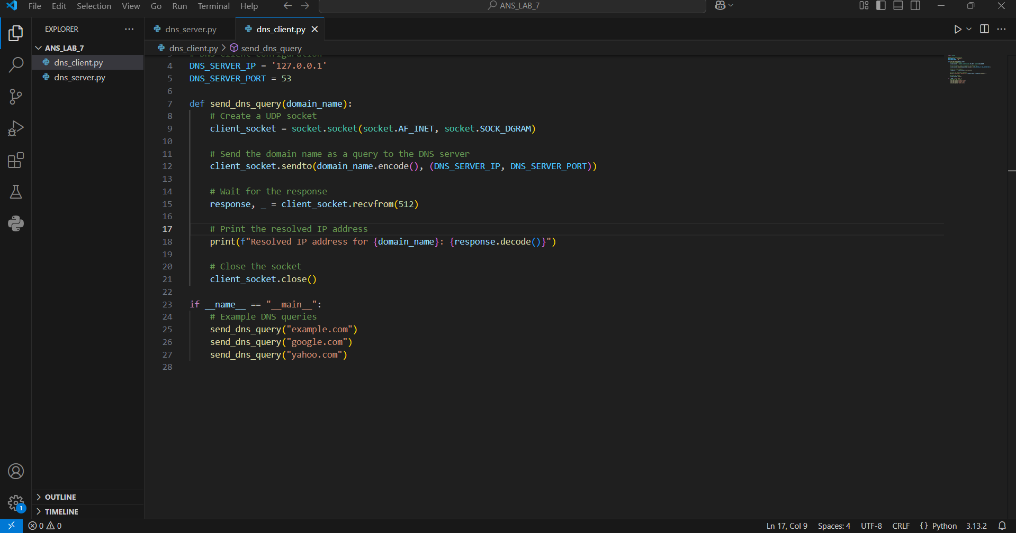

Output:

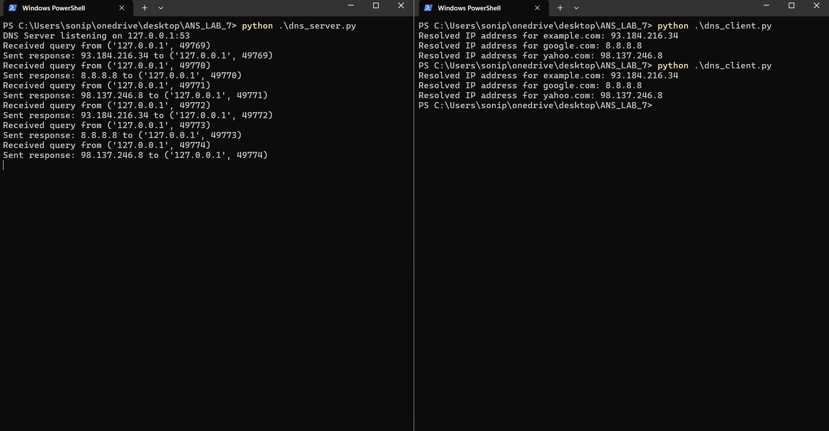

Conclusion:

This simulation of DNS using UDP sockets, This demonstrated the basic functionality of a DNS system, where a client sends a domain name query to a server, and the server responds with a predefined IP address.

