PRACTICAL 8

AIM: Implement Caesar Cipher Encryption-Decryption in Python.

Definition:
The Caesar Cipher is a simple and well-known encryption technique where each letter in the plaintext is shifted a certain number of places down or up the alphabet. It is a type of substitution cipher.
For example, with a shift of 3:
- A becomes D,
- B becomes E,
- Z becomes C, and so on.

Steps to Implement Caesar Cipher in Python:

1. Define a function for encryption:
- Accept a string (plaintext) and a shift key.
- Loop through each character.
- Shift letters forward by the key (maintaining case).
- Keep non-alphabet characters unchanged.

2. Define a function for decryption:
- Similar to encryption, but shift letters backward by the key.

Handle both uppercase and lowercase letters

4. Test the functions:
- Try encrypting and then decrypting to verify results.

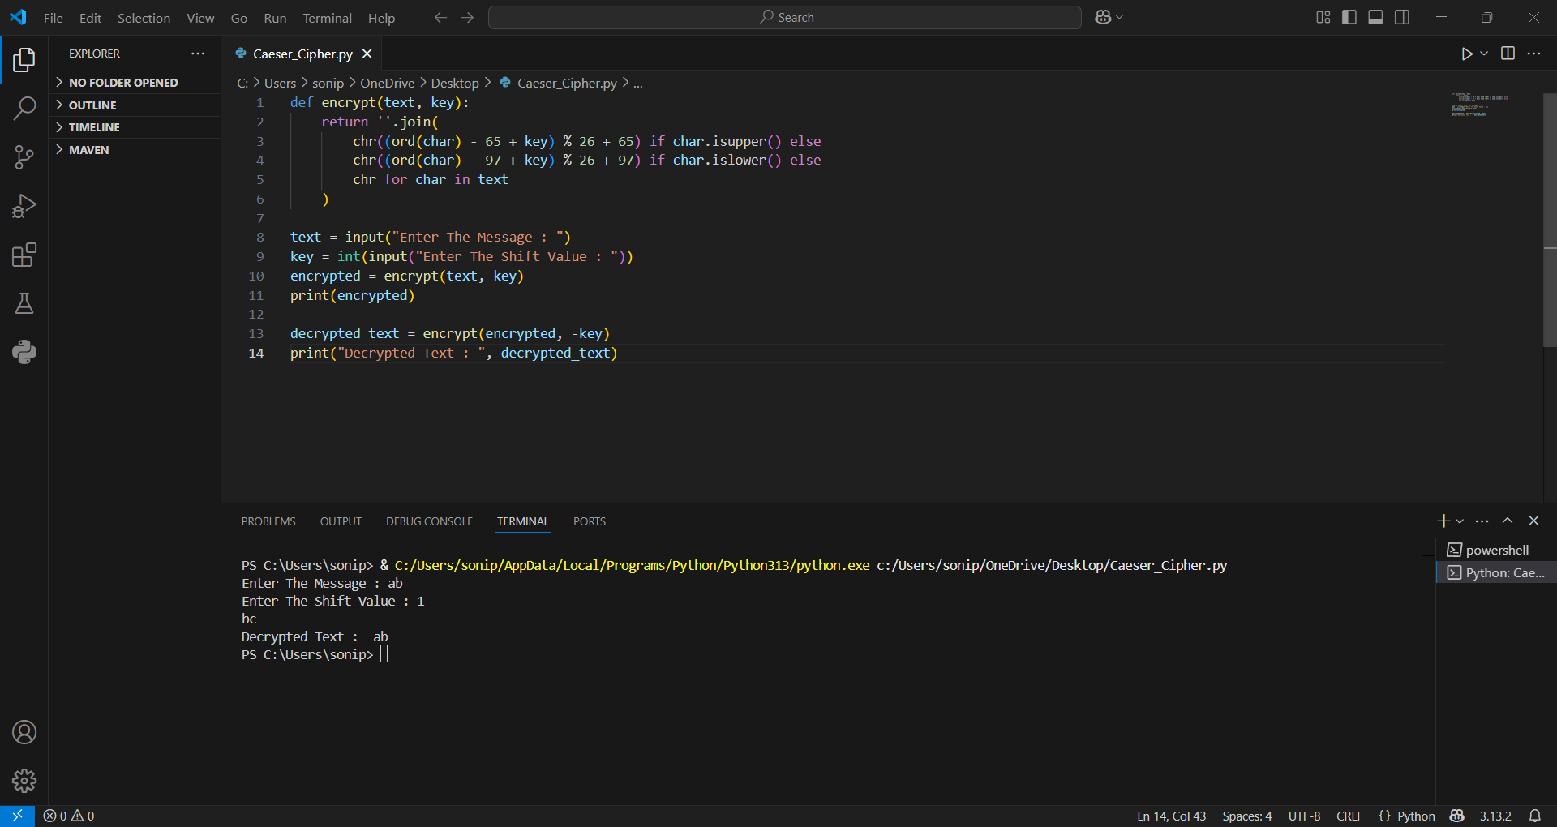

Code:

def encrypt(text, key):
return ''.join(
chr((ord(char) - 65 + key) % 26 + 65) if char.isupper() else
chr((ord(char) - 97 + key) % 26 + 97) if char.islower() else
chr for char in text
)

text = input("Enter The Message : ")
key = int(input("Enter The Shift Value : "))
encrypted = encrypt(text, key)
print(encrypted)

decrypted_text = encrypt(encrypted, -key)
print("Decrypted Text : ", decrypted_text)

Output:

Enter The Message : ab
Enter The Shift Value : 1
bc
Decrypted Text : ab

Conclusion:-

The Caesar Cipher is an introductory concept in cryptography, demonstrating how a simple shift can encode and decode a message. Though it is not secure for modern use, it's a great way to understand how encryption and decryption work. Implementing it in Python is straightforward using basic string manipulation and character encoding.

