PRACTICAL 1

DATE: 05/01/2025

AIM: Scan Vulnerabilities Using Nmap.

Nmap:

- Nmap, or Network Mapper, is a free, open-source network security tool that scans networks for vulnerabilities and security issues.

Command Used To Scan Vulnerabilities:

- nmap --script <IP address> -v

Output:

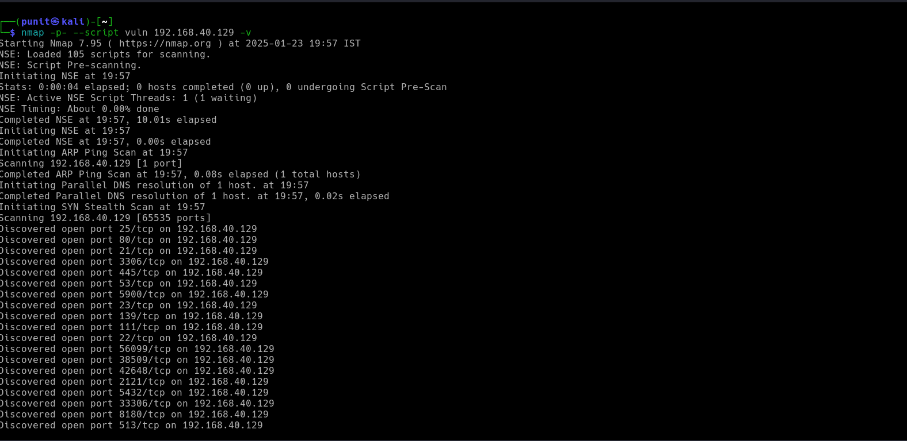

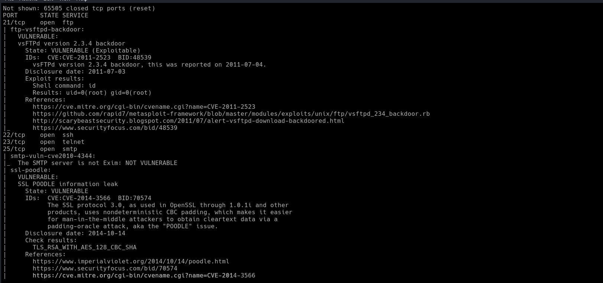

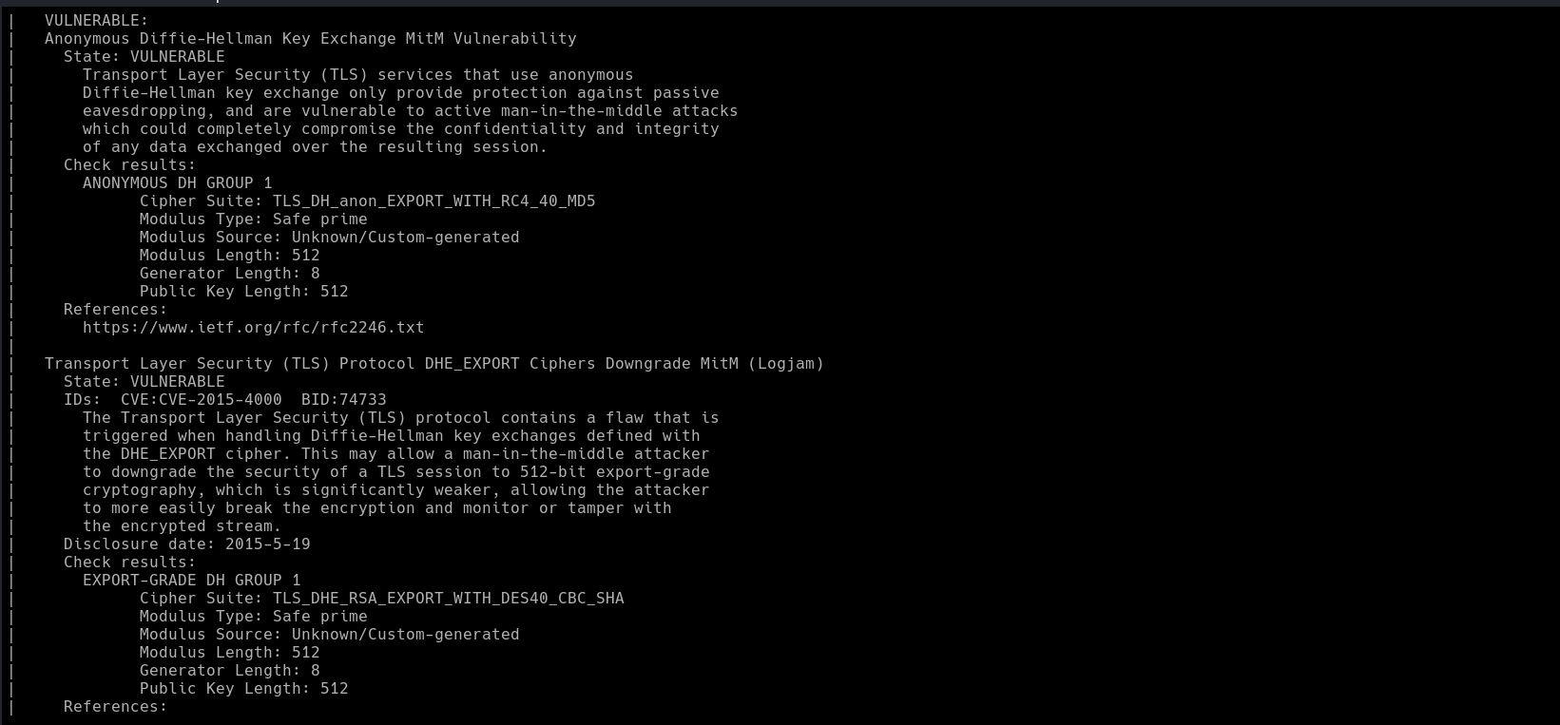

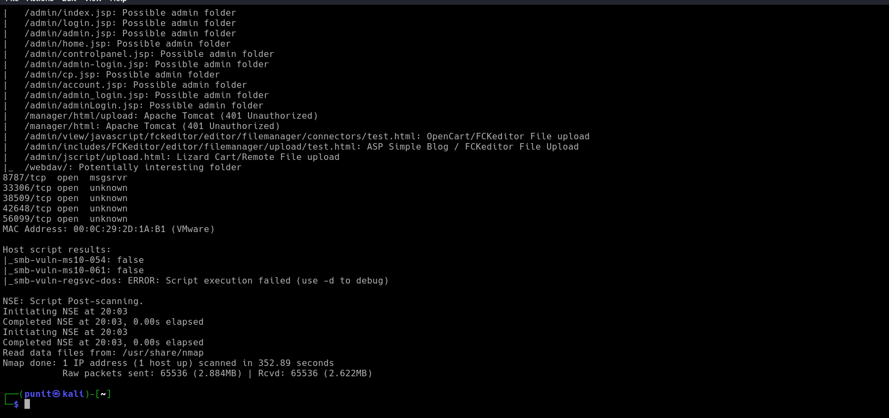

Conclusion:

- Nmap is that it is a powerful tool for network security professionals to identify and address vulnerabilities on a network. Nmap is a free, open-source network scanning tool that can help network professionals to enhance their network understanding and strengthen their digital defenses.

