PRACTICAL 4

Date: 10/02/2025

AIM: To develop skills in intelligence analysis, IOCs, and CTI sharing and collaboration.

Theory:

IP (Internet Protocol):

- An IP address is a unique identifier for a device on a network. In the context of cyber threat analysis, an IP address can be associated with malicious activities (e.g., botnet command and control, DDoS attacks, etc.).

Virus Total:

- VirusTotal is a free online tool that analyzes files and URLs to detect malware, viruses, trojans, and other types of malicious content.

- Use in Threat Intelligence: By uploading files (e.g., executables or suspicious documents) or providing URLs to VirusTotal, you can quickly gather intelligence on potential threats, learn more about their behavior, and share your findings with the security community.

Nmap (Network Mapper):

- Nmap allows security professionals to scan networks for vulnerabilities or suspicious activities, such as unauthorized open ports or services that might be exploited by attackers.

Steps:

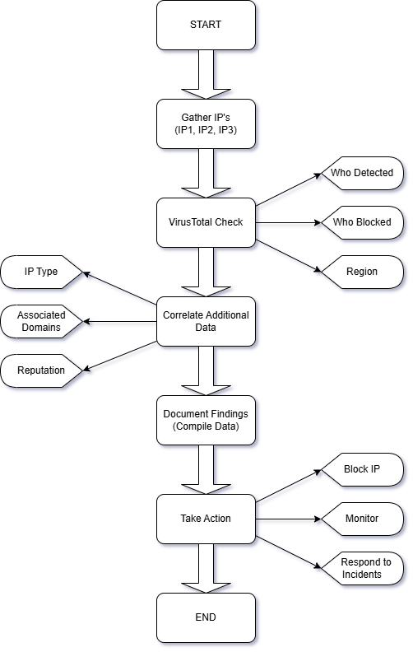

Scope | IP1(73.32.175.15) | IP2(31.3.96.40) | IP3(45.84.107.198)
From Where You Get | MaxMind | Google | MaxMind
Who Blocked | - | - | -
Who Detected | MalwareURL | MalwareURL | Criminal IP
Attacks | - | - | -
Region | US | NetherLand | Sweden
Service | ftp | https | tor-orport
Open Ports | 21/tcp | 80/tcp | 443/tcp
Version | - | Apache httpd | Tor 0.3.1.1 or later

