PRACTICAL - 9

DATE: 11-04-2025

AIM: Conducting a social engineering attack and analyzing the results to identify vulnerabilities - II.

Steps:-

1: - Open Social Engg attack toolkit
Setoolkit

2:- Select From the menu
Select from the menu:

1) Social-Engineering Attacks
2) Penetration Testing (Fast-Track)
3) Third Party Modules
4) Update the Social-Engineer Toolkit
5) Update SET configuration
6) Help, Credits, and About
99) Exit the Social-Engineer Toolkit

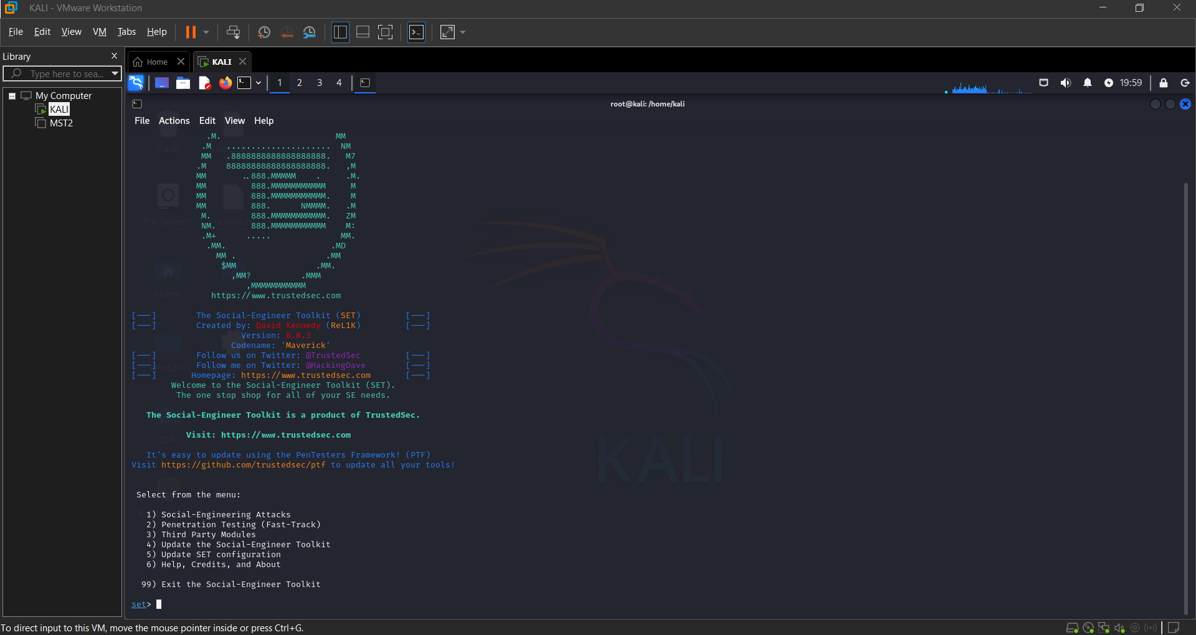

3:- select type of attack
Select from the menu:

1) Spear-Phishing Attack Vectors
2) Website Attack Vectors
3) Infectious Media Generator
4) Create a Payload and Listener
5) Mass Mailer Attack
6) Arduino-Based Attack Vector
7) Wireless Access Point Attack Vector
8) QRCode Generator Attack Vector
9) Powershell Attack Vectors
10) Third Party Modules
99) Return back to the main menu.

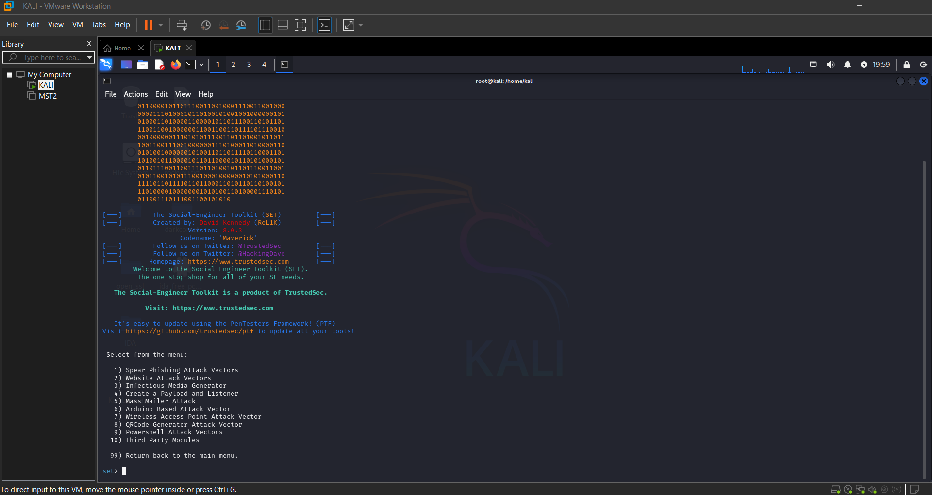

4:- Select Number 8 QRcode Generator Attack Vector

Enter The Url That Embedd in QRcode Scanner

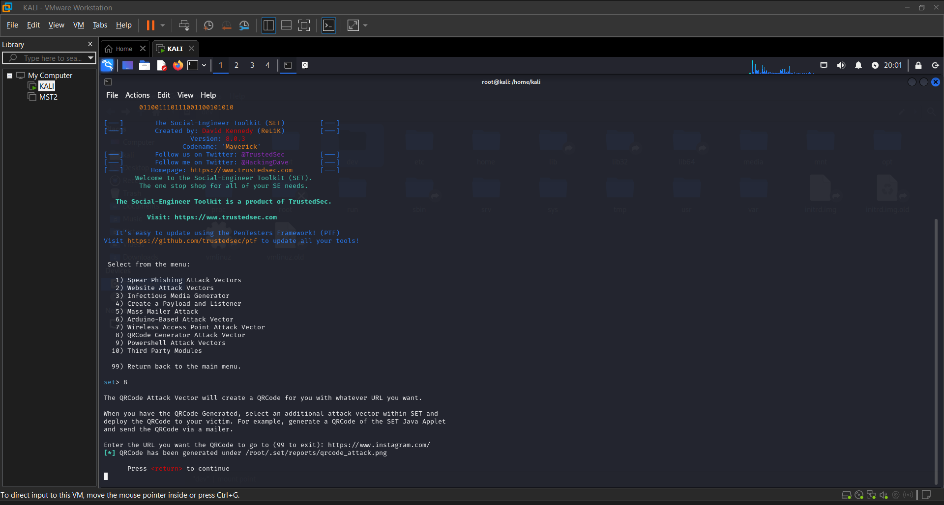
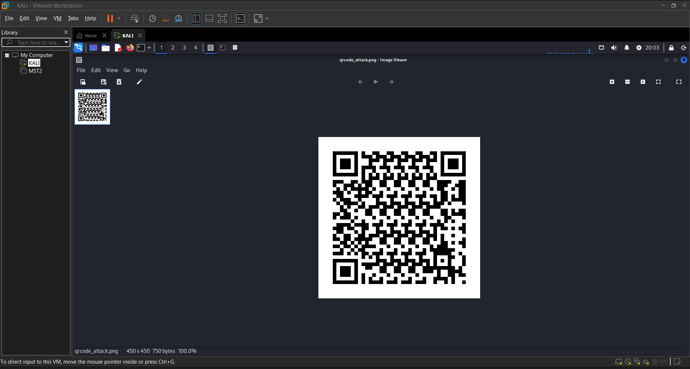

- After Generating the QRcode When Victim Scan the QRcode it will redirect to the URL That you insert in the QRcode.

Conclusion:

- The conducted social engineering attack successfully highlighted several critical vulnerabilities in human behavior and organizational security protocols. Through simulated phishing emails, pretexting scenarios, and other manipulation techniques, it was evident that even well-established systems can be compromised through human error or lack of awareness.

