LAB 6

AIM: Analyzing mobile and IoT malware samples using tools like VirusTotal and Yara.

VirusTotal:

SHA-256 (file hash):
00e9b5f2aba25bef484527b7efcbbd79b73f135abcfe03a8c23f25582c2e025f

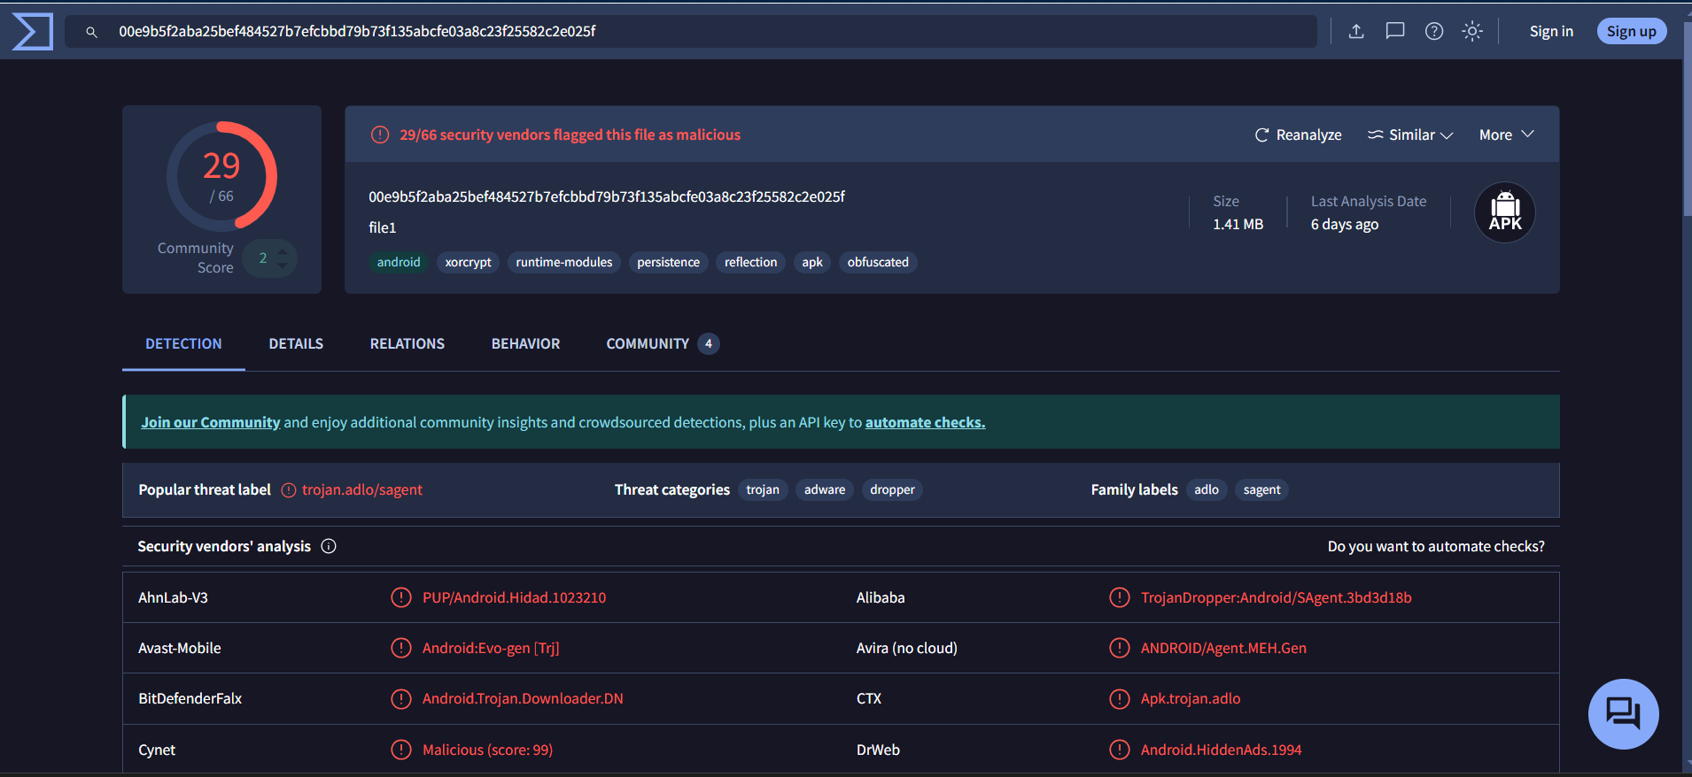

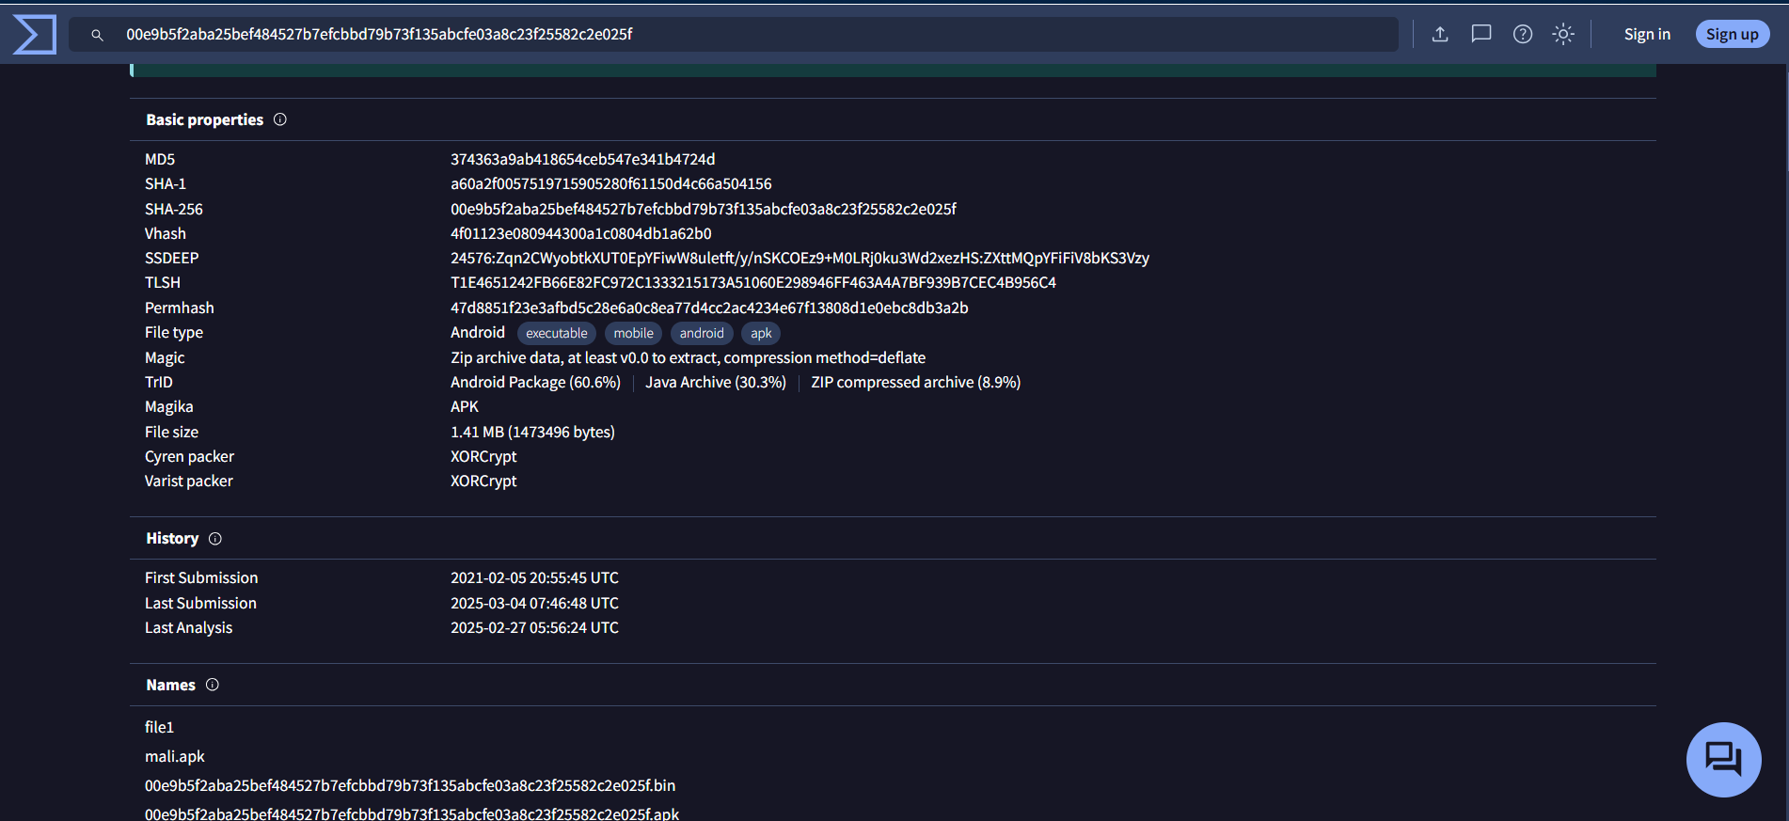

Yara Tool: Scan Using Custom Rules(malware_rules.yar)

cridex.vmem (Malware Sample):

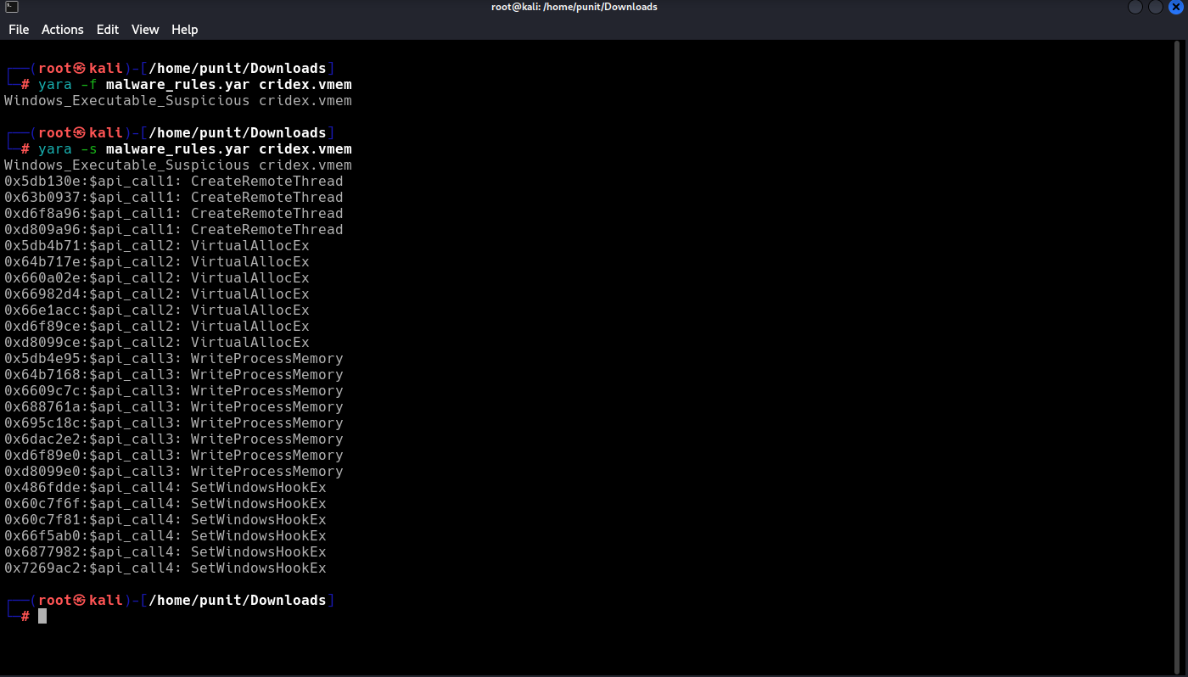

Spybot.vmem (Malware Sample):

