PRACTICAL 7

Aim: Install Mobsf and do Static/Dynamic Analysis

Mobsf: Mobsf (Mobile Security Framework) is an open-source automated mobile application security testing framework designed to perform static and dynamic analysis of mobile applications. It is primarily used for identifying security vulnerabilities in Android and iOS applications.

Step 1: Open Mobsf. Live Web Application and start static analysis for Android Analysis.
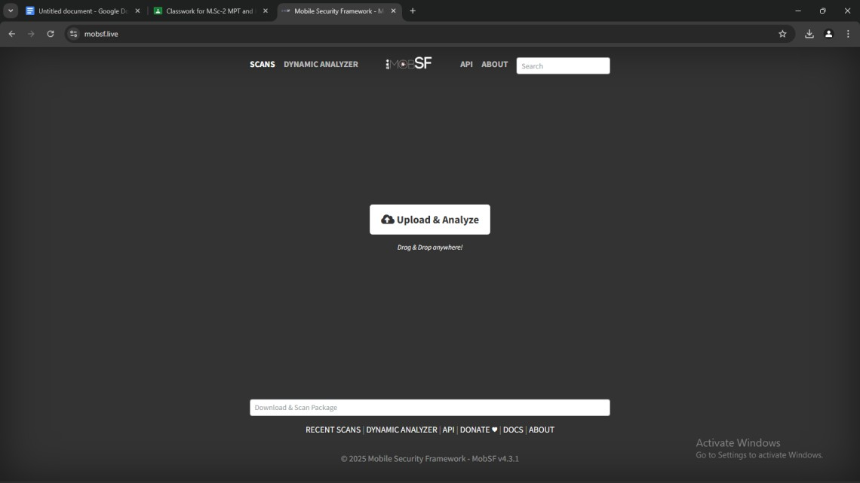

Step 2: Upload A base Andriod Application and analyze that the App is malicious or Not ?

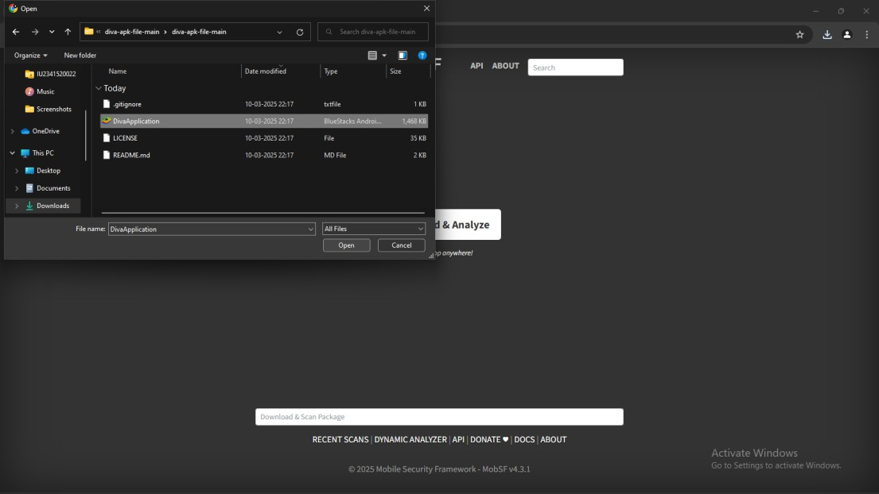

Step 3: Now the Mobsf.live will give the Scan report of the android application.
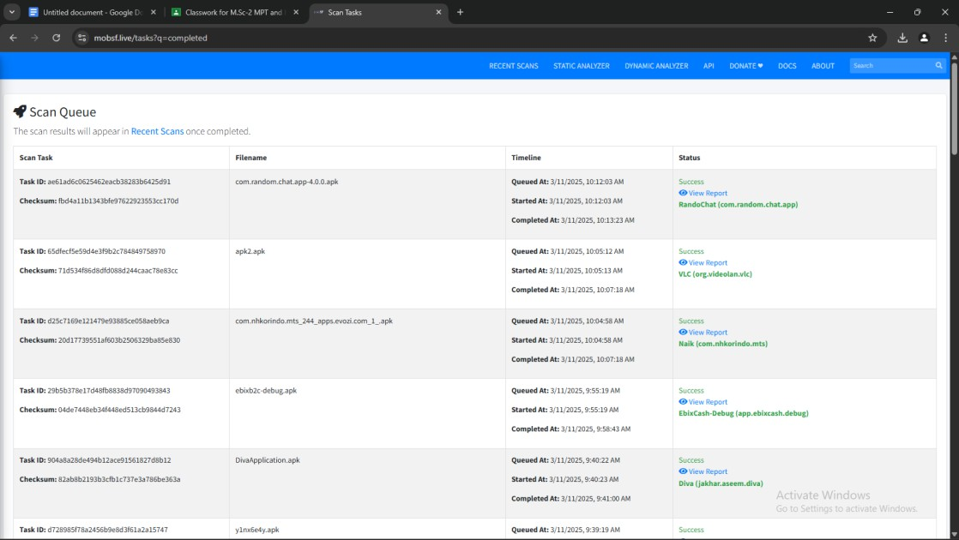

Step 4: Now mobsf.live will give you the report of the application.
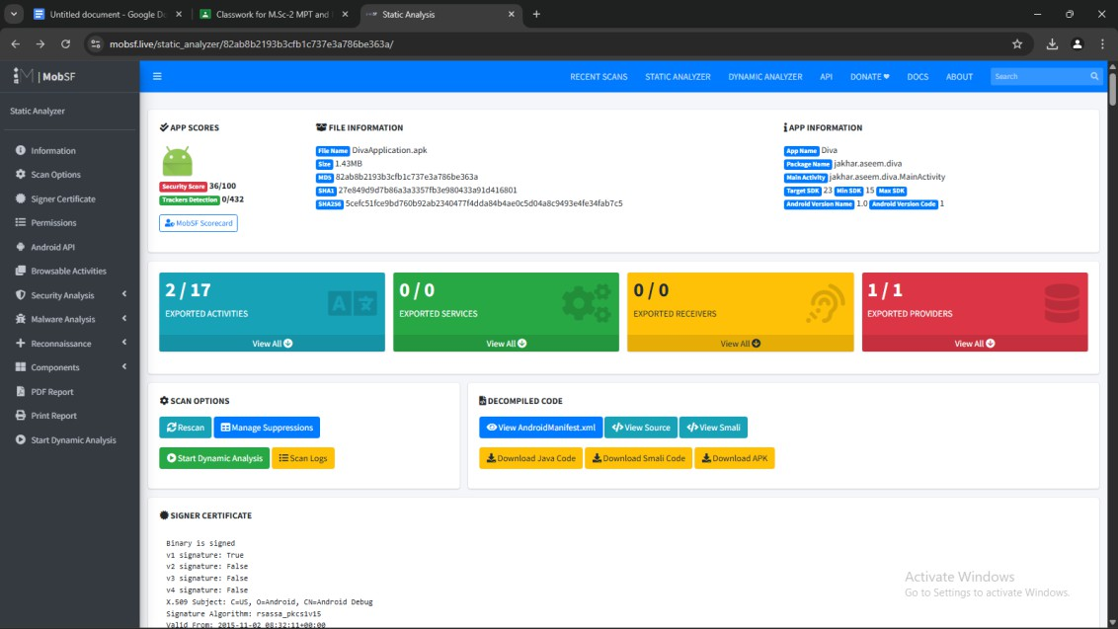

Step 5: Mobsf. Live Web application will provide you types of vulnerabilities in the application.

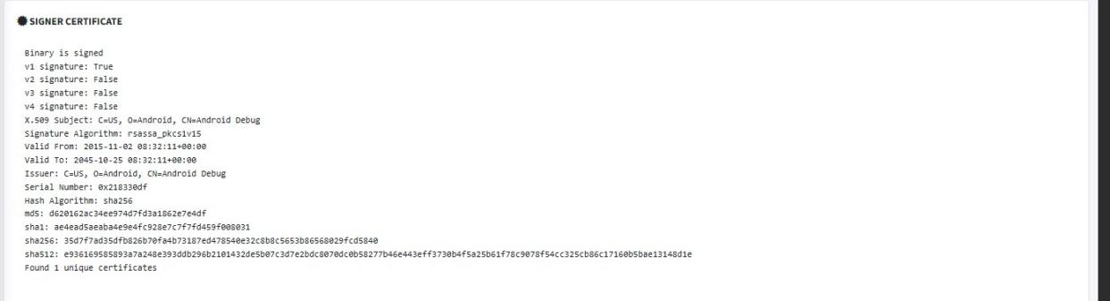

Step 6: The Permission of Application and Android API

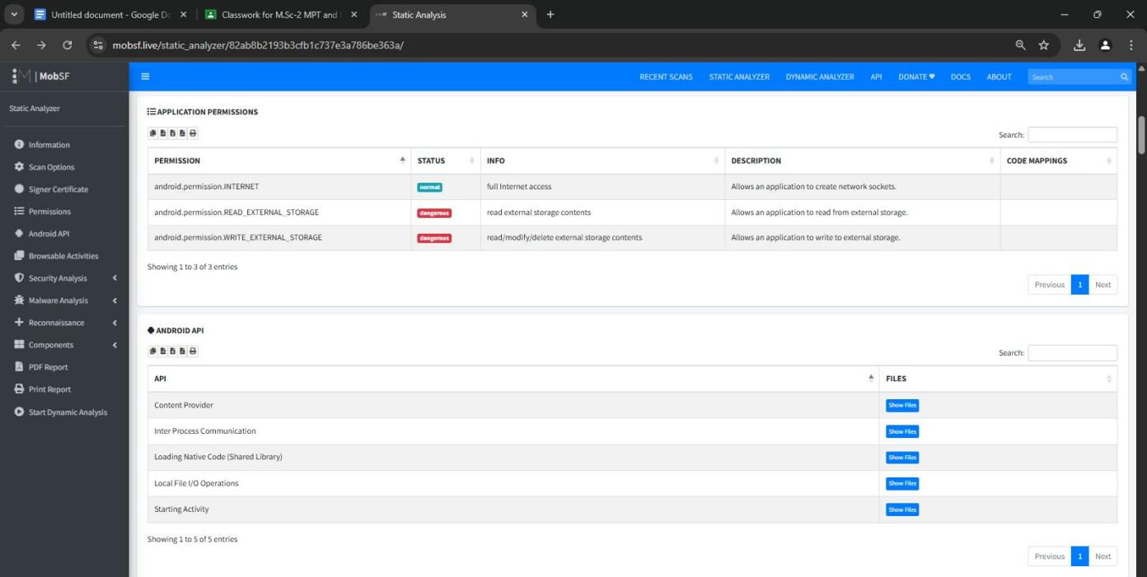

Step 7: The manifest analysis of the application

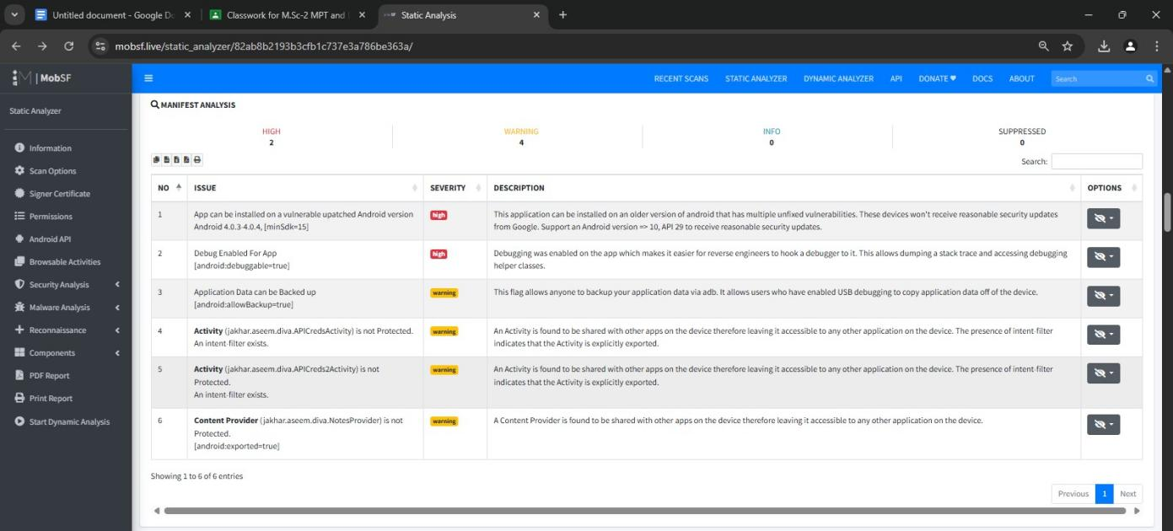

Step 8: The Application code Analysis:
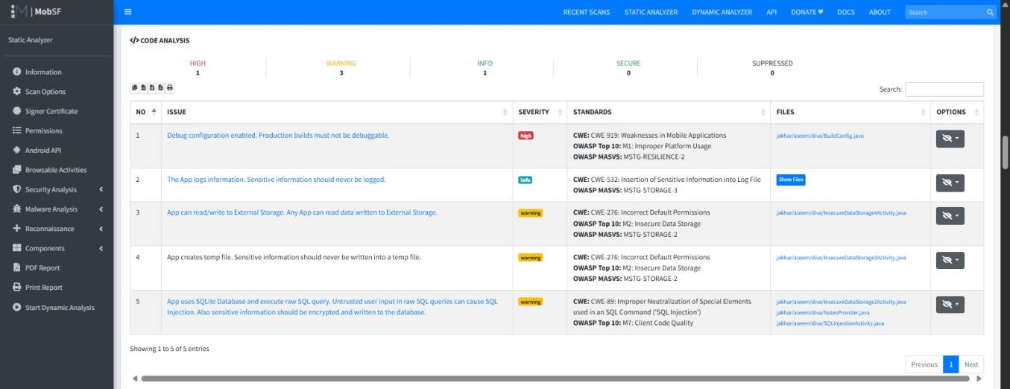

Step 9: Shared library Binary Analysis
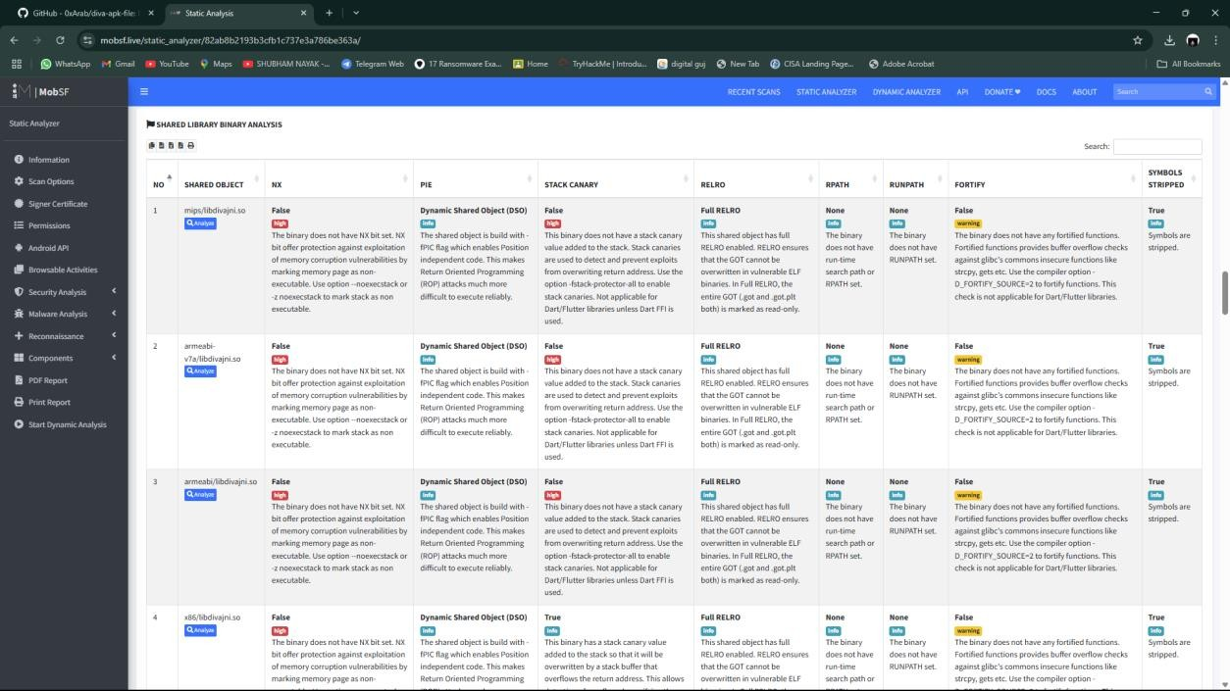

Conclusion:

Once MobSF is running, upload your APK or IPA file for static analysis. After the analysis, review the report for key findings related to permissions, code issues, and security risks. The conclusion will depend on the specific vulnerabilities and security issues identified in the report.

