LAB - 11

Aim :- converting apk into jar file.

Definition:
Converting an APK into a JAR file is a process used to extract and convert the compiled Dalvik bytecode (.dex files inside an APK) into a Java Archive (.jar) format using tools like dex2jar. This allows developers or security analysts to view the Java-like source code using a decompiler (e.g., JD-GUI). It's commonly used for reverse engineering Android applications to understand their logic or behavior.

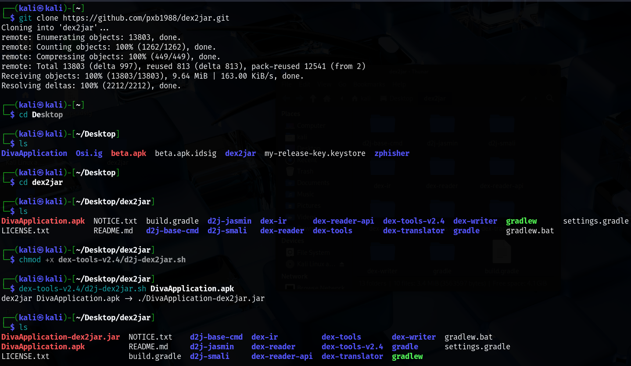

Conclusion :-
Converting an APK into a JAR file allows you to reverse engineer an Android application and understand its internal logic by converting Dalvik bytecode (.dex) into Java bytecode (.jar). Using tools like dex2jar and JD-GUI, developers and security researchers can analyze app functionality or debug issues. This process should always be done ethically and with proper authorization to respect intellectual property and privacy.

