LAB – 12
Aim :- Opening jar file in jdx GUI and find hardcore strings.

Definition:
Opening a JAR file in JD-GUI and finding hardcoded strings refers to the process of analyzing a Java archive file (usually converted from an APK) in JD-GUI, a Java decompiler. JD-GUI allows you to view the decompiled Java source code inside a .jar file. By exploring the code, you can search for hardcoded strings — like API keys, passwords, URLs, tokens, or any static values embedded directly in the source code — which can pose security risks if not handled properly.

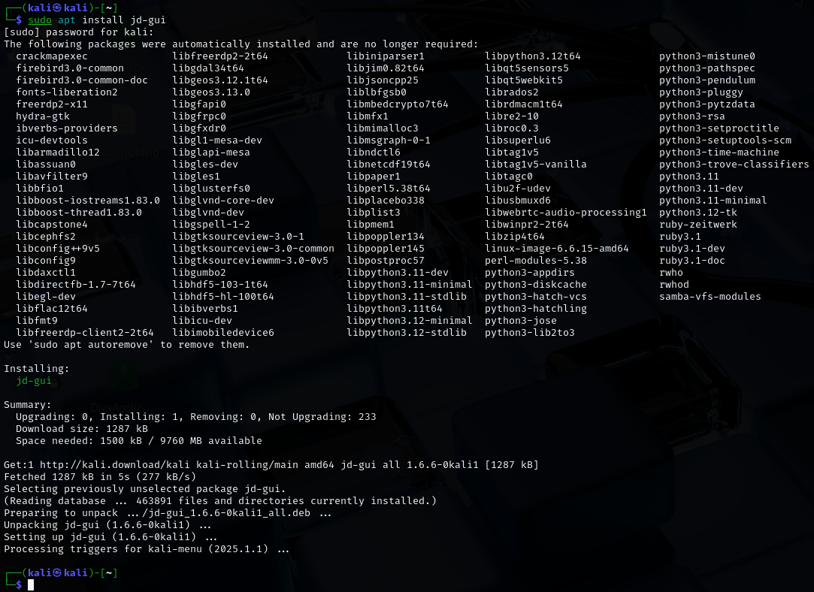

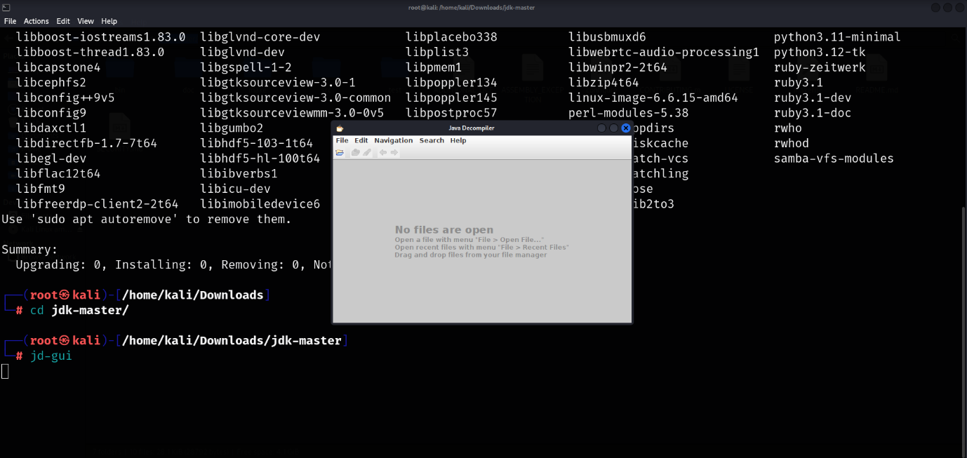

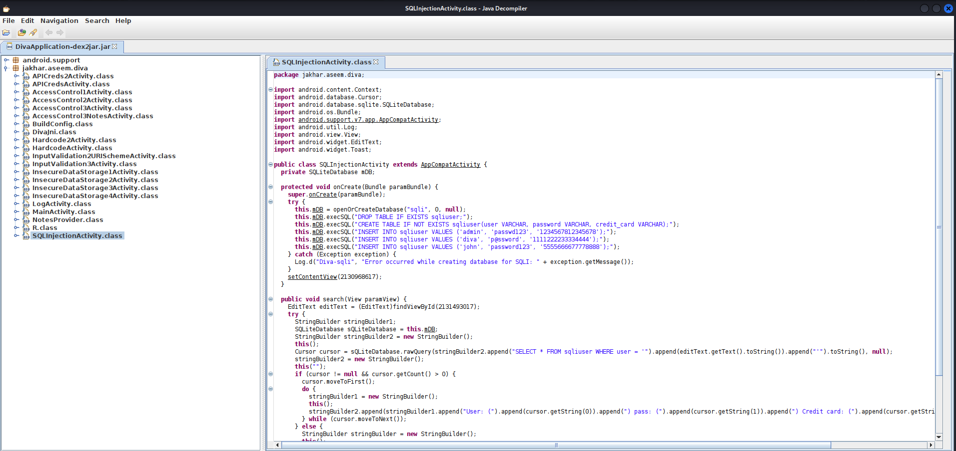

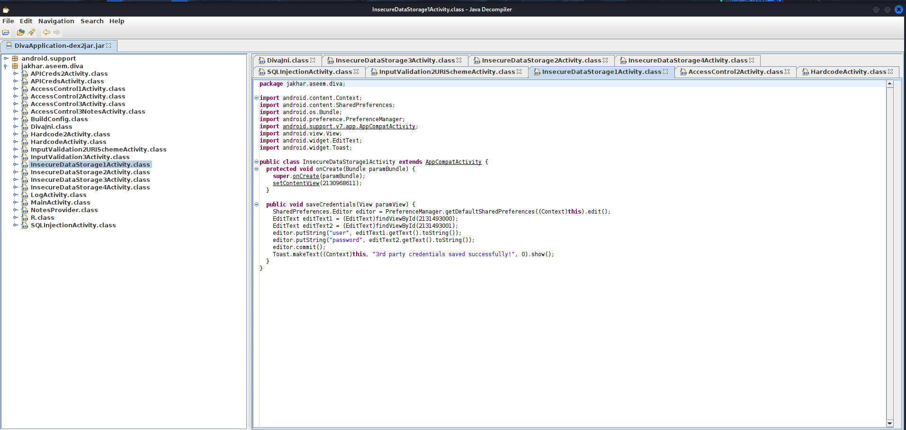

Conclusion :-
Using JD-GUI to open a JAR file and find hardcoded strings is a valuable technique for reverse engineering and security analysis. It helps identify sensitive data (like API keys, tokens, or credentials) that may have been unintentionally hardcoded in the app's source code. This process is essential for penetration testers, ethical hackers, or developers performing code audits. However, it should only be used on your own apps or with permission to ensure ethical and legal compliance.

