LAB - 13
Aim :- Analyzing network traffic on mobile and IoT devices to identify potential security risks.

Definition:
Analyzing network traffic on mobile and IoT devices to identify potential security risks involves monitoring and inspecting the data packets exchanged between a device (mobile or IoT) and external servers, networks, or other devices. This analysis helps identify vulnerabilities or malicious activities, such as unsecured data transmission, unauthorized access attempts, or communication with known malicious IP addresses. The goal is to assess the device’s communication and ensure data confidentiality, integrity, and proper authentication.

To understand how to capture and analyze network traffic from mobile devices (and simulate IoT traffic) to detect potential security threats.
Tools Used:
- Wireshark (for packet capture and analysis)
- Android phone (connected to same Wi-Fi network)
- Windows/Linux PC (running Wireshark)
- (No real IoT devices used – IoT traffic is simulated)

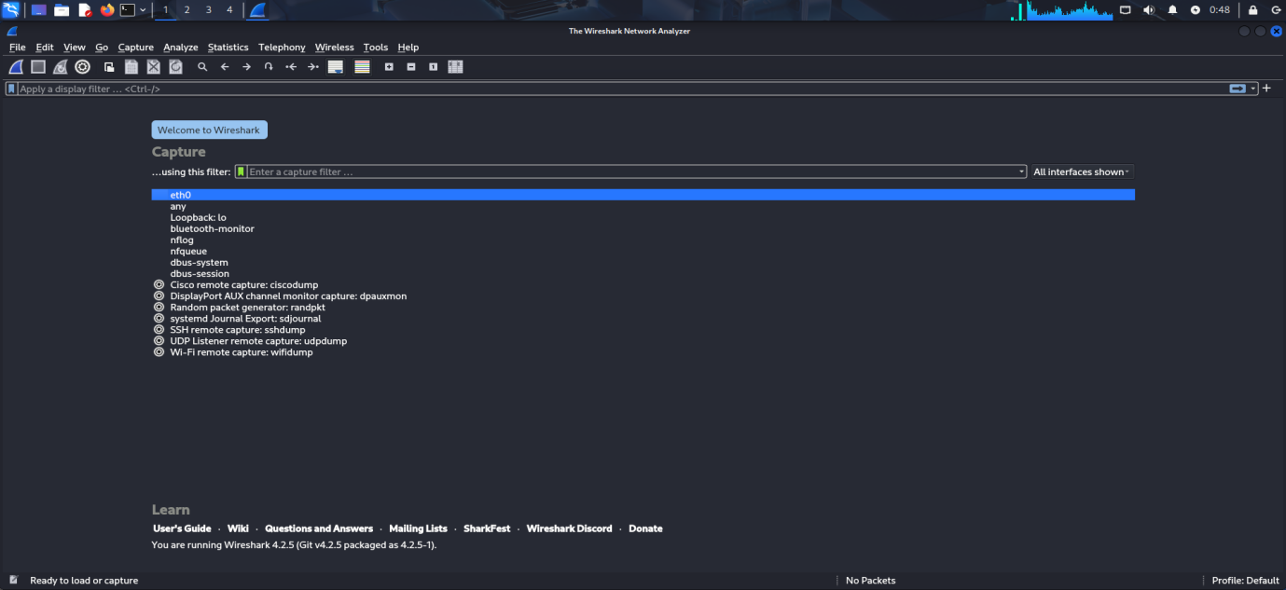
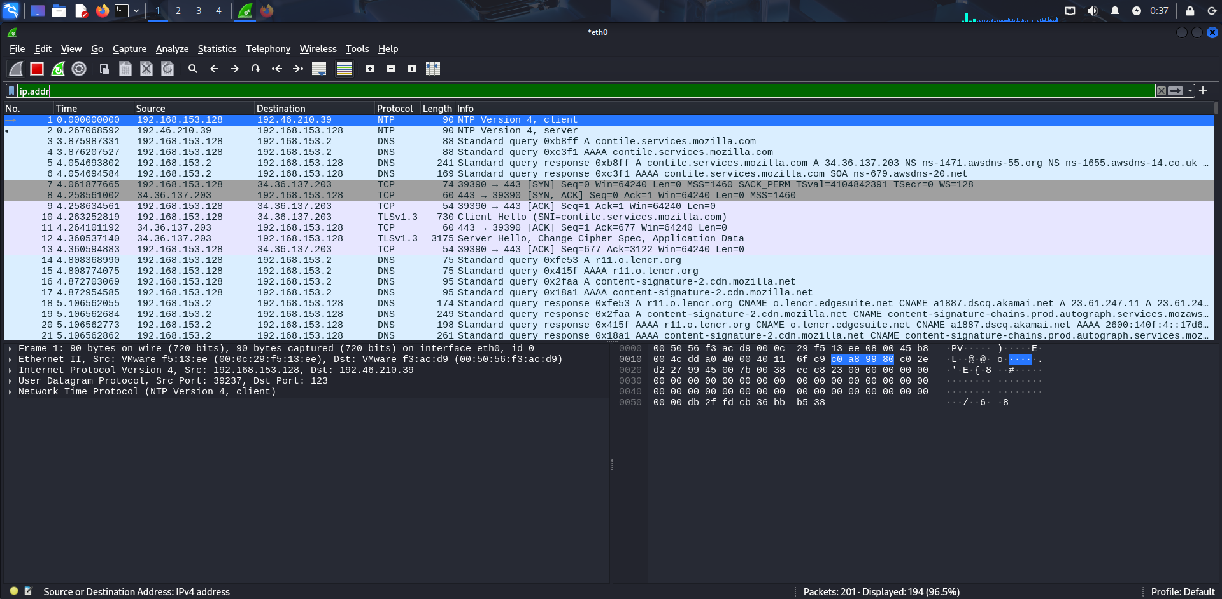
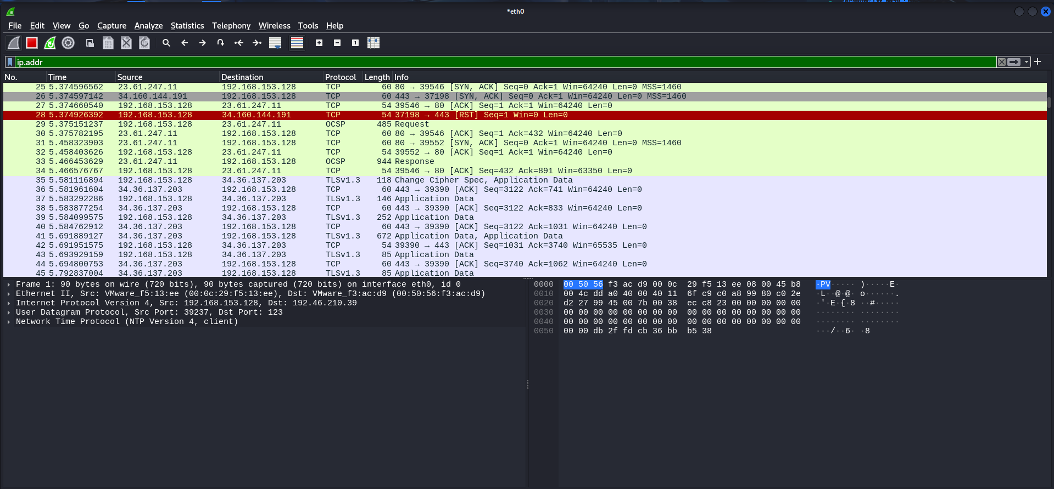

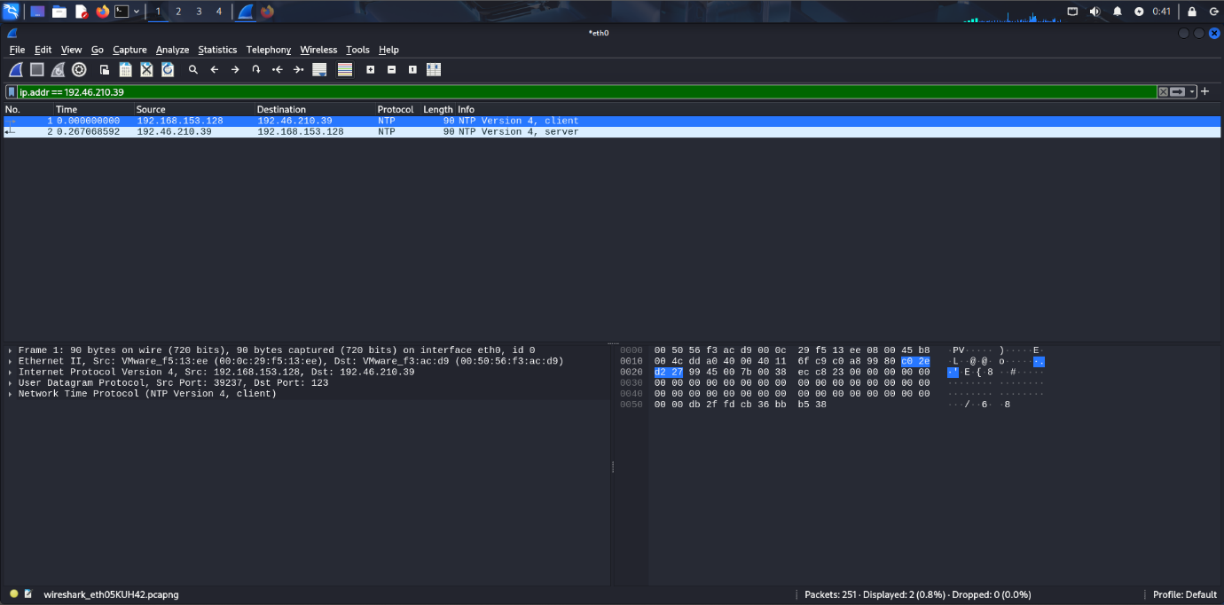

Conclusion :-
Analyzing network traffic on mobile and IoT devices is a critical step in identifying potential security risks. By using tools like Wireshark, Fiddler, tcpdump, or Burp Suite, security analysts can monitor communication between devices and external servers, ensuring that sensitive data is not exposed, malicious activity is detected, and communication is properly secured. This process helps in detecting issues like unencrypted traffic, weak authentication, or unauthorized access, which are critical for maintaining the security and integrity of devices and networks.

