LAB - 8
Aim:- Re-compiling the apk using apktool kit

Definition:
Re-compiling an APK using APKToolkit refers to the process of taking a previously decompiled Android application (APK) — including its resources, manifest, and smali code and packaging it back into a working .apk file. This is commonly done after making changes to the app's contents, like modifying layouts, strings, or functionality in the smali code.



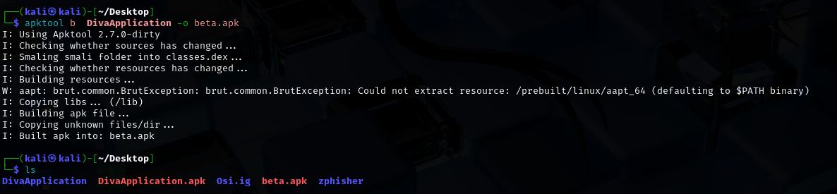

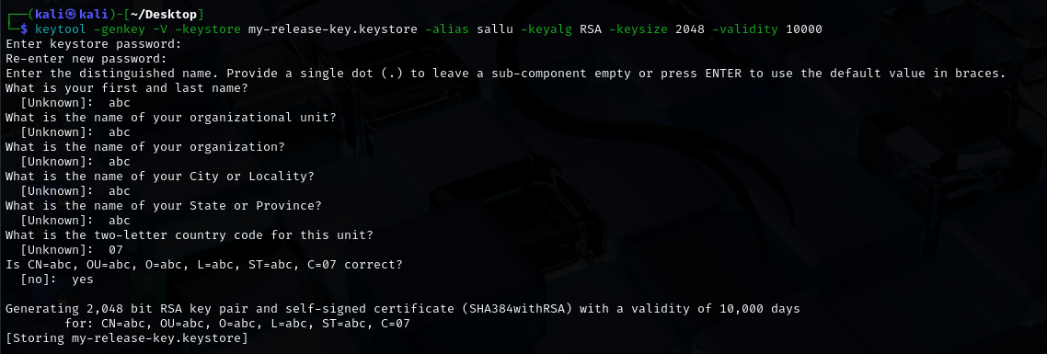

Conclusion :-
Re-compiling an APK using APKToolkit is the final step in modifying Android apps. After making changes to a decompiled project (resources or smali code), you use apktool b to rebuild it into a valid APK. The rebuilt APK must then be signed before it can be installed on an Android device. This is a powerful process, useful for debugging, customizing apps, or studying how Android apps work — always within legal and ethical boundaries.

