LAB - 9
Aim :- Decompiling apk by using apktoolkit.

Decompiling an APK using APKToolkit is the process of extracting and converting an Android application's APK file back into a more human-readable format using the APKToolkit (a utility or collection of tools like apktool, dex2jar, jd-gui, etc.). This process helps understand the app’s structure, resources, and behavior — often used in reverse engineering, app debugging, or security testing.

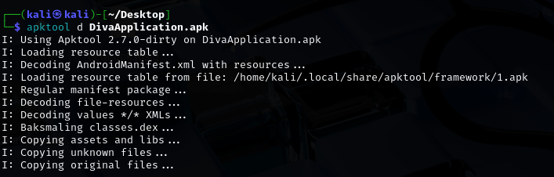

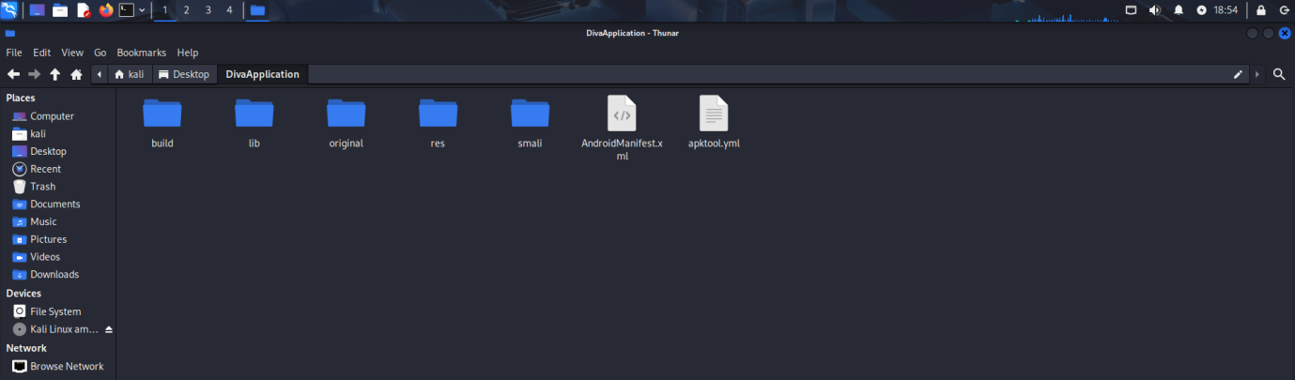

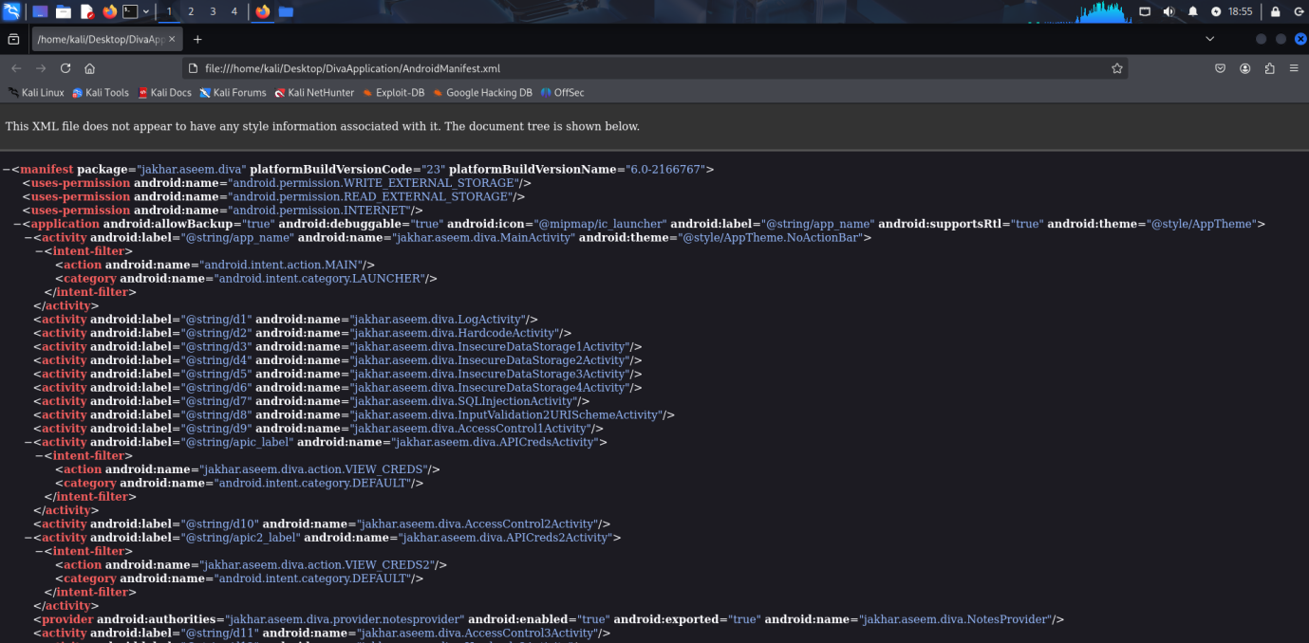

Conclusion :-
Decompiling an APK using APKToolkit helps developers and security researchers understand app structure and behavior without original source code. It involves decoding the APK to extract resources and smali code, and optionally converting to Java for better readability. While powerful, this method should always be used responsibly and ethically — with permission or for educational purposes.

