Lab-2 Report
AIM: Packet Capture and Network Traffic Analysis Using Wireshark & tcpdump

Introduction
The purpose of this lab is to provide hands-on experience in capturing and analyzing network traffic to identify potential security threats. Using tools like Wireshark and tcpdump, students will learn how to detect various types of attacks and security anomalies in a network, including DoS attacks, port scanning, ARP spoofing, DNS spoofing, and cleartext data transmission. These tools allow for detailed inspection of network traffic, providing insights into potential vulnerabilities and threats in a network environment.

Objective
- To use Wireshark and tcpdump for capturing and analyzing network traffic.
- To detect potential security threats and abnormal patterns such as SYN Floods, port scanning, ARP poisoning, DNS spoofing, and cleartext transmission of sensitive data.

Tools & Resources
- Wireshark: A graphical network protocol analyzer.
  - Official site: Wireshark
- tcpdump: A command-line network packet analyzer.
  - Installation for Linux: sudo apt install tcpdump
- Kali Linux (for simulating attacks)
- Ubuntu/Windows (for performing normal operations and being attacked)
- Nmap (for scanning and testing vulnerabilities)

Methodology
4.1. Installation & Setup
- Wireshark was installed on the system, ensuring that the network interface was correctly selected for packet capture.
- tcpdump was installed on both Kali Linux and Ubuntu systems to capture traffic from a command-line interface.
- A Virtual Lab Network was created using virtual machines, assigning static IP addresses (e.g., Kali: 192.168.1.1, Ubuntu: 192.168.1.2) to allow safe and controlled testing of network behaviors.

Results
SYN Flood Attack

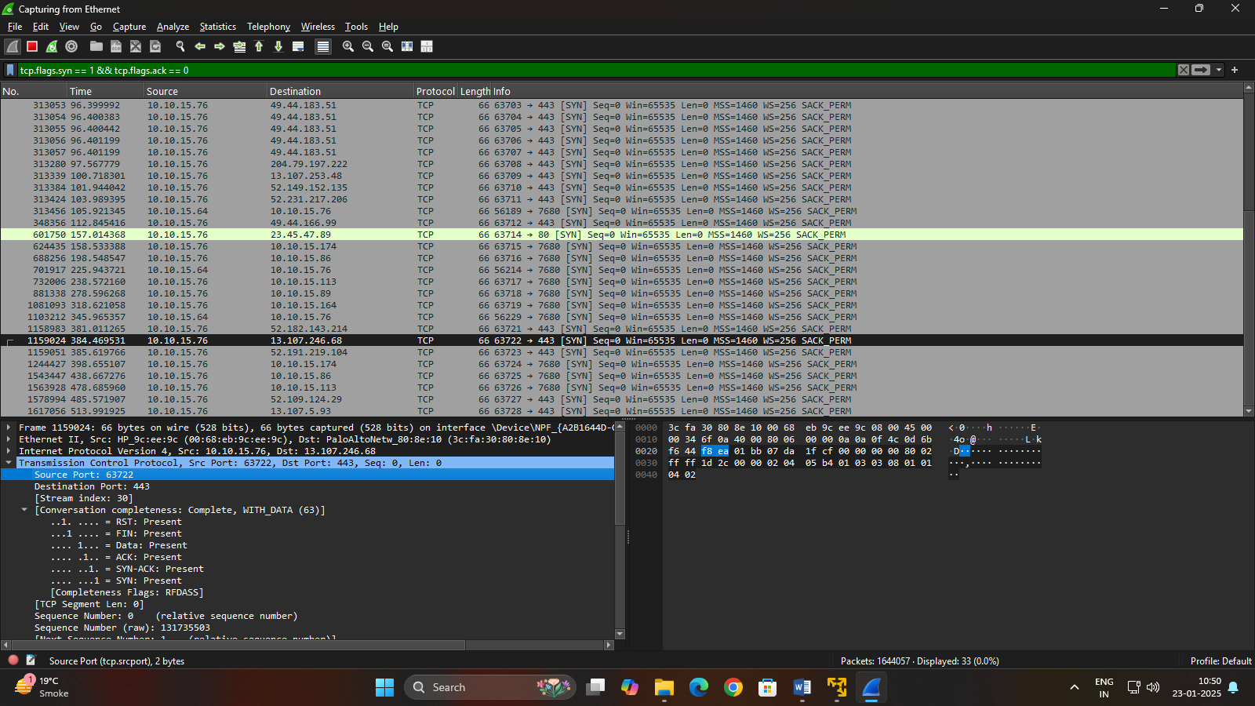

Port Scanning
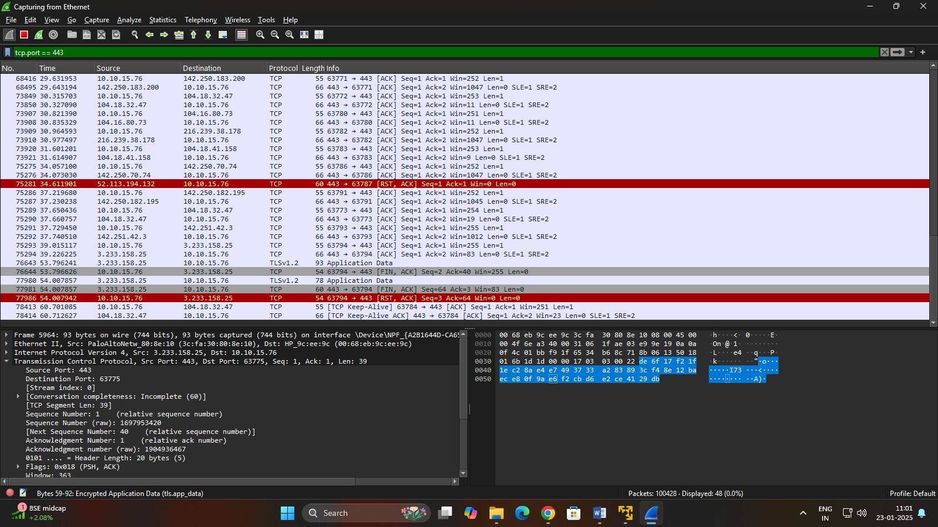

Conclusion
Packet capture and network traffic analysis using tools like Wireshark and tcpdump are essential for gaining deep insights into network performance, identifying issues, and ensuring security.

