Practical – 1
Title: network scanning and reconnaissance using nmap and identify open ports,operating system and potential vulnerabilities.
Objective:
- Identify open ports on target machine.
- Determine the operating system running on target machine.
- Detects potential vulnerabilities that may exist based on ports and service running.
Tools Require : Nmap
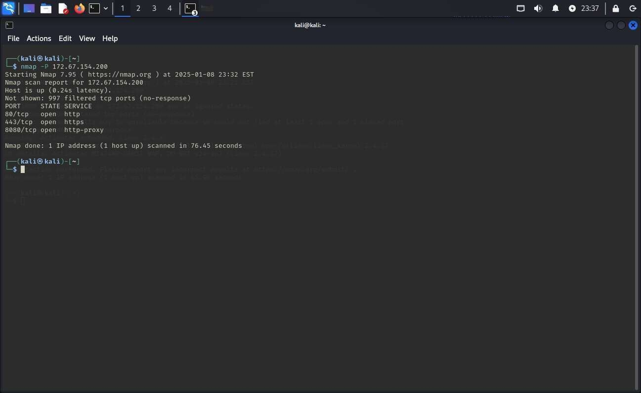
- Identify open ports on target machine

- Determine the operating system running on target machine
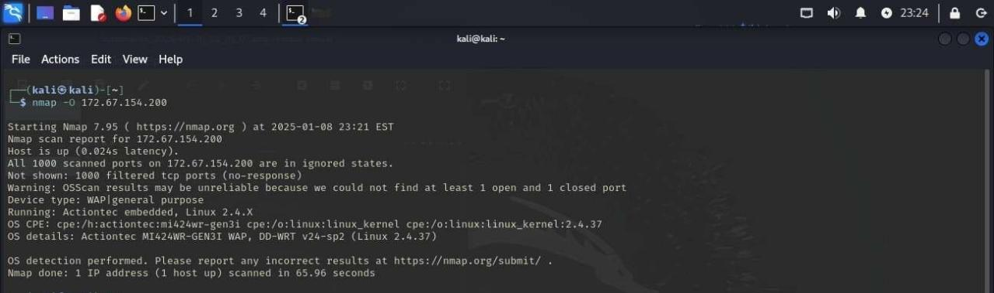

- Detects potential vulnerabilities that may exist based on ports and service running
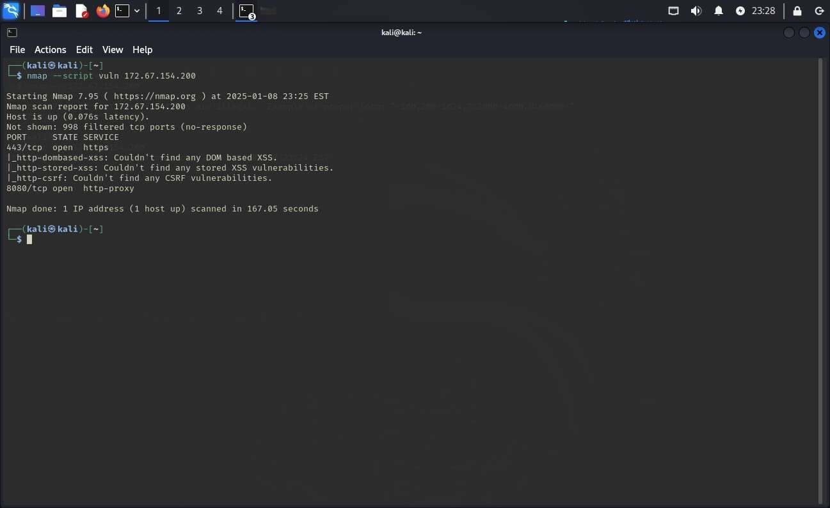
Report:
service | port | version | Vulnerability found
http | 80 | Not found | Not found
https | 443 | Not found | Not found
http-proxy | 8080 | Not found | Not found

Conclution

Nmap identifies open ports on the target machine revealing active services. It detects the operating system in use. Nmap also checks for known vulnerabilities in the services running on those ports. This helps identify security risks and areas to improve.

