Practical-2

Aim: Packet capture and analysis using Wireshark or tcpdump to capture and analyze network traffic for potential security threats.

introduction to Packet Capture
Packet capture is the process of intercepting and logging network traffic that passes through a computer or network interface. This data can be analyzed to detect anomalies, diagnose issues or investigate potential security threats.

Tools for Packet Capture:
- Wireshark – A graphical tool with deep packet inspection and filtering capabilities.
- tcpdump – A command-line tool for quick packet captures, often used on Linux servers.

Steps to Capture Packets in Wireshark
- Download and Install Wireshark
  - Available for Windows, macOS and Linux.
  - https://www.wireshark.org/download.html

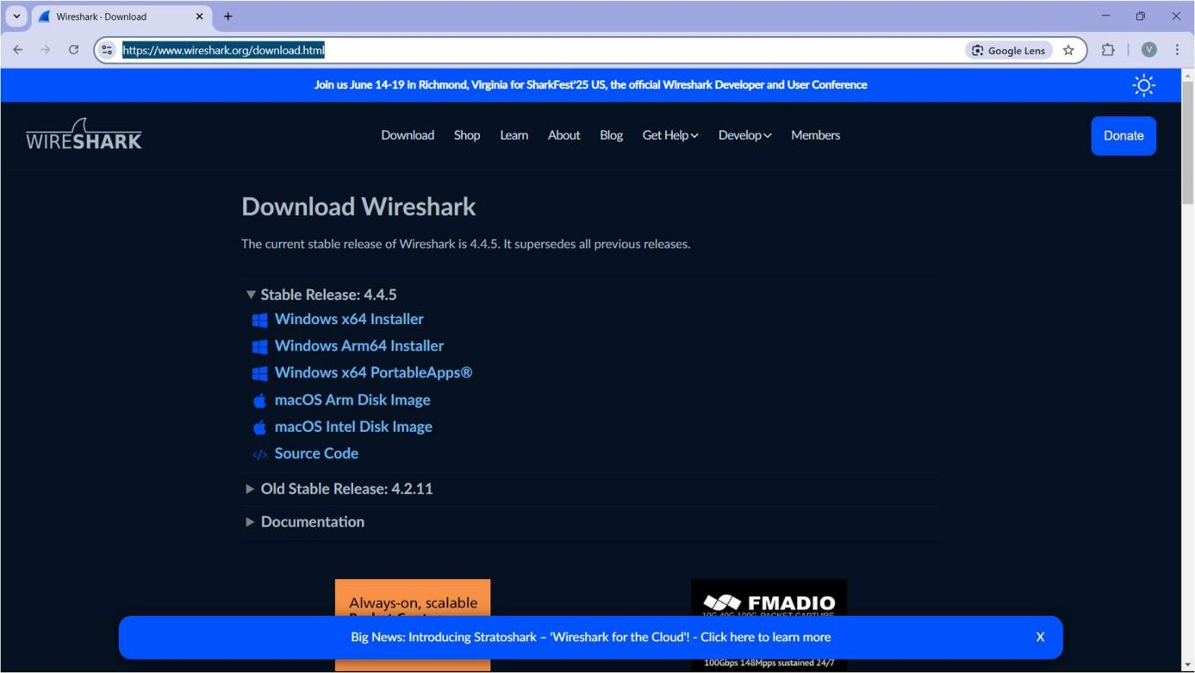

Select a Network Interface
  - Open Wireshark and choose the network adapter you want to monitor (e.g., Ethernet or Wi-Fi).
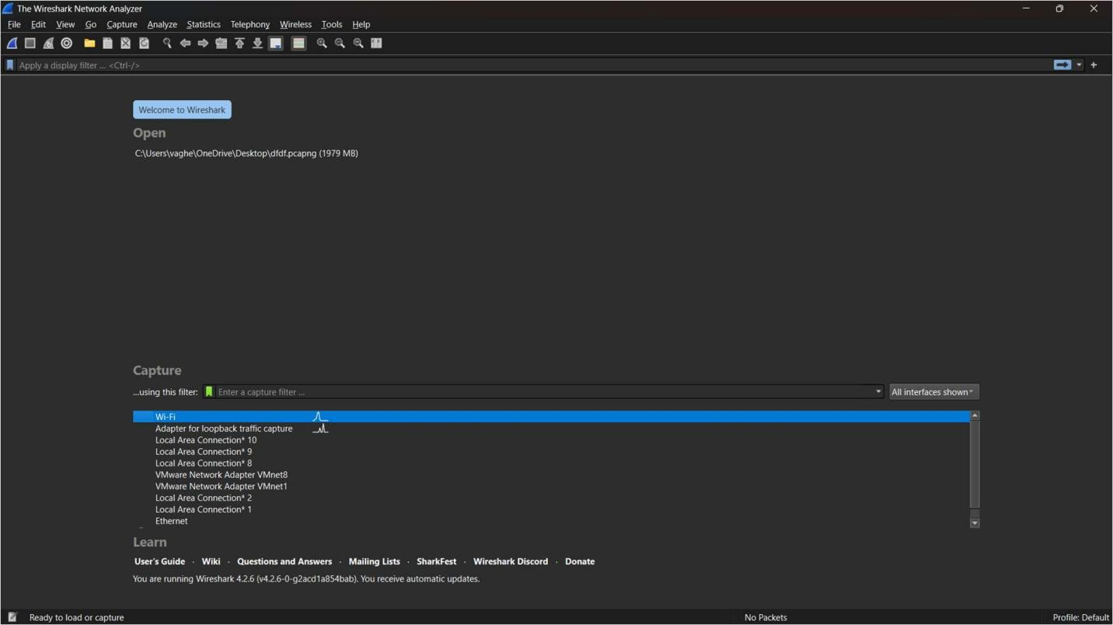

Start Capturing Packets
  - Click the "Start" button to begin capturing network traffic.
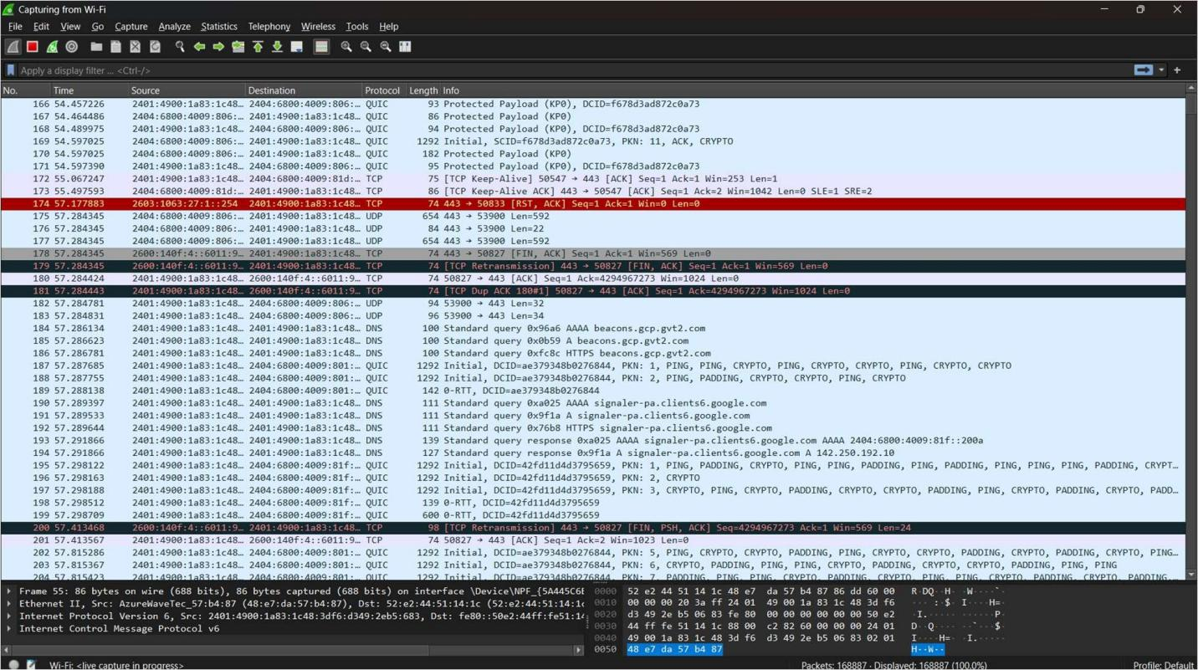

Apply Filters (Optional but Recommended)
  - Use display filters like:
    - tcp.port == 443 → Capture only HTTPS traffic.
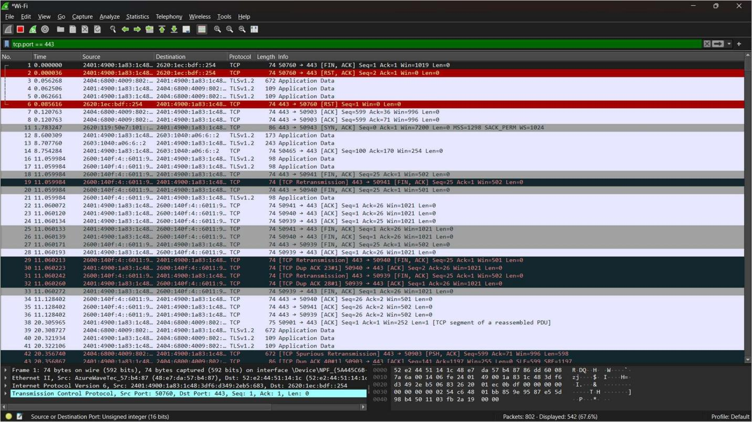

Analyze Captured Packets
  - Click on a packet to inspect details :
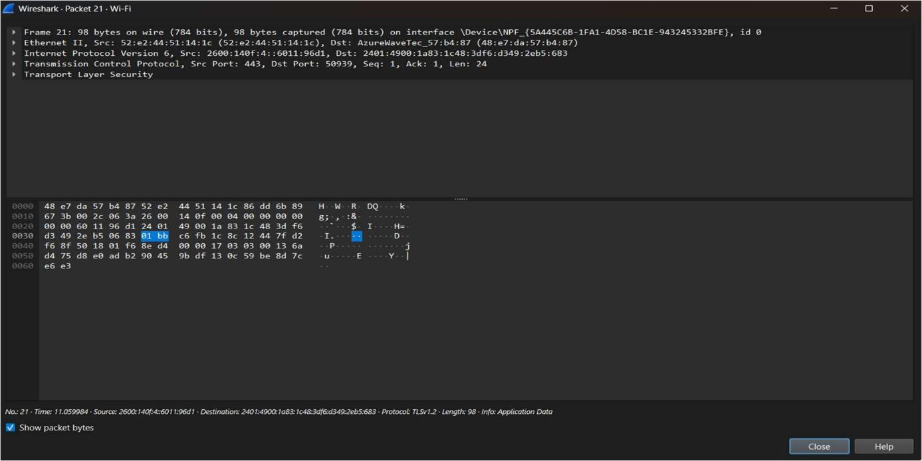

Conclusion

Both Wireshark and tcpdump are powerful tools for packet capture and analysis. Wireshark is ideal for deep packet inspection with a graphical interface, while tcpdump is lightweight and perfect for command-line environments. By monitoring and analyzing network traffic, security threats like intrusions, malware activity and data exfiltration can be detected early.

