AIM: Reverse engineering malware using reverse engineering frameworks such as Radare2.

Step 1: Install Radare2 on your system using the following command:
- sudo apt install radare2

Step 2: Set up a secure analysis environment (VM or sandbox) to avoid executing malicious code.
- Loading the Malware Sample in Radare2
- Open the terminal and navigate to the folder containing the malware binary.
- Run the following command to load the binary into Radare2:
- r2 -AA malware_sample.exe

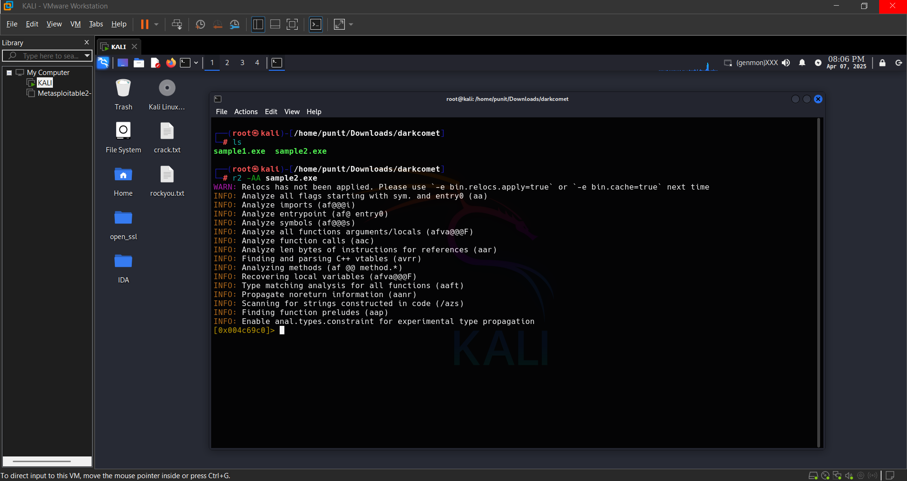

Step 3: Analyzing the Binary Structure
- Use the `i` command to display basic binary information:

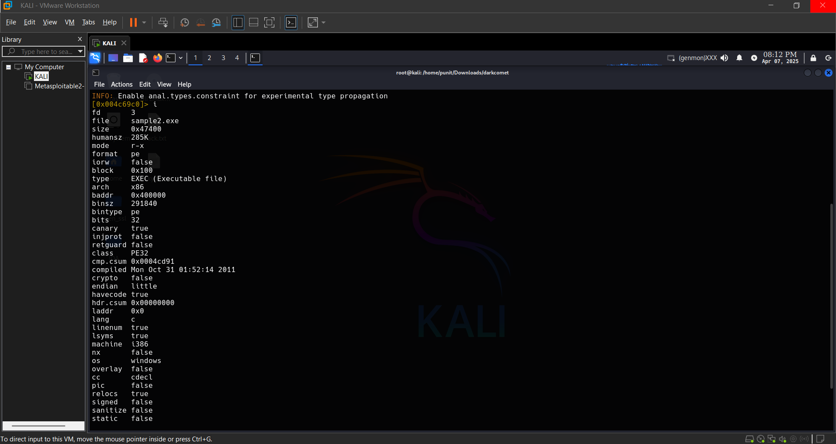

- List the functions detected in the binary using: afl

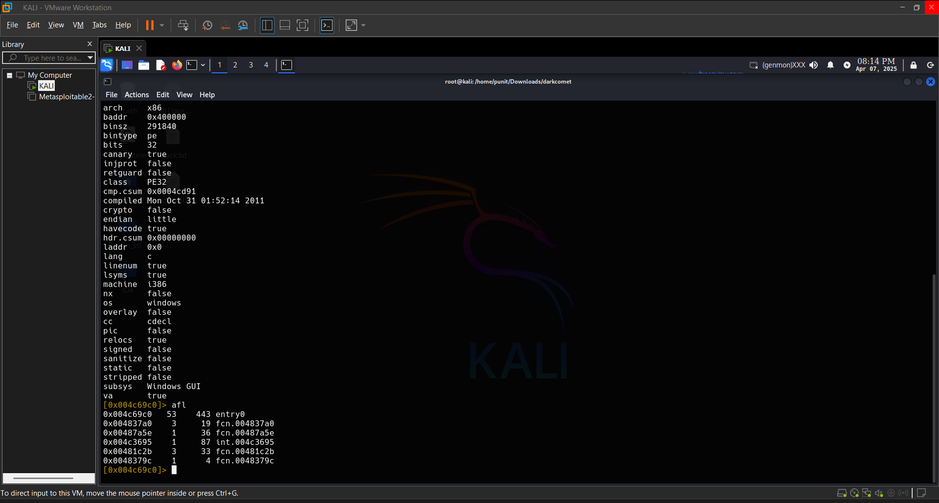
Step 4: Disassembling and Identifying Code Flow

- Run the following command to extract readable strings: iz

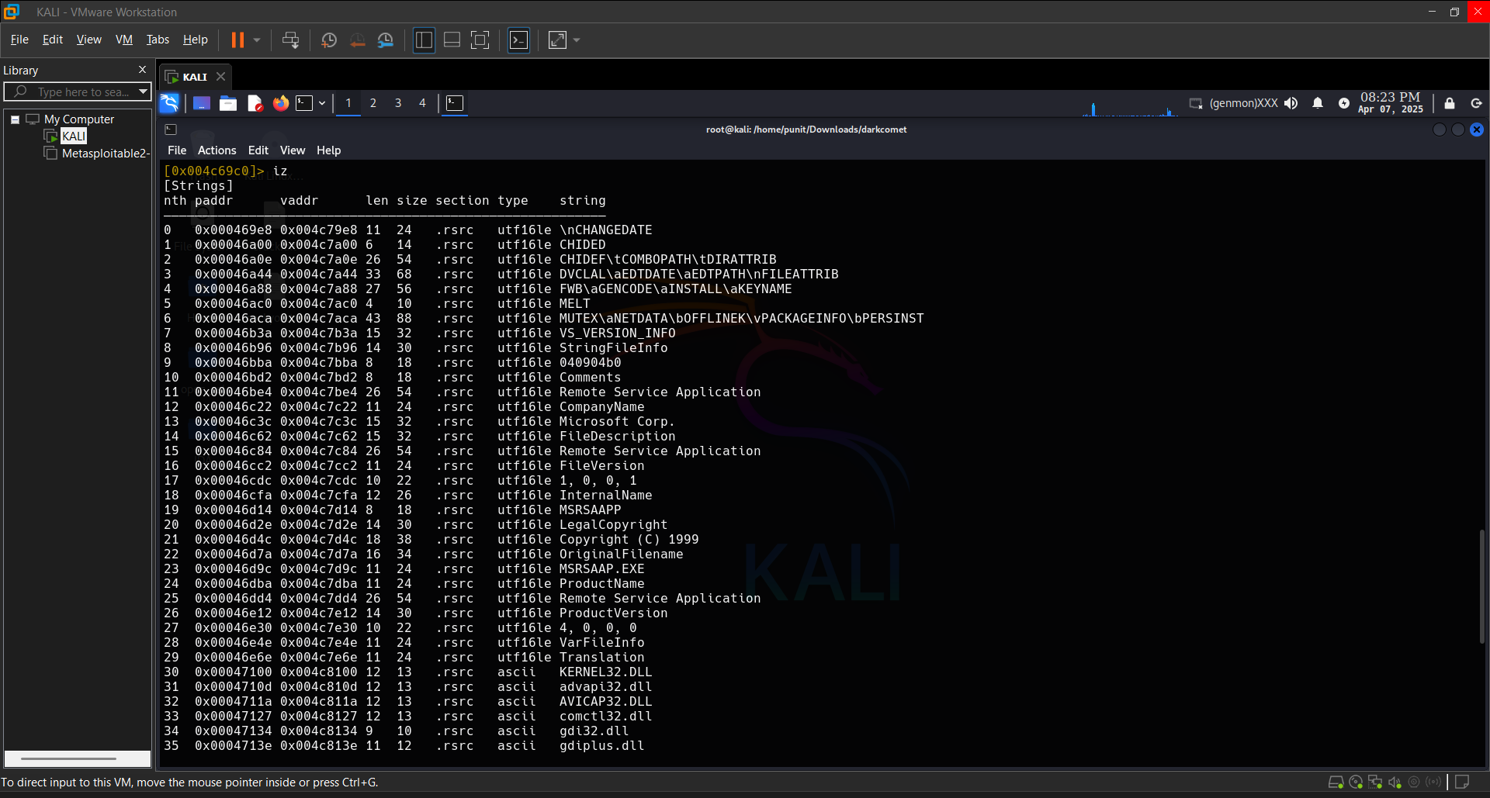

Step 5: Disassembling and Identifying Code Flow
- Open the disassembler view using: pdr @entry

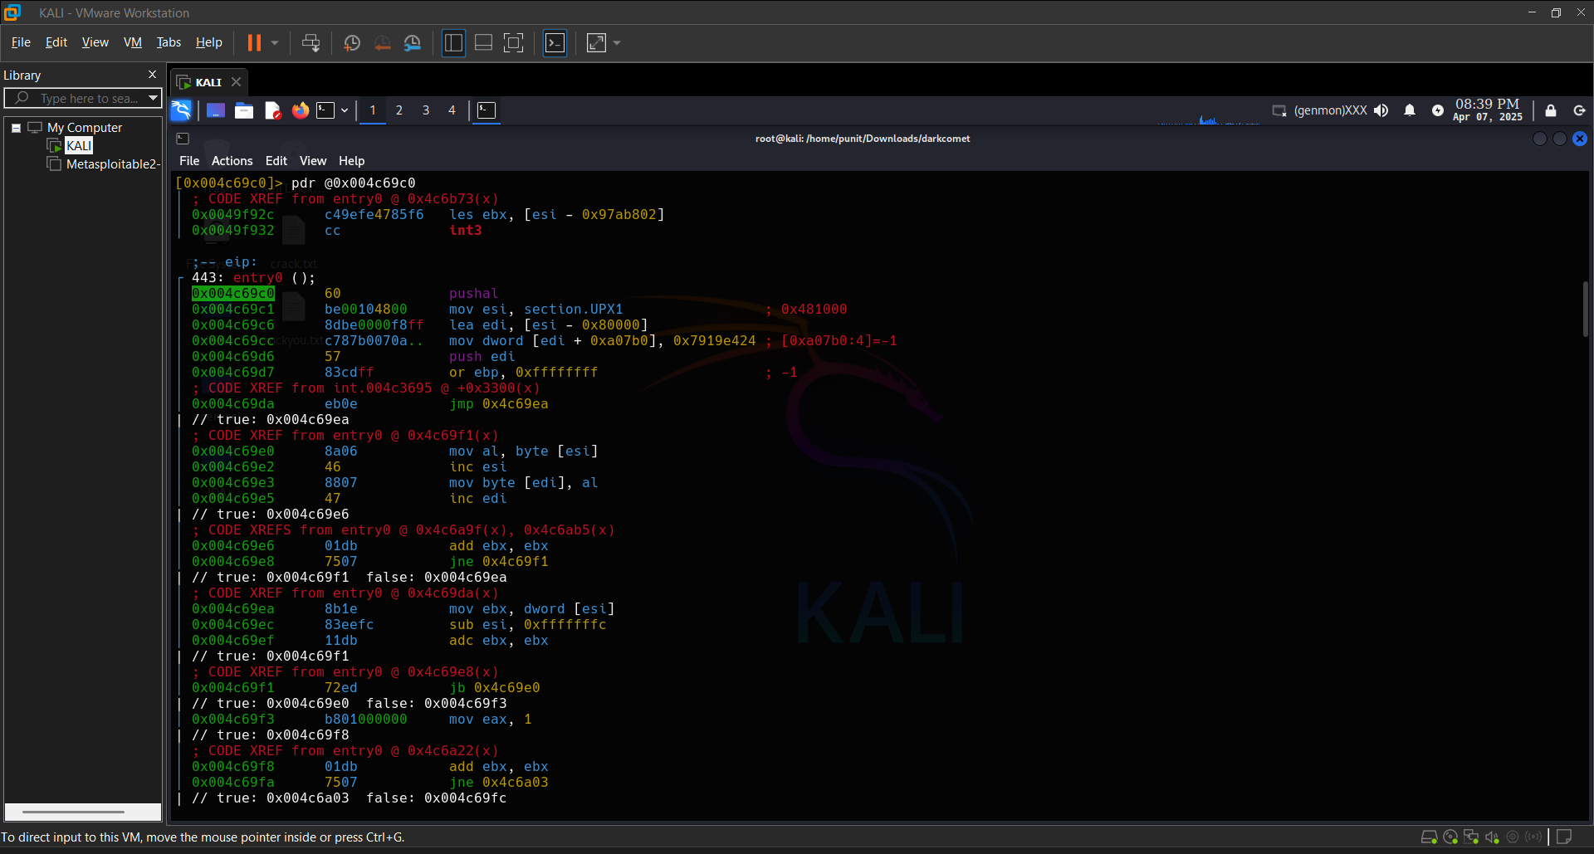

Conclusion:
By following these steps, you can successfully reverse engineer a malware sample using Radare2. Reverse engineering helps security professionals understand malware behavior, detect threats early, and develop strategies to defend against cyberattacks. Always remember to work in a secure and isolated environment to avoid any risk of accidental execution of the malware.

