PRACTICAL 9

AIM: Analyzing malware that uses rootkits to hide its presence on a system.

Description:
A rootkit is a type of stealthy malware that Operates with root/admin-level privileges Hides files, processes, registry keys, and network connections Often hooks or modifies kernel/system calls Can be user-mode or kernel-mode
Rootkits are dangerous because they persist across reboots, evade detection, and enable backdoors, data exfiltration, and command execution.
Step 1: Use Anti-Rootkit Scanners.

chkrootkit:

Checks for known rootkits
Detects anomalies in system binaries (e.g., ifconfig, ls, ps)

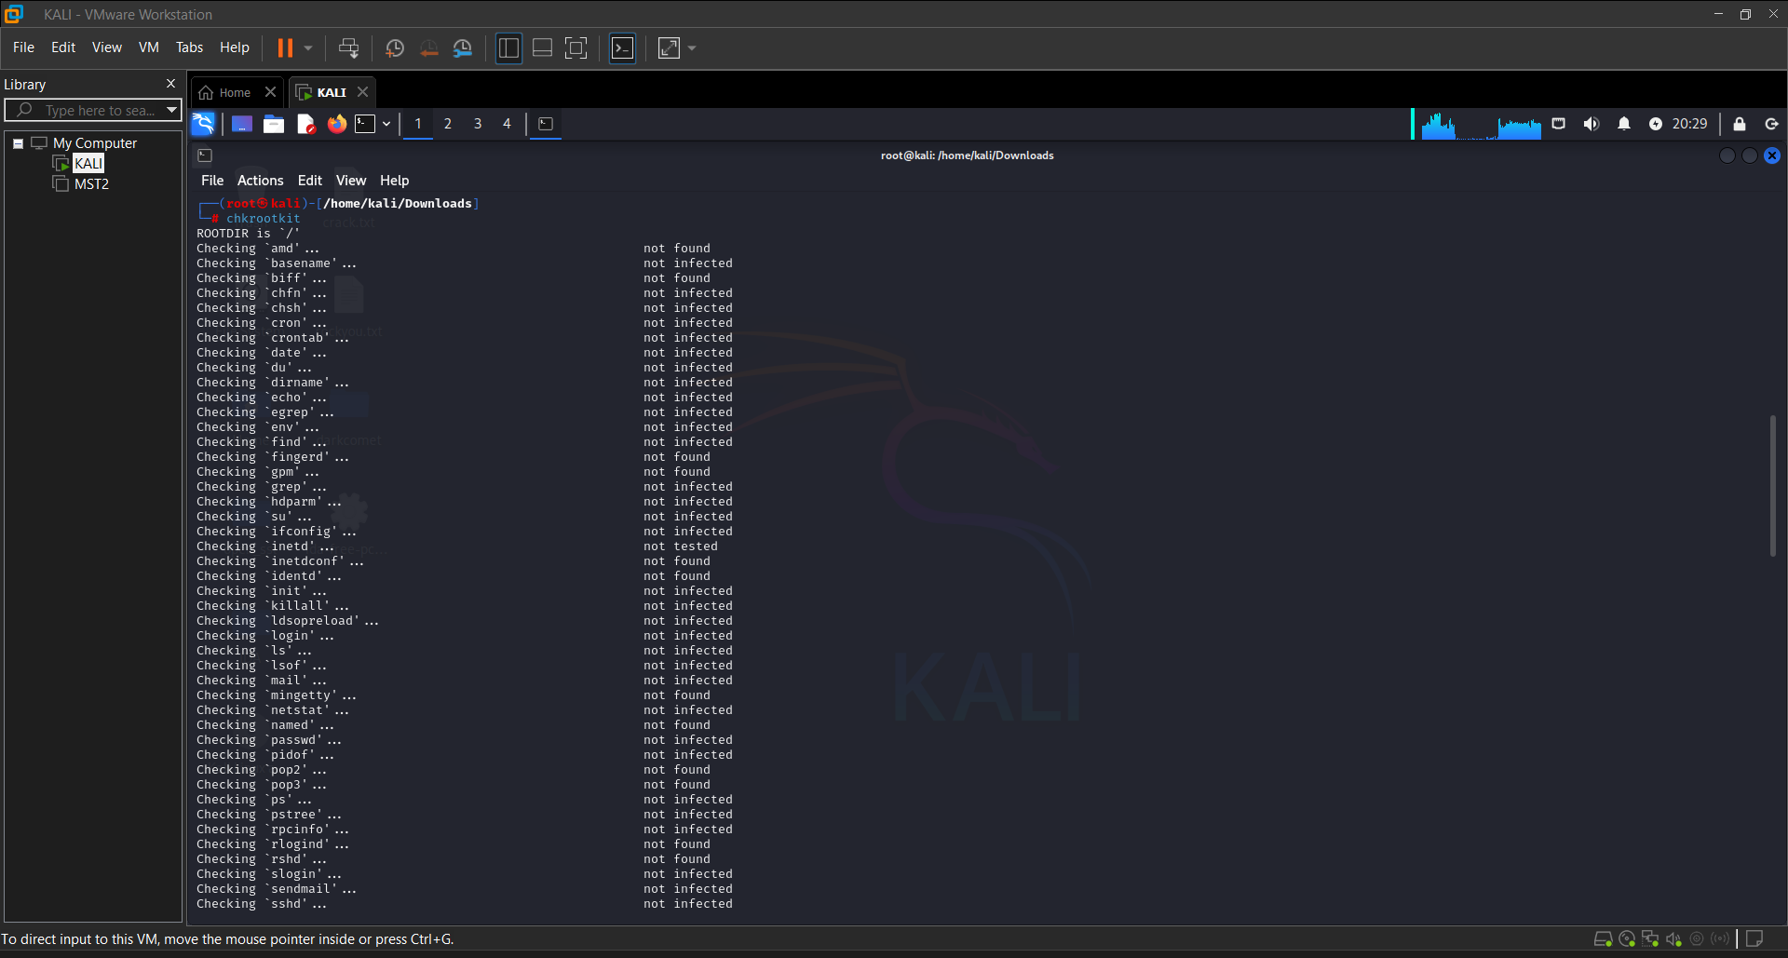

Step 2: Use rkhunter (Rootkit Hunter):

rkhunter --checkall
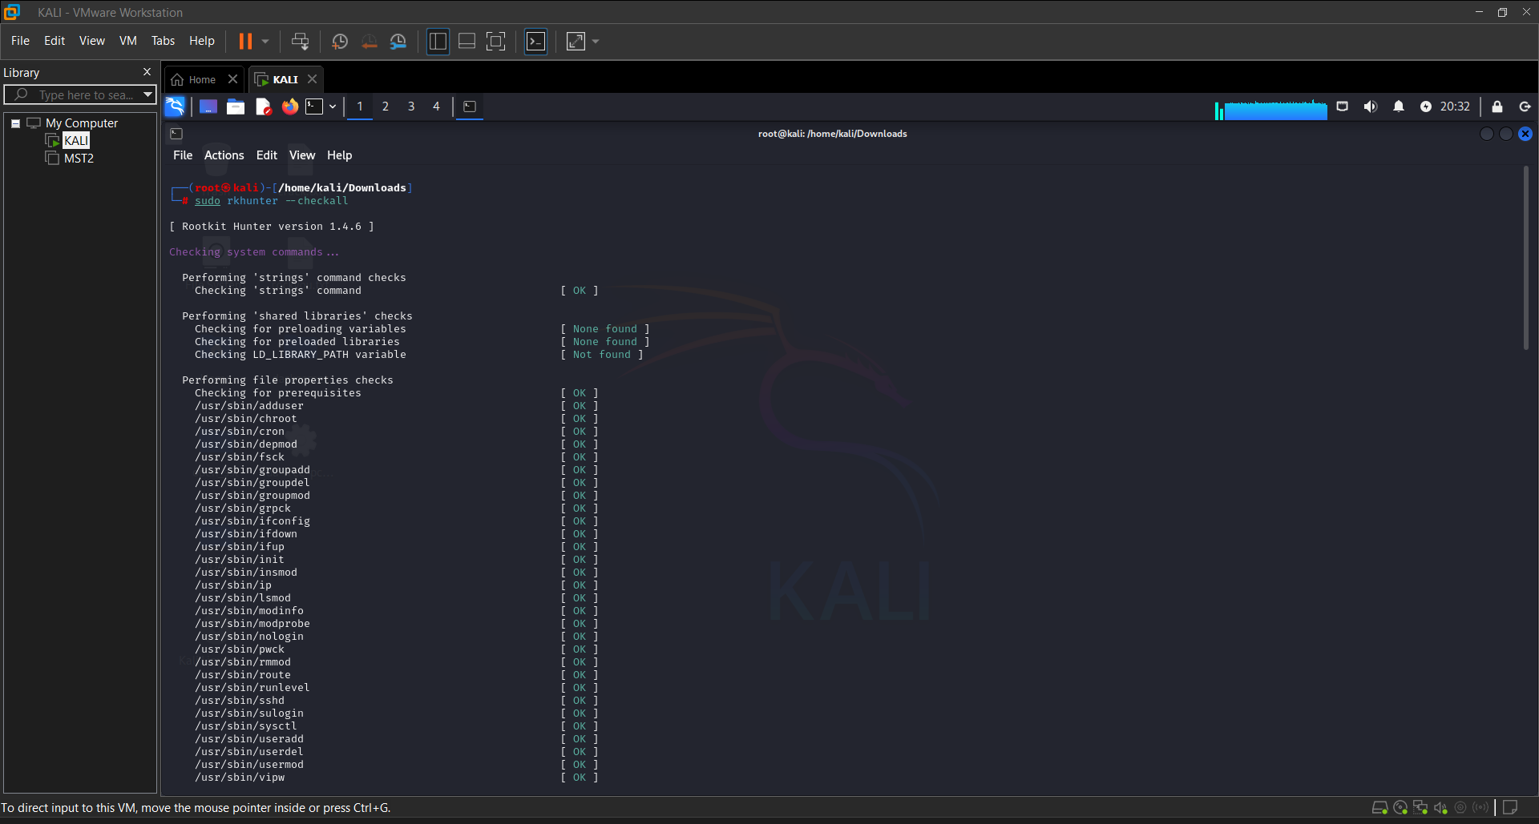

Step 3: Analyze Kernel Modules

Rootkits often insert malicious kernel modules.

List loaded modules: lsmod

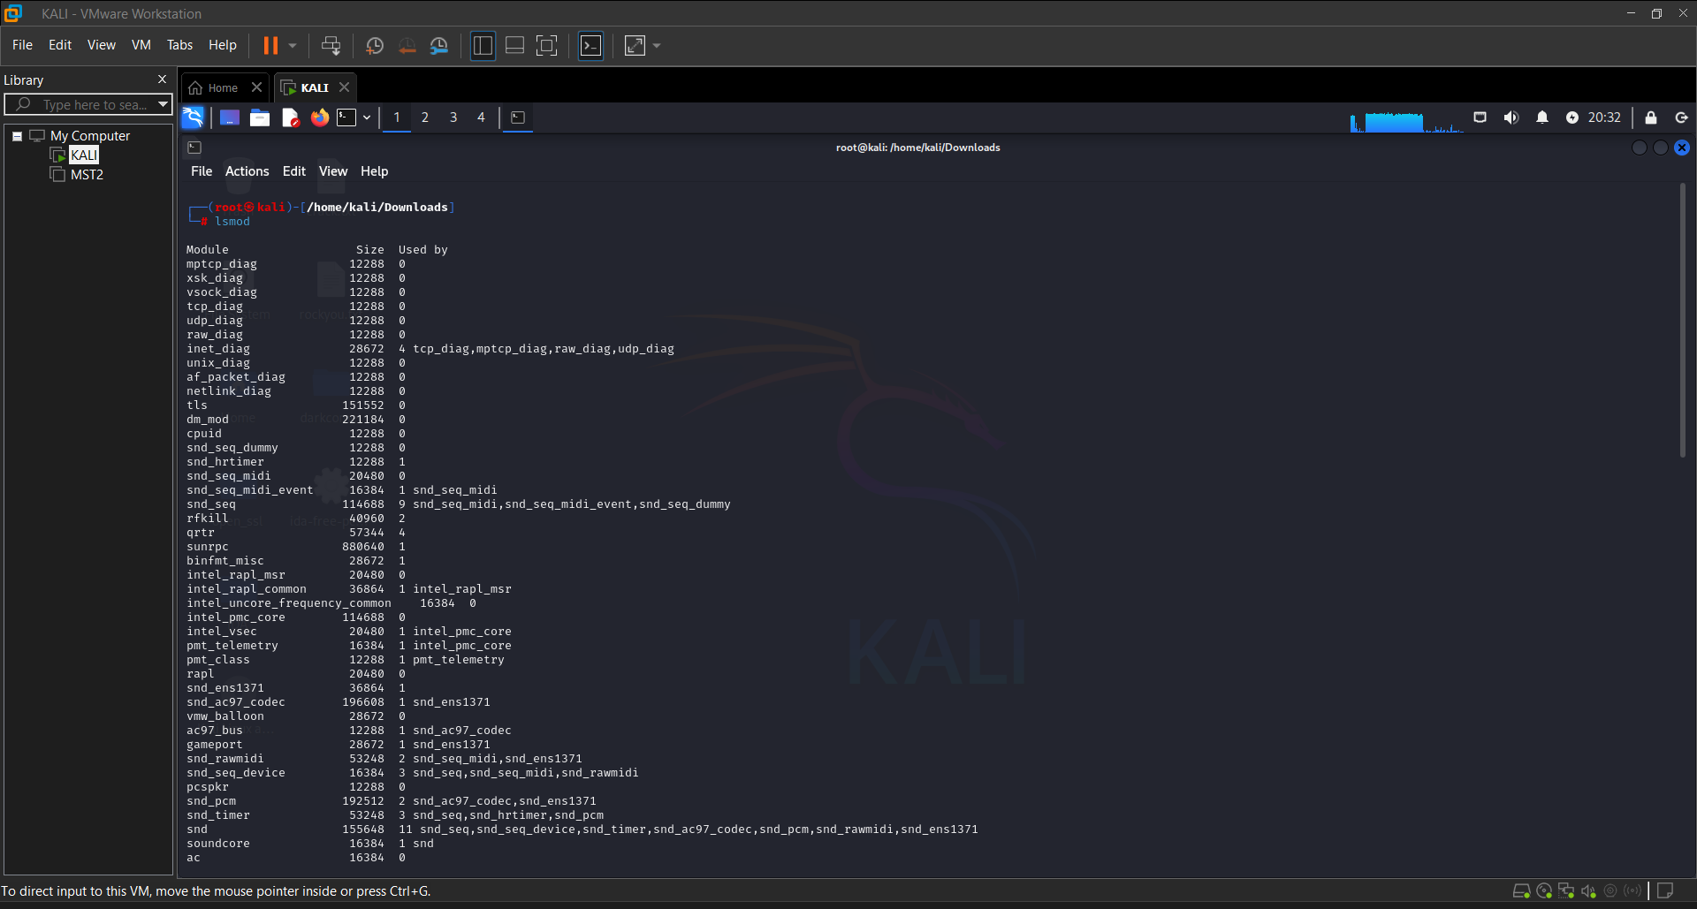
Conclusion:
Analyzing malware that uses rootkits requires advanced techniques, because rootkits are designed to hide their presence by manipulating system internals. On Kali Linux, tools like chkrootkit, rkhunter, and file integrity checkers like AIDE help you uncover these hidden threats. Always compare suspected systems to known-good baselines, and perform memory and disk analysis to detect signs of manipulation. Rootkit detection is an essential part of deep forensic investigations and system hardening.

