Visvesvaraya Technological University

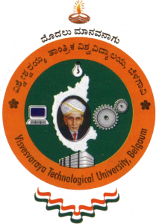

A Project Report

On

BUSINESS MODEL INNOVATOR

Submitted in partial fulfillment of the requirements for the award of the degree of

BACHELOR OF ENGINEERING
In

COMPUTER SCIENCE & ENGINEERING

By

DHRUPAD C KANERIA 1PI10CS037
RAHUL HANDA 1PI10CS064
AYUSH BHATTACHARYA 1PI10CS030

Under the guidance of
Dr. Kavi Mahesh

January 2014 – May 2014



Department of Computer Science & Engineering
PES Institute of Technology
(An autonomous institute under VTU, Belgaum and UGC, New Delhi)
100 Feet Ring Road, BSK- III Stage, Bangalore – 560085

