**FundFlow Project Setup Instructions**

**Prerequisites**

**- Node.js and npm installed on your system.**

**- XAMPP installed to run Apache and MySQL.**

**Folder Structure**

**- fundflow-frontend/ → React frontend code**

**- fundflow-backend/ → Express backend code**

**- fundflow.sql → MySQL database file located in the root directory**

**Step-by-Step Setup**

**1. Start Apache and MySQL with XAMPP**

**- Open XAMPP Control Panel.**

**- Click Start next to Apache and MySQL.**

**2. Import the Database**

**- Open your browser and go to: http://localhost/phpmyadmin/**

**- Click New, create a database named fundflow**

**- Click the Import tab**

**- Click Choose File and select fundflow.sql from the root directory**

**- Click Go to import the tables**

**3. Configure and Run the Backend**

**- Open a terminal**

**- Navigate to the backend folder:**

**cd fundflow-backend**

**- Install dependencies:**

**npm install**

**- Start the backend server:**

**npm start**

**4. Install and Run the Frontend**

**- Open another terminal**

**- Navigate to the frontend folder:**

**cd fundflow-frontend**

**- Install dependencies:**

**npm install**

**- Start the frontend:**

**npm start**

Table of Contents

List of Figures / Screenshots 3

**1. Introduction** 4

**2. Problem Definition** 4

**2.1.Challenges** 4

**2.2 Project Scope** 5

**2.3 Project Perspective** 5

**2.4 Project Functionality** 6

**2.4.1 Login Module:** 6

**2.4.2 Campaign Module (View/Donate):** 6

**2.4.3 Create Campaign Module:** 6

**2.4.4 User Profile Module:** 6

**2.4.5 Feedback Module:** 6

**2.5 Software Requirements** 7

**2.6 Hardware Requirements** 7

**3. Objective** 7

**4. Methodology** 8

**4.1 Application Development** 8

**4.2 Database Management** 9

**4.3 Testing and Deployment** 9

**4.4 Sequence Diagram** 9

**5. Work Done So Far** 10

**5.1 Screenshots** 11

**6. Future Work** 13

**7. Conclusion** 13

**8. References** 13

# 

# List of Figures / Screenshots

|  |  |
| --- | --- |
| Fig 1 | Sequence Diagram |
| Fig 2 | Login Page |
| Fig 3 | Home Page |
| Fig 4 | Start Fundaiser Page |
| Fig 5 | Donate Page |

# **1. Introduction**

FundFlow is a crowdfunding platform designed to help individuals in need of financial assistance for medical emergencies, educational expenses, Animal shelters and other critical situations. It is a crowdfunding website that bridges the gap between those in need and those who wish to help. Users can create campaigns, and receive contributions. The platform ensures security, transparency, and ease of use. Users who wish to donate can also contribute to campaigns securely , FundFlow ensures that everyone can access or provide help effortlessly.

# **2. Problem Definition**

Crowdfunding is a vital financial support method for many individuals who are in urgent need of help, be it for medical emergencies, education, animal welfare, or relief efforts. However, there is a lack of dedicated platforms that are trustworthy, user-friendly, and secure for managing such fundraising activities. The absence of organized systems often leaves genuine individuals without a proper channel to raise funds, and donors unsure about the legitimacy of the campaigns. FundFlow is designed to address these gaps by providing a transparent and structured platform that connects those in need with potential donors.

## **2.1.Challenges**

* Ensuring trust and authenticity in campaigns.
* Secure transaction processing.
* User-friendly interface for seamless navigation.
* Providing an efficient search and filtering system.
* Ensuring effective user engagement through feedback mechanisms.
* Lack of trust in existing fundraising platforms.
* Difficulty in reaching a wide audience for financial support.
* No proper tracking system for donations and funds.
* Traditional fundraising involves delays and manual effort.
* Donors are skeptical about how and where the money is used.
* Beneficiaries often lack the technical know-how to set up campaigns.
* Limited features in free platforms for managing donations and feedback.
* No unified dashboard to view campaign performance or manage personal details.

## **2.2 Project Scope**

FundFlow aims to simplify the fundraising process through a secure and intuitive web-based solution that empowers users to raise and donate funds for causes such as medical emergencies, education, animal welfare, and relief efforts. The scope of the project includes:

* Launching campaigns under multiple predefined categories.
* Allowing users to create fundraising campaigns using a step-by-step multi-form.
* Enabling donors to browse campaigns using filters and search functionality.
* Allowing users to register, log in, and manage their profiles.
* Providing each user with a personalized dashboard to track donations, campaigns
* Collecting funds into the organization’s bank account before transferring them to the beneficiary’s account at the end of the campaign.
* Ensuring secure data handling and transaction management.
* Allowing users to give feedback and suggestions through a dedicated feedback module.

## **2.3 Project Perspective**

This project serves as a platform for social impact, helping communities by allowing individuals to raise funds from the public and track campaign progress. It incorporates a user dashboard, campaign tracker, and feedback module to ensure continuous engagement. FundFlow is designed to bridge the gap between donors and those in need by offering a transparent, secure, and reliable system for fundraising. The platform not only supports the immediate goal of raising funds but also promotes trust and accountability through proper verification and fund management. By providing features like real-time updates, profile management, and category-based campaigns, FundFlow aims to create a user-centric experience that encourages more participation and generosity from the public.

## **2.4 Project Functionality**

### **2.4.1 Login Module:**

* + **Description**: Allows users to log in securely to access the platform, manage campaigns, and donate.
  + **Key Features**:
    - Login with mobile number/email and password.

### **2.4.2 Campaign Module (View/Donate):**

* + **Description**: Users can view available fundraising campaigns and donate to them.
  + **Key Features**:
    - View campaigns by category (Health, Education, etc.).
    - Browse campaigns with descriptions, goals, and donation progress.

### **2.4.3 Create Campaign Module:**

* + **Description**: Allows users to create new fundraising campaigns for causes.
  + **Key Features**:
    - Forms to input campaign title, description, and fundraising goal.
    - Option to upload supporting documents (e.g., medical reports).

### **2.4.4 User Profile Module:**

* + **Description**: Users can view and manage their profiles, see their donation history
  + **Key Features**:
    - View personal details and update information.
    - View donation history and impact.

### **2.4.5 Feedback Module:**

**Description:** Allows users to provide feedback about their experience with the platform.  
**Key Features:**

* Submit feedback about platform usability, donation process, and overall experience

## **2.5 Software Requirements**

* Frontend: HTML, CSS, React.js
* Backend: Node.js,Express.js
* Database: MySQL for structured data storage

## **2.6 Hardware Requirements**

* PC/Laptop with 8GB RAM or more
* Latest version of Chrome or Firefox
* Stable internet connection

# **3. Objective**

The main objective of FundFlow is to create a secure, user-friendly, and transparent crowdfunding platform where individuals can create, manage, and contribute to fundraising campaigns effortlessly. The platform aims to bridge the gap between donors and beneficiaries by ensuring seamless fund transactions, transparency, and accessibility.

**Key Objectives:**

* Simplified Fundraising Process: Provide an easy-to-use interface for individuals to start and manage fundraising campaigns for various causes such as medical emergencies, education, animal welfare, and disaster relief.
* Secure Transactions: Ensure that all donations and fund transfers are safe, encrypted, and properly managed to maintain donor trust.
* User Profile & Dashboard: Enable users to manage personal details, track their donation history, and monitor campaign performance.
* Engaging Donor Experience: Allow donors to browse and search for campaigns based on categories, apply filters, and donate seamlessly.
* Feedback System: Implement a feedback module where users can share their experiences, suggest improvements, and help enhance the platform.
* Efficient Fund Distribution: Ensure that at the end of the campaign, the collected funds are transferred to the beneficiary’s bank account, ensuring fair and legitimate fund distribution.
* Scalability & Future Growth: Develop a system that can accommodate a growing number of users, campaigns, and donations efficiently over time.

# **4. Methodology**

## **4.1 Application Development**

The frontend will be developed using React.js, providing a dynamic and responsive user experience. React.js will allow for reusable components, ensuring efficient UI management. The backend will be built with Node.js and Express.js, ensuring a scalable and efficient server-side architecture.

**Key aspects of application development:**

* **Frontend (React.js)**
  + Responsive and interactive UI components.
  + Search and filter functionalities for campaigns.
  + User authentication and authorization.
  + Real-time updates for campaign progress.
* **Backend (Node.js & Express.js)**
  + API development for handling user requests.
  + Secure authentication using JWT or OAuth.
  + Business logic for campaign creation, donations, and fund transfers.
  + Middleware for error handling and logging.

## **4.2 Database Management**

A MySQL database will be used to securely store and manage user data, campaign details, donation transactions, and feedback. The database will be designed to optimize performance and ensure data integrity.

**Key aspects of database management:**

* **Tables and relationships:**
  + Users Table (stores user information and authentication details).
  + Campaigns Table (stores campaign details, goals, and progress).
  + Donations Table (stores donor details and transaction records).
  + Feedback Table (stores user feedback for platform improvement).
  + Update Table(stores user update)

## **4.3 Testing and Deployment**

Before deployment, FundFlow will undergo multiple levels of testing to ensure stability, security, and usability.

Testing Phases:

* Unit Testing: Testing individual components and API endpoints.
* Integration Testing: Ensuring seamless interaction between frontend and backend.
* Security Testing: Identifying vulnerabilities and securing transactions.
* User Acceptance Testing (UAT): Conducted with real users to refine UI/UX.

## **4.4 Sequence Diagram**

A sequence diagram will illustrate the process of creating a campaign and interacting with donors.

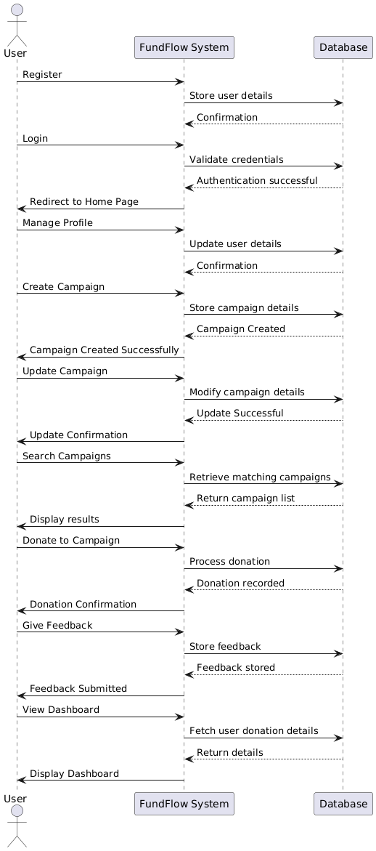

**Fig 1:Sequence diagram**

# **5. Work Done So Far**

* Created all front-end pages.
* User registration and login functionality is implemented.
* After login, users are directed to the home page.
* Profile option is available where users can fill in their personal details and manage there profile
* Campaign creation functionality is implemented with multiple input fields.
* A news page displaying updates related to the platform has been developed.
* About Us, Teams, Contact, and Career pages have been completed.
* Feedback functionality is integrated to allow users to provide suggestions.
* Search functionality is implemented to help users find campaigns easily.

## **5.1 Screenshots**

**Fig 2: Login page**

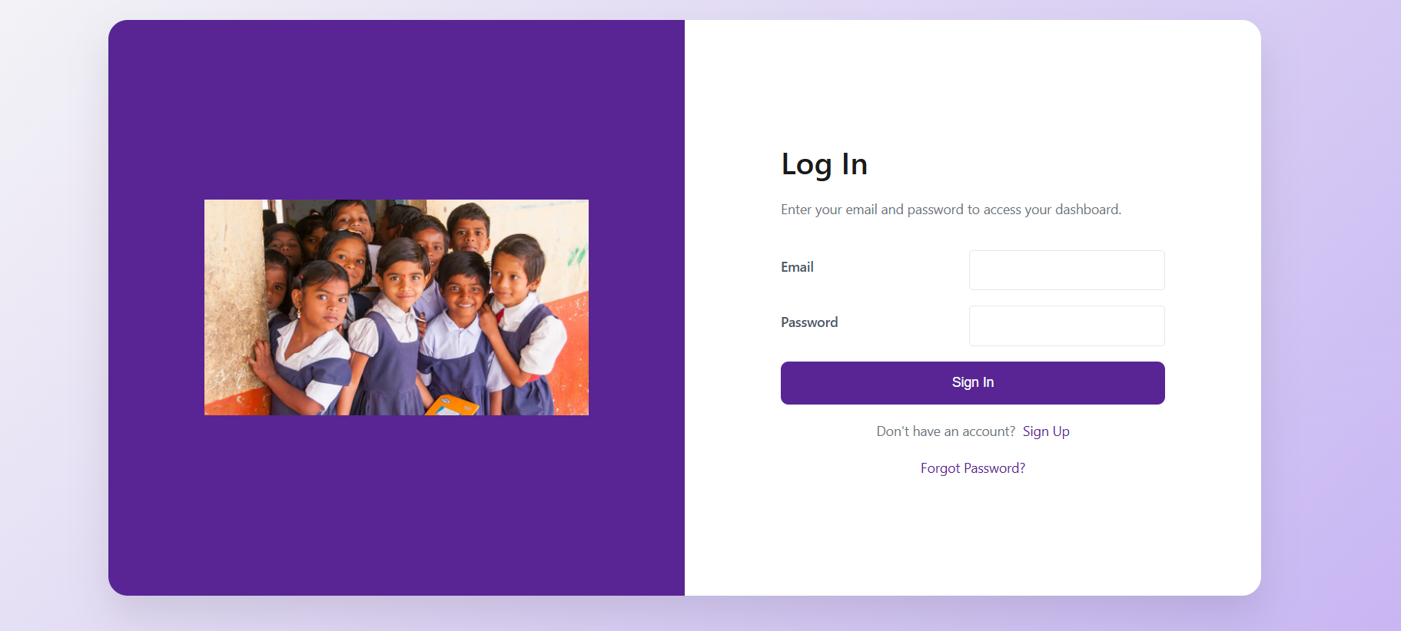

**Fig 3: Home page**

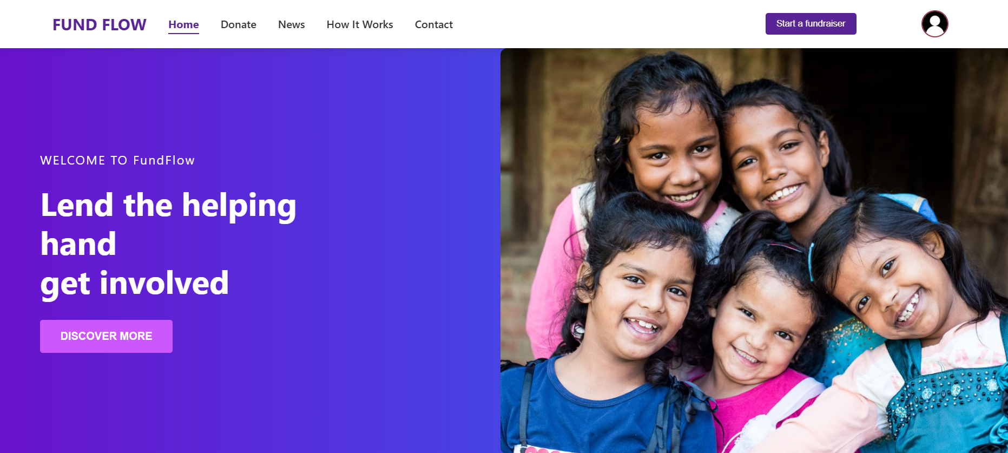

**Fig 4: Start fundaiser**

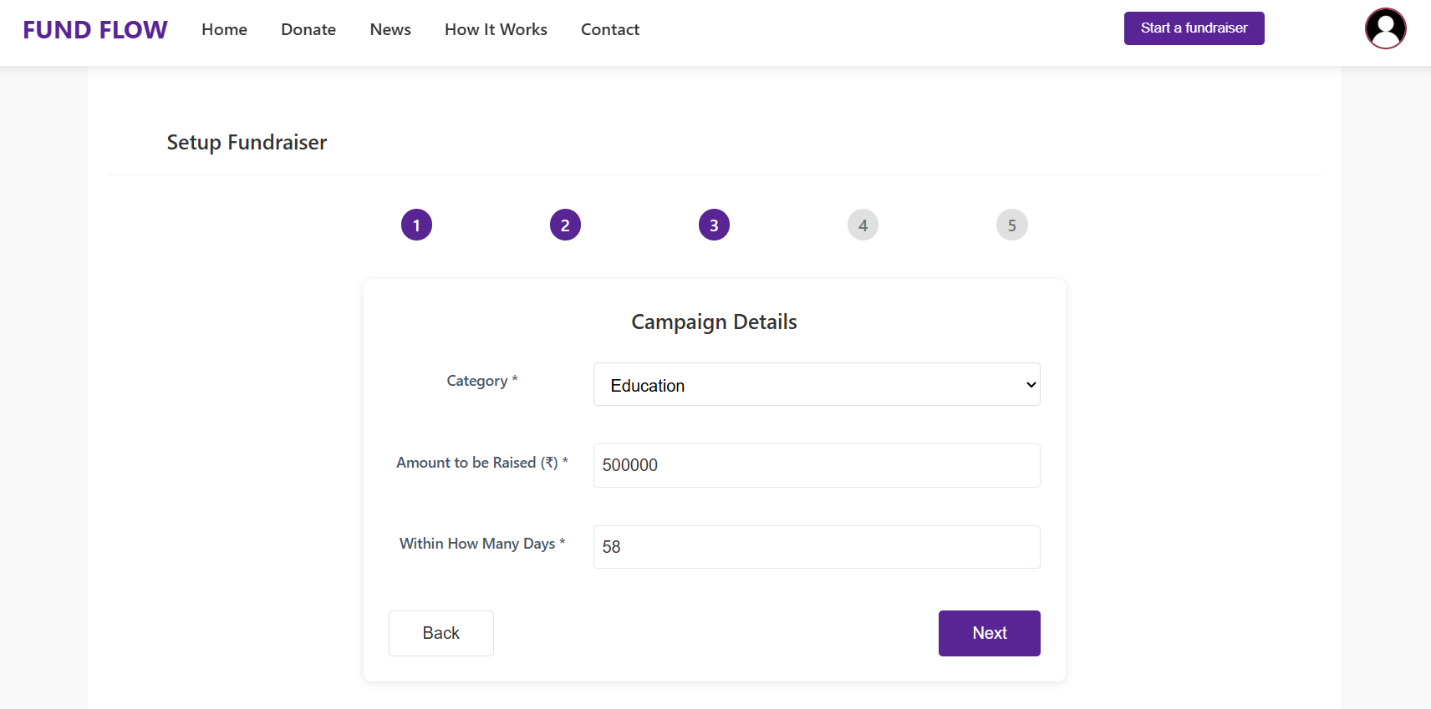

**Fig 5: Donate page**

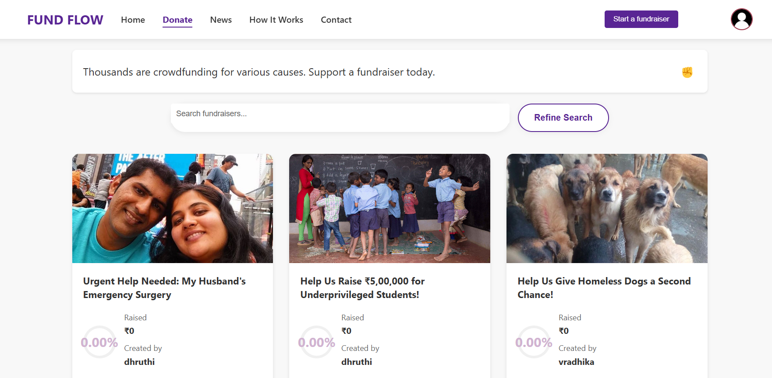

# **6. Future Work**

* Implementing AI-based campaign verification.
* Mobile app development.
* Additional security measures.
* Enhanced recommendation system for campaign discovery.

# **7. Conclusion**

FundFlow is a reliable fundraising platform that connects those in need with potential donors. With a secure and transparent system, it ensures that funds reach the right people at the right time. Additional features like search, user profiles, and feedback mechanisms enhance user engagement and platform usability.

Furthermore, FundFlow aims to build trust between donors and recipients by implementing secure transactions. The intuitive user interface and robust backend infrastructure ensure a seamless experience for all users. As the platform continues to evolve, future enhancements will further improve usability, security, and reach, making FundFlow a comprehensive solution for online crowdfunding.

# **8. References**

* **MySQL**-<https://dev.mysql.com/doc/>
* **React.js**- <https://react.dev/learn>
* **Node.js**- <https://nodejs.org/en/docs>
* **Express.js**-<https://expressjs.com/en/starter/installing.html>