TASK: 3
Question: 1

Open Group Policy Management Console (GPMC) on your Windows Server and create a new GPO named 'PasswordPolicyDemo' that enforces a minimum password length of 8 characters. Link it to your test OU and verify the setting is applied using gpresult.
>
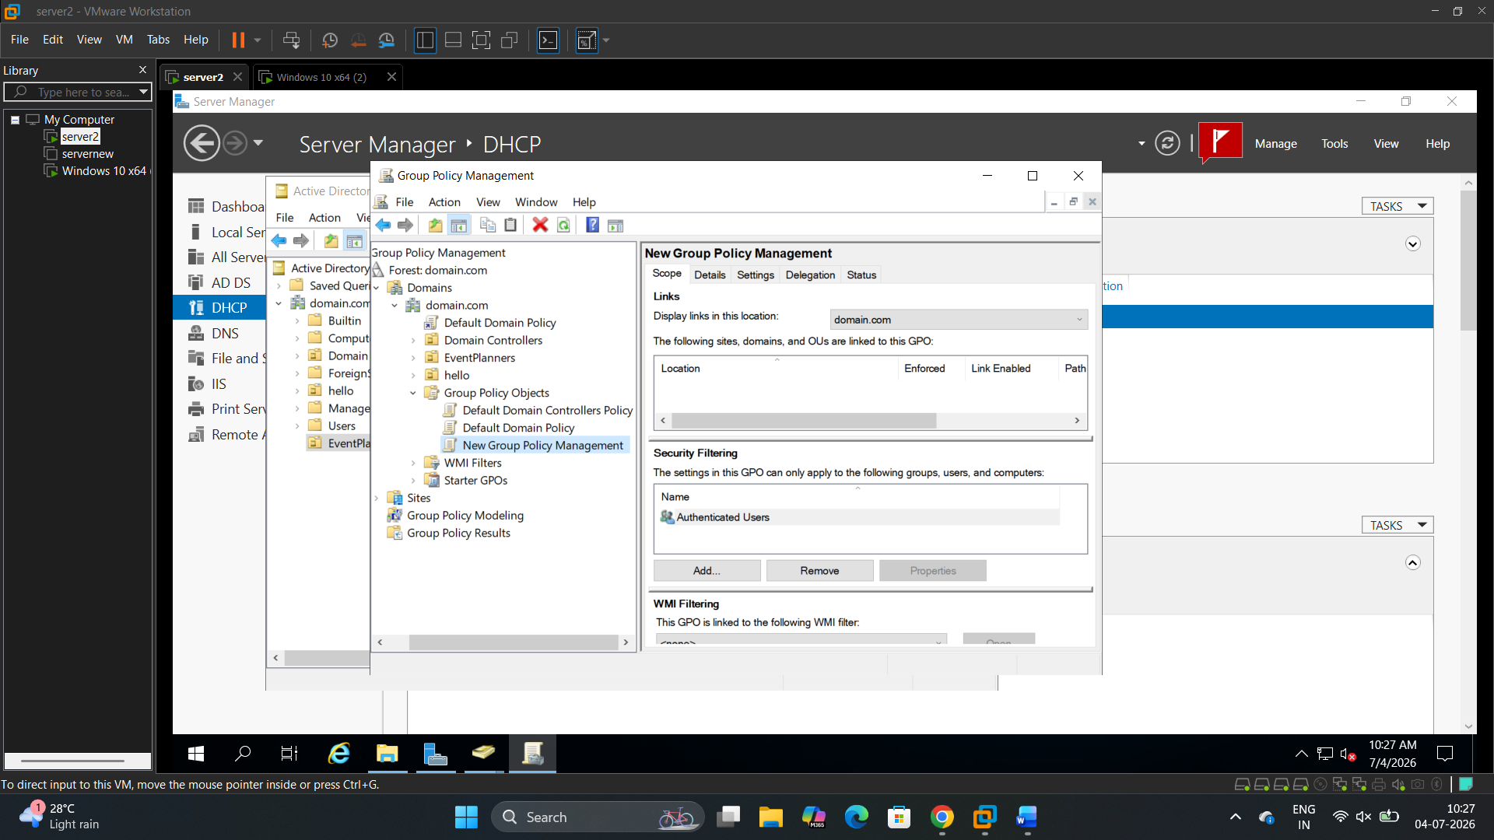

Question: 2
Configure a GPO to restrict access to the Control Panel for all users in a specific OU, similar to how public computers in a cybercafe or college lab prevent users from changing system settings.<br><br><em><strong>Hint:</strong> In the GPO, navigate to User Configuration > Administrative Templates > Control Panel and set 'Prohibit access to Control Panel and PC settings' to Enabled.</em>

>
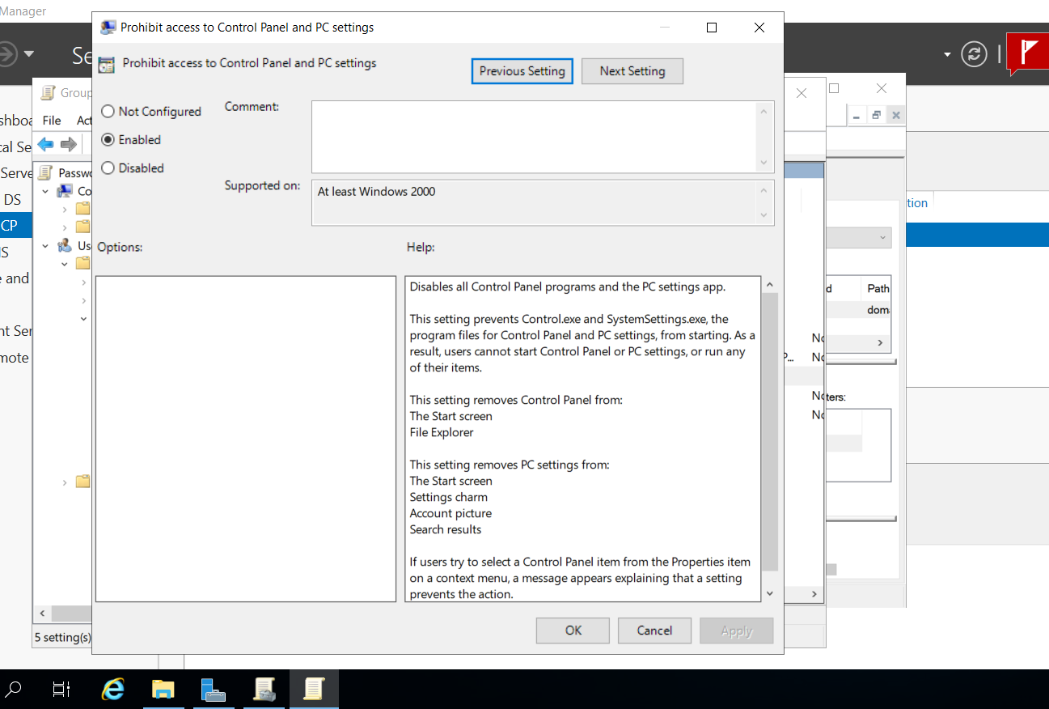

Question: 3
Edit your 'PasswordPolicyDemo' GPO to enable account lockout after 3 invalid login attempts and set the lockout duration to 10 minutes. Run gpupdate /force on a client PC and test the lockout by entering the wrong password.
>
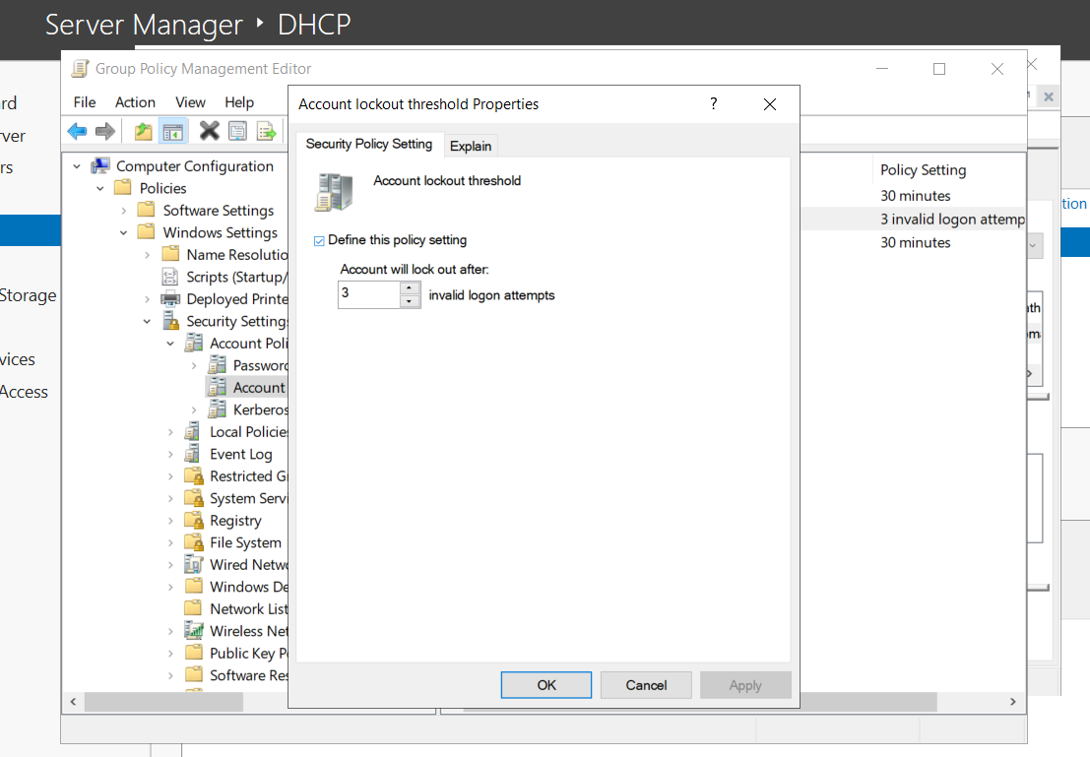
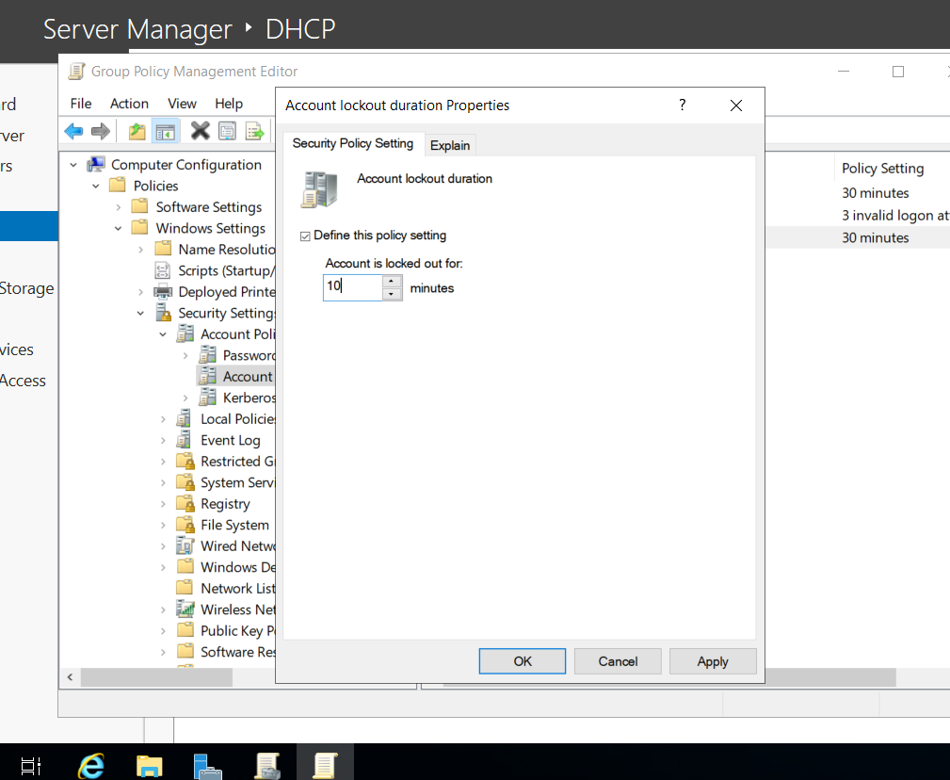

Question: 4
Document all GPO settings you applied in this session (password policy, desktop restriction, lockout policy) in a table format, and for each setting, describe its expected impact on users in 1-2 sentences.
>
Serial No. | GPO Setting Category | Specific Policy Name | Configured Value | Expected Impact on Users (1-2 Sentences)
1 | Password Policy | Minimum password length | 8 Characters | Users will be forced to choose passwords containing at least 8 characters whenever they create or reset their domain passwords, increasing resistance to guessing attacks.
2 | Desktop Restriction | Prohibit access to Control Panel and PC settings | Enabled | Users will be completely blocked from opening the Control Panel or system settings, preventing unauthorized alterations to system configurations.
3 | Account Lockout Policy | Account lockout threshold | 3 invalid logon attempts | If a user enters an incorrect password three consecutive times, their account will be automatically disabled to block unauthorized brute-force entry.
4 | Account Lockout Policy | Account lockout duration | 10 minutes | Once a user account is locked due to failed login attempts, it will remain unusable for 10 minutes unless manually unlocked by a network administrator.

