FINAL RESEARCH ARCHITECTURE DECISION

CHMT-Q
  - Causal Hierarchical Market Transformer with Quantile Heads
OHLC + L1 + L2 | MATHEMATICS, TRAINING, EVALUATION, AND DEPLOYMENT
A primary-source research synthesis and implementable specification for a small, causal, numeric Transformer that forecasts five Volume Footprint horizons with calibrated uncertainty.
PRO-PRIVATE | ARCHITECTURE SELECTED | NOT YET PRODUCTION-TRAINED
Version 1.0 | 21 July 2026 | 2,089,518 designed parameters

Contents
The section list mirrors the reviewed source. Word's Navigation pane provides live heading navigation.
Executive decision
1. What the model is solving
2. Research method and evidence boundary
3. Final architecture: CHMT-Q v1
4. Numeric tensor contract
5. Causal feature compiler
6. Numeric time, modality, side, and rank encoding
7. The custom CHMT attention block
8. The three causal encoders
9. Quality-aware fusion
10. Direct five-horizon decoder
11. Monotone probabilistic output
12. Training objective
13. Exact parameter and compute ledger
14. End-to-end training workflow
15. Evaluation and calibration
16. Ablation and scaling program
17. DeepSeek research: what transfers and what does not
18. Moonshot and recurrent linear attention research
19. Adaptive and evolutionary model research: bounded offline use
20. Time-series Transformer research
21. Limit-order-book research and target-specific lessons
22. Complete forward pass
23. Export, package, and Volume Footprint runtime
24. Runtime state machine, monitoring, and rollback
25. Implementation blueprint
26. Failure modes and design responses
27. Practical questions
28. Final architecture decision record
29. Primary-source bibliography
Appendix A. Symbol table
Appendix B. Non-negotiable invariants
Appendix C. Deliverable status
Evidence boundary: architecture selection is complete; real-data predictability and production readiness remain to be demonstrated.

Version: 1.0 research architecture decision Date: 21 July 2026 Scope: OHLC bars, Level 1 quotes, Level 2 depth, and Volume Footprint forecasts Status: architecture selected; synthetic prototype exists; real-data training and production integration are not yet complete Boundary: Pro-private research document. Nothing in this document is copied into public/.

Executive decision
The recommended first production candidate is CHMT-Q v1, the Causal Hierarchical Market Transformer with Quantile heads. It is a compact, approximately 2.09-million-parameter model built from numeric primitives. It treats bars, L1 quotes, and L2 books as different structures; fuses them only after independent causal encoding; predicts five future footprint horizons directly; and returns monotone 10th, 50th, and 90th percentiles plus buy/sell-presence probabilities.
The research conclusion is deliberately conservative. The strongest ideas for this workload are not the largest or newest language-model mechanisms. They are:
- hierarchical encoding of book levels before temporal encoding, supported by DeepLOB and later LOB Transformer work [R18]-[R21];
- causal patching of dense microstructure frames, adapted from PatchTST [R12];
- direct multi-horizon probabilistic decoding and data-quality gating, adapted from Temporal Fusion Transformers [R14];
- primitive dense attention and masking [R01], relative-relation bias as inspiration [R02], RMSNorm [R03], and SwiGLU feed-forward layers [R04]. Pre-norm placement, Q/K normalization, LayerScale, safe all-masked behavior, and the physical elapsed-time formula are CHMT-Q design hypotheses;
- an auxiliary intermediate-horizon loss inspired by multi-token prediction, without feeding future targets into the deployable network [R08]; and
- leakage-safe walk-forward development, strong linear and market baselines, calibration, shadow serving, and abstention.
DeepSeek MLA/MoE/sparse attention, Moonshot Kimi Delta Attention, Sakana runtime self-adaptation, Mamba-style state-space layers, and evolutionary model merging are valuable research results, but their published advantages address very long contexts, enormous models, autoregressive KV caches, or families of pretrained checkpoints. None is justified in the first 64/60/60-token CPU/ONNX model. They are documented as later experiments with explicit entry gates rather than silently imported.
The architecture does not claim that future footprint values are economically predictable. That claim can only be earned on untouched chronological data after fees, latency, calibration, and drift tests. A sophisticated model cannot repair incomplete tape, timestamp leakage, an ambiguous decision cutoff, or labels reconstructed from L1/L2 instead of genuine trades.
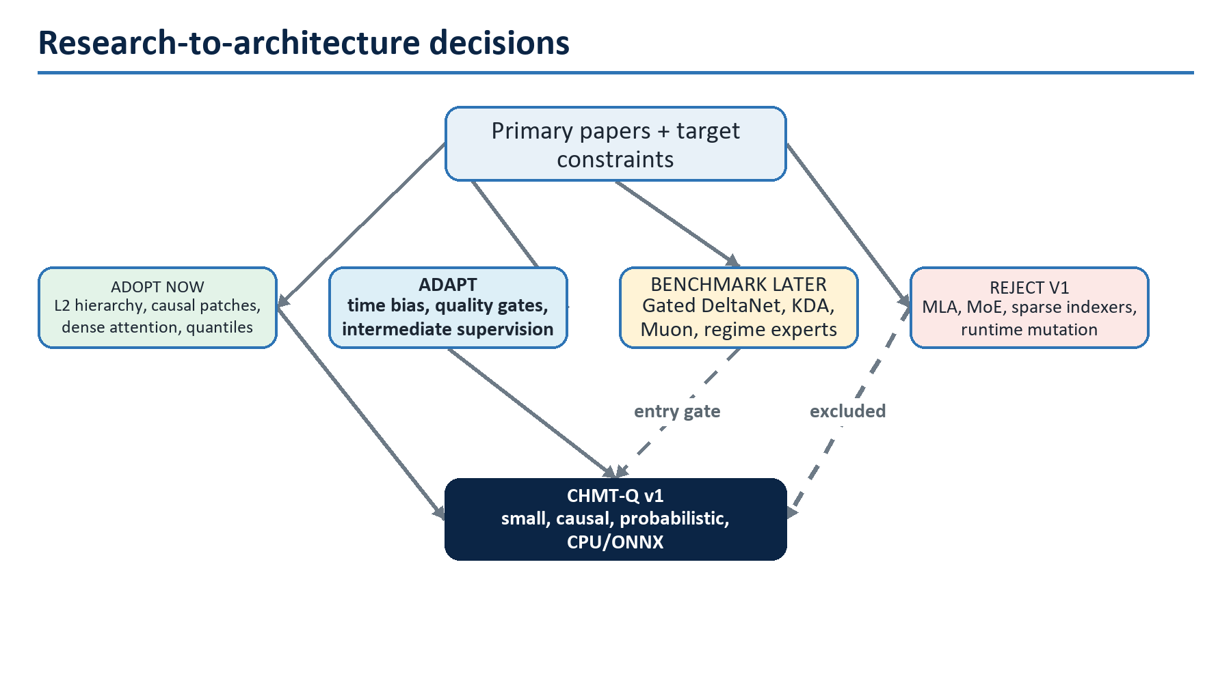
Figure 1. Research-to-architecture decision map

The one-sentence architecture
At cutoff c, CHMT-Q independently turns 64 finalized one-minute bars, 240 half-second L1 frames, and 240 hierarchical top-10-per-side L2 snapshots into 64, 60, and 60 causal tokens; quality-aware gates fuse the 184 historical tokens; five learned horizon queries decode five future footprint bars; and a monotone quantile head emits calibrated uncertainty without autoregressive rollout.

Recommended first build
Decision | CHMT-Q v1 choice | Reason
External inputs | Numeric float32 tensors plus boolean masks | Matches market data; no tokenizer or text vocabulary
Temporal attention | Full causal softmax, four heads, width 128 | Only 60-64 tokens per branch; exact recall is affordable
L2 representation | One masked Transformer across 20 side/rank levels per snapshot | Preserves cross-side and depth-rank geometry
High-rate compression | Four 500 ms frames per causal patch | Reduces 240 frames to 60 tokens without crossing cutoff
Fusion | Hard availability masks plus learned quality gates | Missing data remains missing, not a zero-valued observation
Decoder | Five direct non-autoregressive horizon queries | Avoids error accumulation and future-target teacher forcing
Forecast | q10/q50/q90 for five values plus two presence logits | Supplies point estimates, uncertainty, and missing-side semantics
Training | AdamW baseline, walk-forward folds, pinball plus median and presence losses | Simple, auditable, and supported across toolchains
Serving | Fixed batch-one ONNX; host reconstruction and abstention | Keeps UI and chart contracts deterministic

1. What the model is solving
For each decision cutoff c, the model observes only information demonstrably available by c and predicts the next five completed Volume Footprint intervals. For horizon h it forecasts:
- total point of control P_h;
- buy point of control B_h when classified buy volume exists;
- sell point of control S_h when classified sell volume exists;
- total traded volume V_h; and
- delta fraction D_h / V_h when volume and classification coverage are valid.
The model is a forecast provider, not an order policy. It does not decide position, size, stop, leverage, or execution venue. A later strategy may consume a forecast only after separate risk, latency, and transaction-cost controls.

1.1 Formal causal information set
Every observation x_i has, at minimum, an event time, receive time, availability time, source epoch, and sequence identity. Event time says when the market event occurred. Availability time says when the feature compiler could legally know it. Causality is defined by availability:
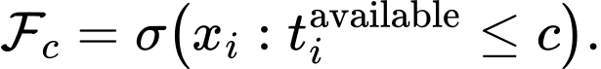
The forecast is a function of that information set and fixed model state:
For stateless CHMT-Q v1, M_c contains only immutable configuration and normalization constants. A future recurrent experiment may add market state, but that state must be instrument/venue-specific, causally updated, and reset across discontinuities.
The target interval begins strictly after the decision boundary. If the application defines cutoff as "after consuming event e," the event may enter the features; if it defines cutoff as "immediately before event e," it may not. That convention is versioned and tested rather than inferred.

1.2 Forecast target transformation
Let p_ref be a fresh causal reference price, q the instrument tick size, and ell_ref a causal trailing log-volume reference. The training targets are stationary residuals:
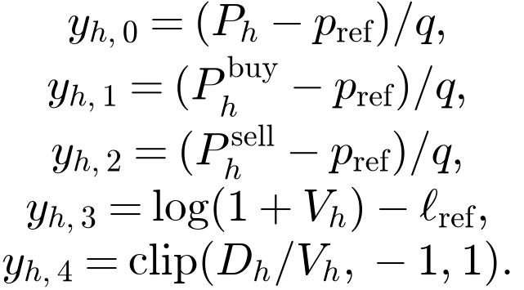
Each (h,k) pair has its own validity mask. Buy or sell POC is missing when the corresponding side has no eligible classified volume. In a complete interval with no eligible trades, V_h=0, buy/sell presence is false, and total/buy/sell POC plus D_h/V_h are masked as undefined. The selected 17-output design has no total-volume-presence head, so the empty-interval rate is an acceptance diagnostic; a material rate requires revising the output distribution before promotion. An interval with unprovable tape continuity is unknown, not a zero-volume example.

1.3 Why L1 and L2 are not footprint labels
Quotes and book updates describe displayed liquidity. Footprint POC, volume, and delta describe executed trades. They can diverge because of cancellations, hidden liquidity, sweep behavior, classification ambiguity, feed loss, and venue aggregation. Real labels therefore require genuine tape/trade events covering the entire future interval. OHLC, L1, and L2 are model inputs; they are not a substitute for the label source.

1.4 Success is probabilistic, not cosmetic
The chart can display a model only after all of the following are true:
- forecast loss beats persistence, seasonal, linear, tree, and DeepLOB-like baselines on untouched chronological data;
- interval coverage is close to nominal without unusably wide intervals;
- performance survives high/low volatility, spread, liquidity, missing-data, session, instrument, and calendar slices;
- ONNX outputs match the training runtime within declared tolerances;
- warmed batch-one latency and memory fit the target machine;
- shadow-serving error, abstention, and drift rates remain inside promotion bounds; and
- economic tests include fees, slippage, latency, capacity, and a policy fixed before the outer test.

2. Research method and evidence boundary
This specification uses primary papers, official technical reports, official repositories, and peer-reviewed venue pages. The literature was not treated as a menu of fashionable components. Each mechanism was mapped to this model's actual sequence length, parameter budget, training data, inference hardware, ONNX operator surface, and error cost.

2.1 Decision labels
Label | Meaning
Adopt | Place in the first production candidate because the mechanism fits the problem and budget
Adapt | Preserve the principle but change the mechanism for causal numeric forecasting
Benchmark | Implement only after the dense baseline; promote only on measured gain
Reject v1 | Published motivation does not match the present bottleneck or operational constraints
Watch | Too new, too weakly validated, or outside the immediate problem

2.2 Scale-fit test
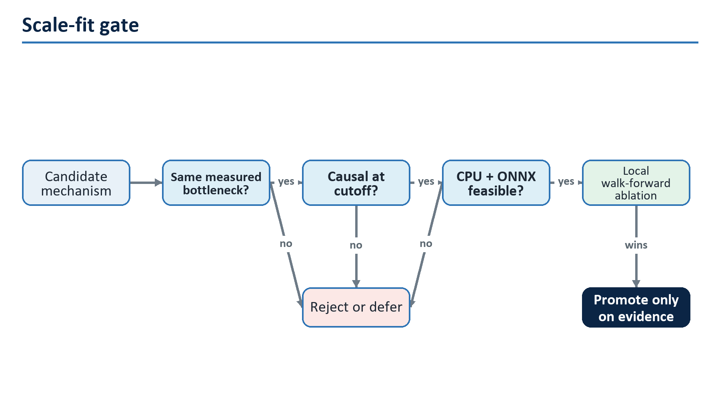
Figure 2. Scale-fit gate for imported mechanisms
A reported result is not portable merely because both systems use matrices. Kimi Linear evaluates 128K-to-1M-token language contexts [R10]. DeepSeek MLA targets autoregressive KV-cache width, and DeepSeekMoE targets hundreds of billions of total parameters [R05]-[R07]. CHMT-Q has at most 64 tokens in any temporal branch, 184 memory tokens, fixed five-query decoding, no token-by-token generation, and a CPU/ONNX serving target. These are different bottlenecks.

2.3 Literature decision matrix
Source family | Mechanism | Decision | Exact reason
Transformer [R01] | Scaled dot-product attention | Adopt | Exact content-addressed recall is inexpensive at 60-64 tokens
Relative positions [R02] | Pairwise relative bias | Adapt | Use actual elapsed seconds rather than token distance
RMSNorm [R03] | Root-mean-square pre-normalization | Adopt | Stable, simple, and ONNX-expressible
GLU variants [R04] | SwiGLU feed-forward | Adopt | Strong Transformer FFN default at the existing parameter budget
DeepSeek-V2/V3 [R05]-[R07] | MLA and MoE | Reject v1 | Solves KV cache and giant-model capacity, neither present here
Multi-token prediction [R08] | Auxiliary future-depth supervision | Adapt | Apply an auxiliary head to intermediate horizon states; never input future targets
NSA/DSA [R09] | Hardware-aligned sparse attention | Reject v1 | Specialized long-context kernels; more machinery than all dense attention here
Kimi Linear [R10] | KDA plus periodic MLA | Benchmark later | Fixed recurrent state helps very long streams, not a 60-token baseline
Gated DeltaNet [R11] | Forgetful delta-rule memory | First recurrent benchmark | Simpler than KDA if raw event context grows into thousands
PatchTST [R12] | Patching | Adapt | Four causal micro-frames per patch reduce temporal cost; noise reduction remains an ablation question
iTransformer [R13] | Variate tokens | Partial adapt | Use grouped feature projections; do not destroy book side/rank geometry
TFT [R14] | Gating and direct quantiles | Adapt | Quality-aware fusion and multi-horizon uncertainty fit the output contract
RevIN [R15] | Per-instance reversible normalization | Reject live v1 | Input-window centering may erase absolute regimes; masked irregular statistics require a dedicated ablation
DLinear [R16] | Linear decomposition baseline | Adopt as baseline | Any complex model must beat it
TimesNet [R17] | Periodic 2-D variation | Benchmark baseline | Useful only if stable periodic structure survives session-aware testing
DeepLOB/TLOB [R18]-[R21] | Local LOB structure plus temporal/feature processing | Adopt principle | Convergent evidence motivates, but does not prove, CHMT-Q's exact rank-first hierarchy
Mamba [R22] | Selective state-space sequence model | Benchmark later | Valuable only when measured context makes quadratic attention material
Transformer-Squared [R23] | Runtime singular-value expert adaptation | Offline idea only | Two-pass weight mutation complicates determinism, quantization, and audit
Evolutionary merging [R24] | Search over task-vector and data-flow merges | Offline idea only | CHMT-Q would restrict the selected task-vector route to same-base experts; no role in v1
Muon [R25] | Orthogonalized matrix updates | Later optimizer A/B | Training-only benefit is unproven for a two-million-parameter numeric model

3. Final architecture: CHMT-Q v1
CHMT-Q is hierarchical because the three inputs have different native geometry:
- bars are slow, regular, and already aggregated;
- L1 is a fast one-dimensional quote process with gaps and carry-forward state;
- L2 is a fast process whose individual observation is itself a structured two-sided ranked set.
Flattening them into one sequence would make side/rank semantics implicit, magnify padding, and allow the largest modality to dominate. Collapsing each modality to one vector would erase useful temporal evidence. Independent encoders plus gated memory retain both structure and traceability.
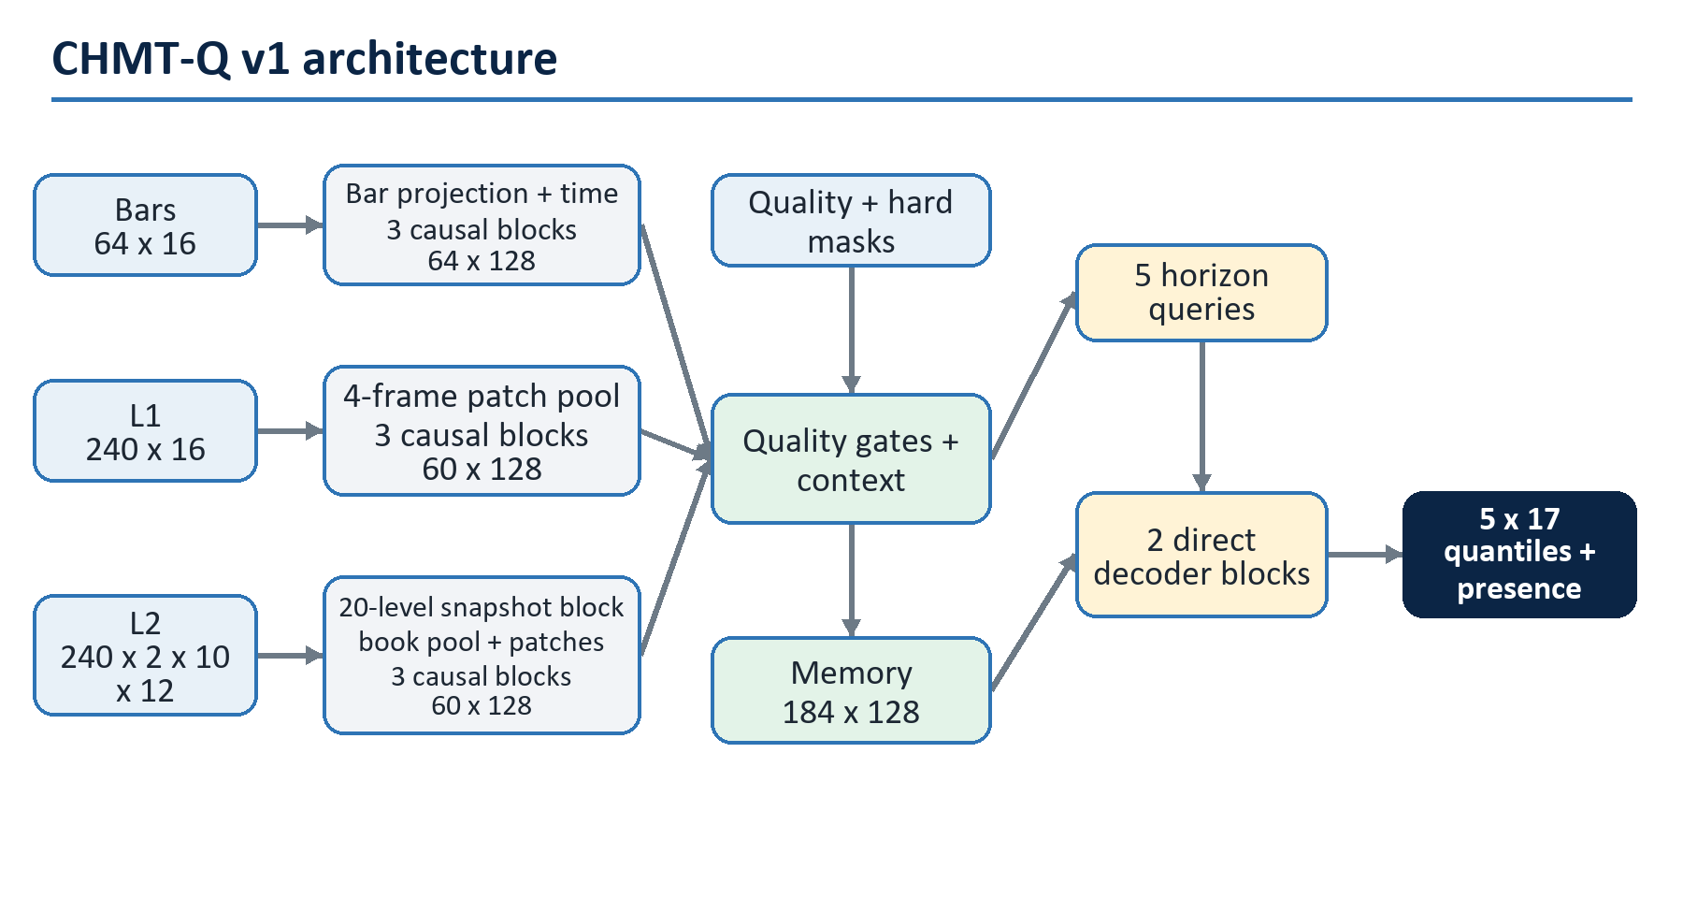
Figure 3. CHMT-Q version one architecture

3.1 Fixed dimensions
Component | Value
Main width d | 128
Main attention heads n_h | 4
Main head width d_h | 32
Main SwiGLU hidden width d_ff | 256
L2 level width | 32
L2 level heads / head width | 4 / 8
L2 level SwiGLU width | 64
Bar temporal blocks | 3
L1 temporal blocks | 3
L2 temporal blocks | 3
L2 per-snapshot blocks | 1
Decoder blocks | 2
Microstructure patch | 4 frames x 500 ms = 2 s
Historical memory | 64 + 60 + 60 = 184 tokens
Horizon queries | 5
Raw outputs per horizon | 17
Dropout | 0.10 during training, disabled at inference
Exact designed parameter count | 2,089,518

3.2 End-to-end shape trace
Stage | Bars | L1 | L2 | Quality / decoder
External tensor | [B,64,16] | [B,240,16] | [B,240,2,10,12] | [B,16]
Initial projection | [B,64,128] | [B,240,128] | [B*240,20,32] | [B,128]
Structural encoding | unchanged | unchanged | [B,240,128] | gates [B,3]
Causal patching | unchanged | [B,60,128] | [B,60,128] | context [B,128]
Temporal encoding | [B,64,128] | [B,60,128] | [B,60,128] | memory [B,184,128]
Direct decoding | - | - | - | queries [B,5,128]
Raw head | - | - | - | [B,5,17]
Stable median contract | - | - | - | [B,5,5] plus intervals/presence

3.3 Why full attention wins at this scale
The total temporal score matrix per layer and head is small:
Across three layers and four heads, all three encoders materialize only:
Two decoder cross-attention layers add only:
Replacing this with a sparse indexer, recurrent scan, or compressed KV latent introduces operators, state, and approximation risk while eliminating a cost that is already tiny. The expensive portion is the dense projection/FFN work and the repeated per-snapshot L2 level encoder, not temporal score storage. Complexity must be optimized from measured profiles, not from asymptotic slogans.

4. Numeric tensor contract
Training supports arbitrary batch B. Export fixes batch one. Every model input is float32 numeric data or a boolean validity mask; no strings, text tokens, identifiers, timestamps, or enums cross the ONNX boundary.
Input | Training shape | ONNX shape | Meaning
bars | [B,64,16] | [1,64,16] | 64 consecutive one-minute slots, oldest first
bars_mask | [B,64] | [1,64] | eligible finalized slot
l1 | [B,240,16] | [1,240,16] | 120 s half-second quote grid
l1_mask | [B,240] | [1,240] | accepted and fresh L1 observation
l2 | [B,240,2,10,12] | [1,240,2,10,12] | half-second bid/ask top-ten book grid
l2_level_mask | [B,240,2,10] | [1,240,2,10] | valid level slots
l2_snapshot_mask | [B,240] | [1,240] | accepted snapshot with at least one valid level
quality | [B,16] | [1,16] | causal coverage, carry, gaps, and anchor quality
The exported raw output is [1,5,17]. Host reconstruction exposes medians and lower/upper intervals for the five primitive marginals, buy/sell presence probabilities, a plug-in raw-delta point diagnostic (never a derived raw-delta interval), and an overall quality/abstention state. Invalid input rows are numerically zero after normalization, but zero never means valid; masks remain authoritative.

4.1 Bar features
Index | Field | Causal definition
0-3 | open/high/low/close offsets | ticks from the previous valid close
4 | log return | log(close / previous_close) for positive prices
5-8 | range/body/upper/lower wick | tick distances
9 | close location | (close-low)/max(high-low,q)
10 | log volume | log(1+volume)
11 | log-volume EMA residual | value minus trailing causal EMA
12 | availability age | max(0,c-AvailableTimeUtc) in seconds
13 | preceding missing slots | log(1+min(g,63))/log(64) for consecutive missing-slot count g
14-15 | session phase | sine/cosine of versioned exchange-session progress
The axis is a clock grid, not "the last 64 non-empty bars." The compiler retains one eligible earlier close only to calculate the oldest token's return; it is not a hidden 65th input.

4.2 L1 features
All price offsets use the cutoff reference price. Fields are midpoint offset/change, spread, log bid and ask size, size imbalance, microprice offset, bid/ask changes, signed log-size changes defined as log(1+size_t)-log(1+size_previous), observation age, event-to-availability lag, normalized sequence-gap magnitude min(missing_sequence_count,16)/16, carry-forward flag, and approximate-time flag. Crossed, non-positive, stale, or causally unavailable books are masked and counted in quality.

4.3 L2 level features
Each side/rank row contains signed distance from a fresh grid-time midpoint, better-level gap, log size, log cumulative size, local and cumulative side share, paired-rank imbalance, snapshot age, event-to-availability lag, sequence gap, carry-forward flag, and approximate-time flag. Bid/ask side and rank 0-9 use learned internal embeddings over fixed axes; the market pipeline does not supply arbitrary integer token IDs.
The nested mask invariant is mandatory:
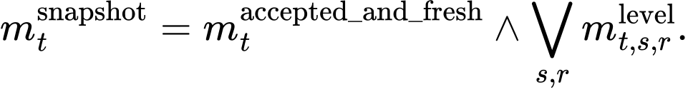
A true snapshot with every level false is invalid input. A one-sided book can keep eligible levels on one side while masking the other, with an explicit quality signal.

4.4 Quality vector
The 16 values are valid fractions for bars/L1/L2 snapshots/L2 levels; L1/L2 carried fractions; approximate-time fractions; quote/depth sequence-gap rates; late-bar fraction; out-of-order rate; one-sided and crossed/rejected rates; anchor-from-L1 flag; and normalized session progress. Every rate uses only observations available by the cutoff and a versioned trailing window.

5. Causal feature compiler
Most catastrophic market-ML failures occur before the first matrix multiplication. The compiler is therefore a versioned, testable component with the same importance as the model.
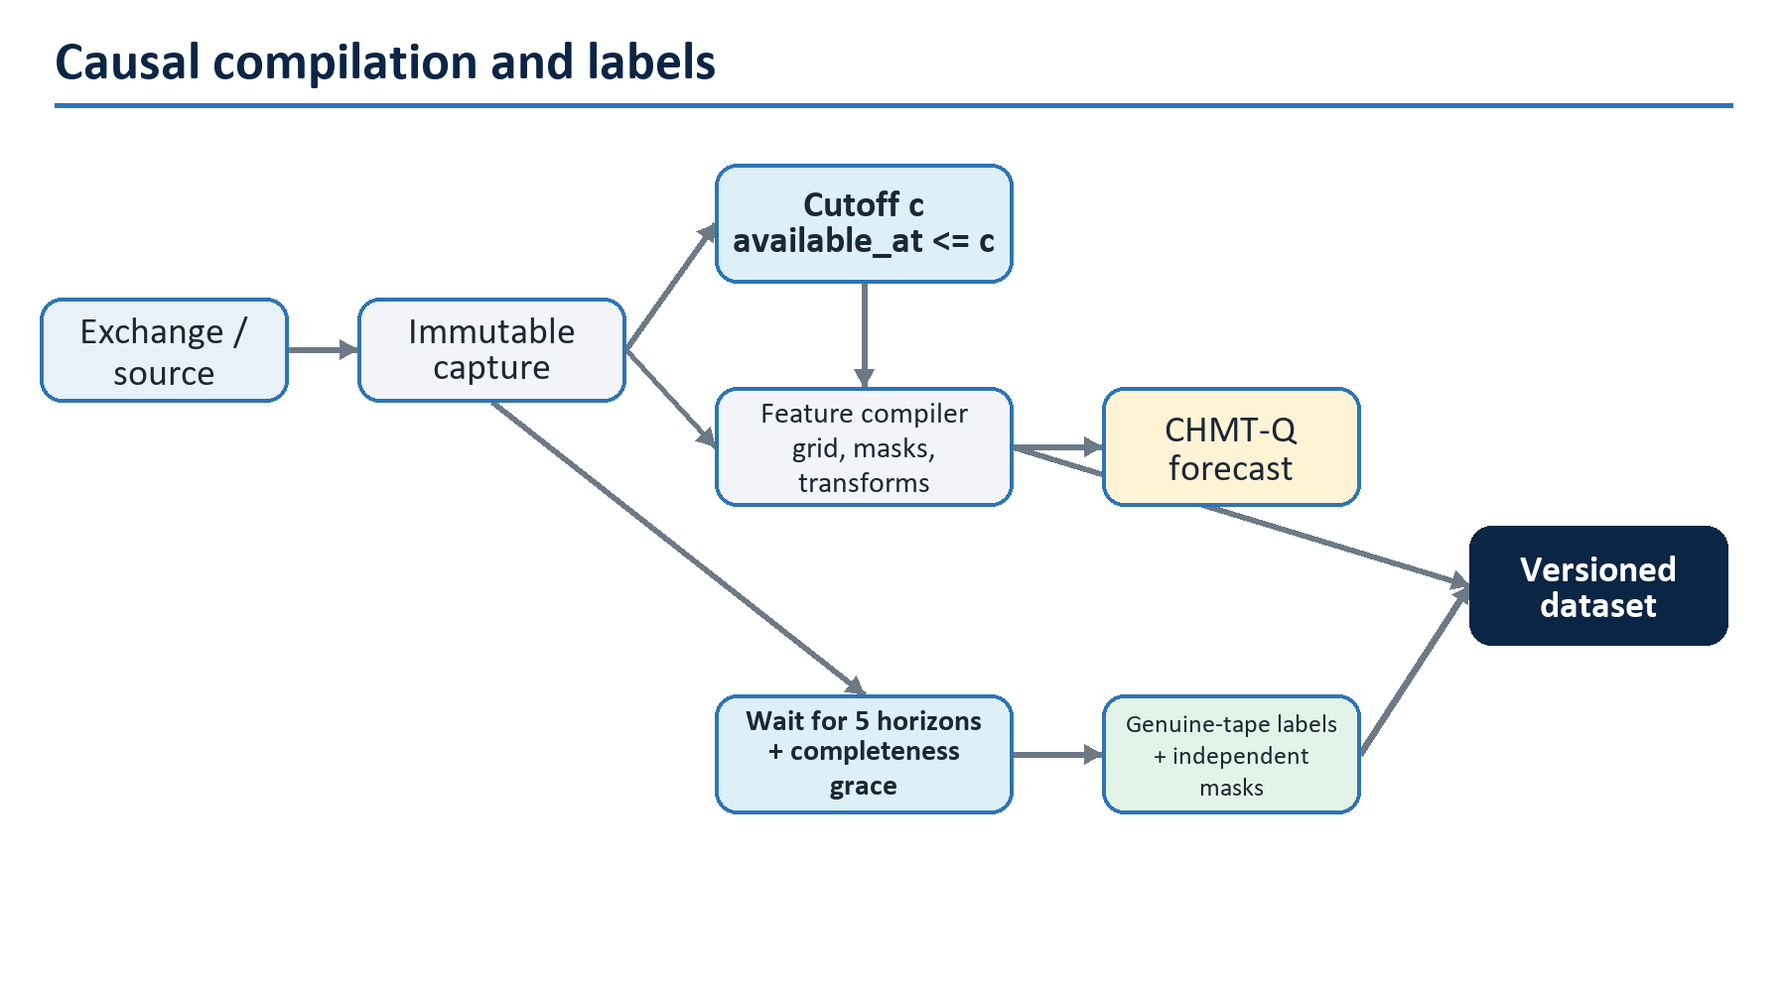
Figure 4. Causal compilation and delayed label construction

5.1 Clock and identity rules
Every capture row carries source, venue, instrument, feed epoch, native sequence when available, event time, receive time, normalized availability time, and a payload checksum. Processing order is deterministic: feed epoch, sequence, availability time, then a documented tie-break. The compiler never sorts solely by exchange event time because late or corrected messages could then appear earlier than they were knowable.
Session schedules, tick sizes, contract rolls, trading halts, daylight-saving changes, and symbol mapping are versioned reference data. A continuous contract must not splice price levels without an explicit roll transform and a split boundary. Instrument identity never enters the model as an uncontrolled string; either train a homogeneous model or use a fixed numeric instrument embedding whose unseen-instrument behavior is defined.

5.2 Resampling without future fill
The 500 ms L1/L2 grids are sampled as-of each grid timestamp from observations already available at that timestamp. Forward carry is allowed only while the source-specific freshness limit holds. It is recorded in both row features and the quality vector. Back-filling from the first later observation is forbidden. Clock slots remain present even when invalid so the age geometry is stable.
For grid time g_j, the selected observation index is:
subject to epoch continuity, sequence policy, acceptance checks, and maximum age. If that set is empty or the chosen observation is stale, the row is masked.

5.3 Training-fold normalization
The default is robust fixed normalization fitted on valid values from the training partition only:
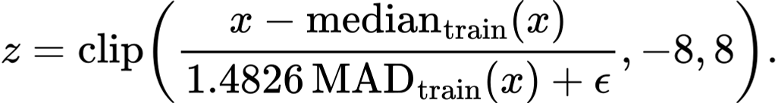
If MAD degenerates, a versioned minimum scale applies. Bounded fractions, masks, and binary flags use identity scaling. Invalid rows are zeroed after normalization. Target normalization is separately fitted per horizon and target, excluding invalid labels, and inverted by the export wrapper.
RevIN [R15] is not in the v1 path. A past-window-only robust reversible variant may be tested, but it must retain the removed level/scale as input features and must never pool future, batch-peer, masked, or cross-instrument values. Absolute spread, depth, and volatility regimes can be predictive; blindly normalizing them away is not invariance.

5.4 Leakage assertions
For every sample, automated tests establish:
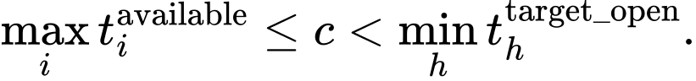
They also establish that scaler-fit rows precede the evaluation partition, every bar was finalized by cutoff, carried observations respect freshness limits, no target trade contributes to a feature, and no sample crosses a session/roll/gap boundary prohibited by policy. Tests inject deliberately late, out-of-order, missing, crossed, one-sided, and epoch-reset messages and expect masks or rejection.

5.5 Label construction
For each future interval [open_h, close_h), the label builder selects eligible genuine trades, classifies aggressor side with a versioned rule, buckets prices by instrument tick, and aggregates total/buy/sell volume. POC is the highest-volume bucket; a deterministic tie chooses the higher price. The exact tie and rounding convention must match chart semantics.
TapeCompletenessPolicy must prove continuity for the interval plus grace. It reconciles feed epoch, sequence gaps, connection/subscription state, capture drops, writer drops, heartbeats, and session coverage. When completeness cannot be proven, all dependent labels are masked even if no trade was observed.

6. Numeric time, modality, side, and rank encoding
Text Transformers learn token positions because word sequences have no physical clock. Market observations do. CHMT-Q uses actual elapsed seconds and preserves logical axes.

6.1 Continuous elapsed-time features
For nonnegative age a and fixed scales tau_k, define:
Bars use K=7, scales 60, 120, 240, 480, 960, 1920, and 3840 seconds. Patched L1/L2 use K=8, scales 0.5, 1, 2, 4, 8, 16, 32, and 64 seconds. The time MLP is:
Bar ages are fixed slot-close ages 3780 through 0 seconds. Patch ages are the 60 patch-end ages 118 through 0 seconds. Row-level observation age and availability lag remain input features; they describe data freshness and do not replace logical token time.

6.2 Learned structural embeddings
A learned modality vector is added to every bar, L1, or L2 temporal token. The L2 level encoder also adds fixed-axis lookup vectors for side and rank:
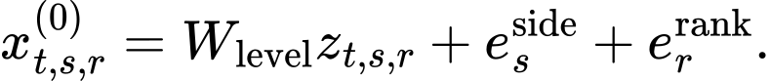
The indices are compile-time axes, not market-supplied categorical IDs. This distinction prevents an arbitrary numeric rank value from being treated as a meaningful continuous distance.

6.3 Relative elapsed-time bias
Temporal head j learns nonnegative decay softplus(gamma_j). For a query at logical time t_i and an eligible past key at t_l:
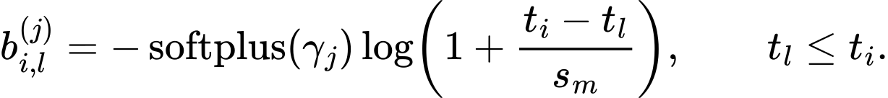
s_m is 60 seconds for bars and 2 seconds for L1/L2 patches. This is a learnable recency prior, not a hard exponential decay; content can still retrieve an older state. Causal and validity masks are separate.

7. The custom CHMT attention block
No framework Transformer, MultiheadAttention, fused attention API, tokenizer, or third-party block defines the reference path. The architecture is implemented from linear projections, reshape, matrix multiplication, masks, softmax, pointwise functions, reductions, and residual addition. This makes the math, mask behavior, and ONNX graph reviewable.
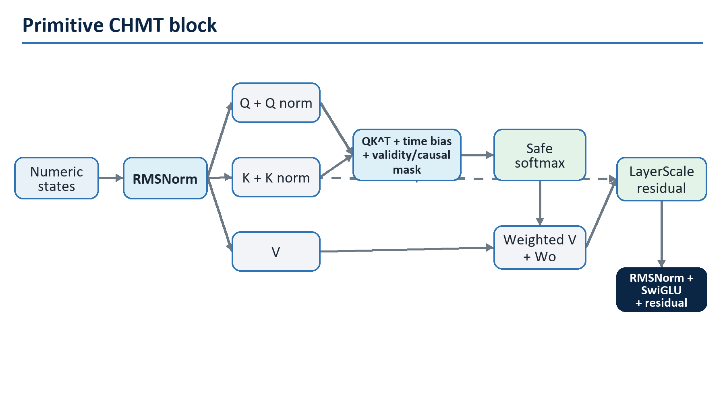
Figure 5. Primitive CHMT attention block

7.1 RMSNorm
For width d, gain g, and epsilon eps:
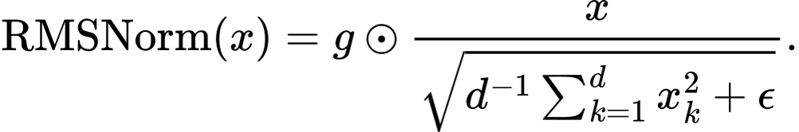
RMSNorm removes the mean-subtraction step of LayerNorm while retaining scale control [R03]. All reductions and accumulations use at least float32 in the reference implementation.

7.2 Q/K-normalized multi-head attention
For normalized input U, head j, and head width d_h:
where M=U in self-attention and M is fused memory in cross-attention. Normalize each query/key vector without learned dimensions:
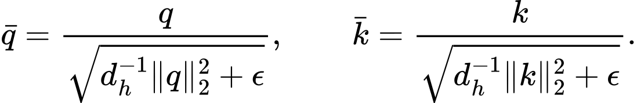
Each head has a learned log temperature theta_j, initialized so the denominator equals sqrt(d_h). Scores are:
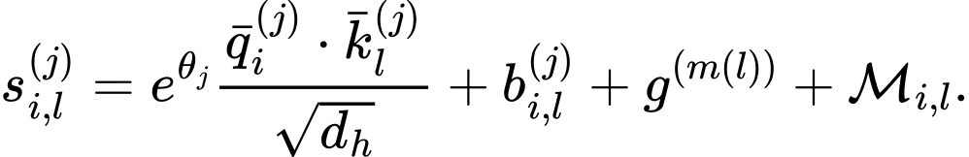
b is optional elapsed-time bias; g is optional log modality-gate bias in decoder cross-attention; and M is zero for an eligible pair and a large negative finite constant otherwise.
Q/K normalization bounds score growth and makes the temperature explicit. It avoids adopting MuonClip's LLM-scale threshold [R28] without evidence. Training still logs maximum logits per head; non-finite or runaway logits fail the run.

7.3 Safe masked softmax
Naive softmax over an all-masked key row can emit NaN. Let a_i indicate whether query row i has any eligible key. For a row with at least one eligible key, define s_i^max=max_(l:m_i,l=1) s_i,l and r_i,l=m_i,l exp(s_i,l-s_i^max):
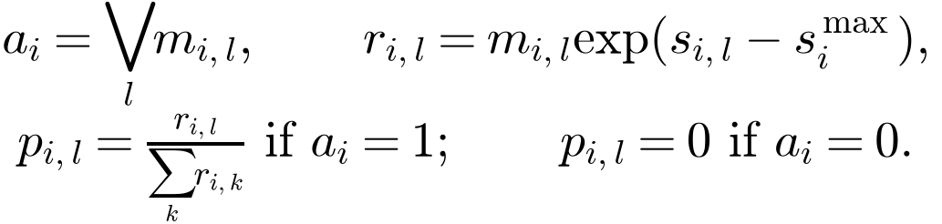
The maximum is evaluated only on eligible keys; the explicit zero-row branch handles an all-masked row. The context and final residual state are zeroed for invalid queries. Tests cover all-valid, partially-masked, all-key-masked, invalid-query, and mixed-batch cases. Masked keys must receive exactly zero probability within the comparison tolerance.

7.4 Attention output
Dropout applies to attention weights and projected residual branches during training only.

7.5 SwiGLU feed-forward network
The main block maps 128 -> 256 -> 128; the level block maps 32 -> 64 -> 32. SwiGLU is selected from the GLU-variant evidence [R04] and costs the same order as the previous GEGLU proposal.

7.6 Pre-norm residual with LayerScale
For learned vectors lambda_a and lambda_f, initialized to 0.1:
Finally z is multiplied by the query-validity mask. LayerScale supplies an inspectable residual gain and helps the small network begin near an identity mapping. Its value is trainable; it is not a runtime confidence score.

8. The three causal encoders

8.1 Bar encoder
Each normalized 16-field bar row is projected to width 128, receives bar modality and elapsed-time embeddings, is zeroed when invalid, and passes through three causal CHMT blocks. The output retains all 64 states rather than pooling to one regime vector.
The triangular mask is necessary even though the final forecast sees an entirely historical window. It lets intermediate bar states represent only their own prefix, supports auxiliary causal tasks, and prevents future-within-window information from leaking if states are reused for sequence training. The final query may still retrieve any historical bar state through decoder cross-attention.

8.2 L1 causal patch encoder
L1 rows are first projected to width 128. Four consecutive half-second frames form one non-overlapping two-second patch. A learned static within-patch offset vector is added to each of the four rows. Scores come from a small masked pooling MLP:
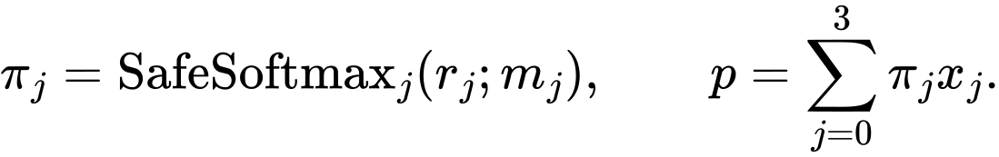
An all-invalid patch returns zero and false. The patch receives its endpoint time embedding and L1 modality vector, then passes through three causal CHMT blocks. Patching is inspired by PatchTST [R12], but strict channel independence is rejected because spread, prices, sizes, imbalance, and freshness interact physically.
Non-overlapping patches are chosen for deterministic low latency and a fixed 60-token contract. An overlapping stride-two variant is a registered ablation, not a silent tuning option.

8.3 Hierarchical L2 encoder
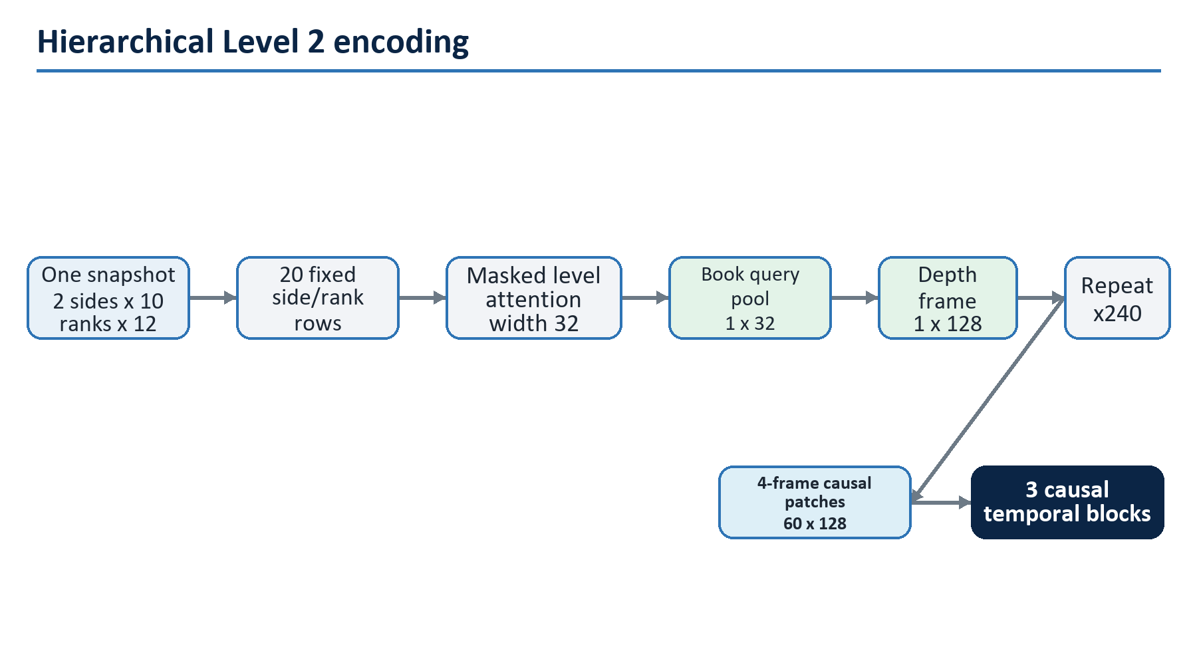
Figure 6. Hierarchical Level 2 encoder
Within a single accepted snapshot, bid/ask ranks coexist at the same logical time, so the level block uses a validity mask but no causal triangle. It captures cross-side imbalance, local gaps, cumulative shape, and rank interactions. A learned query pools eligible level states:
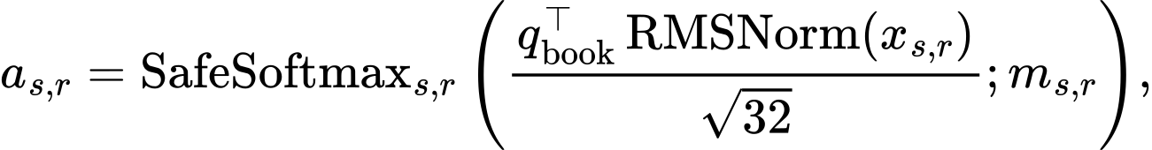
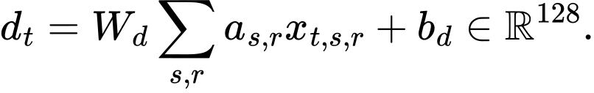
The 240 depth-frame tokens then use the same four-frame patch mechanism and three temporal CHMT blocks as L1, with independent weights.
This hierarchy is essential. Flattening 240 snapshots times 20 levels would create 4,800 temporal tokens and approximately 23 million score entries per head per layer. More importantly, it would make temporal order compete with same-snapshot price-rank geometry. DeepLOB, TransLOB, and TLOB all support the principle that spatial/feature structure and temporal evolution deserve distinct processing [R18]-[R20].

8.4 Why no convolution in the selected v1
DeepLOB's convolutional stem is a mandatory baseline and a strong optional ablation. CHMT-Q itself uses level attention because missing ranks, one-sided books, and explicit side/rank masks are easier to represent without pretending every ladder cell is present. If a shallow depthwise causal convolution or DeepLOB-like stem wins on the same folds without harming ONNX parity, it may be added in v1.1; it is not required to call the current design a custom Transformer.

9. Quality-aware fusion
The latest valid state from each causal encoder summarizes that modality's prefix. Let these be s_b, s_1, and s_2; let c_q be the quality MLP output; and let a_m be a hard indicator that modality m contains at least one valid token.
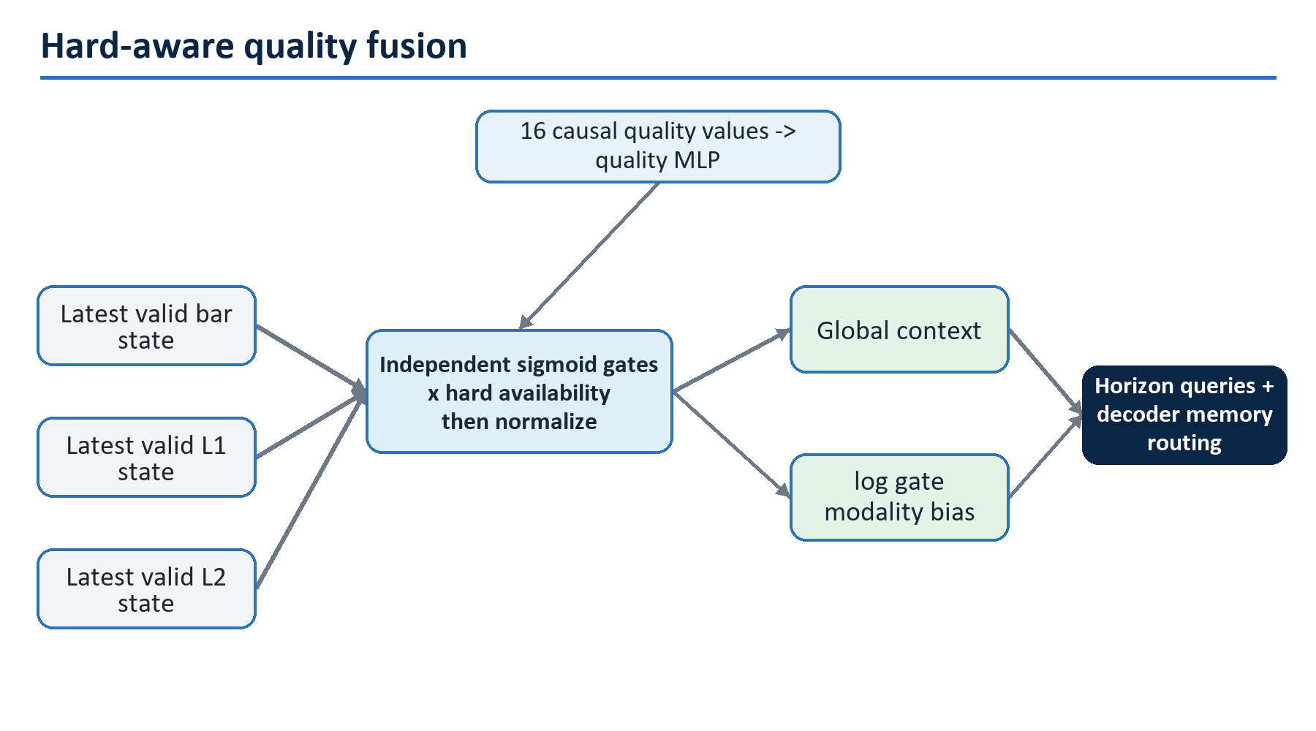
Figure 7. Hard-aware quality fusion
Each modality has an independent two-layer gate:
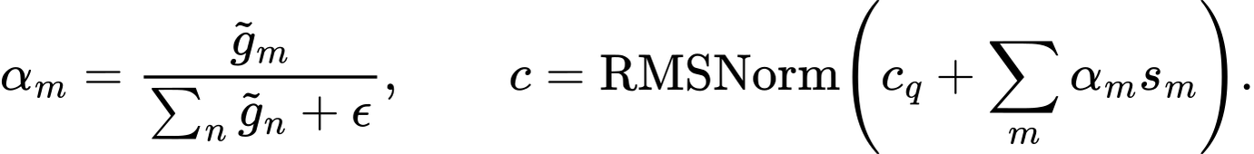
The historical memory is the concatenation of all encoded token sequences:
The gate does not multiply memory values a second time. Instead, decoder score entries receive log(alpha_m + epsilon) according to the key's modality. This shifts attention probability without erasing content magnitude. Hard invalid branches have false key masks and cannot be resurrected by a learned gate. If every modality is invalid, the host abstains before model execution.
The gates are reliability routing, not interpretation. Their values can be logged, but they do not prove feature causality or explain a forecast. Permutation, ablation, counterfactual data-quality, and stability tests are needed for diagnostic claims.

10. Direct five-horizon decoder
CHMT-Q predicts all horizons simultaneously. It does not generate horizon 2 from its prediction for horizon 1. That avoids teacher-forcing mismatch, error propagation, and five serial inference steps.
For horizon index h and interval seconds Delta, construct:
Five learned base queries e_h distinguish horizons; the numeric features preserve distance. Each of two decoder blocks performs pre-RMSNorm horizon self-attention, cross-attention to all valid historical memory, and a SwiGLU FFN, each with its own LayerScale residual.
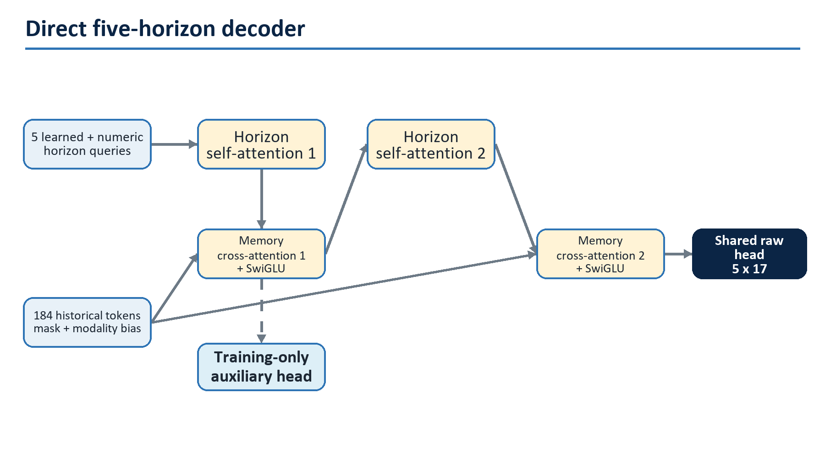
Figure 8. Direct multi-horizon decoder
Horizon self-attention has no causal triangle because all five queries represent forecasts made at the same cutoff. It learns coherent term structure; it does not reveal future observations.

10.1 MTP-inspired deep supervision
DeepSeek-V3 multi-token prediction supplies the next target-token embedding to an auxiliary sequential module during language-model training [R07]. Gloeckle et al. instead use independent heads to predict several future tokens in parallel from the same causal past representation, without future-token input [R08]. CHMT-Q follows the latter information boundary but makes an original deep-supervision adaptation: it applies the same output head to the first decoder block's five states and adds a lower-weight auxiliary loss. The deployable input graph remains unchanged, and the auxiliary output is discarded at inference.
This is conceptual adaptation, not a claim that CHMT-Q implements DeepSeek MTP. It encourages useful multi-horizon states earlier in the network while preserving strict causality.

11. Monotone probabilistic output
One point forecast hides uncertainty and encourages false precision on a chart. CHMT-Q emits three ordered marginal quantiles for each target plus explicit buy/sell-presence logits.
For target k, the raw head supplies center c, lower gap logit a, and upper gap logit b:
This guarantees Q_0.10 <= Q_0.50 <= Q_0.90 before numerical tolerance. For delta fraction, apply the monotone tanh function to all three ordered values. Price and log-volume targets are inverse- normalized by frozen training statistics. The 17 raw outputs per horizon are:
Positions | Meaning
0-14 | three raw quantile parameters for each of five targets
15 | buy-POC presence logit
16 | sell-POC presence logit
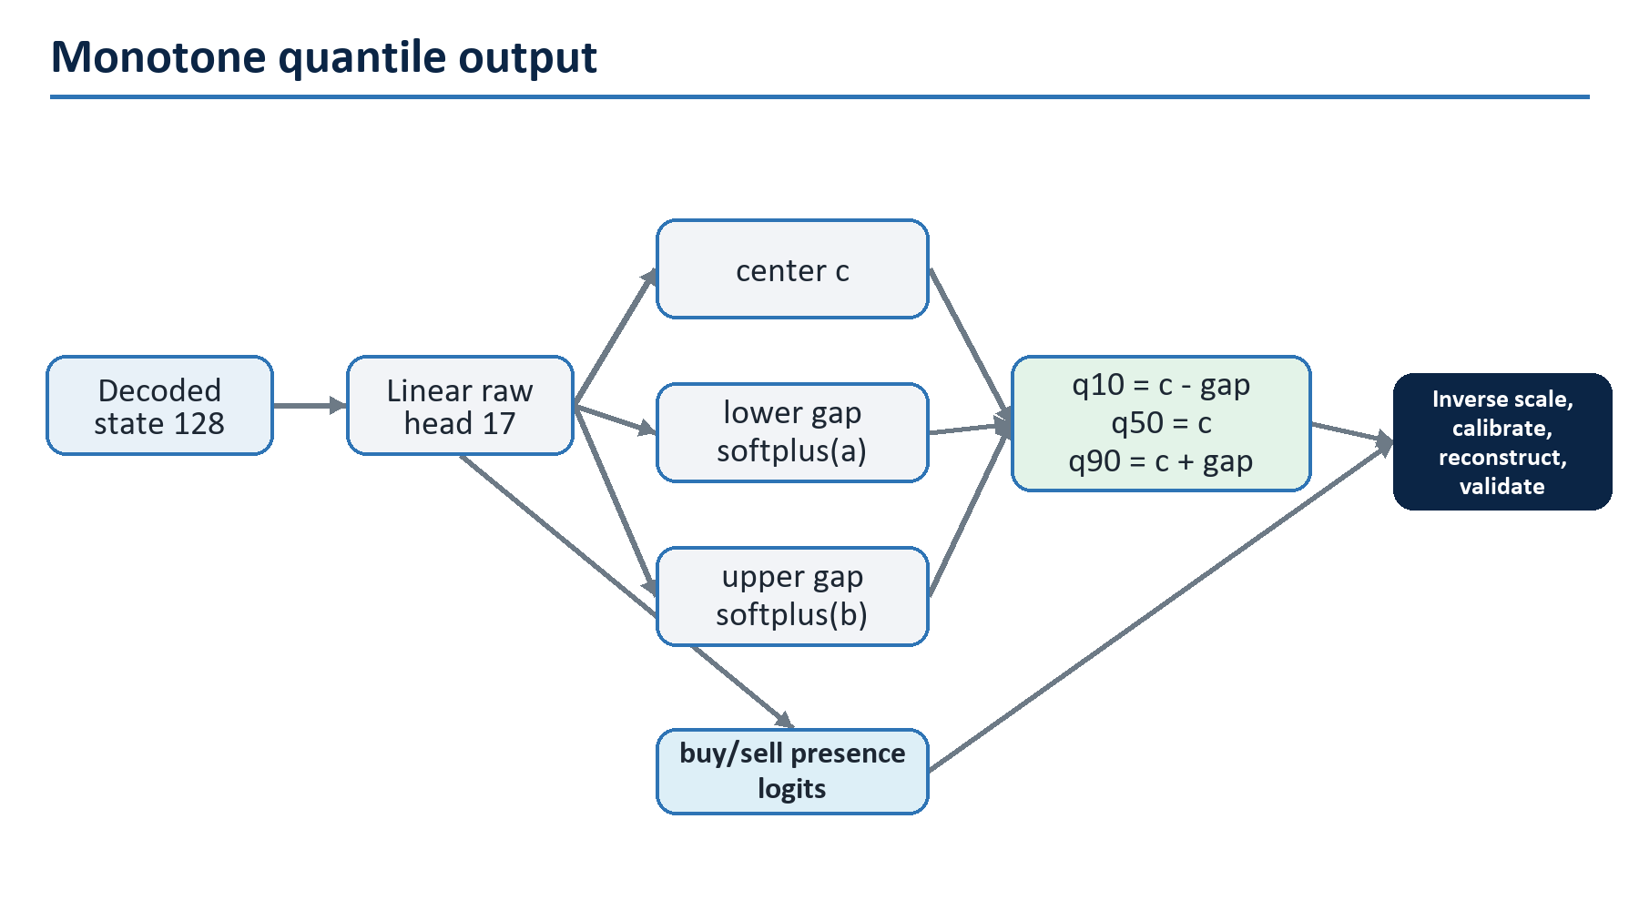
Figure 9. Monotone probabilistic output

11.1 Runtime reconstruction
After finite checks, inverse target scaling, and the monotone delta-fraction transform:
The inverse transform is applied separately to each primitive marginal quantile. POC values are snapped to the instrument tick only afterward. Every primitive quantile is checked for finite values, order, volume nonnegativity, and bounded delta fraction; the plug-in point diagnostic must satisfy |D_tilde| <= V_hat_0.50. Buy/sell POC is omitted when its calibrated presence probability is below the frozen threshold. A violation rejects the entire five-horizon result; partial corrupted output never reaches the chart.

11.2 What these quantiles do not mean
The five horizons are marginal distributions, not a coherent joint price/volume path. The 80% interval does not mean that all five values or all five horizons jointly fall inside their intervals 80% of the time. Multiplying separately calibrated volume and delta-fraction quantiles does not produce raw-delta quantiles and can reverse endpoints when the fraction is negative. D_tilde is therefore only a plug-in point diagnostic; v1 exposes no claimed raw-delta interval. If downstream simulation requires derived distributions or joint paths, it needs a directly supervised target, conditional copula, or sample decoder evaluated with proper multivariate scores. Those are intentionally outside v1.
This direct marginal design is closer to MQTransformer's horizon-specific quantiles [R37] than to DeepAR's autoregressive sample paths [R36]. Pinball loss is a proper quantile score; model comparisons must preserve that property rather than selecting visually narrow intervals [R38].

12. Training objective

12.1 Pinball loss
For quantile level tau, error u=y-q, and prediction q:
With horizon weights w_h=1/sqrt(h), target weights v=(1,1,1,0.5,0.5), quantile set T={0.1,0.5,0.9}, and independent mask m_bhk, the normalized forecast loss is:
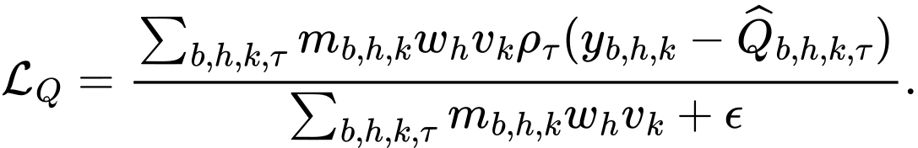

12.2 Median Huber stabilization
For residual r and threshold delta=1 in normalized target units:
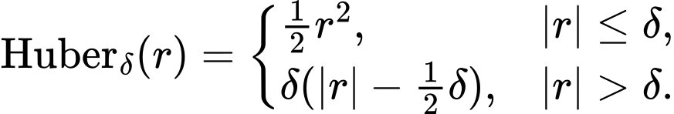
The masked, weighted median loss L_H uses r=y-Q_0.50. It supplies smooth local gradients while pinball loss remains the proper quantile objective.

12.3 Presence loss
Buy and sell presence are known only when interval tape continuity and classification coverage pass. For label r and logit z, use numerically stable binary cross-entropy:
Class-balanced sampling or positive weights may be used only if derived inside each training fold and recorded in the run configuration. Thresholds are selected on calibration data for the declared cost, never on the outer test.

12.4 Total loss
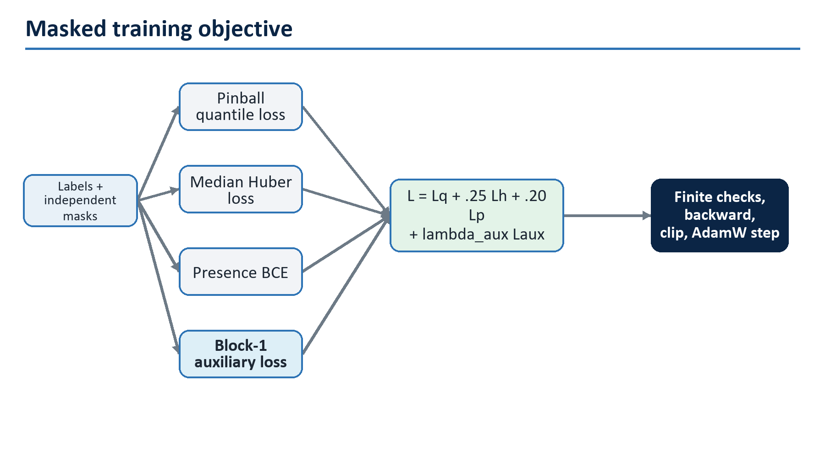
Figure 10. Masked training objective
The baseline objective is:
L_aux repeats the quantile, Huber, and presence objective on decoder block 1. Set lambda_aux=0.25 for the first 60% of optimizer steps, linearly decay it to 0.05 by 90%, and hold there. These coefficients are hypotheses frozen before a fold, not universal constants. The ablation must compare lambda_aux=0.
No loss term directly optimizes backtest PnL in v1. PnL objectives are unstable, policy-dependent, and easy to exploit through turnover or exposure. Proper forecast scores train the model; a separate, frozen policy evaluates economic usefulness.

12.5 Optional causal auxiliary tasks
Only after the supervised baseline is stable, training may add discarded heads for next-bar return, next L1 spread/imbalance change, or next L2 shape change. Their inputs are historical states and their labels begin after each state's local cutoff. They may improve representation learning on abundant unlabeled capture, but they require separate leakage tests and an ablation. Random bidirectional mask reconstruction is not the default because it teaches a representation with access patterns unavailable at inference.

13. Exact parameter and compute ledger
The parameter count below follows the stated biased linear layers, learned embeddings, RMSNorm gains, two 128-element LayerScale vectors per encoder block, three per decoder block, and one learned Q/K temperature per attention head. It is a design ledger; the implementation must assert equality.
Component | Parameters
Bar, L1, and level projections | 4,768
Quality MLP | 18,688
Bar time MLP | 4,768
L1 patch-time MLP | 4,832
L2 patch-time MLP | 4,832
Modality embeddings | 384
L2 side/rank embeddings | 384
L2 level CHMT block | 10,660
Book query, pool norm, and 32-to-128 projection | 4,288
L1/L2 within-patch embeddings and pool MLPs | 9,346
Nine temporal CHMT blocks | 1,489,572
Two decoder blocks | 463,632
Three modality gate MLPs | 49,539
Fusion norm and context projection | 16,640
Horizon queries and horizon MLP | 4,992
Shared 128-to-17 output head | 2,193
Total | 2,089,518
FP32 weights occupy approximately 7.97 MiB before graph/container overhead. The packaging target is below 12 MiB for the ONNX file and below 64 MiB incremental worker memory, both measured on the target runtime.
Approximate batch-one work is about 160-180 million multiply-accumulates depending on how the exporter fuses masked operations. The repeated 240-snapshot L2 level encoder and the nine FFNs dominate. The full attention score operations do not. Acceptance uses measured p50/p95/p99 latency, not this estimate.

13.1 Why the model is not larger
Market labels are noisy, nonstationary, and expensive. A large network can memorize sessions, instruments, and feed artifacts while improving random validation. Width 128 supplies four 32-wide heads and enough capacity for three modalities; depth three supplies local-to-window abstraction; two decoder layers supply horizon coordination. Scaling begins only after data-size curves show underfitting on multiple chronological folds and a larger model wins net of latency and calibration.

13.2 Why the model is not smaller
The L2 branch must represent within-snapshot book geometry and temporal evolution separately. The three encoders must not share weights because bar, quote, and depth distributions differ. A one-vector fusion loses event chronology, and a single shared decoder cannot express horizon-specific retrieval. The baseline suite determines whether this extra capacity is actually earned.

14. End-to-end training workflow
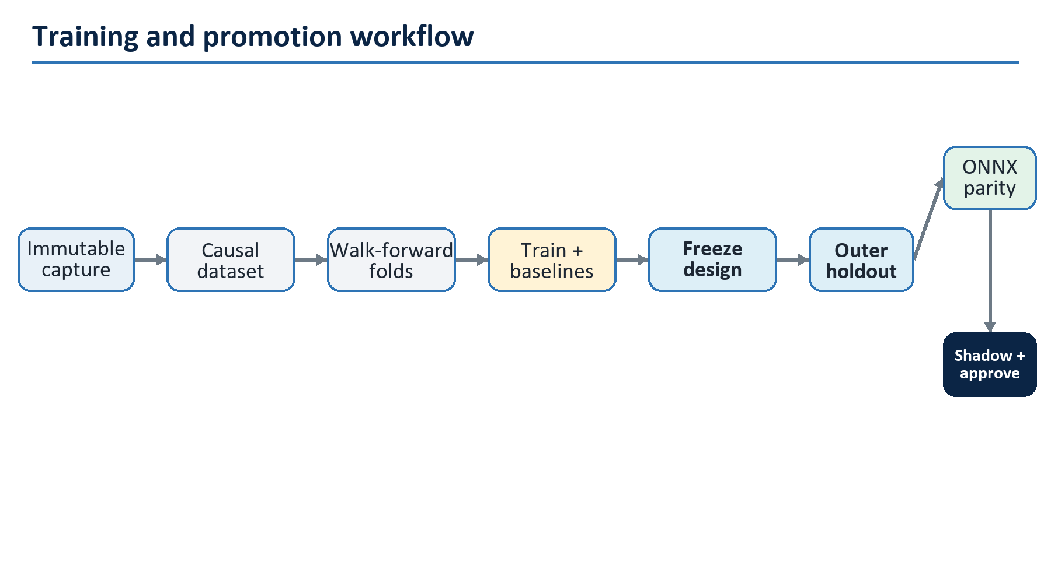
Figure 11. End-to-end training and promotion workflow

14.1 Stage 0: capture and provenance
Write append-only source events before building training examples. Record adapter/source version, instrument metadata, session calendar version, capture host clock diagnostics, connection epochs, native sequences, drops, and corrections. Hash immutable shards. Training manifests reference shard hashes and row/time bounds; copying a mutable "latest" file is forbidden.
Licensing matters independently of engineering. The project must document whether stored L1/L2/tape can be retained, transformed, used for model training, moved across machines, or embedded in derived artifacts. A trained model is not automatically exempt from feed terms.

14.2 Stage 1: deterministic dataset build
For each eligible cutoff:
- resolve instrument/session/tick metadata;
- establish the exact decision boundary and reference price;
- compile fixed bar, L1, L2, mask, and quality tensors from F_c;
- wait until all five future intervals plus completeness grace have matured;
- build each target and independent mask from genuine tape;
- reject impossible nested masks, non-finite values, missing anchors, and prohibited boundaries;
- write a versioned example shard plus a compact audit record containing source bounds and reasons;
- reproduce a random sample from source events byte-for-byte before accepting the dataset.
The split manifest is generated before scaler fitting. Dataset code never chooses random row splits.

14.3 Stage 2: nested chronological development
Use an outer chronological holdout once, after architecture and hyperparameters are frozen. Inside the earlier development period, use expanding walk-forward folds.
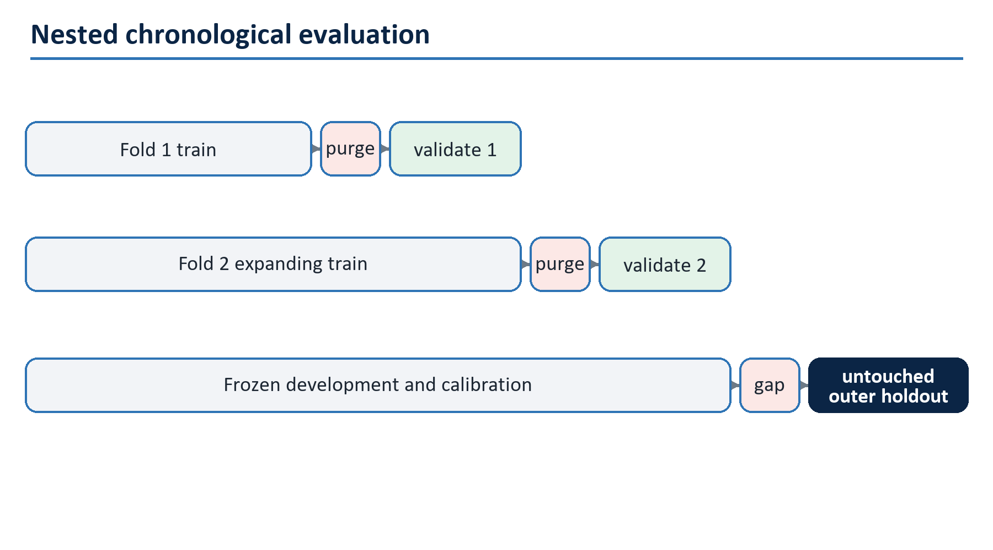
Figure 12. Nested chronological evaluation
The dates above illustrate ordering, not a mandatory calendar. Actual boundaries align to complete sessions and contract regimes. For an evaluation origin c_v, no training label may close after the purge boundary. The minimum purge is maximum forecast horizon plus label grace and execution latency. If the experiment requires disjoint raw input windows, add a lookback embargo as well.
All preprocessing choices-including missingness limits, clipping, target scaling, label thresholds, calibration, and feature selection-are fitted inside the training side of each fold. The outer holdout is never used for architecture selection, early stopping, calibration design, or a persuasive chart.

14.4 Stage 3: reference training recipe
The first recipe is intentionally conventional:
Item | Initial value
Optimizer | AdamW
beta1, beta2, epsilon | 0.9, 0.95, 1e-8
Peak learning rate | 3e-4
Weight decay | 0.05 on matrix weights; none on biases, norms, embeddings, LayerScale
Warm-up | 5% of optimizer steps
Decay | cosine to 3e-5
Global gradient norm clip | 1.0
Effective batch | 128 examples, using accumulation if required
Precision | bf16 activations where supported; FP32 norms, softmax, loss, optimizer master weights
Maximum epochs | 50
Early stopping | 8 validations without primary-score improvement
Seeds | at least 17, 29, and 43 for final candidates
Checkpoint selection | weighted validation pinball, tie-broken by calibration and median MAE
These are starting hypotheses. A learning-rate range test may be run entirely inside development data. The final recipe and stopping rule are frozen before the outer holdout.

14.5 One optimizer step
- Load examples without crossing their assigned chronological partition.
- Validate shapes, dtypes, nested masks, and finite valid values.
- Apply frozen training-fold normalization.
- Optionally perform registered modality dropout while preserving at least one valid branch.
- Run the CHMT-Q forward pass and auxiliary block-1 head.
- Compute mask-normalized quantile, Huber, presence, and auxiliary losses.
- Reject non-finite loss before backward.
- Backpropagate, unscale mixed precision, and verify finite gradients.
- Clip global gradient norm and take the AdamW step on accumulation boundary.
- Advance the warm-up/cosine scheduler.
- Log loss denominators, per-target/horizon terms, gradient/update norms, attention logits, gates, mask fractions, throughput, and memory.
- Periodically run deterministic validation with dropout disabled.
No batch is silently skipped because a target is inconvenient. If a loss denominator is zero, that specific term returns zero and records a zero-count metric. A batch with every supervised term absent is rejected by the sampler or logged and skipped explicitly.

14.6 Sampling and augmentation
Uniform sampling over highly overlapping cutoffs can overrepresent long quiet sessions. The default samples at a fixed decision cadence and caps examples per session/instrument. Optional training-only weights may balance regimes defined from past-only volatility, spread, and liquidity; weights are fitted in the fold and evaluation remains unweighted.
Safe optional augmentation is modality dropout: with a small registered probability, mask an available modality and update quality consistently, never dropping all branches. It trains graceful degradation but cannot simulate arbitrary feed faults. Price translation is already removed by tick offsets. Time reversal, future-window cropping, random book-rank permutation, synthetic target noise, and unverified bid/ask mirroring are prohibited defaults because they break market semantics.

14.7 Training from scratch
All trainable CHMT-Q parameters are initialized for this numeric task. No pretrained text model, token embedding, vocabulary, or language checkpoint is loaded. Linear weights use variance-preserving truncated normal or Xavier initialization appropriate to their fan-in; biases are zero; RMSNorm gains are one; LayerScale is 0.1; output centers may initialize to training-target medians and interval gaps to empirical central widths from training data only.

15. Evaluation and calibration

15.1 Required forecast metrics
Report every metric per target, horizon, instrument group, and fold before aggregating.
Output | Primary metrics | Diagnostic metrics
POC offsets | pinball; median MAE in ticks | RMSE, within-1/2-tick rate, signed bias
Log volume / volume | pinball; log-space MAE | WAPE, RMSLE, extreme-volume slices
Delta fraction | pinball; MAE | sign accuracy, correlation, boundedness
Buy/sell presence | log loss; Brier score | precision/recall, PR-AUC, reliability/ECE
Intervals | empirical coverage and mean width | coverage-width curve, Winkler score, slice coverage
Whole model | weighted pinball versus baselines | latency, abstention, seed variance, drift sensitivity
Quantile coverage is checked directly:
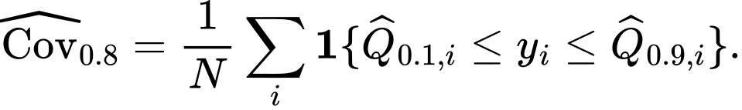
Do not celebrate nominal coverage without interval width. A trivially wide interval is safe but useless. Do not aggregate horizons before inspecting horizon-specific failures.

15.2 Baseline suite
At minimum, CHMT-Q competes with:
- last valid value / zero residual / seasonal same-session value;
- robust historical median and exponentially weighted residual forecasts;
- ridge and elastic-net direct multi-horizon regression;
- DLinear and NLinear [R16];
- gradient-boosted trees on the same causal summary features;
- logistic models for POC presence/direction;
- a causal TCN;
- a DeepLOB-like convolution plus LSTM/temporal head [R18]; and
- the existing point-estimate Transformer configuration.
Every baseline receives the same cutoffs, labels, masks, training partitions, and target transforms. The point is not to make the baseline weak enough to beat.

15.3 Calibration
Quantile heads are not automatically calibrated. Fit conformal expansion on a dedicated chronological calibration slice after model selection. For lower/upper quantiles l_i,u_i and target y_i, use [R34]:
Let q_e be the finite-sample corrected empirical (1-alpha) quantile of calibration scores. Return [l-q_e,u+q_e], separately by target and horizon when sample size permits. Freeze q_e into the candidate package before outer evaluation.
Financial data are not exchangeable. Therefore this is reported as empirical rolling coverage, not an unconditional finite-sample guarantee. Adaptive conformal updates [R35] are a later shadow-only experiment. Any online update must wait until the corresponding horizon label is complete and use a separate delayed queue per horizon.

15.4 Slice and stress evaluation
Pre-register slices for session phase, volatility, spread, depth, trade intensity, missingness, carried-data rate, sequence gaps, one-sided books, news/calendar windows, contract roll distance, instrument, year/quarter, and source adapter version. Stress tests deliberately:
- remove one modality;
- age L1/L2 within and beyond accepted limits;
- introduce valid mask sparsity and long gaps;
- shift input scales to clipping boundaries;
- simulate crossed/one-sided books and sequence resets;
- replay high-volume bursts and empty-but-complete intervals;
- test cutoff timestamps around session open/close, halt, roll, and daylight-saving boundaries; and
- run bit-identical repeated inference under process restart.

15.5 Statistical uncertainty
Report three or more training seeds and block-bootstrap confidence intervals with sessions or days as blocks, not individual overlapping examples. Compare loss differences against the best baseline per block. A single lucky seed or a confidence interval spanning zero is not a robust architectural win.

15.6 Promotion gates
Before seeing the outer holdout, freeze numerical gates such as:
Gate | Initial candidate threshold
Weighted pinball | at least 5% better than the best registered non-neural baseline
Horizon regressions | no target/horizon more than 2% worse without a documented trade-off
Nominal 80% interval | 76%-84% overall and at least 70% in each sufficiently populated critical slice
Seed stability | all three final seeds beat baseline; relative spread reported
ONNX parity | max absolute 1e-5 or relative 1e-4, plus identical masks/presence decisions
Batch-one latency | warmed worker p95 at most 25 ms on the declared target CPU
Worker memory | incremental steady state below 64 MiB
Safety | zero non-finite accepted results and zero invariant violations in stress replay
The numbers are proposals and must be reconciled with product latency and sample size. They may be made stricter before holdout, never relaxed after seeing a disappointing holdout.

15.7 Economic evaluation is downstream
Freeze a simple forecast-to-action policy on development data, then test executable prices, fees, slippage, latency, queue/fill assumptions, turnover, capacity, exposure, and drawdown. Report periods with no trade and all rejected/abstained predictions. The LOB literature shows that high classification scores need not align with forecast-implied entry/exit sequences and do not establish executable profitability [R31]-[R33]. A chart forecast may still be useful without authorizing automated execution.

16. Ablation and scaling program
An ablation changes one registered factor, reuses identical folds/seeds/budgets, and reports forecast, calibration, latency, and stability-not only the best run.
Question | Baseline | Variant | Promotion condition
Does L2 help? | bars+L1 | bars+L1+L2 | consistent proper-score gain in liquid and thin slices
Is hierarchy necessary? | hierarchical 20-level snapshot | flattened/summary L2 | keep hierarchy unless simpler model is non-inferior and faster
Patch width | 4 frames | 2, 8, overlap stride 2 | better validation score within latency budget
Causal triangle | causal encoders | historical-window bidirectional | causal remains default unless deployment never reuses intermediate states and gain is robust
Time encoding | elapsed-time MLP+bias | ordinal position only / no bias | retain only measured gain
Quality fusion | hard+learned gates | hard mask only / concatenated quality token | gates must improve degraded-data behavior without hurting clean data
Block design | RMSNorm+QK norm+SwiGLU | LayerNorm/GEGLU/no QK norm | compare stability and score
Uncertainty | monotone quantiles | point Huber / unconstrained quantiles | quantiles must calibrate and not degrade median materially
Deep supervision | auxiliary loss | lambda_aux=0 | keep only across seeds/folds
Local stem | attention-only L2 | DeepLOB-like conv / causal TCN stem | add only with parity and latency evidence
Optimizer | AdamW | Muon on matrices | equal data/FLOPs/seeds; better loss and stable logs
Long context | dense attention | Gated DeltaNet/KDA/Mamba | enter only after raw context exceeds threshold and attention profiles as bottleneck
Scaling order is data first, then context, then width/depth. Build learning curves at 10%, 25%, 50%, and 100% of development data. If loss continues to improve with data and train/validation are close, collect more data. If both losses are high and larger width wins, test width 192 before adding exotic routing. If attention is not a measured bottleneck, do not replace it.

17. DeepSeek research: what transfers and what does not

17.1 Multi-head latent attention
DeepSeek-V2 compresses autoregressive key/value state through a low-rank latent [R06]. In abbreviated form:
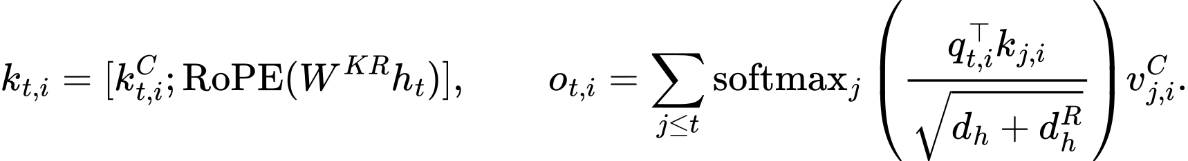
Only the compressed latent and rotary key component need be cached during token-by-token generation. However, attention still sums over every past position. MLA reduces KV-cache width; it is neither sparse nor linear in sequence length.
Decision: reject for CHMT-Q v1. The model produces five queries in one forward pass and has no autoregressive KV cache. Its 184 memory tokens require only 7,360 decoder cross-attention scores. A low-rank memory projection could discard small but important queue events while adding custom export logic. Revisit MLA only if a future streaming decoder performs long autoregressive generation.

17.2 DeepSeekMoE and load balancing
DeepSeekMoE combines always-active shared experts with top-k routed experts [R05]:
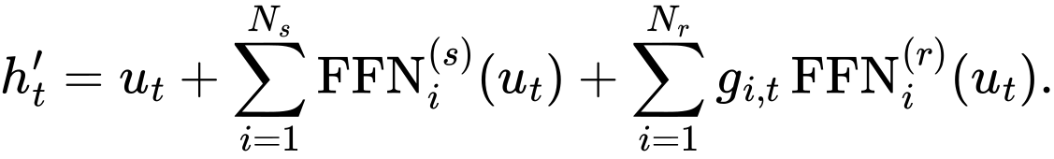
DeepSeek-V2 used 236B total/21B active parameters, and V3 used 671B total/37B active [R06]-[R07]. V3's auxiliary-loss-free controller adjusts expert-selection biases from historical load [R27]; it still exists to keep enormous distributed expert fleets balanced.
Decision: reject for v1. A 2.09M dense model has no capacity or distributed-compute bottleneck. Three tiny regime experts would duplicate parameters, produce data-starved routes, complicate ONNX, and invite a gate to learn session or instrument artifacts. If dense scaling later saturates, compare a supervised, causally routed small expert family against simple FiLM modulation and separate models.

17.3 Multi-token prediction
DeepSeek-V3 uses an auxiliary next-depth module and loss [R07]. The separate multi-token-prediction paper predicts several future tokens in parallel from the same causal past representation, without future-token input [R08]:
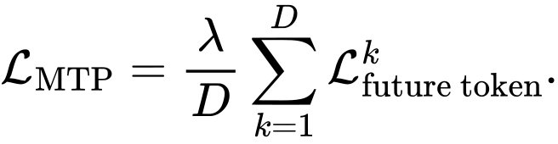
The DeepSeek-V3 language mechanism receives the embedding of a future token in its training-only auxiliary path; the R08 parallel heads do not. CHMT-Q adopts only the shared principle of auxiliary future supervision and supplies no future observation to either path.
Decision: adapt the principle. Apply the shared prediction head to the intermediate decoder layer and supervise all five direct horizons. No future observation is supplied to the trunk or auxiliary head. The ablation can remove it with zero inference graph change.

17.4 NSA and DSA
Native Sparse Attention mixes compressed, selected, and sliding-window branches [R09]:
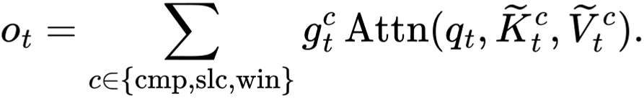
Its published configuration used a 27B/3B-active model, 270B training tokens, 64K contexts, eight A100 GPUs, and custom Triton kernels. DeepSeek-V3.2 DSA later selects top-k MLA entries but retains an O(L^2) lightning indexer; its reported recipe used a short 2.1-billion-token dense/indexer warm-up followed by extensive 943.7-billion-token sparse adaptation [R26].
Decision: reject for v1. CHMT-Q's complete dense score matrices are smaller than the bookkeeping for these mechanisms. If a GPU research branch later consumes tens of thousands of raw events, sparse attention becomes an empirical candidate, not an automatic upgrade.

17.5 DeepSeek-R1 reasoning does not define a numeric forecaster
DeepSeek-R1 studies reinforcement learning and reasoning behavior in language models [R45]. A trading forecaster has supervised numeric targets, severe nonstationarity, and no verifiable chain-of-thought reward. Importing reasoning traces, textual rationales, or outcome-only reward would create a different system and is outside this architecture. The useful lesson is methodological: separate the base model, training objective, evaluation, and deployment evidence rather than attributing all gains to a brand.

18. Moonshot and recurrent linear attention research

18.1 Kimi Delta Attention
Kimi Linear combines three KDA layers with one full MLA layer and demonstrates very-long-context language performance [R10]. With recurrent state S_t:
alpha_t is channel-wise decay and the delta term selectively overwrites the association at key k_t. The fixed state removes growth with context length, but finite state can collide and forget rare associations; Kimi retains periodic full attention for that reason. Reported advantages concern 128K-to-1M contexts, multi-billion-parameter models, GPU kernels, and much larger batches enabled by saved memory.
Decision: benchmark only after context expansion. At 60 temporal tokens, exact attention is both simpler and more faithful. A future raw-event worker may compare KDA with key/value/state widths 16 or
- Its ONNX contract must expose S_{t-1} and S_t, keep state FP32, isolate state per instrument/venue/feed epoch, and reset on gaps or session policy.
For irregular market time, a proposed-not Kimi-published-decay is:
This makes a five-second gap decay more than a millisecond update. It must be compared against explicit gap reset, scalar decay, and dense attention.

18.2 Gated DeltaNet is the first recurrent benchmark
Gated DeltaNet [R11] uses scalar forgetting and a delta-rule fast-weight update:
The delta term corresponds to one gradient step on 0.5 ||S k_t-v_t||^2. Scalar alpha_t is smaller and easier to export than KDA's channel gate. If raw event contexts exceed roughly 2,000 observations and profiling shows attention cost material, compare full/local attention, scalar Gated DeltaNet, channel KDA, and Gated DeltaNet plus one local-attention layer. Rare-event recall and gap reset behavior are first-class metrics.
The comparison also includes ungated DeltaNet [R41], classical kernel linear attention [R40], and Gated Linear Attention [R39]. Ungated recurrence can retain stale regimes; the reported ELU+1 linear kernel replaces softmax rather than reproducing it; gated recurrence can forget but still has finite associative capacity. These are useful controls, not substitutes for measuring rare-event recall.

18.3 Muon and MuonClip
Muon orthogonalizes matrix updates through approximate Newton-Schulz iterations [R25]:
The paper's fitted compute-efficiency claim comes from large proprietary language-model scaling. Five orthogonalization iterations may not amortize on a two-million-parameter model, and Muon applies only to matrix parameters while AdamW remains for norms, embeddings, heads, and biases.
Decision: AdamW first; Muon is a controlled training-only A/B. Use identical data order, seeds, wall-clock/FLOP reporting, and update/weight/gradient RMS logs. Exported inference is unaffected. MuonClip from Kimi K2 rescales Q/K weights only when measured softmax logits explode [R28]. Q/K normalization is the v1 prevention; a threshold copied from trillion-parameter training is not.

19. Adaptive and evolutionary model research: bounded offline use

19.1 Transformer-Squared
Transformer-Squared freezes singular vectors and learns task-expert scaling of singular values [R23]:
The published system identifies a task or searches a mixture, then performs a second inference with adapted weights. This is attractive conceptually for volatility/liquidity regimes, but runtime weight mutation conflicts with frozen ONNX optimization, quantization, deterministic replay, and simple model lineage. Its few-shot search costs and correctness-plus-KL reward do not map to sub-second forecasting.
Decision: do not self-modify the v1 model. If regime specialization becomes necessary, train experts from one common base using strictly causal regime labels and choose among pre-exported, signed packages at a coarse session/regime boundary. A simpler activation-level FiLM/gate is the first comparison. Routing can use only features available at decision time.

19.2 Evolutionary model merging
For same-base checkpoints, task arithmetic represents expert k by:
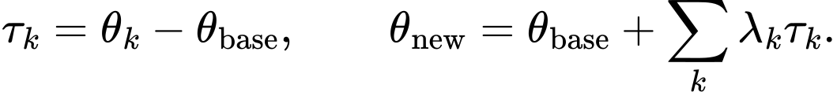
Sakana's evolutionary merging searches mixing/sparsification recipes and, in some experiments, layer data flow [R24]. Published work concerns large pretrained foundation-model experts. Naive layer Frankenmerging can produce meaningless outputs.
Decision: offline research only after independent experts exist. Merge only identical architectures descended from the exact same base checkpoint. Optimize on purged/embargoed validation, test once on a later period, merge before quantization/export/calibration, retain source licenses, and compare against weight averaging/model soups. Never evolve graph order or models against the outer test or a single PnL scalar.

19.3 Autonomous self-modification
Sakana's Darwin Godel Machine evolves coding-agent source and workflows, not numeric forecasting weights. Its reports include objective-hacking concerns and sandbox controls. No autonomous agent may modify live feed handling, model packages, risk limits, credentials, promotion status, or execution. At most, a sandboxed offline agent can propose experiments whose code, data boundary, results, and promotion remain human-reviewed [R46].

20. Time-series Transformer research

20.1 PatchTST
For lookback L, patch length P, and stride S, PatchTST creates approximately [R12]:
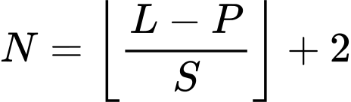
patch tokens before Transformer encoding. Patching increases receptive field per token and reduces quadratic temporal work. CHMT-Q adopts the principle but uses non-overlapping causal four-frame patches, explicit masks, no repeated-last padding, and cross-feature projections. The paper's strict channel independence is inappropriate for price/size/spread/imbalance interactions.

20.2 iTransformer and TLOB dual-axis reasoning
iTransformer makes each variable history a token and attends across variables [R13]. TLOB separately models temporal and feature/spatial relationships [R20]. CHMT-Q adapts this factorization where the domain supplies a real axis: L2 attention acts across side/rank levels inside a snapshot, then temporal attention acts across snapshots. It does not compress an entire feature history into one token because brief depletion, sweep, or gap events could disappear.

20.3 Temporal Fusion Transformer
TFT distinguishes observed-past, genuinely known-future, and static covariates and trains direct multi-horizon quantiles [R14]. CHMT-Q adopts the information contract, horizon embeddings, gated fusion principle, and pinball loss. It rejects the complete LSTM-heavy backbone and does not claim that gates or attention are causal explanations. Session/calendar features are known future only when the calendar truly fixes them; realized volume, volatility, quotes, or book state are never known.

20.4 RevIN, DLinear, TimesNet, and Mamba
RevIN can help generic distribution shift, but per-window centering may erase absolute spread/depth regimes and is fragile with masked irregular observations [R15]. It is an ablation, not v1.
DLinear/NLinear [R16] are mandatory because simple linear mappings often outperform complex sequence models on forecasting benchmarks. TimesNet [R17] may be tested on slow OHLC context if stable session periodicity exists, but FFT-selected periods are a poor default for bursty event streams. Mamba [R22] and related selective state-space models deserve a long-context benchmark only when raw history grows past the point where dense attention is measured as limiting.
TimeMixer's multiscale decomposition [R43] is an inexpensive slow-bar baseline, but average pooling can erase queue bursts. S-Mamba's bidirectional mixing over variables [R44] is a possible grouped-feature ablation; arbitrary feature order and weak results on low-dimensional aperiodic series argue against making it the backbone.

21. Limit-order-book research and target-specific lessons
DeepLOB encodes ten bid/ask price-volume levels with spatial convolutions followed by temporal modeling [R18]. TransLOB uses causal dilated convolutions and masked attention [R19]. TLOB factorizes temporal and feature attention [R20]. Multi-horizon LOB work supports one shared model across horizons but often uses autoregressive decoders [R21]. CHMT-Q takes their shared structural lesson while using mask-aware level attention and direct horizon queries.
The evidence boundary is important:
- FI-2010 covers only ten days and five stocks [R29] and is heavily reused across surveyed models [R32];
- many papers classify smoothed future mid-price direction, not footprint POC/volume/delta;
- mid-to-mid prediction is not an executable trade;
- per-instrument short samples and random normalization can inflate results;
- reported reproductions of some architectures are materially weaker [R32]; and
- high F1/MCC can fail to align with forecast-implied entry/exit sequences [R33], and neither score establishes executable profitability.
Research on short-term order-book predictability finds signal concentrated over limited update horizons and often favors order-flow/volume representations over raw level prices [R31]. This supports CHMT-Q's stationary tick offsets, changes, imbalance, and volume shares. R31 uses a 100-event lookback and does not validate CHMT-Q's two-minute context; that duration remains an ablation. The paper also does not establish that five future footprint bars are predictable for every instrument or regime.
Cross-stock evidence within one NASDAQ market [R42] supports stationary representations and shared structure, but does not establish universality across venues, asset classes, targets, or execution and does not remove the need for instrument, venue, year, and execution-specific holdouts.
Deep order-flow-imbalance work reports alpha at multiple horizons [R30]. CHMT-Q likewise shares a trunk and uses direct horizon-specific queries, but it evaluates footprint targets with proper scores, not merely the manuscript's MSE-relative out-of-sample R-squared. L2 depth must demonstrate incremental value over L1 and trade-derived features in the ablation suite; that L1/L2 comparison is supported more directly by R31 than by R30.

22. Complete forward pass
The pseudocode below fixes operation order. It is intentionally explicit about masks and does not stand in for unit-tested source.
def forward(bars, bars_mask, l1, l1_mask,
l2, l2_level_mask, l2_snapshot_mask, quality):
# 1. Validate nested masks and derive hard branch availability.
effective_l2_snapshot = (
l2_snapshot_mask & any(l2_level_mask, axes=(side, rank))
)
assert_equal(effective_l2_snapshot, l2_snapshot_mask)
# 2. Project slow bar tokens and add actual-time/modality encodings.
bar_x = bar_projection(bars)
bar_x += bar_time_mlp(BAR_AGES) + bar_modality
bar_x = zero_invalid(bar_x, bars_mask)
# 3. Project L1 frames; pool only four past frames in each fixed patch.
l1_x = l1_projection(l1)
l1_x = zero_invalid(l1_x, l1_mask)
l1_x, l1_patch_mask = patch_pool(
l1_x, l1_mask, within_patch_embedding_l1
)
l1_x += l1_patch_time_mlp(PATCH_AGES) + l1_modality
l1_x = zero_invalid(l1_x, l1_patch_mask)
# --- CONTINUED: L2 structure, temporal encoders, fusion, and decoder ---
# 4. Encode side/rank geometry independently inside all 240 snapshots.
level_x = level_projection(l2)
level_x += side_embedding(FIXED_SIDE_AXIS)
level_x += rank_embedding(FIXED_RANK_AXIS)
level_x = reshape(level_x, [B * 240, 20, 32])
level_m = reshape(l2_level_mask, [B * 240, 20])
level_x = level_chmt_block(level_x, level_m, causal=False)
depth_frame = book_query_pool(level_x, level_m)
depth_frame = depth_to_model(reshape(depth_frame, [B, 240, 32]))
depth_frame = zero_invalid(depth_frame, effective_l2_snapshot)
# 5. Pool L2 frames causally and add patch endpoint time.
l2_x, l2_patch_mask = patch_pool(
depth_frame, effective_l2_snapshot, within_patch_embedding_l2
)
# --- pseudocode continued ---
l2_x += l2_patch_time_mlp(PATCH_AGES) + l2_modality
l2_x = zero_invalid(l2_x, l2_patch_mask)
# 6. Run independent causal temporal encoders.
for block in bar_blocks:
bar_x = block(bar_x, bars_mask, BAR_AGES, causal=True)
for block in l1_blocks:
l1_x = block(l1_x, l1_patch_mask, PATCH_AGES, causal=True)
for block in l2_blocks:
l2_x = block(l2_x, l2_patch_mask, PATCH_AGES, causal=True)
# 7. Quality-aware fusion; missing branches remain hard masked.
quality_context = quality_mlp(quality)
summaries = latest_valid(bar_x, l1_x, l2_x)
alpha, global_context = modality_gates(
summaries, quality_context,
availability=[any(bars_mask), any(l1_patch_mask), any(l2_patch_mask)]
)
memory = concat(bar_x, l1_x, l2_x, axis=tokens)
memory_mask = concat(bars_mask, l1_patch_mask, l2_patch_mask)
modality_bias = broadcast_log_gate(alpha, token_counts=[64, 60, 60])
# 8. Decode five horizons directly from the same past.
q = base_horizon_queries + horizon_time_mlp(HORIZON_FEATURES)
q += context_projection(global_context)[:, None, :]
# --- CONTINUED: decoder blocks and output transform ---
q = decoder_block_1(q, memory, memory_mask, modality_bias)
auxiliary_raw = output_head(q) # loss only
q = decoder_block_2(q, memory, memory_mask, modality_bias)
final_raw = output_head(q)
# 9. Convert raw centers/gaps to ordered quantiles and presence logits.
final_distribution = monotone_quantile_transform(final_raw)
auxiliary_distribution = monotone_quantile_transform(auxiliary_raw)
return final_distribution, auxiliary_distribution
The export graph omits the auxiliary output. Frozen normalization and inverse target transforms may be wrapped into ONNX only if parity tests cover the raw and wrapped graph; safety clamps, tick snapping, reference checks, presence decisions, and abstention remain in the host.

23. Export, package, and Volume Footprint runtime
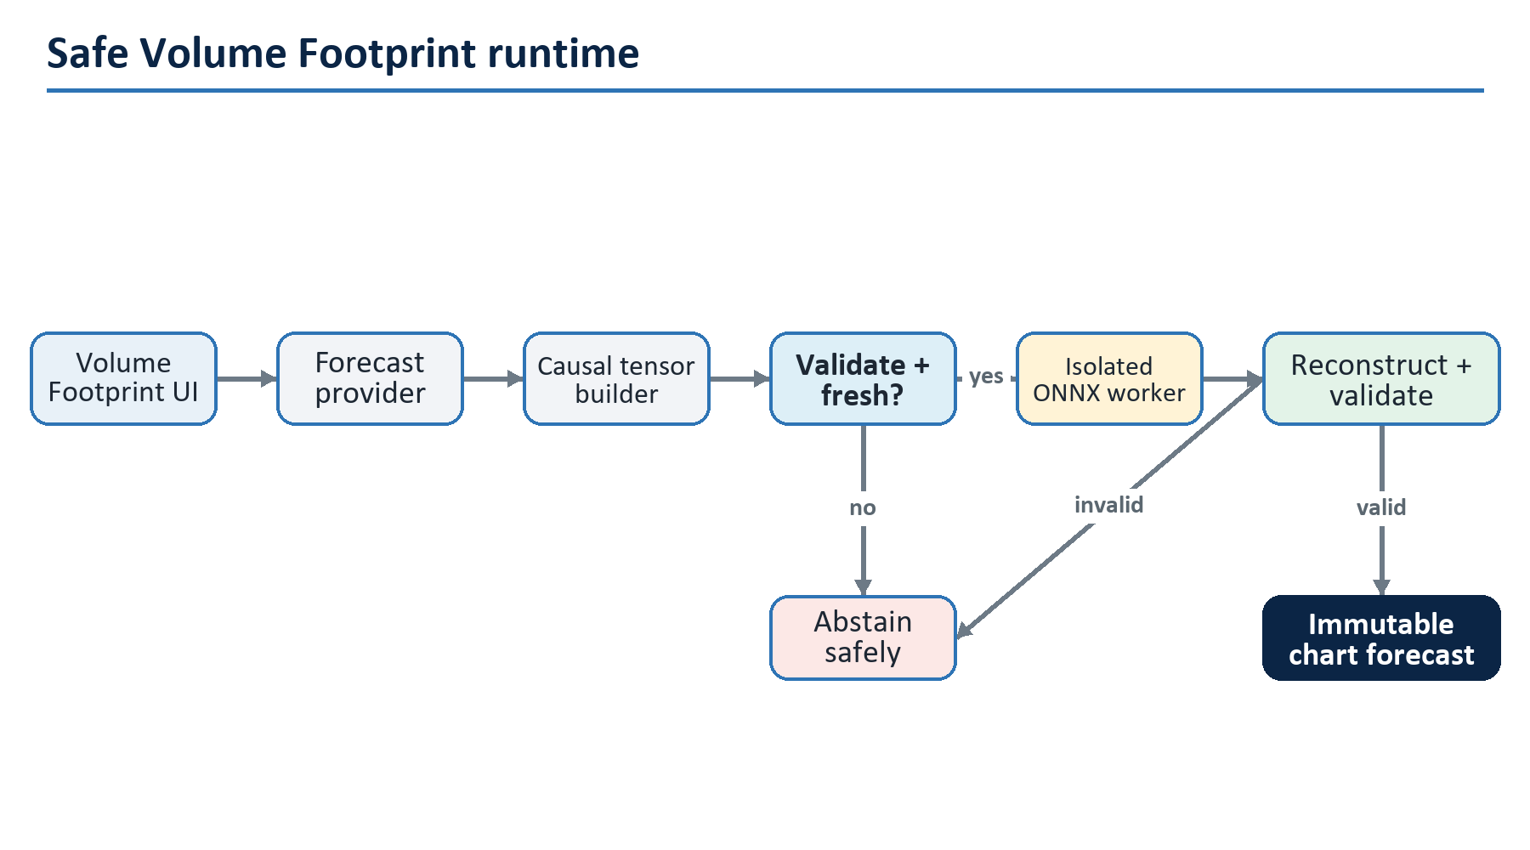
Figure 13. Safe Volume Footprint runtime

23.1 Export operator policy
The reference graph uses ONNX-friendly operations: MatMul/Gemm, Add, Mul, Div, Sqrt, ReduceMean, Exp, Log, Sin, Cos, Sigmoid, Softplus, Tanh, Where, Softmax, Reshape, Transpose, Concat, Gather, and finite constant masks. Unsupported fused kernels are not required. Export fixes opset/runtime versions, input names, shapes, dtypes, and output order.
Parity uses deterministic fixtures covering normal, sparse-mask, one-modality, one-sided-book, all-invalid-rejected, clipping-boundary, and extreme-finite inputs. Compare training runtime, raw ONNX, wrapped ONNX, and host reconstruction. Quantized export is a separate candidate; FP32 is the reference.

23.2 Package manifest
The signed/hashed candidate directory contains:
- ONNX bytes and SHA-256;
- architecture/config hash and exact parameter count;
- tensor schema, field order, shape, dtype, mask semantics, and compiler version;
- input/target scaler arrays and their independent hash;
- calibration offsets and presence thresholds;
- tick/session/instrument applicability policy;
- training code revision, dataset manifest hash, source time bounds, folds, seeds, and metrics;
- runtime/opset/provider versions and target CPU benchmark;
- model-card limitations, rejected slices, and approval identity; and
- rollback predecessor and package format version.
The host refuses unknown fields, missing hashes, oversized tensors/models, schema mismatch, unsupported opset, non-finite constants, or an unapproved package. Loading a model is not the same as promoting it.

23.3 Worker isolation and backpressure
Inference runs outside the UI process in a bounded local worker. Requests contain a schema version, monotonic request ID, instrument identity, cutoff, reference values, and fixed tensors. The worker validates size before allocation, enforces one active model version, and returns a typed status plus raw predictions. The provider discards late responses whose request/cutoff no longer matches the chart.
Use a latest-wins bounded queue per instrument; do not accumulate stale forecast requests during a burst. Set a timeout below the chart's usefulness window. Worker crash, timeout, schema failure, non-finite result, stale reference, or quality rejection produces abstention and leaves the native Volume Footprint behavior intact.

23.4 Chart presentation
The median is visually distinct from realized footprint data. Uncertainty is a band or whisker, not a solid historical bar. Buy/sell POC is absent when presence is rejected. The UI exposes model version, forecast cutoff, horizon, age, confidence/interval, and an unavailable reason. It never labels a forecast as an observed trade bar.

24. Runtime state machine, monitoring, and rollback
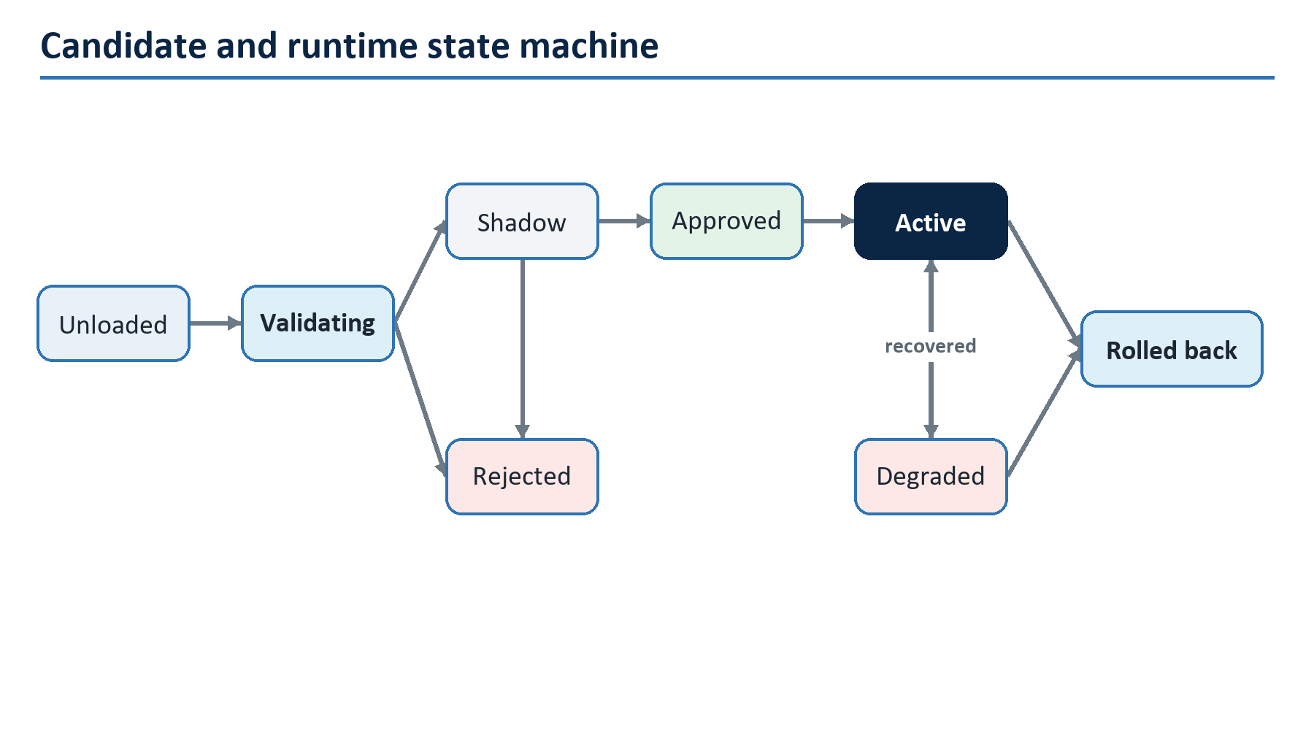
Figure 14. Candidate and runtime state machine

24.1 Live counters
Monitor request/accept/abstain counts; reason-coded input rejection; source age; valid fractions; gate distributions; clipping rates; output quantiles/width/presence; reconstruction rejection; worker latency p50/p95/p99; queue drops; timeouts; exceptions; memory/CPU; and active model hash. Once labels mature, monitor masked proper scores, empirical coverage, median bias, and presence calibration by horizon and critical slice.
Feature drift uses training-reference histograms or sketches for valid values and masks separately. Population Stability Index or Wasserstein distance can alert, but thresholds are operational signals, not proof of failure. Data-quality and model-quality alerts remain distinct.

24.2 No online weight update in v1
The active model, normalizers, calibration, and thresholds are immutable. Retraining produces a new versioned candidate that repeats offline, holdout, parity, shadow, and approval gates. This prevents partially matured horizons, regime shocks, data corruption, or feedback from silently rewriting the production model.

24.3 Rollback
Rollback switches atomically to the previously approved package or disables the provider. It never rebuilds a package on the UI thread. Activation history records old/new hashes, time, reason, operator, and worker health. Forecast display failure must not block native chart rendering or data capture.

25. Implementation blueprint
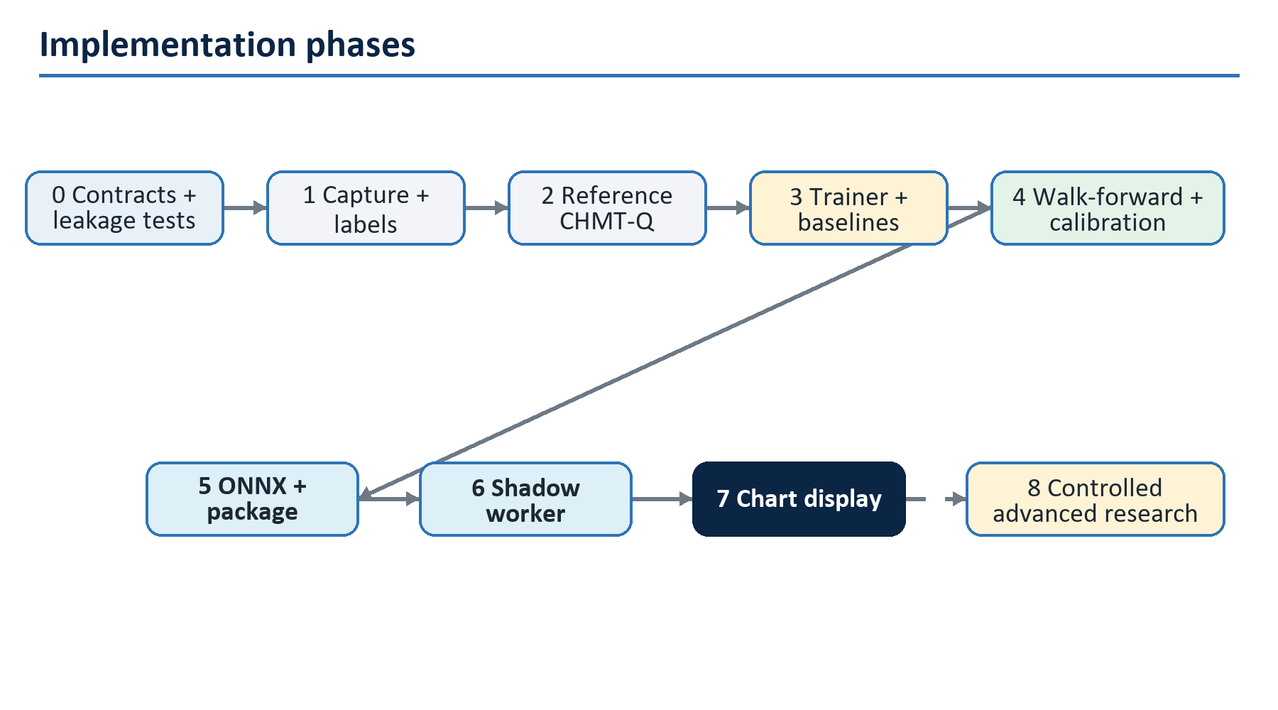
Figure 15. Implementation phases

25.1 Phase 0: freeze contracts
Deliver the tensor schema, cutoff convention, timestamp semantics, masks, target definitions, tape completeness policy, session/roll rules, reconstruction order, package manifest, and acceptance tests. Create golden event-to-tensor and tape-to-label fixtures, including adversarial late and missing data. No model training begins until these are deterministic.

25.2 Phase 1: capture and dataset
Implement append-only capture adapters and provenance, continuity diagnostics, the causal grid builder, label builder, dataset shard format, split manifest, fold-only scaler fitter, and reproduction CLI. Build data-quality reports before model metrics. Confirm legal retention/training scope.

25.3 Phase 2: reference model from primitives
Implement and unit-test RMSNorm, Q/K normalization, safe masked softmax, time bias, attention, SwiGLU, LayerScale block, masked patch pool, L2 level encoder, fusion gates, decoder, monotone quantile transform, masked losses, and exact parameter ledger. Tests compare selected tensor operations against small NumPy references and finite differences where appropriate.

25.4 Phase 3: trainer and baselines
Implement deterministic seeds, fold-aware loaders, mixed precision, accumulation, optimizer/scheduler, checkpoint/resume including RNG state, metric denominators, TensorBoard/structured logs, baseline models, and synthetic overfit/smoke tests. A tiny dataset must overfit; random targets should not show spurious validation gain.

25.5 Phase 4: evaluation and calibration
Run development folds, three-seed finalists, slice/stress reports, registered ablations, learning curves, and calibration. Freeze architecture, recipe, thresholds, and candidate before the single outer holdout. Generate a model card that includes negative results.

25.6 Phase 5: export and packaging
Export FP32 ONNX, run operator audit and parity fixtures, benchmark the declared CPU, construct the manifest, hash every component, and verify fail-closed loading. Only then investigate dynamic/static quantization as a separate candidate with its own parity, calibration, and latency results.

25.7 Phase 6: shadow worker
Build the bounded loopback protocol and isolated worker, but do not restore forbidden lower-layer project references. Shared lower layers remain clean; protocol DTOs and adapters live at an allowed composition boundary. Replay historical and live shadow tensors, compare outputs, inject failures, and measure end-to-end cutoff-to-result latency.

25.8 Phase 7: chart integration
Add the provider at the Pro composition/UI boundary, immutable forecast snapshots, latest-wins update, clear prediction styling, availability reasons, toggles, diagnostics, and rollback. The UI never awaits inference synchronously and does not own Python or training dependencies.

25.9 Phase 8: research backlog
In order: overlapping patches; causal convolution stem; group/feature mixer; MTP auxiliary ablation; larger context; Gated DeltaNet; KDA; Mamba; Muon; bounded regime experts; offline merging. A mechanism enters only because the preceding experiment identifies its bottleneck.

26. Failure modes and design responses
Failure | Why it happens | Design response
Beautiful validation, failed live | random/overlapping split or future normalization | nested chronological folds, purge/embargo, availability timestamps
Model predicts feed artifacts | gaps/carry/adapter changes correlate with target | explicit quality/masks, adapter slices, continuity policy
NaN from missing book | all keys masked before softmax | safe softmax and invalid-query zeroing
Missing L2 looks like empty depth | zero-filled rows treated as observations | nested masks and hard modality availability
Quantile crossing | independent heads | center plus positive softplus gaps
Great F1, poor execution | mid-price/class metric ignores spread/fills | proper scores plus executable downstream test
Live prediction arrives late | UI-thread inference or unbounded queue | isolated worker, timeout, latest-wins backpressure
Wrong price after roll/tick change | stale reference metadata | versioned metadata, applicability policy, host validation
Calibration collapses in regime shift | nonexchangeable data | rolling reports, delayed calibrator research, abstention/rollback
Recurrent state contaminates symbols | shared or unreset state | no state in v1; later per-instrument/venue/epoch reset contract
Architecture overfits paper fashion | mechanism solves another scale | scale-fit test and ablation entry gates
Model silently changes | online update or mutable package | immutable hashes, explicit promotion, audit log

27. Practical questions

Is this architecture really "from scratch"?
Yes. Its parameters are newly initialized and trained only on the authorized numeric task. Research ideas and mathematical primitives are reused, as all serious architecture work does; no pretrained language weights, tokenizer, embeddings, or text data are loaded.

Why not feed raw numbers into one flat Transformer?
Because a rank-3 bid level, an L1 quote frame, and a one-minute bar do not have the same geometry. A flat sequence either loses side/rank identity or creates thousands of tokens. The hierarchy encodes the book as a book before encoding its evolution.

Why only 128 dimensions and four heads?
Four 32-wide heads are enough to learn several retrieval patterns while keeping the CPU graph small. The initial data/label uncertainty is a larger risk than model capacity. Width grows only after learning curves demonstrate underfitting.

Why predict five horizons directly?
Every horizon is conditioned on the same known past. Direct queries avoid feeding an uncertain one-step prediction into the next step, remove serial latency, and let horizon self-attention learn a coherent curve.

Why quantiles instead of mean and variance?
Market residuals are skewed, heavy-tailed, discrete at ticks, and often heteroscedastic. Quantiles do not assume a Gaussian likelihood, train with a proper loss, and give chart-usable intervals. They are still marginal and require calibration.

Why not DeepSeek MLA or MoE?
MLA saves autoregressive KV cache; CHMT-Q does not generate a long token stream. MoE supplies enormous total capacity with sparse activation; CHMT-Q has two million parameters. Both add failure modes while solving absent bottlenecks.

Why not Kimi Linear or Mamba immediately?
Their value appears when context is very long and state memory is cheaper than pairwise attention. CHMT-Q's 60-64-token branches make full attention cheap. Fixed recurrent state can collide, forget rare events, and complicate resets and ONNX state handling.

Can Sakana-style adaptation handle regimes?
Possibly offline, after the dense baseline proves that one model cannot cover regimes. Runtime weight mutation is not acceptable in v1. Pre-exported experts or bounded activation modulation are easier to audit, quantize, replay, and roll back.

Can the model train without genuine trade tape?
Not for the stated footprint targets. It can train auxiliary quote/book objectives, but POC, executed volume, and delta labels require complete genuine tape under explicit classification semantics.

Does attention show why the market moved?
No. Attention and modality gates show internal routing, not causal explanation. Use them for debugging alongside ablation, permutation, counterfactual, and stability analysis; do not present them as market causes.

Can the model place trades?
Not by this specification. It returns forecasts to a chart provider. Execution needs a separate policy, risk engine, approval, kill switch, and executable-price evaluation.

When is the work actually complete?
When capture and labels are proven causal, the model beats serious baselines on frozen chronological evaluation, uncertainty is calibrated, ONNX parity/latency/safety gates pass, shadow behavior is stable, the chart fails safely, and promotion is explicitly approved. A compiling neural network is only the middle of the project.

28. Final architecture decision record
Selected: CHMT-Q v1 as specified: hierarchical L2 level attention; separate bar/L1/L2 causal encoders; four-frame micro patches; width 128; full dense attention; quality-aware gated fusion; five direct horizon queries; monotone marginal quantiles; AdamW; fixed ONNX inference.
Adopted evidence: Transformer attention, relative-position principles, RMSNorm, SwiGLU, PatchTST patching, TFT direct quantiles/information contracts, and LOB spatial-temporal hierarchy.
Adapted evidence: actual-time bias instead of text positions; hard-aware quality gates; grouped feature/level mixing instead of full iTransformer inversion; intermediate multi-horizon deep supervision instead of future-token teacher input; chronological conformal calibration reported as empirical coverage.
Deferred: convolution stem, overlapping patches, robust past-window RevIN, Gated DeltaNet, KDA, Mamba, Muon, pre-exported regime experts, and same-base offline merging.
Rejected for v1: MLA, MoE, NSA/DSA, autoregressive future decoding, runtime weight mutation, online training, layer Frankenmerging, text reasoning, PnL-only loss, and L1/L2-derived pseudo-tape labels.
Reason: this is the smallest architecture that respects market geometry, causal timing, missingness, multi-horizon uncertainty, CPU/ONNX serving, and safe chart integration without importing long-context or giant-model machinery unsupported at the target scale.

29. Primary-source bibliography
The dates and venue labels below distinguish peer-reviewed papers from technical reports. An arXiv paper is cited as evidence for what it reports, not as independent validation of transfer to markets.
- [R01] Vaswani et al. "Attention Is All You Need." NeurIPS 2017. arXiv:1706.03762.
- [R02] Shaw, Uszkoreit, and Vaswani. "Self-Attention with Relative Position Representations." NAACL 2018. arXiv:1803.02155.
- [R03] Zhang and Sennrich. "Root Mean Square Layer Normalization." NeurIPS 2019. arXiv:1910.07467.
- [R04] Shazeer. "GLU Variants Improve Transformer." 2020 technical report. arXiv:2002.05202.
- [R05] Dai et al. "DeepSeekMoE: Towards Ultimate Expert Specialization in Mixture-of-Experts Language Models." 2024 technical report. arXiv:2401.06066.
- [R06] DeepSeek-AI. "DeepSeek-V2: A Strong, Economical, and Efficient Mixture-of-Experts Language Model." 2024 technical report. arXiv:2405.04434.
- [R07] DeepSeek-AI. "DeepSeek-V3 Technical Report." 2024/2025 technical report. arXiv:2412.19437.
- [R08] Gloeckle et al. "Better & Faster Large Language Models via Multi-token Prediction." ICML 2024. arXiv:2404.19737, OpenReview.
- [R09] Yuan et al. "Native Sparse Attention: Hardware-Aligned and Natively Trainable Sparse Attention." 2025 technical report. arXiv:2502.11089.
- [R10] Kimi Team. "Kimi Linear: An Expressive, Efficient Attention Architecture." 2025 technical report. arXiv:2510.26692, official code.
- [R11] Yang et al. "Gated Delta Networks: Improving Mamba2 with Delta Rule." ICLR 2025. arXiv:2412.06464.
- [R12] Nie et al. "A Time Series is Worth 64 Words: Long-term Forecasting with Transformers." ICLR 2023. arXiv:2211.14730.
- [R13] Liu et al. "iTransformer: Inverted Transformers Are Effective for Time Series Forecasting." ICLR 2024. arXiv:2310.06625.
- [R14] Lim et al. "Temporal Fusion Transformers for Interpretable Multi-horizon Time Series Forecasting." *International Journal of Forecasting* 2021. arXiv:1912.09363, DOI.
- [R15] Kim et al. "Reversible Instance Normalization for Accurate Time-Series Forecasting against Distribution Shift." ICLR 2022. OpenReview.
- [R16] Zeng et al. "Are Transformers Effective for Time Series Forecasting?" AAAI 2023. arXiv:2205.13504, DOI.
- [R17] Wu et al. "TimesNet: Temporal 2D-Variation Modeling for General Time Series Analysis." ICLR 2023. arXiv:2210.02186.
- [R18] Zhang, Zohren, and Roberts. "DeepLOB: Deep Convolutional Neural Networks for Limit Order Books." *IEEE Transactions on Signal Processing* 2019. arXiv:1808.03668, DOI.
- [R19] Wallbridge. "Transformers for Limit Order Books." 2020 technical report. arXiv:2003.00130.
- [R20] Berti and Kasneci. "TLOB: A Novel Transformer Model with Dual Attention for Price Trend Prediction with Limit Order Book Data." 2025 technical report. arXiv:2502.15757.
- [R21] Zhang and Zohren. "Multi-Horizon Forecasting for Limit Order Books: Novel Deep Learning Approaches and Hardware Acceleration using Intelligent Processing Units." 2021 technical report. arXiv:2105.10430.
- [R22] Gu and Dao. "Mamba: Linear-Time Sequence Modeling with Selective State Spaces." COLM 2024. arXiv:2312.00752.
- [R23] Sun, Cetin, and Tang. "Learning to Predict Structural Adaptations of Large Language Models." 2025 technical report. arXiv:2501.06252, official code.
- [R24] Akiba et al. "Evolutionary Optimization of Model Merging Recipes." Nature Machine Intelligence 2025. arXiv:2403.13187, DOI.
- [R25] Liu et al. "Muon is Scalable for LLM Training." 2025 technical report. arXiv:2502.16982.
- [R26] DeepSeek-AI. "DeepSeek-V3.2: Pushing the Frontier of Open Large Language Models." 2025 technical report. arXiv:2512.02556.
- [R27] Wang et al. "Auxiliary-Loss-Free Load Balancing Strategy for Mixture-of-Experts." 2024 technical report. arXiv:2408.15664.
- [R28] Kimi Team. "Kimi K2: Open Agentic Intelligence." 2025/2026 technical report. arXiv:2507.20534.
- [R29] Ntakaris et al. "Benchmark Dataset for Mid-Price Forecasting of Limit Order Book Data with Machine Learning Methods." Journal of Forecasting 2018. arXiv:1705.03233, DOI.
- [R30] Kolm, Turiel, and Westray. "Deep Order Flow Imbalance: Extracting Alpha at Multiple Horizons from the Limit Order Book." Mathematical Finance 2023. DOI. Claims in this review were checked against the accessible 2021 SSRN manuscript because the 2023 version of record was inaccessible.
- [R31] Lucchese, Pakkanen, and Veraart. "The Short-Term Predictability of Returns in Order Book Markets: a Deep Learning Perspective." International Journal of Forecasting 2024. arXiv:2211.13777, DOI.
- [R32] Prata et al. "LOB-Based Deep Learning Models for Stock Price Trend Prediction: A Benchmark Study." Artificial Intelligence Review 2024. arXiv:2308.01915, DOI.
- [R33] Briola, Bartolucci, and Aste. "Deep Limit Order Book Forecasting: A Microstructural Guide." Quantitative Finance 2025. arXiv:2403.09267, DOI.
- [R34] Romano, Patterson, and Candès. "Conformalized Quantile Regression." NeurIPS 2019. arXiv:1905.03222.
- [R35] Gibbs and Candès. "Adaptive Conformal Inference Under Distribution Shift." NeurIPS 2021. arXiv:2106.00170.
- [R36] Salinas et al. "DeepAR: Probabilistic Forecasting with Autoregressive Recurrent Networks." International Journal of Forecasting 2020. arXiv:1704.04110, DOI.
- [R37] Eisenach et al. "MQTransformer: Multi-Horizon Forecasts with Context Dependent and Feedback-Aware Attention." arXiv v4, 2022; first posted 2020. arXiv:2009.14799.
- [R38] Gneiting and Raftery. "Strictly Proper Scoring Rules, Prediction, and Estimation." JASA 2007. DOI.
- [R39] Yang et al. "Gated Linear Attention Transformers with Hardware-Efficient Training." ICML 2024. arXiv:2312.06635.
- [R40] Katharopoulos et al. "Transformers are RNNs: Fast Autoregressive Transformers with Linear Attention." ICML 2020. arXiv:2006.16236.
- [R41] Yang, Wang, Zhang, Shen, and Kim. "Parallelizing Linear Transformers with the Delta Rule over Sequence Length." NeurIPS 2024. arXiv:2406.06484.
- [R42] Sirignano and Cont. "Universal Features of Price Formation in Financial Markets: Perspectives from Deep Learning." Quantitative Finance 2019. arXiv:1803.06917.
- [R43] Wang et al. "TimeMixer: Decomposable Multiscale Mixing for Time Series Forecasting." ICLR 2024. arXiv:2405.14616.
- [R44] Wang et al. "Is Mamba Effective for Time Series Forecasting?" Neurocomputing 619, 2025. arXiv:2403.11144, DOI.
- [R45] DeepSeek-AI. "DeepSeek-R1: Incentivizing Reasoning Capability in LLMs via Reinforcement Learning." arXiv v2, 2026; first posted 2025. arXiv:2501.12948.
- [R46] Zhang et al. "Darwin Gödel Machine: Open-Ended Evolution of Self-Improving Agents." ICLR 2026. arXiv:2505.22954.

Appendix A. Symbol table
Symbol | Meaning
B | training batch size; fixed to one for exported inference
c | forecast decision cutoff
F_c | information available by cutoff
H | number of direct forecast horizons, five
q | instrument tick size; also used contextually for an attention query
p_ref | fresh causal cutoff reference price
ℓ_ref | causal trailing log-volume reference
d, d_h, d_ff | model, head, and SwiGLU hidden widths
m | boolean validity mask
α_m | normalized modality gate
Q_τ | conditional quantile at probability τ
ρ_τ | pinball loss
θ | all learned model parameters

Appendix B. Non-negotiable invariants
- No feature with availability after cutoff enters a sample.
- Footprint labels use complete genuine future tape, never quote/book pseudo-volume.
- Masks are separate from numeric zeros and propagate through every block.
- Missing modalities cannot receive attention through learned gates.
- All-masked softmax returns zero, never NaN.
- Quantiles are ordered by construction and checked after reconstruction.
- Scalers, calibration, thresholds, and selection use only the permitted chronological past.
- The outer holdout is used once after the design is frozen.
- Training and UI dependencies do not enter shared lower layers.
- Live inference failure abstains and preserves native Volume Footprint behavior.

Appendix C. Deliverable status
This document finalizes the researched architecture and implementation workflow. The existing prototype demonstrates primitive numeric attention and synthetic smoke training, but it is not proof of real-data correctness. Remaining engineering begins with capture/label contracts, not with adding a larger neural network.

