PRIVATE ENGINEERING HANDBOOK • VERSION 1.0
Hyperion
LLM Coordinator
Engineering Handbook
Coordinator • model-evidence pipeline • isolated verifier
For ML, platform, safety, and operations teams

DATE 30 July 2026
REPOSITORY github.com/dhruuvsharma/Hyperion
CLASSIFICATION Private engineering material
STATUS Infrastructure implemented; no trained Hyperion checkpoint or production deployment

Contents
1. Executive orientation
2. Naming, compatibility, and provenance
3. Repository and technology map
4. Coordinator runtime from first principles
5. Hosted API, credits, and desktop client
6. Private retrieval
7. Corpus and data governance
8. Teacher capture, selection, and materialization
9. Base-model catalog and bake-off
10. Training system
11. Evaluation, replay, and promotion
12. Serving, readiness, and hosted operation
13. C# verifier and execution-security boundary
14. Signing, trust separation, and key custody
15. Kimi K3 research adoption
16. Proposed small-GPU-cluster architecture
17. Engineering workflow and operator runbooks
18. Testing and continuous integration
19. Roadmap and release gates
20. Limitations and non-goals
21. Glossary
22. Primary sources and internal evidence
Evidence boundary: Hyperion has implemented and tested infrastructure, but no rights-approved production corpus, conforming training run, trained checkpoint, accepted benchmark, or production deployment. Every quality and readiness claim must remain attached to its evidence.
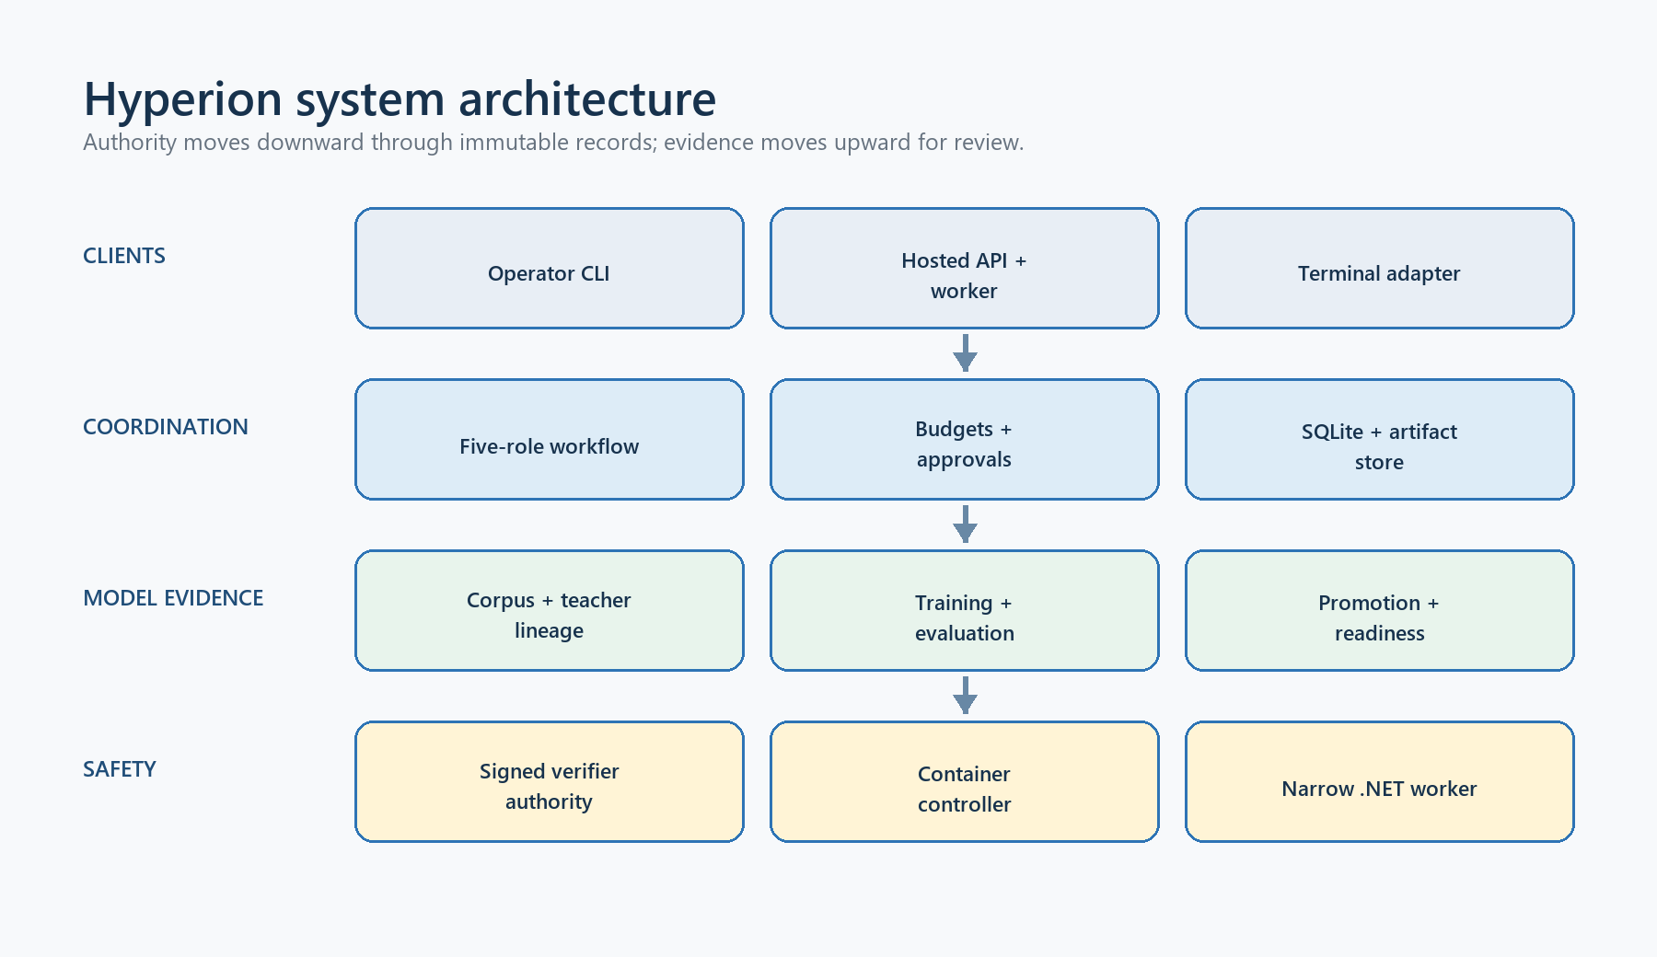

1. Executive orientation

1.1 The problem Hyperion solves
A general coding model can generate plausible C#, financial reasoning, and strategy code, but plausibility is not enough for a trading product. The system must know which private architecture is current, distinguish quantitative truth from confident prose, obey risk and execution boundaries, produce reviewable artifacts, and preserve an evidence trail. It must also prevent a desktop client or generated program from deciding its own price, model identity, approval state, or safety result.
Hyperion addresses this as a system, not merely as a fine-tuned model. It combines:
- a deterministic five-role workflow around one or more LLM providers;
- explicit budgets, approvals, persistence, resumability, and content-addressed artifacts;
- a private data path with rights, provenance, contamination, independent review, and signed receipt gates;
- raw-base comparison, adapter training, sealed evaluation, and promotion contracts;
- server-owned model, retrieval, credit, and readiness authority;
- independently signed evidence and detached KMS/HSM handoffs; and
- a deliberately narrow C# strategy verifier executed outside the coordinator process.
The model is one replaceable component. The evidence chain is the product boundary.

1.2 Three planes
Hyperion is easiest to understand as three interacting planes.
Plane | Responsibility | Primary implementation
Coordination plane | Convert an objective and bounded evidence into role outputs, a final inert artifact, and a human release decision. | C# contracts, coordinator, client, CLI, hosted API
Model-evidence plane | Govern corpus, teacher capture, base selection, training, evaluation, artifact sealing, promotion, and readiness. | Python package and 113 JSON Schemas
Execution-safety plane | Evaluate a small allowed C# strategy surface without loading submitted managed code into the host. | Python controller, signed authority, Docker protocol, .NET verifier worker

The planes exchange immutable, content-addressed records. A passing record in one plane does not silently grant authority in another. For example, a verifier result is evidence, not corpus review; a corpus review is not training authorization; a training artifact is not model promotion; and a readiness proof is not hardware attestation.

1.3 Current status at a glance
Capability | Status | Meaning
Five-role coordinator and Mock/OpenAI-compatible providers | Implemented and tested | Runnable orchestration infrastructure
Durable SQLite state and hash-chained events | Implemented and tested | Recoverable run state with optimistic concurrency and integrity checks
Corpus authoring, review, receipts, releases | Implemented contracts and tooling | No production-approved rows or release currently exist
Candidate catalog and raw-base bake-off | Implemented contracts and synthetic tests | No real signed bake-off has selected a base
QLoRA training harness and sealed runtime profile | Implemented, not run on target hardware | No trained adapter/checkpoint exists
Evaluation, replay audit, promotion, readiness | Implemented contracts and synthetic evidence | No accepted production promotion exists
Hosted credits and worker integration | Implemented and tested | Disabled by default without real deployment evidence
C# verifier | Implemented and adversarially tested | Narrow strategy subset only; not a general C# sandbox
Production KMS/HSM, account/device broker, GPU cluster | External work | Required before production use

2. Naming, compatibility, and provenance

2.1 Hyperion is the product name
The repository, solution, operator executable, Python distribution, and new documentation use Hyperion. The initial source was exported from private Pro revision 003685a92e7ddba9​e4149d3bb545f4ce​82446f3e. Shared Core and SDK code is not duplicated; it is the read-only public/ submodule pinned at ae19c5eb7ab7b3c6​d6e1a5647fc127a8​38e6dd05.

2.2 Why legacy names remain
The code still contains DaxAlgo, TradingTerminal, VibeQuant, and vibe_quant_model. These are not accidental branding leftovers when they appear in:
- JSON Schema $id or schemaVersion values;
- signature domain separators, payload shapes, IDs, and hashes;
- prompt-catalog hashes and policy/workflow versions;
- API routes such as /api/v1/vibe-quant;
- database columns, persisted snapshots, golden fixtures, and existing namespaces; or
- downstream client contracts.
Changing one byte can invalidate a signature, fixture, persisted record, replay identity, or client. Hyperion therefore adds aliases at human-facing surfaces and preserves legacy wire values until a deliberate versioned migration can dual-read, dual-verify, and retire the older form. A global rename would be a security and compatibility defect.

2.3 What was intentionally excluded
The extraction excludes build caches, ignored tmp/vibe-quant-model experiments, local databases, credentials, private keys, model caches, weights, checkpoints, and draft evidence. Those bytes were not needed to reproduce the code and were not an authorized training release. The full inventory and boundary are recorded in docs/​architecture/​source-​provenance.​md.

3. Repository and technology map
Path | Technology | Role
src/​windows/​AI/​TradingTerminal.​Ai.​Coordinator.​Contracts | .NET 9 | Immutable run, provider, budget, role-output, approval, and artifact contracts
src/​windows/​AI/​TradingTerminal.​Ai.​Coordinator | .NET 9, SQLite | Orchestration, validation, providers, persistence, dataset/retrieval tools
src/​windows/​AI/​TradingTerminal.​Ai.​Coordinator.​Client | .NET 9 HTTP/JSON | Strict hosted API client and wire contracts
src/​windows/​Tools/​DaxAlgo.​Coordinator.​Cli | .NET 9 | hyperion operator CLI and restricted DAXQ review verifier
tools/​hyperion-​model/​vibe_​quant_​model | Python 3.11+ | Model-data, training, evaluation, signing, promotion, and serving logic
tools/​hyperion-​model/​schemas | JSON Schema 2020-12 | Closed wire contracts for every evidence/authority family
platform/​src/​DaxAlgo.​Platform.​Api | ASP.NET Core, EF Core | Identity, credits, hosted runs, promotion, readiness, worker orchestration
platform/​src/​DaxAlgo.​Platform.​VerifierWorker | .NET, Roslyn | Source/IL policy and bounded replay worker
src/​windows/​AI/​DaxAlgo.​Daxq.​* | .NET | Restricted bytecode verification path used by corpus review
public/ | Pinned Git submodule | Shared Core and SDK compile surface used by verifier/compiler
tests/, platform/tests/, Python tests/ | xUnit, pytest | Contract, integration, adversarial, and cross-language evidence

The Python import package remains vibe_quant_model; the installed commands include hyperion, hyperion-model, and the legacy vibe-quant-model alias.

4. Coordinator runtime from first principles

4.1 Inputs
A run begins with a CoordinatorRunSpec. It fixes:
- a unique run ID, owner, objective, and creation time;
- bounded context sources with IDs, titles, exact content, optional URI/license, and retrieval time;
- one provider descriptor: provider/model/protocol/endpoint, pricing, credential reference, and optional replay identity;
- a CoordinatorBudget; and
- exact policy, workflow, prompt-catalog, and purpose identities.
The two purposes are Research and StrategyAuthoring. Research ends in a decision memo. Strategy authoring uses a different prompt/policy/workflow tuple and can emit an inert source bundle. The purpose is part of semantic identity and idempotency; it is not inferred from a UI mode.

4.2 Budgets
The default contract caps requests, attempts per role, prompt tokens, output tokens, output tokens per request, cost, response bytes, artifact bytes, elapsed time, and per-request timeout. It can require provider-reported usage. Before dispatch, the coordinator reserves the worst-case request budget; after completion, it records reported usage and reconciles totals. A provider cannot omit mandatory usage, return an oversized body, or silently overrun the run budget.
Budgets serve four purposes:
- bound operational and financial exposure;
- make replay and evaluation conditions comparable;
- stop pathological retry or overthinking loops; and
- provide the control surface for future low/high/max reasoning effort.

4.3 Fixed role workflow
Every run executes these roles in order:
- Planner — decomposes the objective, defines falsifiable checks, and identifies evidence gaps.
- Evidence Analyst — evaluates supplied evidence and labels uncertainty.
- Critic — challenges leakage, bias, causality, feasibility, assumptions, and missing counter-evidence.
- Synthesizer — reconciles the prior outputs into the final memo or inert strategy draft.
- Risk Judge — approves, requests revision, or rejects the result for human review.
Each role sees a deterministic system instruction, role instruction, run objective, bounded source material, and the exact prior role artifacts it needs. The prompt builder computes a hash before the provider call. The returned JSON must deserialize into a closed CoordinatorRoleOutput with the expected role, schema, claims, evidence-source IDs, risks, recommendations, and decision. Unknown fields, wrong role labels, ungrounded source IDs, invalid confidence values, or malformed strategy artifacts fail validation.

4.4 Provider abstraction
ILlmProvider is deliberately small: accept a structured request and return either a completion or a classified failure. Implementations are:
- DeterministicMoc​kLlmProvider for reproducible tests and rehearsals;
- ReplayLlmProvider for exact captured responses; and
- OpenAiCompatibleLlmProvider for bounded HTTP chat-completion transport.
Provider validation rejects unsafe endpoint/configuration combinations and preserves a credential as a reference, not as persisted run data. Hosted execution constructs the provider server-side; the desktop cannot choose a private model artifact, retrieval pack, price, or readiness identity.

4.5 State machine and approvals
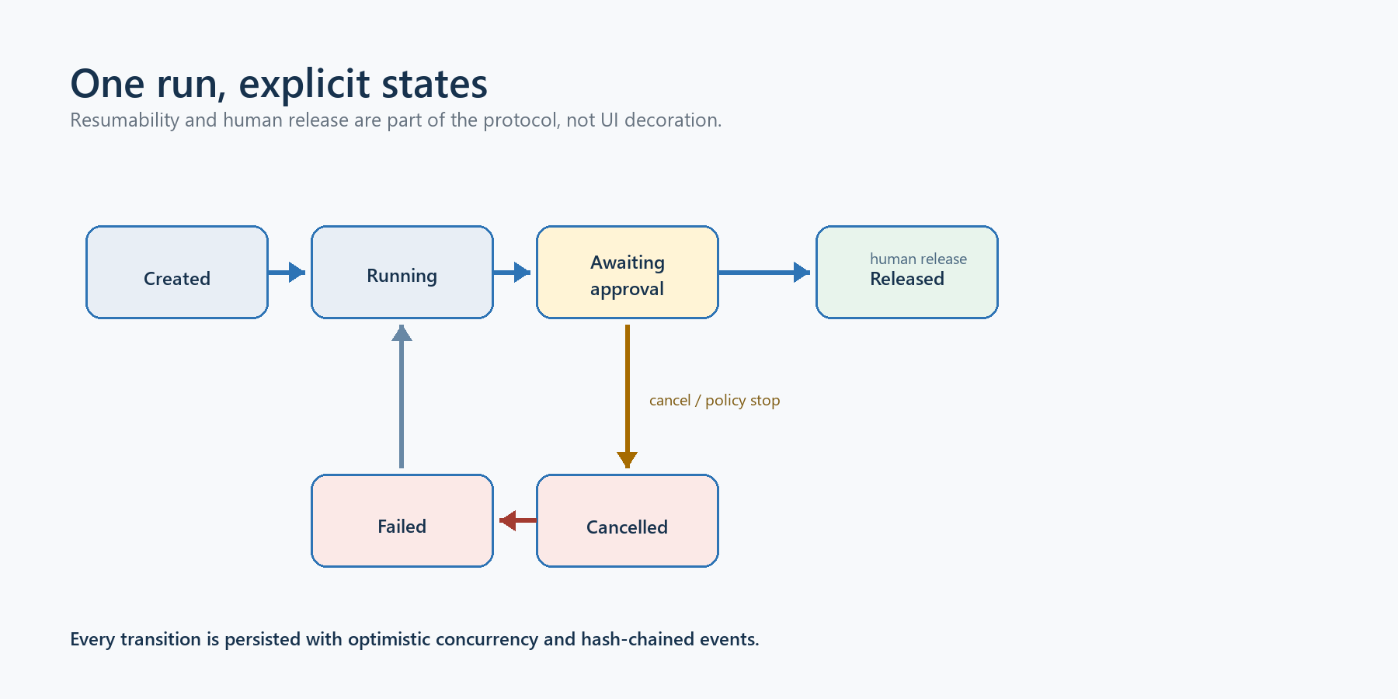
Figure 1. Coordinator state machine
A new run is AwaitingStartApproval. Start approval binds the exact specification hash and moves it to Ready. Resume changes it to Running and executes the next incomplete role. A retryable failure can retry within the role attempt limit; a permanent failure or exhausted budget terminates safely.
After the Risk Judge:
- Approve moves to AwaitingReleaseApproval;
- Revise moves to NeedsRevision; and
- Reject moves to Rejected.
Release approval binds the exact final artifact hash, reopens and revalidates the Synthesizer and Risk Judge artifacts, and only then marks the run Completed. Cancellation and explicit rejection are terminal. An approval is therefore an authenticated statement about exact bytes, not a generic button click.

4.6 Persistence, concurrency, and recovery
SqliteCoordinatorStore stores a current snapshot and an append-only event sequence. Every update uses an expected version inside a transaction; a stale writer receives a concurrency error rather than overwriting newer state. Events contain their predecessor hash, forming a per-run hash chain. Reads verify sequence continuity, previous-hash linkage, each event hash, projection version, and the bound snapshot hash.
An invocation is recorded before transport. If the process dies with an invocation open, resume closes the interrupted attempt explicitly and decides whether another attempt is allowed. This avoids pretending an uncertain provider call never happened. Artifacts are written through a content-addressed store, checked against expected SHA-256, and referenced by relative path, size, role, kind, schema, and creation time.

4.7 Strategy-authoring output
Strategy authoring does not return an executable plugin. The Synthesizer can produce a bounded file set with exact names and hashes, objective/evidence lineage, and an inert-source/v1 delivery state. The Risk Judge reviews that exact artifact. A client may preview it after completion and may import source only after the exact human release. Compilation, registration, installation, execution, broker access, and order placement remain separate capabilities and are not granted by the coordinator.

5. Hosted API, credits, and desktop client

5.1 Server authority
The hosted Platform owns authentication, Professional entitlement, tenant/run ownership, model and retrieval configuration, credit accounting, worker claim, cancellation, promotion validation, and readiness. The client sends the objective and public evidence; it does not send a trusted price, model hash, corpus path, promotion, or charge result.

5.2 Credit lifecycle
Credits are integers in a server-owned wallet and ledger. A quote is derived from the frozen specification and policy. Start reserves credits atomically. Completion settles actual bounded usage; terminal failure or valid cancellation refunds the reservation according to the trusted run state. Idempotency prevents the same purpose/specification from charging twice. Claim-time checks refund a run whose frozen model activation is retired or invalid while leaving a temporarily unavailable current activation queued for retry.

5.3 API lifecycle
The compatibility route family is /api/v1/vibe-quant. The strict client supports:
- read credits;
- create and list runs;
- fetch status and public specification;
- start, cancel, and resume monitoring;
- fetch a bounded artifact; and
- approve release by exact hash.
The stored server execution specification includes the private retrieval selection and internal activation binding. The public response deliberately omits private daxctx.* source content. Replay uses the frozen stored specification and does not reopen a changed/deleted pack.

5.4 Desktop boundary
The extracted Terminal adapter demonstrates quote, explicit start, polling/recovery, exact preview, release approval, and source-only import. Its bookmark store uses a bounded, connection-bound, compare-and-swap record with cross-process locking. It prevents a stale process from clearing or starting from changed state.
Production remote authentication is not solved by this adapter. A full-trust plugin host is not an acceptable bearer-token or device-signing boundary. Production needs an isolated, user-approved account/device/session broker. Loopback Mock development does not prove that design.

6. Private retrieval
Private DaxAlgo architecture belongs in retrieval, not indiscriminately in model weights. Stable coding, mathematics, probability, finance, and risk concepts are candidate weight knowledge; current private APIs, product topology, and changing policies are versioned retrieval knowledge.
An expert context pack is immutable and content addressed. Pack construction verifies source-root containment, no reparse traversal, byte hashes, rights, cutoff, domain ordering, line coverage, canonical chunks, and derived pack/index IDs. The in-memory lexical index uses deterministic integer scoring and ordinal tie-breaking. Selection binds tenant, corpus/version/hash, query, policy, and ordered chunk hashes, while exposing only citation IDs to the public view.
The Platform prepares the pinned pack once at startup, caches immutable maps, and creates lightweight tenant activations. A run uses a bounded query derived from its objective/evidence. No compatible selection produces a privacy-safe request failure, not a fallback to arbitrary files.

7. Corpus and data governance
Hyperion treats training data as a governed release, not as a directory of convenient JSONL files. The governing question is never only “is this answer useful?” It is also: who produced it, from which exact sources, under which rights, before which cutoff, for which permitted use, with what independent evidence, and against which withheld material was it checked?
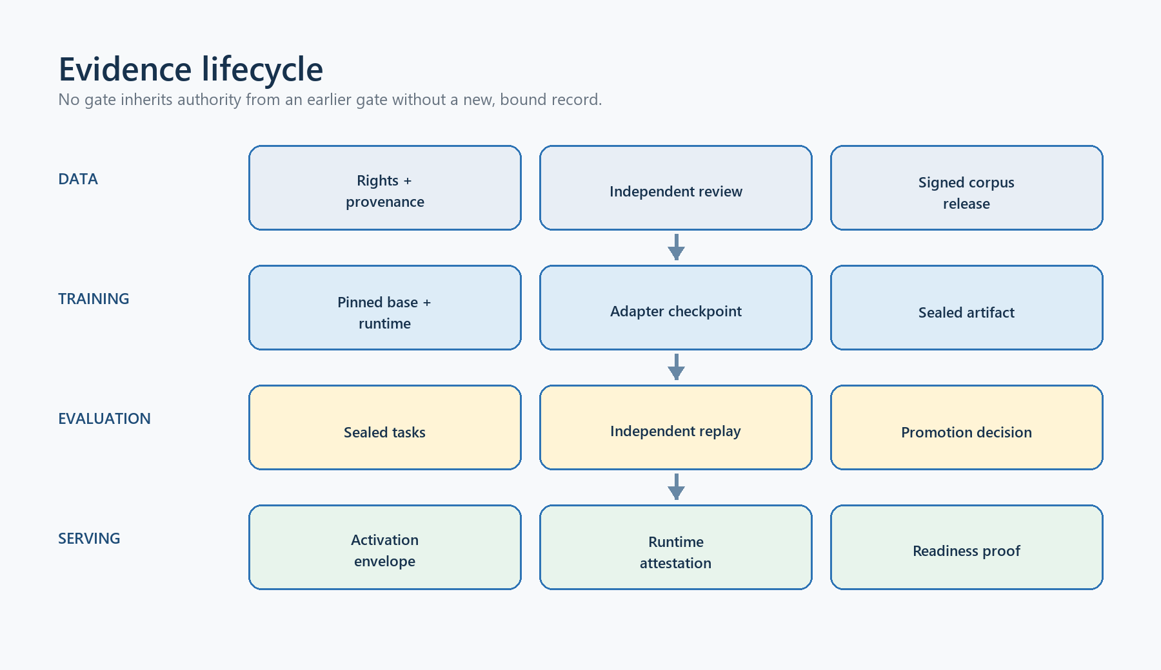
Figure 2. Hyperion evidence lifecycle
Reading guide — evidence lifecycle: authored draft → deterministic checks → independent row decision → signed receipt → SFT export → corpus/evaluation release → corpus admission → training → trainer provenance → evaluation → promotion. Every arrow must show the authority it does not grant.

7.1 Record model
An expert example carries the following material fields:
- an exact schema version and stable row ID;
- one task kind and one or more domains;
- an ordered chat conversation and its cross-language, length-prefixed SHA-256;
- source assets, provenance, licence declarations, retrieval/availability times, and source hashes;
- lineage identifying HumanAuthored, OpenWeightTeacher, HostedTeacher, or DerivedRepair;
- verification evidence, including compile/test facts when the task claims executable code;
- one of the development, calibration, or sealed splits;
- a contamination group, cutoff, review state, and explicit training-selection bit; and
- five independent rights: MayStore, MayEvaluate, MayTrain, MayUploadToProvider, and MayRedistribute.
The eight canonical domains are C#, DaxAlgo architecture, quantitative mathematics, probability and statistics, risk management, portfolio management, finance and markets, and WPF/UI design. Task kinds cover general questions, generation, repair, review, architecture, quantitative/statistical reasoning, risk, portfolio, market analysis, and WPF design. Labels are coverage dimensions, not proof that the answer is correct. A reviewer must assess the actual content.

7.2 Rights and knowledge classes
Rights are conjunctive and purpose specific. Permission to store a source does not imply permission to train on it; permission to evaluate locally does not imply permission to upload it to a hosted teacher; and training permission does not imply redistribution permission. The most restrictive source in a row constrains the row. The exporter re-derives this result from the live source and row bytes rather than trusting a cached trainingEligible flag.
Stable, generally teachable concepts may be candidates for model weights. Current private APIs, changing product topology, account policy, and customer-specific information are retrieval-only. Retrieval-only rows cannot acquire training rights by changing a label. This distinction limits memorisation of private implementation details and makes later architecture changes less likely to leave stale facts in the model.

7.3 Splits and leakage controls
The three splits have different authority:
Split | Purpose | May become training input?
development | Prompt, compiler, verifier, and workflow iteration | Only after all rights, review, receipt, release, and admission gates pass
calibration | Select thresholds and diagnose evaluator behaviour | No; it must remain outside optimization
sealed | Final held-out comparison and promotion evidence | No; prompts, answers, rubrics, and hidden assets must remain withheld

Exact conversation hashes, normalized user turns, contamination families, task/context/verifier asset hashes, and cutoff rules are checked across the governed corpus. Exact matching is deliberately conservative and can reject legitimate repeated language. It does not detect semantic paraphrase, memorisation from an upstream base model, or leakage through an unrecorded human workflow. Those risks require provenance review, rolling post-cutoff shadow sets, and periodic leakage audits.

7.4 Drafting, verification, and human decisions
The draft compiler is fail closed. It accepts bounded contained inputs, canonicalizes records, checks messages and rights, refuses path traversal/reparse aliases, and publishes atomically without overwriting an existing artifact. Draft text checks such as exact equality, required/forbidden text, and assistant hashes prove conformance to an authored checklist; they do not prove subject-matter truth.
The human-decision compiler requires a complete decision for every exact row and source. It binds the dataset, verification manifest, freshly re-executed report, evidence inventory, decisions, and chronology. A row cannot be silently omitted. The independent-review package and editable decision form are non-authorizing until compiled, revalidated, and followed by the separately authenticated receipt process.

7.5 Receipts, SFT export, releases, and admission
A current review receipt is a low-S ES256/P-256 statement about one exact row and its exact source corpus and verification-evidence identities. The receipt’s reviewer, role, audience, key ID, validity window, and permitted authorizations are explicit. Open-weight-teacher rows additionally require a distinct, valid teacher-lineage admission. Human-authored rows reject an extraneous teacher admission.
SFT export reopens the corpus and receipts, re-derives canonical metadata, rejects expired or duplicated receipts, and emits only rows that satisfy every gate. A release then binds the corpus, optional SFT bytes, receipt set and trust, optional teacher-lineage admission, calibration/sealed tasks, context/rubric/verifier assets, cutoff, lineage, and evaluation-authoring approval. A separate corpus-quality admission binds that exact release and SFT dataset to reviewer-selected coverage and anti-inflation thresholds before any non-smoke training run.
None of these hashes or signatures proves that a licence declaration is legally true, a reviewer is honest, or an answer is correct. They make the exact claim and claimant auditable and substitution resistant. Legal review, source custody, and technical review remain human responsibilities.

7.6 Current corpus status
The originating workspace contained small, ignored draft seeds and calibration material. They were not copied into this repository because they were not a production-authorized release. Hyperion currently contains the contracts, validators, tests, and synthetic fixtures needed to build a real release, but no rights-approved production corpus, authenticated row-receipt set, signed evaluation-authoring approval, or corpus admission. The first ML milestone is therefore governed data, not optimizer execution.

8. Teacher capture, selection, and materialization
Teacher generation is a data-acquisition workflow with a strict authority ceiling. A fluent answer from a strong model is only an unreviewed candidate.

8.1 One-way source-grounded manifest
The C# compiler derives teacher-generation manifest v2 from a private development draft plus an explicit capture plan. It reopens the raw draft, candidate catalog, and every source byte; binds their hashes; removes the terminal reference answer from model-visible messages; rejects that answer from every emitted string; and preserves storage/evaluation-only rights. It cannot manufacture a teacher response, review, receipt, release, or training authorization.
The current catalog assigns Qwen3-Coder 30B-A3B Instruct as teacher/fallback and keeps the three smaller candidates as students. The commit/revision and licence in the catalog are inputs to identity, not mutable display metadata.

8.2 Passive runtime binding and token preflight
Before capture, a passive binding process derives the expected model/template execution identity from bounded descriptor, catalog, and chat-template bytes. It observes an already-open literal-loopback vLLM endpoint and records its claimed version, model, root string, and context limit. Capture revalidates the same binding before tokenization and again after generation.
This is intentionally labelled an unattested observation. The endpoint can lie about loaded weights, revision, template, executable, image, process owner, GPU, driver, kernel, clock, or egress. Loopback does not prove isolation. Production-quality capture requires a separately controlled process owner, immutable weight store, image/runtime evidence, and governed signer.
Every source-grounded prompt is tokenized through the bound endpoint before dispatch. Prompt tokens, requested completion tokens, context window, request count, and aggregate worst-case totals must fit the signed/compiled plan. Completion-reported prompt usage must agree with the reservation. This prevents a “successful” capture whose real prompt was truncated or whose cost envelope was silently exceeded.

8.3 Multi-seed candidate capture
Capture uses positive temperature and several distinct seeds under hard request, token, byte, and elapsed-time budgets. Each candidate binds task, source snapshot, prompt, model/revision, runtime binding, seed, sampling parameters, completion usage, and raw response hash. Publication is all or nothing and no-clobber. Every output remains unreviewed, useForTraining=false, and storage/evaluation-only.
Hosted teacher output may be captured only when the provider contract explicitly permits use for training another model. Customer prompts remain excluded from training by default.

8.4 Withheld deny-set and independent selection
An independent custodian builds a hash-only deny-set from exact calibration/sealed tasks, normalized user turns, contamination families, and context/rubric/verifier assets. Candidate selection rejects:
- an exact authored conversation prefix;
- a normalized user-turn overlap;
- a forbidden contamination-family match;
- any exact withheld task, context, rubric, or verifier asset used as a source; and
- missing, duplicate, out-of-order, or inconsistently bound candidates.
The selector can admit at most one candidate per task and records why. Selection quality is still a review assertion; hashes protect the chosen bytes but cannot prove the custodian supplied a complete secret set or that a semantic leak was absent.

8.5 Materialization and lineage admission
Materialization creates a self-contained immutable package: canonical draft JSONL, exact manifest, runtime binding, selected candidate, source snapshots, deny-set identity, selection record, and a content-addressed materialization record. The package remains unsigned and non-training.
A separate lineage reviewer then revalidates that complete chain against the proposed final corpus and signs only the stable teacher-derived subjects it accepts. The lineage signer must be distinct from the row reviewer. Receipt issuance for an OpenWeightTeacher row fails without that exact admission; downstream SFT export and release revalidate both. Hyperion ships this machinery but no real captured candidate, materialized teacher package, or lineage admission.

9. Base-model catalog and bake-off

9.1 Current catalog
The frozen catalog is intentionally small enough to evaluate honestly:
Role | Candidate | Revision | Declared licence
Student | Qwen2.5-Coder 7B Instruct | c03e6d358207e414​f1eca0bb1891e29f​1db0e242 | Apache-2.0
Student | Qwen2.5-Coder 14B Instruct | aedcc2d42b622764​e023cf882b6652e6​46b95671 | Apache-2.0
Student | gpt-oss-20b | 6cee5e81ee839178​06bbde320786a8fb​61efebee | Apache-2.0
Teacher/fallback | Qwen3-Coder 30B-A3B Instruct | b2cff646eb4bb1d6​8355c01b18ae02e7​cf42d120 | Apache-2.0

Licence fields are reproducibility inputs, not legal opinions. Before downloading or using weights, the team must archive and review the exact upstream licence/model card at the pinned revision.

9.2 Exact snapshots
base-​model-​source-​lock.​v1.​json enumerates the expected files, sizes, and SHA-256 values for each student. Snapshot tooling rejects links/reparse components, unknown or missing files, mutable revisions, unsafe names, and tree drift; it publishes a content-addressed snapshot identity. Training and later activation reopen the external read-only snapshot and rehash it. The repository does not contain the multi-gigabyte weight files.
Read-only POSIX mode checks and repeated hashes are an operator contract, not protection from root, a hostile kernel, or storage/driver substitution. Production needs an immutable model store and a privileged owner separate from the training/serving child.

9.3 Comparable raw-base evidence
Every student is evaluated under one frozen comparison condition: same release, task suites, baseline, policy family, seeds, context rules, output limits, and verifier inventory. A raw-base profile binds model/revision, snapshot/source lock, tokenizer/template, engine launch plan, sampling, and resource policy. Candidate and baseline responses cover the same task set and retain exact request/completion receipts where the v2 trust path is used.
The bake-off matrix is catalog complete. It rejects a missing or extra student, duplicate row, teacher/fallback substitution, source-label drift, unequal release/suite/baseline, or policy-family drift. Non-selected rows may fail—honest evidence must preserve weaker candidates—but the selected row must pass every gate.

9.4 Selection authority
An independent selector signs base-model selection v2 over the complete ordered matrix and the exact chosen snapshot/profile, rationale, trust tuple, and validity. Training does not accept an informal “best model” note or pairwise result. It replays the matrix, catalog, source lock, and selected external snapshot. Selection authorizes only that training input; it is not a checkpoint, model-quality guarantee, promotion, or deployment.
No real raw-base captures or signed selection exist yet. Adding Kimi K3 to a research list must not silently change this production catalog or its hashes; any catalog change is a reviewed, versioned experiment followed by a fresh complete bake-off.

10. Training system

10.1 Frozen software environment
The current training profile requires CPython 3.11 on Linux x86_64/manylinux 2.28 with CUDA 12.1. Its direct roots are Accelerate 1.2.1, bitsandbytes 0.45.2, cryptography 48.0.0, datasets 3.2.0, PEFT 0.14.0, PyTorch 2.5.1+cu121, Transformers 4.48.3, and TRL 0.15.2. The PEP 751-style lock is bound by SHA-256 9e55bffe81d66a1f​85bbacb6f910cac5​fc01f0bfff99b441​8fa53188784b3e72.
These versions are a reproducibility baseline, not a permanent security approval. Before a real run, the team must validate wheel availability, licences, vulnerabilities, driver compatibility, GPU architecture support, and the exact container image. Upgrading one root requires regenerating the complete lock and repeating smoke/evaluation evidence.

10.2 Non-smoke preconditions
A production-relevant run uses training manifest v3. It requires:
- a current rights-bearing corpus/evaluation release;
- valid row receipts and, where applicable, teacher-lineage admission;
- a signed evaluation-authoring approval;
- a signed corpus-quality admission over the exact SFT bytes;
- a signed catalog-complete base selection over the exact external snapshot;
- the frozen runtime profile and complete dependency lock; and
- a distinct trainer-provenance trust configuration.
Manifest v1 and selected v2 paths are retained only for explicit smoke scenarios. They cannot be relabelled as production training evidence.

10.3 QLoRA SFT pilot
The near-term method is supervised fine-tuning through QLoRA, not pretraining a new architecture. The harness validates canonical chat rows, snapshots all inputs before work, records model/dataset/ environment identities, enforces GPU/runtime gates, stages output, and republishes only after final revalidation. The initial objective is reliable instruction following, bounded DaxAlgo reasoning, and repair quality—not simulated profitability.
A sensible stop/go sequence is:
- measure every raw base and strongest baseline on calibration and sealed-policy rehearsal;
- run a tiny smoke job to validate tokenization, gradients, checkpoint-free safe output, and memory;
- run one bounded single-seed SFT pilot;
- compare against raw base and baseline under identical evaluation conditions;
- repeat promising settings across multiple seeds and report uncertainty; and
- consider preference optimization or verifier-derived rewards only after SFT plateaus and the evaluator has passed reward-hacking and mutation audits.
Do not train directly on sealed answers, hidden verifier cases, customer prompts, private retrieval facts, unreviewed teacher responses, or failed model outputs. Do not optimize PnL, Sharpe, or backtest rank as a reward: those objectives are noisy, gameable, and invite overfitting and unsafe risk.

10.4 Safe artifact format
The accepted output is a bounded PEFT adapter/inference tree with safe JSON and safetensors. Unknown files, nested links, custom remote code, pickle-based optimizer/checkpoint state, malformed safetensors, template drift, and unexpected mappings fail closed. A deterministic tree hash and artifact core bind the adapter to its base, manifest, run, release, dataset, and environment.
The trainer first creates an unsealed pending tree. A separately custodied signer issues trainer provenance only after training, because the signature must bind the final bytes. Finalization reopens the live inputs and pending tree and installs artifact v2 atomically. An unsigned pending tree or signing bundle is not consumable by evaluation or serving.

10.5 Measurements to retain
For every attempt retain configuration, seed, data/release hashes, model snapshot, tokenizer/template, effective batch and accumulation, sequence-length distribution, optimizer/scheduler, LoRA target modules/rank/alpha/dropout, precision, gradient clipping, loss curve, evaluation checkpoints, wall and GPU time, peak memory, power/thermal data, failures, and final tree identity. Record negative and aborted runs as evidence; deleting them makes selection bias invisible.
Hyperion currently has no conforming training run, adapter, checkpoint, or trained weights.

11. Evaluation, replay, and promotion

11.1 Evaluation layers
Evaluation must separate at least four questions:
Layer | Question
Structural | Did the response obey schema, size, finish reason, and required fields?
Deterministic | Do exact-text, JSON-shape/type/value, numeric, compile, or replay checks pass?
Comparative | Does the candidate beat the strongest frozen baseline without domain regression?
Human/safety | Is the answer correct, useful, risk-aware, and acceptable for release?

Public benchmarks are useful smoke signals but cannot replace the private C#, SDK, quantitative, risk, architecture, and UI suite. Maintain immutable calibration and sealed releases plus a rolling post-cutoff shadow set. Report overall and per-domain acceptance, critical failures, contamination groups, cost/latency, and confidence intervals across seeds rather than one aggregate score.

11.2 Authoring and withholding
The evaluation-suite handoff derives answer-omitting tasks and exact content-addressed context, rubric, and verifier assets from reviewed source rows. A separate evaluation-authoring signer authenticates the complete inventory. This signature proves which bytes were approved; it does not prove the expected values are correct, the suite is representative, or custody was genuinely secret.
Calibration chooses thresholds. Sealed tasks decide promotion. Neither set may appear in teacher prompts, training messages, preference data, prompt tuning, base selection rationale, or development feedback. Hidden C# cases stay host side and never enter the verifier container.

11.3 Candidate/baseline aggregation
Candidate and baseline must cover the exact same sealed tasks. Aggregation rejects missing or extra responses, non-stop completions where stop is required, invalid usage, task/profile/seed drift, critical failures, insufficient suite/domain/contamination coverage, absolute threshold misses, and overall or per-domain regression. The report remains unpromoted even when all gates pass.
Declarative verifiers are freshly replayed from exact bytes. C# rows can be fully replayed offline and then bound by a separate signed replay audit for later promotion/readiness revalidation without running Docker in the production control path. A mixed suite still freshly executes every declarative row and requires the exact C# audit for its covered rows.

11.4 Promotion
Promotion is a new independently signed decision. It reconstructs evidence from the live release, responses, verifier results/audit, policy, selected base, artifact v2 and trainer provenance rather than trusting a self-consistent report. It binds:
- exact candidate adapter and base snapshot identities;
- corpus, evaluation, receipt, authoring, and trainer authorities;
- candidate/baseline results and thresholds;
- serving/deployment profile, provider/model alias, coordinator/prompt policy, and retrieval pack;
- credit/pricing policy and strategy-authoring capability; and
- approval, environment, issue/expiry, signer, and deployment identities.
Validity is capped by the earliest applicable upstream authority. Selection and corpus-admission expiry authorize historical training, while receipt, authoring, replay-audit, trainer-provenance, and promotion lifetimes constrain serving according to their contracts. A production promotion does not exist until an independent signer issues it over real evidence.

11.5 Promotion decision record
The reviewer should publish a compact decision alongside machine evidence: candidate and baseline, releases, primary/secondary metrics, confidence, known regressions, cost/latency, safety failures, accepted limitations, rollback target, and approvers. “Tests passed” is never enough. If proper-score or correctness gains are small, unstable, isolated to one domain, or bought through excessive token use, keep the model in shadow or reject it.

12. Serving, readiness, and hosted operation

12.1 Serving profile
A serving profile binds exact base, adapter/artifact tree, manifest, tokenizer, chat template, quantization, context limit, serving image, hardware class, and endpoint policy. Its hash becomes the internal execution-model identity. A client receives only a reviewed public profile name and the safe specification; it does not choose a snapshot, adapter path, endpoint, API key, or price.

12.2 Engine-owning wrapper
Engine-wrapper config v7 is the only production-launchable contract. Earlier versions remain parseable for migration but cannot start service. V7 revalidates the release, signed selection, external read-only base snapshot, artifact v2/trainer provenance, promotion, evaluation-authoring trust, optional teacher-lineage trust, and required C# replay audit before launch.
The wrapper verifies a pinned executable/version and orchestrator-asserted image digest, starts one deterministic literal-loopback vLLM/LoRA child under a distinct identity, uses the exact snapshot for model and tokenizer, blocks mutable cache/revision lookup, waits for load, and rechecks the model and adapter identities. Only then may it answer readiness or completion requests. It periodically rehashes the bounded activation inputs and fails closed on drift.

12.3 Readiness and Platform gates
Readiness v2 is a short-lived, nonce-bound HMAC proof over the hidden profile, artifact/tree, promotion, deployment, endpoint, provider, hosted policy, and expiry. It proves possession of the configured operational secret and agreement with the wrapper’s software state. It does not prove loaded GPU tensor values, hardware serials, driver/kernel integrity, TEE state, or honest clocks.
The Platform checks the exact activation before reserving credits, claiming queued work, and every provider dispatch. A retired or mismatched activation refunds unstarted work; transient loss of the current activation leaves it queued according to policy. Completed artifacts and release decisions remain readable without reconstructing a retired model.

12.4 Network, secrets, and supervision
Production requires an external authenticated boundary: TLS or mTLS, DNS/egress allowlisting, secret injection, request/body limits, rate limits, structured redacted logs, metrics, tracing, health and queue alerts, process supervision, and an incident-tested rollback. Runtime signing has a pinned-TLS loopback broker seam, but the repository does not supply a deployed broker, credentials, provider IAM, quorum, audit, rotation, or revocation.
The child receives only its minimum runtime environment. Wrapper, signing, and readiness secrets must not enter the child process or persisted artifact. Model responses and prompts require explicit retention policy, encryption, tenant isolation, and deletion/export controls.

12.5 Rollout and rollback
Roll out in stages: offline only, shadow traffic, internal users, small allowlisted tenant cohort, then controlled production. Compare quality, refusal, latency, queue time, GPU memory, token usage, credits, and failure modes at every stage. Keep the previous signed activation and immutable model tree available until the new release completes its observation window. Rollback changes the active signed deployment; it never edits historical evidence.

13. C# verifier and execution-security boundary

13.1 Intended profile
The verifier evaluates one bounded UTF-8 C# source file implementing one public IBacktestStrategy against the exact frozen TradingTerminal.Core and DaxAlgo.Sdk assemblies. It does not accept projects, package restore, source generators, WPF/XAML, full plugins, arbitrary general-purpose programs, broker connections, live orders, or installation.
Each replay runs in a fresh killable worker process inside a digest-pinned Docker image. Host-only expectations are never sent to the container. The host derives six ordered checks:
- source-binding;
- compile;
- analyzers;
- deterministic-execution;
- reference-cases; and
- sandbox-policy.
The result binds source, request, expectations, traces/errors, toolchain, image, sandbox, and authority identities. A pass is evidence for this profile only; it is not permission to compile, install, execute, trade, review a corpus row, train, or promote.

13.2 Source and IL policy
The worker combines a closed source/API surface with post-compilation IL inspection. It rejects unsafe or unbounded constructs and known escape classes, including direct or transitive forbidden Core helpers, randomized hashes, continuations, cancellation/progress machinery, async void, nested async state machines, finalizers, and module initializers. Runtime replay uses bounded input, wall time, process lifetime, output, memory policy, and deterministic duplicate execution.
Static policy reduces attack surface but cannot prove arbitrary semantic safety. Roslyn, the CLR, the allowed SDK surface, the container runtime, and the host remain trusted computing base. A newly discovered runtime/compiler bug or allowed-API gadget requires a policy/version change and fresh authority/evidence.

13.3 Signed authority
Verifier authority v2 is an externally signed, at-most-seven-day lease. It fixes the exact repository digest/config image ID, linux/amd64 platform, absolute entrypoint, worker/runtime/Core/SDK/Roslyn toolchain, request/result protocols, hardcoded sandbox, absolute Docker client path/hash/size, explicit local daemon endpoint, and scrubbed Docker configuration/home/temp environment. Ambient PATH, Docker context/configuration, and environment overrides do not select the client or daemon.
The controller privately snapshots the authenticated client, inspects image/container identities, executes with the signed endpoint, compares the reported toolchain, rechecks client/authority identity before publication, and emits a content-addressed result. Lease renewal with the same stable configuration may preserve semantic result identity; runtime/toolchain drift changes it.

13.4 Explicit residual limits
These limits must appear in every security review and production decision:
- Caller-selected image and entrypoint. The signature authenticates that an external reviewer selected those exact values; it does not discover image provenance or prove the entrypoint is correct. Supply-chain review and a trusted build/publish pipeline remain external.
- Unattested Docker seccomp and host runtime. The controller can bind the declared sandbox and inspect configuration, but it does not independently attest the daemon/socket owner, OCI runtime, kernel, resolved built-in seccomp implementation, namespaces, cgroups, or host hardware. A compromised daemon or privileged host can fabricate evidence.
- Host path-swap windows. The client snapshot and output paths are validated and hashed, but a privileged or same-user actor can still race narrow validate/open or validate/publish windows. Stronger closure requires opened-handle/handle-relative execution, immutable custody, or a privileged owner that untrusted users cannot race.
- No general sandbox claim. The profile deliberately excludes WPF, packages, multi-file builds, arbitrary plugins, and live execution. Passing it cannot be generalized to those surfaces.
- No reward authority by default. The verifier currently supplies offline evaluation evidence. It is not automatically an RLVR reward or hosted-code execution gate.
For higher-risk autonomous or RL workloads, move beyond an ordinary shared-host container to a microVM or separate-host sandbox with immutable images, denied egress, strong identity, external attestation where justified, and an incident-response plan.

14. Signing, trust separation, and key custody
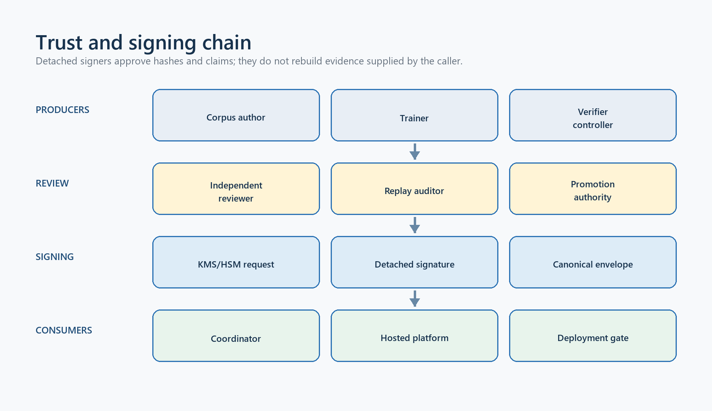
Figure 3. Hyperion trust and signing chain
Reading guide — trust chain: distinct row-review, teacher-lineage, evaluation-authoring, corpus-admission, base-selection, verifier-authority, replay-audit, trainer-provenance, promotion, launcher-activation, and runtime-receipt signers; show exact inputs, expiry propagation, and denied downstream authorities.

14.1 What a signature means
Hyperion uses canonical payloads, domain-separated preimages, SHA-256, ES256/P-256, fixed trust tuples, and low-S signature normalization. A verifier checks exact bytes, payload type, audience, key ID, signer role, subject/deployment identity, chronology, issue/expiry, public-key SPKI hash, and authority flags. Unknown fields and noncanonical encodings fail closed.
A valid signature means the holder of the trusted private key signed that exact statement. It does not prove the real-world identity or honesty of the operator, the truth of a rights declaration, expected-answer correctness, loaded weights, GPU execution, isolation, or an honest clock.

14.2 Separation of duties
The following decisions should use distinct keys and organizational roles:
Authority | Decision
Row review receipt | This exact row/evidence is approved for the declared uses
Teacher-lineage admission | This exact teacher chain maps to these exact reviewed rows
Evaluation authoring | This exact task/rubric/verifier inventory was independently authored
Corpus-quality admission | This exact SFT release meets reviewer-chosen coverage thresholds
Base selection | This catalog-complete matrix selects this exact base snapshot
Verifier authority | This exact verifier image/toolchain/sandbox may execute offline
Replay audit | This exact full C# replay covers these candidate/baseline rows
Trainer provenance | This exact artifact tree came from this exact governed training input/run
Promotion | This exact model/evidence/deployment is approved for the stated capability
Launcher/runtime | This exact process activation or response was observed under its protocol

Do not reuse one “ML signing key” for convenience. Separation limits the damage of compromise and prevents an author from approving their own corpus, evaluator, training output, and deployment.

14.3 Detached prepare/sign/finalize
Current authority families expose provider-neutral handoffs:
- Prepare revalidates live inputs and emits an unsigned, content-addressed bundle containing the exact payload/envelope fields, trust tuple, raw signature preimage, and digest.
- An external KMS/HSM or controlled signer signs either the raw message or explicitly supported prehashed digest.
- Finalize verifies DER or fixed P1363 input, rejects double hashing/wrong keys/malformed values, normalizes valid high-S input, reopens every live binding, and atomically publishes the unchanged consumer wire format.
The unsigned bundle grants no authority. A matching bundle/signature pair is nevertheless sensitive finalization-equivalent material until expiry and must be protected from replay or substitution.

14.4 Production custody still required
The repository supplies protocols, not a production KMS/HSM deployment. Before release, define key owners, IAM, multi-person/quorum approval, environments, audit retention, rotation, revocation, emergency disablement, backup/recovery, clock source, certificate/public-key distribution, and incident procedures. Test expired, revoked, wrong-role, wrong-audience, replaced-key, and compromised signer scenarios. Configuration removal/restart is not a complete long-term revocation service.

15. Kimi K3 research adoption

15.1 Verified source and scale
The reviewed primary source is Kimi Team, “Kimi K3: Open Frontier Intelligence,” arXiv:2607.24653v1, submitted 27 July 2026. The reviewed official report was pinned to MoonshotAI/Kimi-K3 commit 7c5be9599120d799​3748de66a7612861​4f15f210; the 47-page PDF hash recorded by the research review is 936a7a3b655947b0​14ba96b8a790c3cd​b6ea8b37eea514e4​b7b52655e20af0f8.
Moonshot reports a native multimodal mixture-of-experts model with 2.78 trillion total parameters, 104.2 billion activated per token, 93 layers, and a 1,048,576-token maximum context. The architecture uses 69 Kimi Delta Attention and 24 Gated MLA layers; Stable LatentMoE has 896 routed experts, selects 16 per token, and adds two shared experts. A 401-million-parameter MoonViT-V2 encoder supplies vision. The reviewed public weight snapshot was approximately 1.42 TiB across 96 safetensor shards before runtime overhead.
The paper attributes an approximately 2.5× aggregate scaling-efficiency gain over Kimi K2 to the combined architecture, data, optimizer, and systems recipe. Hyperion must not repeat that figure as an expected local gain: the report does not isolate one component, and Hyperion’s model size, data, hardware, objective, and fine-tuning method differ fundamentally.

15.2 Post-training lessons
The reported K3 sequence is verified human-annotated agent-trajectory SFT, reinforcement learning for three broad domains at low/high/maximum reasoning effort to produce nine specialist teachers, and Multi-Teacher On-Policy Distillation to consolidate them. The report also emphasizes independent and hidden verification, bounded submissions, diverse scaffolds, resumable long-running sandboxes, dynamic queue/KV-cache throttling, and separate budgets for workload classes.
These are system lessons, not a recipe Hyperion has reproduced.

15.3 Adopt now
K3 lesson | Hyperion action now | Required evidence
Effort-conditioned specialists | Add explicit low/high/max effort and token/time/cost budgets; begin with routed adapters over one base | Per-effort quality/cost/latency curves and no cross-domain regression
Independent hidden verification | Preserve withheld cases, submission limits, mutation testing, and separate evaluator ownership | Reward-hacking audit and hidden-case stability
Diverse agent scaffolds | Vary prompt shells, context policy, tool schema, memory, and subagent availability while recording exact harness/seed | Cross-harness generalization rather than one-scaffold success
Partial/resumable rollouts | Persist policy, sandbox/context state, budget, harness, verifier, and staleness window | Deterministic resume and off-policy stability tests
Dynamic scheduling | Partition short inference, long context, rollout, training, and evaluation queues using live memory/KV/queue signals | Load tests proving fairness and bounded starvation
Progressive context | Extend context only after shorter-context quality is stable and distant evidence is necessary | Length-stratified quality, memory, latency, and short-context non-regression
Structured transcripts | Separate roles, visible answers, tool calls/results, scope, and provider state; avoid retaining hidden reasoning | Round-trip/provider tests and privacy review
Stronger sandboxing | Plan microVM/separate-host execution for adversarial agent/RL workloads | Threat model, provenance, egress, attestation, and incident exercises

15.4 Research only
Kimi Delta Attention, Attention Residuals, Stable LatentMoE, Quantile Balancing, SiTU-GLU, per-head Muon, MoonEP, and deployment-wide MXFP quantization are architecture/pretraining-system changes. They cannot be faithfully added to Qwen or gpt-oss with QLoRA. Test them only in small ablation models after the dense/adapted baseline, evaluator, and cluster telemetry are trustworthy.
Faithful on-policy distillation requires teacher token probabilities or logits. Hosted text samples support verified sequence-level SFT, not the per-token K3 objective. Multi-teacher consolidation is therefore research-only until specialist adapters each pass frozen gates and a reproducible probability/logit pipeline is available.
Kimi K3 itself is not a practical base for the proposed small cluster. A 1.42 TiB compressed weight snapshot excludes activations, KV cache, optimizer/training state, redundancy, and service overhead. Hyperion should apply K3’s governance, budgeting, scheduling, verification, and experiment-design ideas to the smaller reviewed bases already in its catalog.

15.5 Licence boundary
Kimi K3 uses a custom Kimi K3 License identified as other on the reviewed model card, not a standard OSI/permissive licence. The reviewed text requires notice retention; a separate Moonshot agreement for a qualifying Model-as-a-Service business and affiliates above US$20 million aggregate revenue in any consecutive 12 months; and prominent “Kimi K3” attribution for commercial products above stated monthly-active-user or revenue thresholds. Defined internal use and access through official/certified providers have specified exceptions. Counsel must review the current exact licence before any weight, derivative, hosting, or commercial use.
No Kimi code, weights, training data, prompt traces, or outputs were copied into Hyperion. The paper does not publish the complete pretraining/RL corpora, total tokens/FLOPs, full GPU schedule, or a reproducible end-to-end recipe; all performance and architecture claims remain source claims until independently reproduced.

16. Proposed small-GPU-cluster architecture
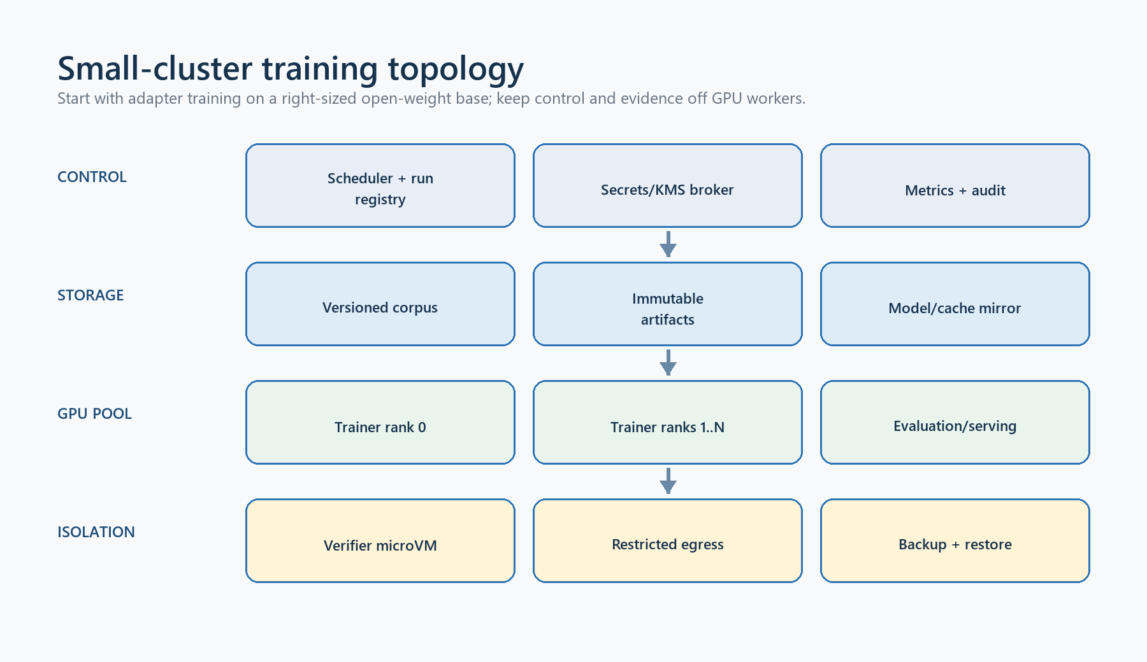
Figure 4. Proposed Hyperion small-GPU-cluster topology
Reading guide — management/control node; immutable data/model store; two or more isolated GPU workers; separate evaluation/serving and verifier-sandbox pools; scheduler/queue; telemetry; external KMS/HSM; denied-by-default egress; backup and artifact registry. Show trust boundaries and which links carry prompts, weights, evidence, and signatures.

16.1 Design principle
Use scale-out experiments before fragile cross-node model parallelism. A small cluster usually gains more reliable evidence by assigning one complete QLoRA run, evaluation shard, or inference server to one sufficiently large GPU/node and running seeds/candidates in parallel. Tensor/expert parallelism across consumer GPUs and weak Ethernet adds communication, failure, and reproducibility complexity. Use it only when measurements show a model cannot fit and the interconnect can sustain it.

16.2 Logical roles
Role | Minimum responsibility
Control node | Git/registry mirror, scheduler, job manifests, audit DB, immutable artifact index, monitoring; no untrusted model execution
Training workers | Homogeneous pinned driver/CUDA/container stack, local encrypted NVMe staging, no default internet, one job identity at a time
Evaluation/serving workers | Frozen vLLM profiles, queue/KV telemetry, no training write access, separate activation identity
Verifier pool | Separate host or microVM-capable workers; no model/corpus secrets; hidden expectations remain on trusted controller
Storage | Versioned read-only base snapshots, governed releases, pending/sealed artifacts, logs, backups, object lock where appropriate
External signer | KMS/HSM or isolated signing service; private keys never mounted on model workers

For early 7B/14B QLoRA, prioritize GPUs with enough VRAM to run one job without multi-node sharding. Practical memory depends on sequence length, attention implementation, batch/accumulation, optimizer, LoRA targets, activation checkpointing, and quantization—not parameter count alone. Treat 24 GB as an engineering floor for useful pilots, prefer 48 GB-class capacity for longer 14B work, and validate 20B/long-context requirements empirically before purchasing. These are planning heuristics, not fit guarantees.

16.3 Interconnect, storage, and power
- Prefer at least 10/25 GbE for model/data distribution and artifact collection; measure before assuming distributed-training viability. RDMA/NVLink benefits must be proven on the chosen stack.
- Keep pinned weight snapshots in central immutable storage and stage a verified read-only copy to local NVMe. Never train from a mutable Hugging Face cache.
- Size local storage for base snapshot, quantized working copy, dataset snapshots, temporary outputs, logs, and at least one failed run. Keep checkpoints disabled unless a reviewed safe/resume format is introduced.
- Budget sustained power, cooling, rack/circuit headroom, UPS shutdown, thermal throttling, and replacement capacity. Record actual GPU clocks, power, temperature, ECC/Xid errors, and throttling.

16.4 Cluster bootstrap gate
Before model work:
- inventory GPU model/serial/VRAM, CPU, RAM, NVMe, NIC, firmware, BIOS, driver, CUDA, and kernel;
- burn in every GPU and memory path under sustained load; fail on Xid/ECC/thermal instability;
- pin and hash the OS/container/runtime/driver matrix and synchronize trusted time;
- configure least-privilege service identities, firewall, denied-by-default egress, secret delivery, encrypted storage, and centralized audit logs;
- validate immutable snapshot copy/rehash and artifact no-clobber publication;
- run deterministic single-GPU smoke jobs twice and compare manifests/artifact identities;
- test queue cancellation, worker loss, disk-full, network partition, thermal alarm, signer outage, and restore from backup; and
- measure throughput, peak memory, power, upload/download, and queue latency before scheduling the base bake-off.

16.5 Scheduling and isolation
Create separate queues and quotas for interactive inference, long-context inference, teacher capture, training, sealed evaluation, and verifier execution. Admission should consider free VRAM, active requests, KV cache, local disk, power/thermal state, and expected duration. A long rollout must not starve a release verifier or production request. Preemption is acceptable only at declared safe boundaries with an exact resumable state contract.
Training workers should not hold promotion, review, or deployment keys. Evaluation workers should not write the training corpus. Verifier workers should not receive sealed expected answers or model weights. Control-plane compromise remains high impact; protect it with MFA, patching, backups, restricted administration, and auditable change control.

17. Engineering workflow and operator runbooks

17.1 How Hyperion was built
The implementation followed a contract-first, fail-closed sequence. Each stage first defined a closed wire schema and authority ceiling, then a validator/producer, adversarial tests, cross-language golden vectors where needed, and documentation of what the result could not prove. Synthetic fixtures were used to exercise contracts without pretending a real reviewer, key, corpus, GPU run, model, or deployment existed. This distinction must continue.

17.2 Team ownership
Team/role | Owns | Must not self-approve
Data steward/legal | Sources, licences, rights, retention, provider-upload permission | Model-quality or technical correctness alone
Domain reviewers | Row correctness, risk, architecture, finance/quant evidence | Their own authored material without independent review
ML engineers | Tokenization, data transforms, training, experiment records | Corpus rights, sealed evaluator, or promotion
Evaluation team | Calibration/sealed suites, hidden cases, baselines, statistics | Candidate training or prompt tuning on sealed data
Platform/SRE | Serving, queue, credits, telemetry, rollback | Model-quality acceptance
Security/release | Key policy, verifier authority, replay audit, promotion | Content they authored without separation

17.3 New-developer bootstrap
From a trusted clone:
git submodule update --init --recursive
dotnet build Hyperion.slnx
dotnet test tests/TradingTerminal.Tests.Pro.Headless/TradingTerminal.Tests.Pro.Headless.csproj
dotnet test platform/tests/DaxAlgo.Platform.VerifierWorker.Tests/DaxAlgo.Platform.VerifierWorker.Tests.csproj
Push-Location tools/hyperion-model
python -m pip install -e ".[auth,promote]" pytest ruff jsonschema
python -m pytest tests
Pop-Location
hyperion --help
Use the [train] extra only in the pinned Linux/CUDA training environment. Never install mutable latest ML dependencies into an evidence-producing worker.

17.4 Corpus-row runbook
- Register exact source bytes, provenance, licence, cutoff, and five rights.
- Author a development row with correct task/domain/knowledge-class labels.
- Compile the draft; fix validation rather than editing generated output.
- Run deterministic and supported executable checks.
- Package exact row/source/evidence for an independent reviewer.
- Compile complete row/source decisions and reapply review to fresh bytes.
- Obtain detached signed row receipts; add independent teacher-lineage admission where required.
- Export SFT and verify coverage/contamination.
- Build and independently sign the evaluation-authoring/release inventory.
- Obtain separate corpus-quality admission before non-smoke training.
At every step preserve previous artifacts and IDs. Never “repair” a signed artifact in place; create a new version and repeat downstream gates.

17.5 Teacher runbook
- Confirm provider/weight licence permits the intended training use.
- Freeze teacher revision, tokenizer/template, runtime descriptor, and capture budget.
- Start the controlled loopback engine and create/revalidate its passive binding.
- Compile manifest v2 from source-grounded development rows; confirm references are absent.
- Run live token/context preflight, then bounded multi-seed capture.
- Have the independent custodian generate the withheld deny-set.
- Select at most one candidate per task and materialize the immutable package.
- Perform subject-matter review; issue separate lineage admission and row receipts.
Failure, timeout, disagreement, overlap, or unverifiable runtime state leaves the candidate unreviewed. There is no “best effort” promotion into SFT.

17.6 Base selection and training runbook
- Acquire every student snapshot at its pinned revision and verify the source lock/tree.
- Create equivalent raw-base profiles and run the complete catalog matrix against the frozen release/suites/baseline.
- Aggregate gates and obtain independent selection v2 over the exact winning snapshot.
- Validate the full Linux/CUDA lock and hardware; execute a smoke run.
- Prepare manifest v3 from signed release, corpus admission, and selection.
- Run the bounded QLoRA pilot; retain telemetry and negative results.
- Produce the pending safe adapter tree; obtain external trainer-provenance signature; finalize artifact v2.
- Evaluate without changing prompts, thresholds, or sealed tasks. A failed gate returns to a new experiment, not an edited report.

17.7 Promotion and deployment runbook
- Re-run complete candidate/baseline aggregation from exact bytes.
- Fully replay C# rows and obtain the distinct replay-audit signature.
- Review quality, regressions, cost/latency, safety, rights, licence, and operational capacity.
- Issue a signed promotion with exact capability and expiry; do not reuse a research-only policy for strategy authoring.
- Prepare engine-wrapper v7 with immutable base/adapter/image and all trust roots.
- Launch under the distinct service identity; verify post-load model/adapter and readiness v2.
- Exercise Platform credit/run flow in shadow mode, then stage the rollout.
- Monitor and retain the rollback activation. Any drift, revoked authority, or critical regression disables new dispatch and invokes the incident plan.

17.8 Incident runbook
For suspected data leak, key compromise, model substitution, verifier escape, corrupted evidence, or unsafe output: stop new dispatch; preserve logs/artifacts; revoke/remove affected trust and activation; isolate workers; record exact times and identities; notify security/data/legal owners; assess every downstream artifact signed by the affected key/input; rotate and redistribute trust; restore from known immutable state; rerun evidence; and document the decision to resume or retire. Never delete evidence to make the system appear clean.

18. Testing and continuous integration

18.1 Required CI lanes
Lane | Required checks
Source hygiene | UTF-8/newline policy, whitespace, generated/cache exclusion, secret/private-key scan, licence/source manifest
.NET coordinator | Build named projects, focused xUnit suites, strict client/contract tests, dotnet format --verify-no-changes
Platform | Build platform/​DaxAlgo.​Platform.​slnx, API tests, credits/idempotency/readiness/promotion cases
Verifier | VerifierWorker tests, format, source/IL adversarial mutations, Docker build/replay when runner supports it
Python | pytest, Ruff check and format check, compileall, stdlib-only CLI import where expected
Schemas | Draft 2020-12 meta-validation, every local $ref, generated positive instances, adversarial unknown/missing/mutated fields
Cross-language | Conversation/SFT hashes, canonical JSON, public-key/signature vectors, promotion fixtures, prompt-catalog hashes
Boundary | Public/private scan, submodule pin, project-reference graph, no model weights/checkpoints/private keys

The originating verifier closure passed 43/43 tests. The model-tool history records large green Python/schema/CLI closures, but Hyperion must establish its own clean baseline after extraction; do not quote an old count as current until the exact commit reruns it.

18.2 Test taxonomy
- Unit: canonicalization, validation, state transitions, IDs, budgets, and math.
- Contract: schema/wire compatibility, strict unknown-field rejection, signatures, versioning.
- Integration: SQLite/EF transactions, HTTP client/API, credits, provider adapters, process owner.
- Adversarial: substitution, replay, expiry, high-S/malformed signatures, links/path races, oversized input, crash/recovery, prompt injection, compiler/IL escapes, daemon/environment drift.
- Golden: cross-language hashes and signed synthetic fixtures; update only through reviewed version changes.
- Hardware: runtime lock, deterministic smoke, peak memory, thermal/fault behaviour, throughput.
- Model quality: frozen candidate/baseline suites and human review; never conflated with software unit tests.

18.3 Evidence discipline in CI
CI keys and fixtures must be explicitly synthetic and incapable of production authorization. CI may prove that a signer protocol rejects tampering; it must not issue a production receipt, selection, promotion, or activation. GPU CI should run only on controlled workers with pinned images and empty mutable caches. Logs must redact prompts, source bodies, bearer tokens, private paths, and secrets while retaining safe content hashes and correlation IDs.

18.4 Change rules
Any change to a schema constant, domain separator, canonicalization, prompt text/hash, catalog, source lock, verifier policy, runtime lock, or authority ceiling is a compatibility/security change. It requires targeted adversarial tests, regenerated golden vectors, migration/rollback notes, and review by the owning security/data/evaluation role. Human-facing Hyperion branding must not mutate legacy wire identities accidentally.

19. Roadmap and release gates
Phase | Work | Exit gate
0. Repository baseline | Re-run all extracted .NET/Python/schema/format/boundary checks; establish CI and owners | Green reproducible commit; no secrets/weights; documented provenance
1. Governed corpus | Expand rights-clean rows, independent correctness/source decisions, receipts, teacher lineage where used, evaluation authoring | Signed release plus corpus admission; meaningful domain/task coverage; no sealed leakage
2. Cluster and custody | Build/burn in workers, immutable storage, denied egress, telemetry, external signers and revocation | Repeated deterministic smoke; incident/restore/key-rotation exercises pass
3. Raw-base bake-off | Run every catalog student and baseline under one frozen condition | Signed selection v2 over complete matrix and exact snapshot
4. QLoRA pilot | Run bounded SFT, safe tree sealing, external trainer provenance, multi-seed comparison | Artifact v2; reproducible improvement without critical/per-domain regression
5. Evaluation/promotion | Full sealed aggregation, C# replay audit, human/safety/cost review | Independent signed promotion with rollback target and bounded capability
6. Serving rollout | Engine-wrapper v7, readiness, remote auth, credits, staged shadow/cohort deployment | Stable SLOs, reconciliation, security sign-off, rollback drill
7. Advanced research | Effort adapters, diverse scaffolds, preference/RLVR, multi-teacher or architecture ablations | Each change independently beats the simpler accepted baseline

Stop rather than advance when rights are ambiguous, sealed custody is compromised, signer separation is unavailable, the runtime/snapshot drifts, the evaluator is gameable, critical failures appear, gains vanish across seeds, cost/latency exceeds policy, or rollback cannot be demonstrated. More infrastructure cannot substitute for missing real evidence.
The first legitimate “trained Hyperion” milestone requires, at minimum: governed SFT bytes; signed base selection and corpus admission; a conforming GPU run; finalized artifact v2 with trainer provenance; and measured candidate/baseline results. The first “production Hyperion” milestone also requires signed promotion, wrapper/readiness activation, production authentication/key custody, operational SLO evidence, and a staged rollback-tested deployment.

20. Limitations and non-goals

20.1 Current limitations
- No rights-approved production corpus, real authenticated receipt release, signed base selection, training run, adapter, checkpoint, benchmark win, promotion, or production deployment exists.
- Current catalog and runtime pins are starting hypotheses. Hardware, licence, vulnerability, performance, and model-quality reviews remain outstanding.
- The hosted Platform is a substantial development foundation, not proof of production identity, multi-instance durability, object storage, KMS, reconciliation, or remote account/device security.
- Private retrieval correctness depends on pack authoring and rights. Deterministic retrieval cannot make wrong/stale chunks true or prevent all prompt injection.
- Hashes and signatures authenticate bytes and claims; they do not prove legal rights, semantic truth, reviewer identity/honesty, GPU computation, loaded tensors, hardware, or clocks.
- The teacher runtime binding is an observation from the same endpoint it measures, not independent attestation.
- Docker verifier image/entrypoint are caller/reviewer selected; daemon, runtime, kernel, built-in seccomp, socket ownership, and privileged host are not independently attested.
- Narrow same-user/privileged path-swap races remain on several compare/open/publish paths; immutable custody or handle-relative privileged execution is still required for stronger assurance.
- The C# verifier covers one restricted strategy profile. It does not validate arbitrary C#, WPF, packages, plugins, installation, broker access, or live trading.
- Evaluation suites can be incomplete or biased; fixed thresholds and a passing score do not prove general competence or economic value.
- Kimi K3 ideas are literature-derived. No K3 component, weight, code, data, or claimed gain has been reproduced in Hyperion.

20.2 Non-goals
Hyperion is not an autonomous trading system, broker, order router, general code sandbox, legal-rights oracle, hardware attestation service, generic multi-agent chat framework, or guarantee of profitable strategies. Model-written source remains untrusted and inert until separate human, compile, installation, runtime-risk, broker, and order approvals are satisfied outside this coordinator.

21. Glossary
Term | Meaning in Hyperion
Activation | Exact signed serving configuration currently allowed to answer requests
Admission | Independent signed permission for one exact input/use, such as corpus quality or teacher lineage
Artifact v2 | Safe adapter tree plus exact trainer-provenance envelope and immutable identity
Authority ceiling | Explicit capabilities a record denies even when its signature is valid
Base selection v2 | Signed catalog-complete decision choosing one exact raw-base snapshot for training
Calibration | Held-out material used to choose thresholds, never for optimization or final promotion
Candidate | Model or response under evaluation; not accepted merely because generated
Canonical JSON | Deterministic byte representation used for hashing/signing
CAS | Content-addressed storage; an object is addressed by the digest of exact bytes
Contamination group | Related examples treated as one leakage/statistical cluster
Corpus admission | Signed decision that one exact governed SFT release meets chosen quality policy
DAXQ | Restricted DaxAlgo bytecode/compiler/VM path used by one corpus review profile
Detached signing | Prepare/sign/finalize flow that keeps private keys outside the model tool
Development split | Material used for workflow/model iteration, subject to later rights gates
ES256 | ECDSA with the P-256 curve and SHA-256
Evaluation-authoring approval | Signature over an exact task/context/rubric/verifier inventory
Evidence | Exact machine/human record supporting a claim; it grants only declared authority
Expert context pack | Immutable private retrieval corpus and deterministic index
Golden fixture | Synthetic fixed vector used to detect contract/canonicalization drift
Hosted policy v2 | Signed capability that can authorize the exact inert StrategyAuthoring tuple
Lineage | Producer/model/prompt/runtime/source chain for an example or artifact
Low-S | Canonical ECDSA form that removes signature malleability
No-clobber | Publication refuses to overwrite an existing destination
Promotion | Independent signed decision accepting exact model/evidence/deployment bytes
QLoRA | Low-rank adapter training with a quantized frozen base model
Raw base | Unadapted upstream model snapshot used for comparison or selected training input
Readiness v2 | Short-lived proof that active wrapper state matches the signed deployment
Receipt | Independent signed approval for one exact corpus row and declared uses
Replay audit | Signed record of one complete candidate/baseline C# verifier replay
Sealed split | Withheld final evaluation material that must never enter optimization
SFT | Supervised fine-tuning on reviewed conversation examples
Source lock | Exact upstream model file/size/hash inventory at one immutable revision
Trainer provenance | Signature binding final adapter bytes to exact inputs, run, and environment
Verifier authority | Short-lived signed permission for one exact verifier image/toolchain/sandbox
Wire identifier | Persisted/signed schema, route, domain, or version string requiring compatibility

22. Primary sources and internal evidence

22.1 Hyperion source of truth
- README.md — repository scope, aliases, build entrypoints, and evidence boundary.
- docs/​architecture/​source-​provenance.​md — exact originating revisions and extraction boundary.
- docs/​guides/​hyperion-​coordinator.​md — hosted workflow and operator/data contracts.
- docs/​research/​hyperion-​expert-​model.​md — detailed model, corpus, evaluation, signing, and serving design.
- docs/​research/​kimi-​k3-​adoption-​notes.​md — pinned K3 source review and adoption analysis.
- tasks/​2026-​07-​27-​1911-​expert-​model-​coordinator.​md — implementation/test history and explicit blockers.
- tools/​hyperion-​model/​schemas/​ and the matching C#/Python validators — normative machine contracts.
- tools/​hyperion-​model/​candidate-​catalog.​v1.​json, base-​model-​source-​lock.​v1.​json, training-​runtime-​profile.​v1.​json, and pylock.train.toml — current frozen research inputs.

22.2 Model, distillation, and training research
- Hinton et al., “Distilling the Knowledge in a Neural Network,” https://arxiv.org/abs/1503.02531.
- Hsieh et al., “Distilling Step-by-Step,” https://arxiv.org/abs/2305.02301.
- Mukherjee et al., “Orca,” https://arxiv.org/abs/2306.02707.
- Hu et al., “LoRA,” https://arxiv.org/abs/2106.09685.
- Dettmers et al., “QLoRA,” https://arxiv.org/abs/2305.14314.
- Rafailov et al., “Direct Preference Optimization,” https://arxiv.org/abs/2305.18290.
- Lambert et al., “Tülu 3,” https://arxiv.org/abs/2411.15124.
- Hui et al., “Qwen2.5-Coder Technical Report,” https://arxiv.org/abs/2409.12186.
- Qwen Team, “Qwen3 Technical Report,” https://arxiv.org/abs/2505.09388.
- DeepSeek-AI, DeepSeek-R1 report/repository, https://github.com/deepseek-ai/DeepSeek-R1.

22.3 Kimi K3 primary sources
- Kimi Team, “Kimi K3: Open Frontier Intelligence,” https://arxiv.org/abs/2607.24653.
- Official report snapshot at reviewed commit: https://github.com/MoonshotAI/Kimi-K3/blob/7c5be9599120d7993748de66a76128614f15f210/k3_tech_report.pdf.
- Official repository, https://github.com/MoonshotAI/Kimi-K3.
- Official model page, https://huggingface.co/moonshotai/Kimi-K3.
- Reviewed licence snapshot: https://github.com/MoonshotAI/Kimi-K3/blob/7c5be9599120d7993748de66a76128614f15f210/LICENSE.

22.4 Evaluation, orchestration, serving, and custody
- Jimenez et al., “SWE-bench,” https://arxiv.org/abs/2310.06770.
- Jain et al., “LiveCodeBench,” https://arxiv.org/abs/2403.07974.
- Anthropic, “Building effective agents,” https://www.anthropic.com/research/building-effective-agents.
- vLLM serving documentation, https://docs.vllm.ai/en/latest/cli/serve/.
- Python Packaging Authority, PEP 751, https://peps.python.org/pep-0751/.
- Astral, uv pip compile, https://docs.astral.sh/uv/pip/compile/.
- IETF RFC 7518 §3.4 (ECDSA/JWA), https://www.rfc-editor.org/rfc/rfc7518#section-3.4.
- AWS KMS Sign, https://docs.aws.amazon.com/kms/latest/APIReference/API_Sign.html.
- Azure Key Vault sign, https://learn.microsoft.com/en-us/rest/api/keyvault/keys/sign/sign.
- Google Cloud KMS asymmetricSign, https://cloud.google.com/kms/docs/reference/rest/v1/projects.locations.keyRings.cryptoKeys.cryptoKeyVersions/asymmetricSign.
Source links and licences must be rechecked at the exact revision and date of any real training or commercial deployment. This handbook is an engineering map, not a substitute for the live schemas, code, signed evidence, security review, or legal advice.

